EXPERIMENT-3
NAME: MOHAMED Aseel S ROLLNO: 240701319

1. COMMAND LINE INTERFACE:
PYTHON CODE:
import platform
import shutil
import argparse
parser = argparse.ArgumentParser()
parser.add_argument("option", help="cpu | memory | disk")
args = parser.parse_args()
if args.option == "cpu":
print("Processor:", platform.processor())
elif args.option == "memory":
total, used, free = shutil.disk_usage("/")
print("Free Disk Space:", free)
elif args.option == "disk":
total, used, free = shutil.disk_usage("/")
print("Disk Used:", used)
else:
print("Invalid option")

2. GRAPHICAL USER INTERFACE:
PYTHON CODE:
import tkinter as tk
import platform
root = tk.Tk()
root.title("Basic System Info")
label = tk.Label(root, text="Click a button", font=("Arial", 12))
label.pack(pady=10)
def show_os():
label.config(text=f"OS: {platform.system()}")
def show_machine():
label.config(text=f"Machine: {platform.machine()}")
tk.Button(root, text="Show OS", command=show_os).pack(pady=5)
tk.Button(root, text="Show Machine", command=show_machine).pack(pady=5)
root.mainloop()
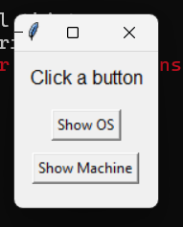

3. VOICE USER INTERFACE:
PYTHON CODE:
import pyttsx3
import platform
engine = pyttsx3.init()
info = platform.system()
engine.say(f"The operating system is {info}")
engine.runAndWait()

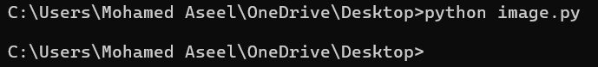

4. USER SATISFACTION COMPARISON
PYTHON CODE:
ratings = {
"CLI": 4,
"GUI": 5,
"VUI": 3
}
for k, v in ratings.items():
print(f"{k} Rating: {v}")
average = sum(ratings.values()) / len(ratings)
print("Average Satisfaction:", average)
