1. Introduction to Version Control System (VCS)

What is a Version Control System?
A Version Control System is a tool that helps developers:
Why VCS is important?
- Track changes in files
- Maintain history of code
- Collaborate with multiple developers
- Recover previous versions if something goes wron
- Keeps backup of all versions

Types of VCS
- Local VCS – Saves versions on local machine
- Centralized VCS – Single central server (SVN)
- Distributed VCS – Each user has full copy (Git)

2. Introduction to Git

What is Git?
Git is a distributed version control system created by Linus Torvalds.

Features of Git
- Fast and lightweight
- Distributed system
- Tracks complete history
- Supports branching and merging
- Open source

Git vs GitHub
Git | GitHub
Tool | Platform
Installed locally | Cloud-based
Version control | Code hosting & collaboration

3. Installing Git

Steps to Install Git (Windows)
1 Download Git
Open browser
Go to the official website:
https://git-scm.com/
Click Download for Windows
This downloads the Git installer file (.exe).

Check Git Version
git --version

Configure Git (One Time Setup)
git config --global user.name "Your Name" “Ashad”
git config --global user.email "yourmail@gmail.com" “md.hussain@sunstone.in”
Check configuration:
git config –list
[output-
91766@DESKTOP-IGOFDPR MINGW64 ~/Desktop/GIT (main)
$ git config --list
diff.astextplain.textconv=astextplain
filter.lfs.clean=git-lfs clean -- %f
filter.lfs.smudge=git-lfs smudge -- %f
filter.lfs.process=git-lfs filter-process
filter.lfs.required=true
http.sslbackend=schannel
core.autocrlf=true
core.fscache=true
core.symlinks=false
pull.rebase=false
credential.helper=manager
credential.https://dev.azure.com.usehttppath=true
init.defaultbranch=master
user.name=Ashad
user.email=“md.hussain@sunstone.in”
core.repositoryformatversion=0
core.filemode=false
core.bare=false
core.logallrefupdates=true
core.symlinks=false
core.ignorecase=true

Before- user.name and user.email
91766@DESKTOP-IGOFDPR MINGW64 ~
$ git config --list
diff.astextplain.textconv=astextplain
filter.lfs.clean=git-lfs clean -- %f
filter.lfs.smudge=git-lfs smudge -- %f
filter.lfs.process=git-lfs filter-process
filter.lfs.required=true
http.sslbackend=schannel
core.autocrlf=true
core.fscache=true
core.symlinks=false
pull.rebase=false
credential.helper=manager
credential.https://dev.azure.com.usehttppath=true
init.defaultbranch=master

after- add username and user.email
91766@DESKTOP-IGOFDPR MINGW64 ~
$ git config --list
diff.astextplain.textconv=astextplain
filter.lfs.clean=git-lfs clean -- %f
filter.lfs.smudge=git-lfs smudge -- %f
filter.lfs.process=git-lfs filter-process
filter.lfs.required=true
http.sslbackend=schannel
core.autocrlf=true
core.fscache=true
core.symlinks=false
pull.rebase=false
credential.helper=manager
credential.https://dev.azure.com.usehttppath=true
init.defaultbranch=master
user.name=Ashad
user.email=“md.hussain@sunstone.in”

note: add username and email in config file
]

4. Git Repository

What is Repository?
A repository (repo) is a folder that Git tracks.

Create New Repository
git init

Git Workflow
Working Directory → Staging Area → Repository
[91766@DESKTOP-IGOFDPR MINGW64 ~
$ git status
fatal: not a git repository (or any of the parent directories): .git

91766@DESKTOP-IGOFDPR MINGW64 ~/Desktop/GIT (main)
$ git init
Reinitialized existing Git repository in C:/Users/91766/Desktop/GIT/.git/

[create hidden folder in location with .git]

[Check by
$ ls -la
total 62
drwxr-xr-x 1 91766 197609 0 Mar 7 12:11 ./
drwxr-xr-x 1 91766 197609 0 Mar 5 14:59 ../
drwxr-xr-x 1 91766 197609 0 Feb 3 16:20 .git/
drwxr-xr-x 1 91766 197609 0 Jan 27 16:18 First/
-rw-r--r-- 1 91766 197609 236 Feb 4 14:42 'New Text Document.txt'
-rw-r--r-- 1 91766 197609 35495 Feb 3 16:55 Notes.docx
drwxr-xr-x 1 91766 197609 0 Jan 27 16:18 Second/
drwxr-xr-x 1 91766 197609 0 Jan 27 16:18 Third/
-rw-r--r-- 1 91766 197609 162 Mar 7 12:11 '~$Notes.docx'
]

91766@DESKTOP-IGOFDPR MINGW64 ~/Desktop/GIT (main)
$ git status
On branch main

No commits yet

Untracked files:
(use "git add <file>..." to include in what will be committed)
New Text Document.txt
Notes.docx
~$Notes.docx
~WRL0003.tmp

nothing added to commit but untracked files present (use "git add" to track)
]
5. Basic Git Commands

Check Status
git status

[output-
91766@DESKTOP-IGOFDPR MINGW64 ~/Desktop/GIT (main)
$ git status
On branch main

No commits yet

Untracked files:
(use "git add <file>..." to include in what will be committed)
New Text Document.txt
Notes.docx
~$Notes.docx
~WRL0003.tmp

nothing added to commit but untracked files present (use "git add" to track)

new file: ~$Notes.docx
]
Working Dir
|
| git add
v
Staging Area
|
| git commit
v
Repo
|
| git push
v
Github

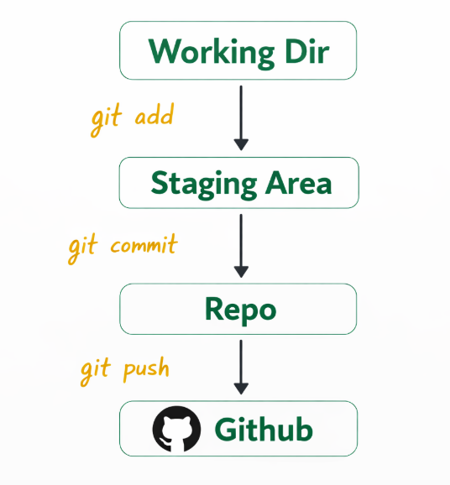

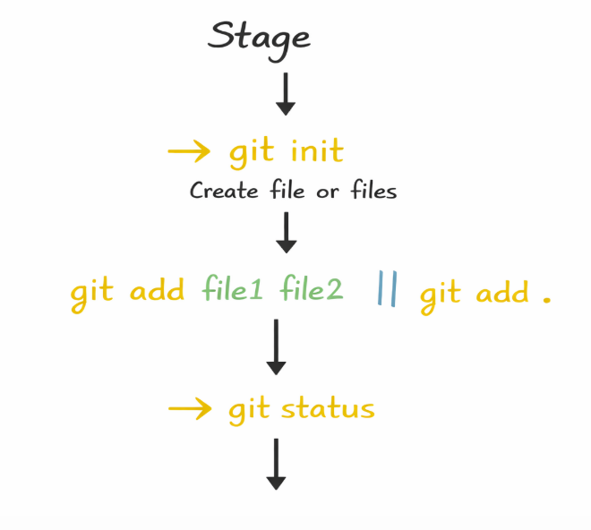
Stage of git
→ git init
Create file or files
git add file1 file2 || git add .
git status
[Git journey]

Add Files to Staging Area
git add file1.txt file2.txt // for individual file
git add . // for all file

[create file as- index.txt, index1.txt]

[91766@DESKTOP-IGOFDPR MINGW64 ~/Desktop/GIT (main)
$ git status
On branch main

No commits yet

Untracked files:
(use "git add <file>..." to include in what will be committed)
File 1.txt
File 2.txt
Git Lab Experiment BCA II Sec A- Index File.xlsx
New Text Document.txt
Notes.docx
~$Notes.docx

nothing added to commit but untracked files present (use "git add" to track)

91766@DESKTOP-IGOFDPR MINGW64 ~/Desktop/GIT (main)
$ git add .

91766@DESKTOP-IGOFDPR MINGW64 ~/Desktop/GIT (main)
$ git status
On branch main

No commits yet

Changes to be committed:
(use "git rm --cached <file>..." to unstage)
new file: File 1.txt
new file: File 2.txt
new file: Git Lab Experiment BCA II Sec A- Index File.xlsx
new file: New Text Document.txt
new file: Notes.docx

Adv: If there is any change in file, it will show the change.
]

Commit Changes
git commit -m "Initial commit"

// -m should be mandatory for msg during commit.

[91766@DESKTOP-IGOFDPR MINGW64 ~/Desktop/GIT (main)
$ git commit -m "First Comment"
[main (root-commit) bf7a2c8] First Comment
6 files changed, 15 insertions(+)
create mode 100644 File 1.txt
create mode 100644 File 2.txt
create mode 100644 Git Lab Experiment BCA II Sec A- Index File.xlsx
create mode 100644 New Text Document.txt
create mode 100644 Notes.docx
create mode 100644 ~$Notes.docx

]

[91766@DESKTOP-IGOFDPR MINGW64 ~/Desktop/GIT (main)
$ git status
On branch main
nothing to commit, working tree clean

91766@DESKTOP-IGOFDPR MINGW64 ~/Desktop/GIT (main)
$ git status
On branch main
Changes not staged for commit:
(use "git add <file>..." to update what will be committed)
(use "git restore <file>..." to discard changes in working directory)
modified: File2.txt

no changes added to commit (use "git add" and/or "git commit -a")

91766@DESKTOP-IGOFDPR MINGW64 ~/Desktop/GIT (main)
$ git add File2.txt

91766@DESKTOP-IGOFDPR MINGW64 ~/Desktop/GIT (main)
$ git status
On branch main
Changes to be committed:
(use "git restore --staged <file>..." to unstage)
modified: File2.txt

91766@DESKTOP-IGOFDPR MINGW64 ~/Desktop/GIT (main)
$ git commit -m "File 2 is updted"
][main 43b5b06] File 2 is updted
1 file changed, 1 insertion(+)

91766@DESKTOP-IGOFDPR MINGW64 ~/Desktop/GIT (main)
$ git status
On branch main
nothing to commit, working tree clean

91766@DESKTOP-IGOFDPR MINGW64 ~/Desktop/GIT (main)
// Just I update a file 2 and do same process.
  - Git status
  - Git add file2.txt
  - Git status
  - Git commit –m “This is file2 updated”
  - Git status]

View Commit History
git log // Its informative command
Git Log is a command used to view the history of commits in a Git repository. It shows information about each commit such as commit ID (hash), author name, date, and commit message.
Important Points
- Displays commit history of the repository.
- Shows commit hash, author, date, and message.
- Helps in tracking project changes.
- Useful for reviewing previous versions of code.

Common Git Log Commands
Command | Description
git log | Shows full commit history
git log --oneline | Shows commits in short one-line format
git log --graph | Displays commit history as a graph
[
91766@DESKTOP-IGOFDPR MINGW64 ~/Desktop/GIT (main)
$ git log
commit 43b5b06ddb930db59cc61125e92bf43d830b35e7 (HEAD -> main)
Author: Abhi <md.hussain@sunstone.in>
Date: Tue Mar 10 11:07:35 2026 +0530

File 2 is updted

commit cab1130db96b2c3682ae2409b4d0fc2ca3157073
Author: Abhi <md.hussain@sunstone.in>
Date: Tue Mar 10 11:05:57 2026 +0530

Now this file is commit

commit bf7a2c87bd01901b10fcf93c510c4b31169b1553
Author: Abhi <md.hussain@sunstone.in>
Date: Tue Mar 10 10:59:07 2026 +0530

First Comment

91766@DESKTOP-IGOFDPR MINGW64 ~/Desktop/GIT (main)
$ git log --oneline
43b5b06 (HEAD -> main) File 2 is updted
cab1130 Now this file is commit
bf7a2c8 First Comment

91766@DESKTOP-IGOFDPR MINGW64 ~/Desktop/GIT (main)
]
Note: .gitignore in Git – Short Notes with Practical
.gitignore is a special file in Git used to ignore certain files or folders so that Git does not track them. It tells Git which files should not be committed to the repository. This is useful for ignoring temporary files, compiled files, log files, system files, or sensitive data like passwords.
If you want to any file that git does not track- you need to put the file or folder in .gitignore folder.

6. Branching in Git

What is Branch?
A branch allows working on features without affecting main code.
A branch in Git is used to create a separate line of development. It allows developers to work on new features, bug fixes, or experiments without affecting the main project code. The default branch in Git is usually main or master.
Important Points
- A branch is a separate version of the project.
- Used for feature development or bug fixing.
- The default branch is main/master.
- Changes from a branch can be merged into another branch.
- Helps in team collaboration.
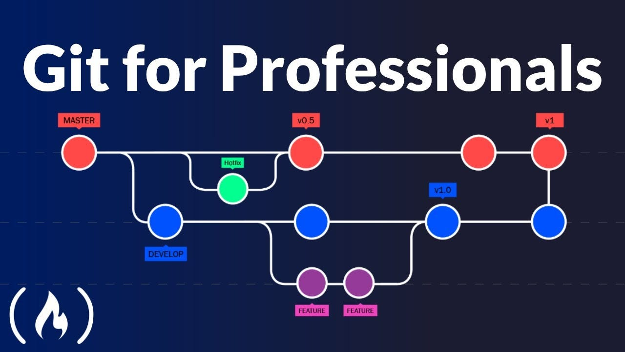

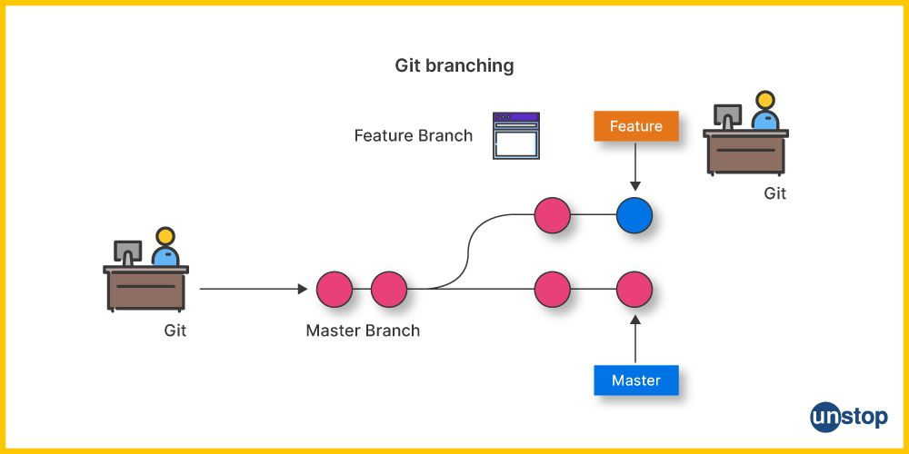

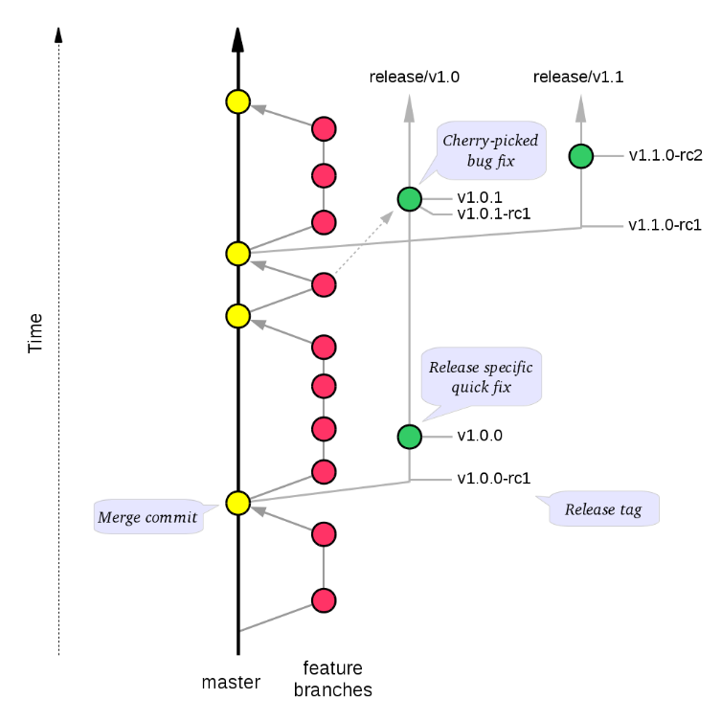
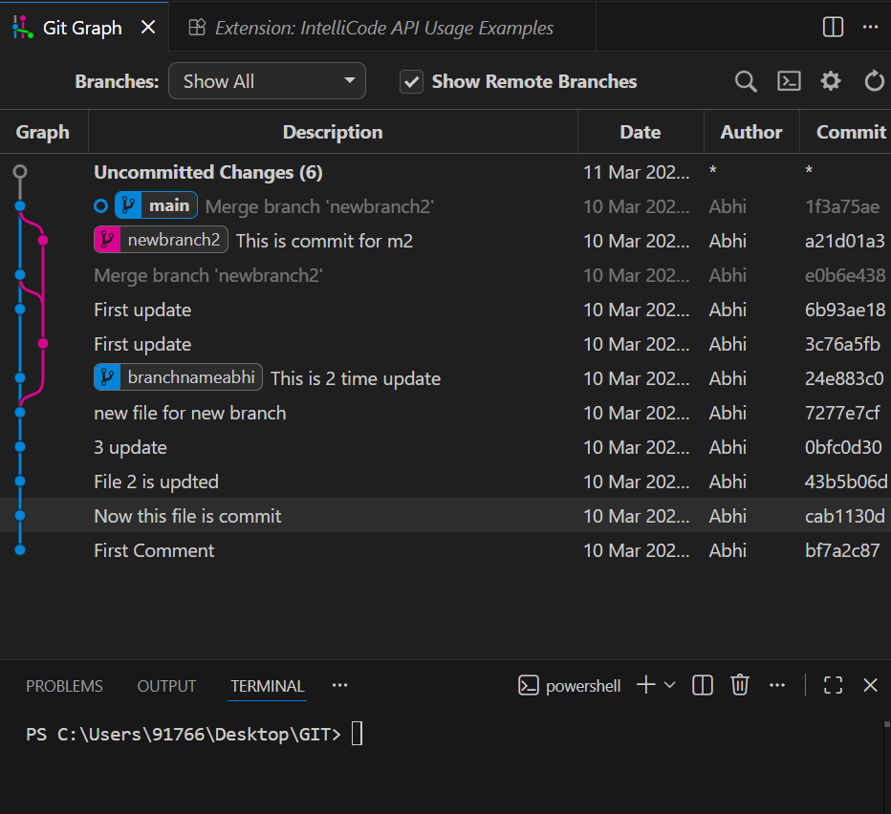
Common Branch Commands
Command | Description
git branch | Show all branches
git branch branchname | Create a new branch
Git switch newbranchname | For switching the branch
Git switch –c newbranchnamae | Switch and creare new branch also
git checkout branch_name | Switch to another branch
git checkout -b branch_name | Create and switch to a branch
git branch -d branch_name | Delete a branch

[Note: Git Switch and Git Checkout – Short Important Notes with Practical
git switch and git checkout commands are used to change branches in a Git repository. Earlier, git checkout was used for both switching branches and restoring files, but now Git provides git switch specifically for branch switching to make it simpler and safer.
git switch is mainly used for moving between branches, while git checkout can be used for switching branches as well as restoring files or commits.
Important Points
- git switch is used only for switching branches.
- git checkout is an older command with multiple purposes.
- git switch is simpler and recommended for branch switching.
- Both commands can create and move to a new branch.
Common Commands
Command | Description
git switch branch_name | Switch to an existing branch
git switch -c branch_name | Create and switch to a new branch
git checkout branch_name | Switch to another branch
git checkout -b branch_name | Create and switch to a new branch

List Branches
git branch

[91766@DESKTOP-IGOFDPR MINGW64 ~/Desktop/GIT (main)
$ git branch
* main

If you want to see.. Goto .git>>refer>>head>> and open
C:\Users\91766\Desktop\GIT\.git\refs\heads

Head file pointing>>ref: refs/heads/main]

Create New Branch
git branch branchnameabhi
[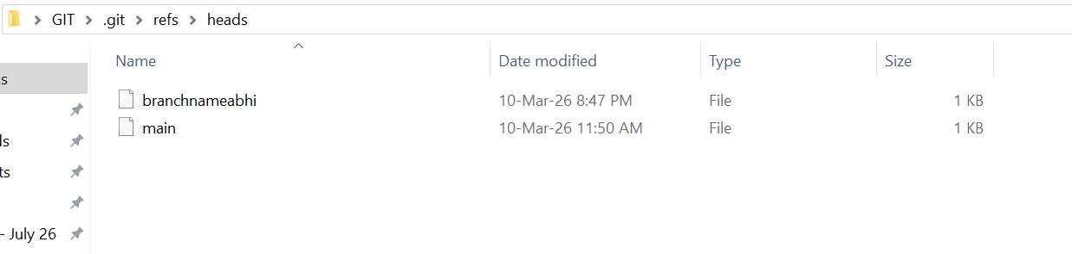]

Switch Branch
git switch newbranchname
[91766@DESKTOP-IGOFDPR MINGW64 ~/Desktop/GIT (main)
$ git switch branchnameabhi
D Notes.docx
D ~$Notes.docx
Switched to branch 'branchnameabhi'

91766@DESKTOP-IGOFDPR MINGW64 ~/Desktop/GIT (branchnameabhi)
$ git branch
* branchnameabhi
Main ]

[Task: create a file in this branch and add and commit in repo>> File (newbranchfile)
91766@DESKTOP-IGOFDPR MINGW64 ~/Desktop/GIT (branchnameabhi)
$ git log --oneline
7277e7c (HEAD -> branchnameabhi) new file for new branch
0bfc0d3 (main) 3 update
43b5b06 File 2 is updted
cab1130 Now this file is commit
bf7a2c8 First Comment

]

[Task: Switch to master or main branch
91766@DESKTOP-IGOFDPR MINGW64 ~/Desktop/GIT (branchnameabhi)
$ git branch
* branchnameabhi
main

91766@DESKTOP-IGOFDPR MINGW64 ~/Desktop/GIT (branchnameabhi)
$ git switch main
D Notes.docx
D ~$Notes.docx
Switched to branch 'main'

91766@DESKTOP-IGOFDPR MINGW64 ~/Desktop/GIT (main)
$ git branch
branchnameabhi
* main

Note: one interesting task happened- your create file(newbranchfile) temporary remove. If you switch to main branch, and again goto create sub branch(branchnameabhi) file will be display. ]

Create and Switch Together
Git switch –c newbranchnamae | Switch and creare new branch also
[91766@DESKTOP-IGOFDPR MINGW64 ~/Desktop/GIT (branchnameabhi)
$ git switch -c newbranch2
Switched to a new branch 'newbranch2'

91766@DESKTOP-IGOFDPR MINGW64 ~/Desktop/GIT (newbranch2)
$ git branch
branchnameabhi
main
* newbranch2
]

Merge Branch
Git Merge – Short Important Notes with Practical
Git Merge is a command used to combine changes from one branch into another branch. It is commonly used when a developer finishes working on a feature branch and wants to add those changes to the main branch.
When merging, Git integrates the commit history of the source branch into the target branch. Sometimes merge conflicts may occur if the same part of a file was modified in both branches.

Important Points
- Used to combine two branches.
- Mostly used to merge feature branch into main branch.
- Keeps the commit history of both branches.
- Sometimes merge conflicts can occur.
- Conflicts must be resolved manually.

Common Git Merge Command
Command | Description
git merge branch_name | Merge the specified branch into the current branch
[91766@DESKTOP-IGOFDPR MINGW64 ~/Desktop/GIT (main)
$ git branch
branchnameabhi
* main
newbranch2

91766@DESKTOP-IGOFDPR MINGW64 ~/Desktop/GIT (main)
$ git merge branchnameabhi
Updating 0bfc0d3..24e883c
Fast-forward
newbranchfile.txt | 2 ++
1 file changed, 2 insertions(+)
create mode 100644 newbranchfile.txt

note: newbranchfile.txt copy to main branch]
[Types of Git Merge
1. Fast-Forward Merge
A fast-forward merge happens when there are no new commits in the target branch. Git simply moves the branch pointer forward.
Example:
git merge feature
In this case, Git directly adds the commits without creating a new merge commit.

Merge Conflict
A merge conflict occurs when two branches modify the same part of a file. Git cannot decide which change to keep.
Example conflict in file:
<<<<<<< HEAD
Hello from main branch
=======
Hello from feature branch
>>>>>>> feature
To fix it:
- Edit the file manually.
- Remove conflict markers.
- Add the corrected file.
Commands to resolve:
git add file.txt
git commit -m "Resolved merge conflict"]

[Task:
RENAME A BRANCH
Git branch –m old_branch_name new_branch_name
DELETE A BRANCH
Git branch –d branchname ]
Note: Branch Name Change
91766@DESKTOP-IGOFDPR MINGW64 ~/Desktop/GIT (main)
$ git branch
branchnameabhi
* main
newbranch2

91766@DESKTOP-IGOFDPR MINGW64 ~/Desktop/GIT (main)
$ git branch -M master

91766@DESKTOP-IGOFDPR MINGW64 ~/Desktop/GIT (master)
$ git branch
branchnameabhi
* master
newbranch2

7. Git diff command
git diff is a command used to show the differences between files or commits in a Git repository. It helps developers see what changes have been made in the code before committing or between different versions of the project.
This command highlights added, deleted, or modified lines in files.

Important Points
- Shows changes between files or commits.
- Used to review modifications before committing.
- Displays added (+) and removed (-) lines.
- Helps in debugging and tracking code changes.

Common Git Diff Commands
Command | Description
git diff | Show changes not yet staged
git diff --staged | Show staged changes
git diff commit1 commit2 | Compare two commits
git diff branch1 branch2 | Compare two branches
git diff filename | Show changes in a specific file

Practical Example

Step 1: Initialize Repository
git init

Step 2: Create a File
echo "Hello Git" > file.txt

Step 3: Add File
git add file.txt
git commit -m "First commit"

Step 4: Modify the File
echo "Git is useful" >> file.txt

Step 5: Check Differences
git diff
Example Output:
+ Git is useful
+ indicates new line added,
- indicates line removed.
Git Diff Between Two Commits

Syntax
git diff commit1 commit2
- commit1 → Older commit ID
- commit2 → Newer commit ID

Step : View Commit IDs
git log --oneline
Example Output:
a3f5b21 Second commit
b7c2d10 First commit

Step 5: Compare the Two Commits
git diff b7c2d10 a3f5b21
Example Output:
+ Learning Git commands
✅ Conclusion:
The git diff command helps developers see changes in files before committing, making it easier to review and manage code updates.

Topic: Git Stash – Short Important Notes with Practical
git stash is a command used to temporarily save changes in a working directory without committing them. It allows developers to store unfinished work and switch branches or work on something else, then later restore those changes.
In simple words, git stash hides your current changes and saves them for later use.

Important Points
- Temporarily saves uncommitted changes.
- Keeps the working directory clean.
- Useful when switching branches quickly.
- Changes can be restored later using stash commands.
- Multiple stashes can be stored.

Common Git Stash Commands
Command | Description
git stash | Save current changes temporarily
git stash list | Show all saved stashes
git stash apply | Restore the latest stash
git stash pop | Restore and remove stash
git stash drop | Delete a stash

Practical Example

Step 1: Initialize Repository
git init

Step 2: Create and Commit File
echo "Hello Git" > file.txt
git add file.txt
git commit -m "Initial commit"

Step 3: Modify the File
echo "New changes added" >> file.txt

Step 4: Save Changes Using Stash
git stash
Now the working directory becomes clean.

Step 5: Check Stash List
git stash list
Example Output:
stash@{0}: WIP on main

Step 6: Restore Stash
git stash pop
The saved changes will come back.
✅ Conclusion:
git stash helps developers temporarily store unfinished changes and continue working without committing them.

Task:

Git Tag – Short Important Notes with Practical
git tag is a command used to mark specific points in the Git history, usually to indicate important versions of a project such as releases (v1.0, v2.0, etc.). Tags help developers easily identify stable versions or milestones in the project.
Unlike branches, tags do not change once they are created.

Important Points
- Used to mark important commits.
- Commonly used for software release versions.
- Tags are permanent references to commits.
- Two main types: Lightweight tag and Annotated tag.

Types of Git Tags

1. Lightweight Tag
A simple tag pointing to a commit.
git tag v1.0

2. Annotated Tag
Contains additional information such as tagger name, date, and message.
git tag -a v1.0 -m "First release"

Common Git Tag Commands
Command | Description
git tag | List all tags
git tag tag_name | Create a lightweight tag
git tag -a tag_name -m "message" | Create an annotated tag
git show tag_name | Show tag details
git tag -d tag_name | Delete a tag

Practical Example

Step 1: Initialize Repository
git init

Step 2: Create and Commit File
echo "Hello Git" > file.txt
git add file.txt
git commit -m "First commit"

Step 3: Create Tag
git tag v1.0

Step 4: View Tags
git tag
Output:
v1.0

Step 5: Show Tag Details
git show v1.0

✅ Conclusion:
git tag is used to mark important commits or release versions, making it easier to track project milestones.
It’s mostly use by project manager. Individual developer less or minimum use.

Q. Git rebase and merge

What is Git Rebase (Simple Meaning- Base ko realign krna)
Git rebase means taking commits from one branch and placing them on top of another branch so the history looks straight and clean.
Instead of combining branches like merge, rebase moves commits.

Example
Assume we have two branches.
main branch:
A --- B
feature branch:
A --- B --- C --- D
C and D are commits in the feature branch.
If we run:
git rebase main
Git will move C and D on top of main.
Result:
main:
A --- B
feature:
A --- B --- C --- D
But if main had a new commit E, then after rebase:
Before:
main: A --- B --- E
feature: A --- B --- C --- D
After rebase:
main: A --- B --- E
feature: A --- B --- E --- C --- D
Now the history is clean and linear.

Simple Practical Steps

1️ Create repository
git init

2️ Create file and commit
echo "hello" > file.txt
git add file.txt
git commit -m "first commit"

3️ Create branch
git branch feature
git switch feature

4️ Make change
echo "feature work" >> file.txt
git commit -am "feature commit"

5️ Rebase with main
git rebase main
Now feature branch commits are placed on top of main.

✅ One-line definition (for exam):
Git rebase is used to move or reapply commits from one branch onto another branch to maintain a clean linear history.

If you want, I can also show the difference between git merge and git rebase in one simple diagram (very easy for viva and exams).
yes give difference

Difference Between Git Merge and Git Rebase (Simple Explanation)
Both git merge and git rebase are used to combine changes from one branch into another branch, but they work in different ways.

Key Difference
Feature | Git Merge | Git Rebase
Working Method | Combines branches together | Moves commits to another branch
Commit History | Creates a merge commit | Keeps linear (straight) history
Safety | Safer for shared branches | Can rewrite history
Usage | Common in team collaboration | Used to clean project history

Example Diagram

1️ Git Merge
Before Merge:
main: A ---- B
\
feature: C ---- D
Command:
git merge feature
After Merge:
main: A ---- B -------- M
\ /
feature: C ---- D
M = Merge Commit

2️ Git Rebase
Before Rebase:
main: A ---- B ---- E
\
feature: C ---- D
Command:
git rebase main
After Rebase:
main: A ---- B ---- E
\
feature: C ---- D
Commits C and D move on top of main.

Simple Definition (for Exams)
- Git Merge: Combines two branches and creates a merge commit.
- Git Rebase: Moves commits from one branch to another to create a linear history.

✅ Easy way to remember
- Merge = Combine branches
- Rebase = Move commits

Git Important Commands – One-Line Notes
Git Init
git init is used to create a new Git repository in a project folder.
Git Add
git add is used to add files to the staging area before committing.
Git Commit
git commit is used to save changes permanently in the Git repository.
Git Log
git log is used to view the history of commits in the repository.
Git Diff
git diff is used to show differences between files, commits, or branches.
Git Branch
git branch is used to create, list, or delete branches in a repository.
Git Checkout
git checkout is used to switch branches or restore files.
Git Switch
git switch is used to move from one branch to another branch.
Git Merge
git merge is used to combine changes from one branch into another branch.
Git Rebase
git rebase is used to move commits from one branch onto another branch to keep a clean history.
Git Stash
git stash is used to temporarily save uncommitted changes and restore them later.
Git Tag
git tag is used to mark important commits such as project versions (v1.0, v2.0).
Git Clone
git clone is used to copy a remote repository to the local system.
Git Pull
git pull is used to download changes from a remote repository and update the local repository.
Git Push
git push is used to upload local commits to a remote repository.

Git Cheat Sheet (Important Commands – Quick Revision)
Asad, here is a one-page Git cheat sheet with the most useful commands for lab exams, viva, and quick practice.

1. Start a Repository
git init
Creates a new Git repository.
git clone repository_url
Copies a remote repository to your local system.

2. Check Repository Status
git status
Shows modified, staged, and untracked files.
git log
Displays commit history.
git log --oneline
Shows short commit history.

3. Add and Commit Changes
git add filename
Adds a specific file to staging area.
git add .
Adds all files to staging area.
git commit -m "message"
Saves changes to the repository.

4. Branch Management
git branch
Shows all branches.
git branch branch_name
Creates a new branch.
git switch branch_name
Switches to another branch.
git switch -c branch_name
Creates and switches to new branch.

5. Compare Changes
git diff
Shows unstaged changes.
git diff commit1 commit2
Compares two commits.

6. Merge Branches
git merge branch_name
Combines another branch into the current branch.

7. Temporary Save Work
git stash
Temporarily saves uncommitted changes.
git stash pop
Restores the saved changes.

8. Version Tagging
git tag v1.0
Marks a specific commit as a version.

9. Remote Repository
git remote add origin repository_url
Connects local repository to GitHub.
git push origin main
Uploads local commits to remote repository.
git pull origin main
Downloads latest changes from remote repository.

✅ Quick Git Workflow
git init
git add .
git commit -m "first commit"
git branch feature
git switch feature
git merge feature
git push origin main

Note:

Git Reflog – (Details note like git log –oneline)
git reflog is a command used to view the history of all actions performed in a Git repository, such as commits, resets, merges, checkouts, and rebases. It records every movement of the HEAD pointer, helping developers recover lost commits or changes.
It is very useful when you accidentally delete a commit or reset the branch.

Important Points
- Shows history of HEAD changes.
- Helps recover lost commits.
- Tracks actions like commit, reset, checkout, merge, rebase.
- Works only in the local repository.

Syntax
git reflog
This displays a list of recent Git operations.
Example Output:
a1b2c3d HEAD@{0}: commit: Added new feature
f4e5d6a HEAD@{1}: checkout: moving from main to feature
9g8h7i6 HEAD@{2}: commit: Initial commit
- HEAD@{0} → Most recent action
- HEAD@{1} → Previous action

Practical Example

Step 1: Check Reflog
git reflog
Example Output:
3f2a1b4 HEAD@{0}: commit: second commit
1a2b3c4 HEAD@{1}: commit: first commit

Step 2: Recover a Commit
If a commit was lost, you can restore it using the commit ID.
git reset --hard 1a2b3c4
This will restore the repository to that commit.

✅ Conclusion:
git reflog helps developers track all Git actions and recover lost commits, making it a powerful tool for fixing mistakes.

8. GitHub Introduction

What is GitHub?
GitHub is a web-based platform used to:
- Store repositories online
- Collaborate with team
- Manage projects

Create GitHub Account
Visit: github.com → Sign Up
Some other alternative of Github are:
- GitLab
- Bitbucket
- Azure Repos
- Gitea
Note: Popular tool is GitHub
If you have not done it already, you need to configure your git config file. Also you can reset your email and name as your global setting from these command.
Git config –global user.email “emailid”
Git config –global user.name “name”

You can check config list by
Git config --list

8. Connecting Local Git with GitHub

Create Repository on GitHub
- Click New Repository
- Copy repository URL

Add Remote Origin
git remote add origin https://github.com/username/repo.git

Push Code to GitHub
git push -u origin main
Note:
[git remote -v

git remote add <name> <url>
git remote add origin https://github.com/hiteshchoudhary/chai.git

git remote rename oldname newname

git remote remove name

git push <remote> <branch>
git push origin main

git push <remote> localBranch:remoteBranch

git push -u origin main

-u setup an upstream that allows you to run future command
git push

& it push the code directly to github
]
[Git Remote and Push Commands (Notes with Practical)
1. git remote -v
Meaning
This command shows the remote repositories connected to your local Git project.
Practical Example
git remote -v
Output Example
origin https://github.com/username/project.git (fetch)
origin https://github.com/username/project.git (push)
Explanation
- origin → default remote name
- fetch → used to download changes
- push → used to upload code

Adding Remote Repository
2. git remote add <name> <url>
Meaning
This command connects your local repository to a remote repository (like GitHub).
Practical Example
git remote add origin https://github.com/username/project.git
Explanation
- origin → remote name (commonly used)
- URL → GitHub repository link
Now your local project is connected to GitHub.

Rename Remote
3. git remote rename oldname newname
Meaning
Used to change the name of an existing remote.
Practical Example
git remote rename origin github
Explanation
- origin → old name
- github → new remote name

Remove Remote
4. git remote remove name
Meaning
Deletes the connection between your local repository and remote repository.
Practical Example
git remote remove origin

Push Code to GitHub
5. git push <remote> <branch>
Meaning
Uploads local commits to the remote repository.
Practical Example
git push origin main
Explanation
- origin → remote repository
- main → branch name
This pushes your code to GitHub.

Push Local Branch to Different Remote Branch
6. git push <remote> localBranch:remoteBranch
Meaning
Pushes a local branch to a specific remote branch.
Practical Example
git push origin dev:main
Explanation
- dev → local branch
- main → remote branch

Upstream Branch
7. git push -u origin main
Meaning
This command pushes the branch and sets an upstream connection.
Practical Example
git push -u origin main
Explanation
-u sets the upstream branch so that future push commands become simpler.
After this you can just run:
git push
Git will automatically push to the connected remote branch.

Simple Workflow (GitHub Push Process)
git init
git add .
git commit -m "first commit"
git remote add origin https://github.com/username/project.git
git push -u origin main
Now your code is uploaded to GitHub.

]

9. Clone and Pull

Clone Repository
Example: git clone https://github.com/mdashad954/Test

[Git Clone – Notes with Simple Meaning and Practical
Meaning
git clone is a command used to copy an existing Git repository from a remote server (such as GitHub) to a local computer.
It downloads the complete project including files, commit history, and branches.
This command is commonly used when you want to work on a project that already exists on GitHub.

Syntax
git clone repository_url
Example:
git clone https://github.com/username/project.git
This command creates a local copy of the repository on your computer.

Important Points
- Used to download a repository from GitHub.
- Copies all files and project history.
- Automatically creates a folder with the repository name.
- Also connects the repository to the remote origin.

Practical Example
Step 1: Copy Repository URL
Open GitHub repository and copy the URL.
Example:
https://github.com/mdashad954/Test

Step 2: Open Terminal or Command Prompt
Navigate to the folder where you want to download the repository.
Example:
cd Desktop

Step 3: Run Clone Command
git clone https://github.com/mdashad954/Test
Step 4: Check Downloaded Project
A new folder will be created:
project
Inside the folder you will see:
project
├── files
├── folders
└── .git
The .git folder contains the Git repository data and history.

Example Workflow
GitHub Repository
↓
git clone
↓
Local Computer
↓
Work on Project
]

Git Pull command
git pull origin main

Git Pull – Notes with Simple Meaning and Practical

Meaning
git pull is a command used to download the latest changes from a remote repository (such as GitHub) and update the local repository.
It combines two operations:
- git fetch – downloads new changes from the remote repository.
- git merge – merges those changes into the current branch.
This command ensures that the local project is updated with the latest version from GitHub.

Syntax
git pull origin branch_name
Example:
git pull origin main
This command downloads and merges the latest changes from the main branch of the remote repository.

Important Points
- Used to update the local repository with remote changes.
- Downloads new commits from GitHub.
- Automatically merges those commits into the current branch.
- Usually used when working with team projects.

Practical Example

Step 1: Clone a Repository
git clone https://github.com/username/project.git
This creates a local copy of the GitHub repository.

Step 2: Move to the Project Folder
cd project

Step 3: Pull the Latest Changes
git pull origin main
Output example:
Updating a1b2c3d..d4e5f6g
Fast-forward
file.txt | 2 ++
This means the local repository has been updated with the latest changes from GitHub.

Simple Workflow
GitHub Repository
↓
git pull
↓
Local Repository Updated

Check Updates After Pull
git log
This command shows the updated commit history after pulling changes.

Conclusion
git pull is used to retrieve and merge the latest changes from a remote repository into the local repository, ensuring that the project stays updated with the most recent code.
Git Clone vs Pull

10. Fork and Pull Request

Fork
- Copy someone else's repository to your account

Pull Request (PR)
- Request to merge your changes into original repository
Steps:
- Fork repository
- Make changes
- Commit changes
- Create Pull Request

11. Common Git Commands Summary
Command | Purpose
git init | Create repo
git status | Check status
git add | Stage files
git commit | Save changes
git push | Upload code
git pull | Download code
git clone | Copy repo

12. Practical Lab Experiments

Experiment 1
Create repository and commit file

Experiment 2
Create branch and merge

Experiment 3
Push project to GitHub

Experiment 4
Clone repository and make changes

13. Viva / Exam Questions
- What is Git?
- Difference between Git and GitHub
- Explain Git workflow
- What is branching?
- What is pull request?

