When the Leaderboard Flips
  - Perturbation-Dependent Ranking in Large Language Model Evaluation
Module 24 — Final Capstone Report | 8 October 2026

1. Define the Problem Statement
Do model rankings remain stable when semantically matched questions are reformatted, paraphrased, given irrelevant context, or have instructions repositioned? The goal is to quantify perturbation sensitivity and develop an interpretable supervised baseline for end-to-end correctness. Aggregate accuracy alone can hide model-by-condition differences.

2. Model Outcomes or Predictions
This is supervised binary classification. The target is end-to-end correctness (1 = correct parseable answer, 0 = incorrect, incomplete or unavailable). Input features are known before response generation: model identity, benchmark, block, condition and prompt length. This predictive task is distinct from the descriptive leaderboard analysis.

3. Data Acquisition
A frozen master of 200 questions is partitioned into four blocks; this report uses A+B: 100 unique questions, two benchmarks (ARC-Challenge and GSM8K), five conditions, and four models, yielding 2,000 intended observations. The experiment includes 1,997 acquired responses and 1,995 parsed responses. Sources are frozen master and separately acquired provider responses, not a simulated dataset. Each observation is checked against its master prompt SHA-256; the erroneous independent Gemini Block-A repeat is excluded.

4. Data Preprocessing and Preparation
The 2,000-row intended grid retains all missingness. Three Qwen prompts were not acquired; two Gemini generations have no parseable final answer. End-to-end success counts these as task failures, while parsed-only accuracy uses its own denominator. No outcomes are imputed. Categorical features are one-hot encoded; numeric prompt length is median-imputed and standardized inside training pipelines. GroupShuffleSplit holds out entire question IDs; StratifiedGroupKFold is used for training-only hyperparameter tuning, preventing cross-condition leakage.

5. Modeling
Compared majority-class DummyClassifier, class-weighted logistic regression, and class-weighted random forest. GridSearchCV selects logistic regularization and random-forest depth, leaf size and ensemble size. Four-fold group-aware cross-validation is applied within the training split only. The final held-out test questions are not used in fitting or tuning.

6. Model Evaluation
Metrics include accuracy, balanced accuracy, F1 and ROC AUC. The strong majority-class baseline exposes severe class imbalance; no fitted classifier establishes robust minority-error prediction. We therefore present model selection conservatively, alongside grouped evaluation, question-paired transition counts and bootstrap uncertainty for perturbation effects.

7. Results and Interpretation
Block | Model | Acquired | Parsed | E2E accuracy
A | GPT-OSS-120B | 250 | 250 | 97.2%
A | GPT-OSS-20B | 250 | 250 | 99.2%
A | Gemini | 250 | 250 | 100.0%
A | Qwen | 250 | 250 | 99.6%
B | GPT-OSS-120B | 250 | 250 | 94.0%
B | GPT-OSS-20B | 250 | 250 | 94.0%
B | Gemini | 250 | 248 | 95.6%
B | Qwen | 247 | 247 | 95.2%
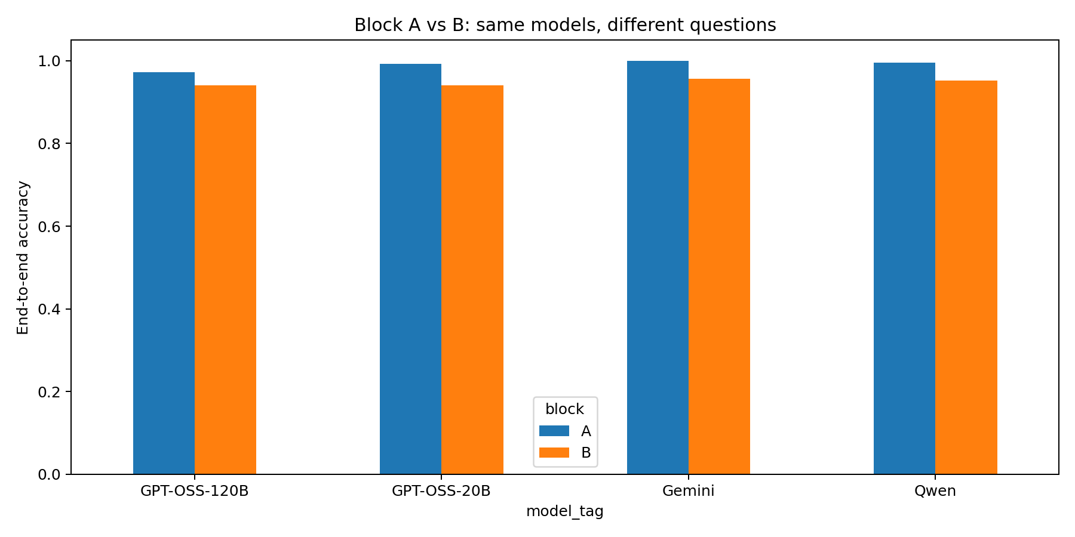
Block Comparison
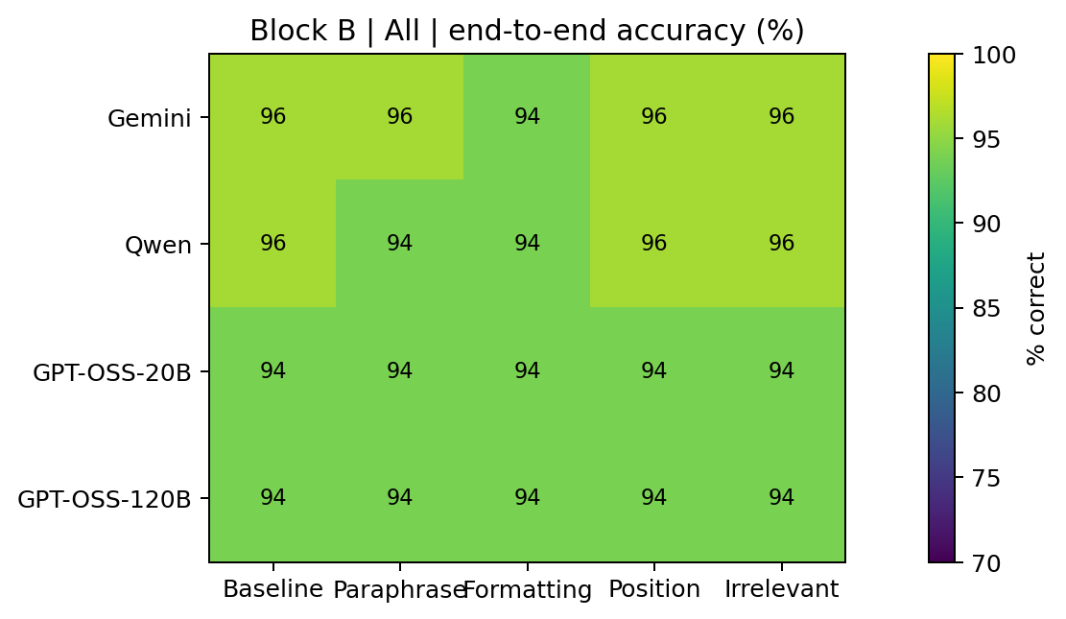
Heatmap B All
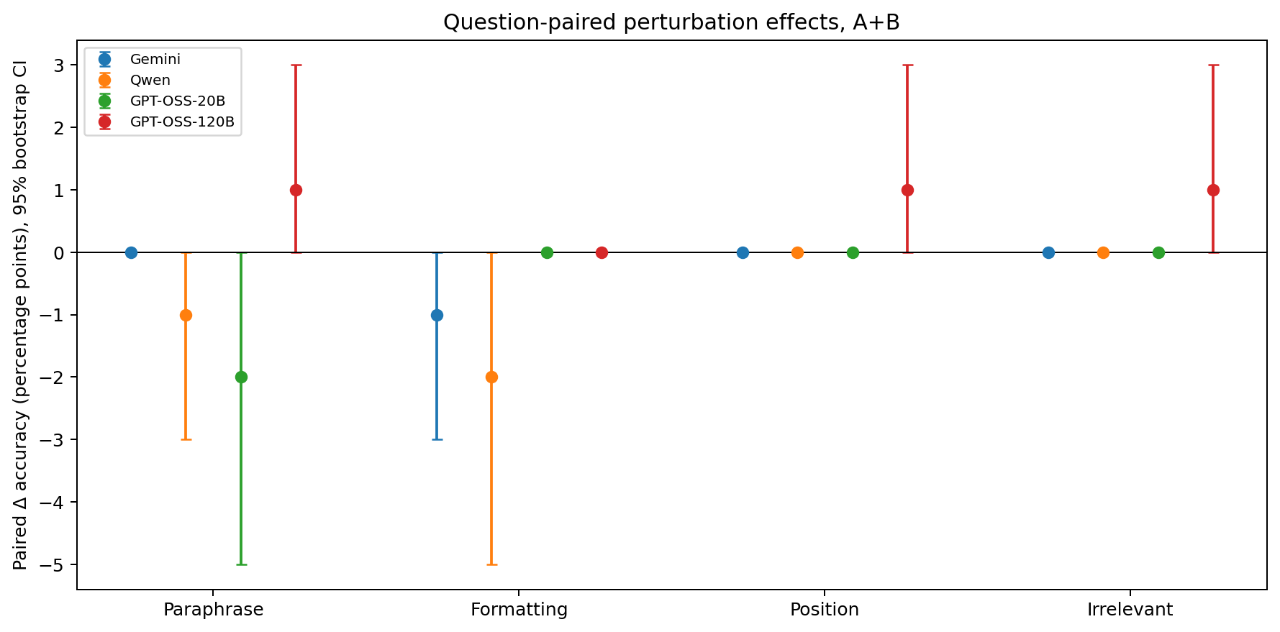
Paired Bootstrap CI
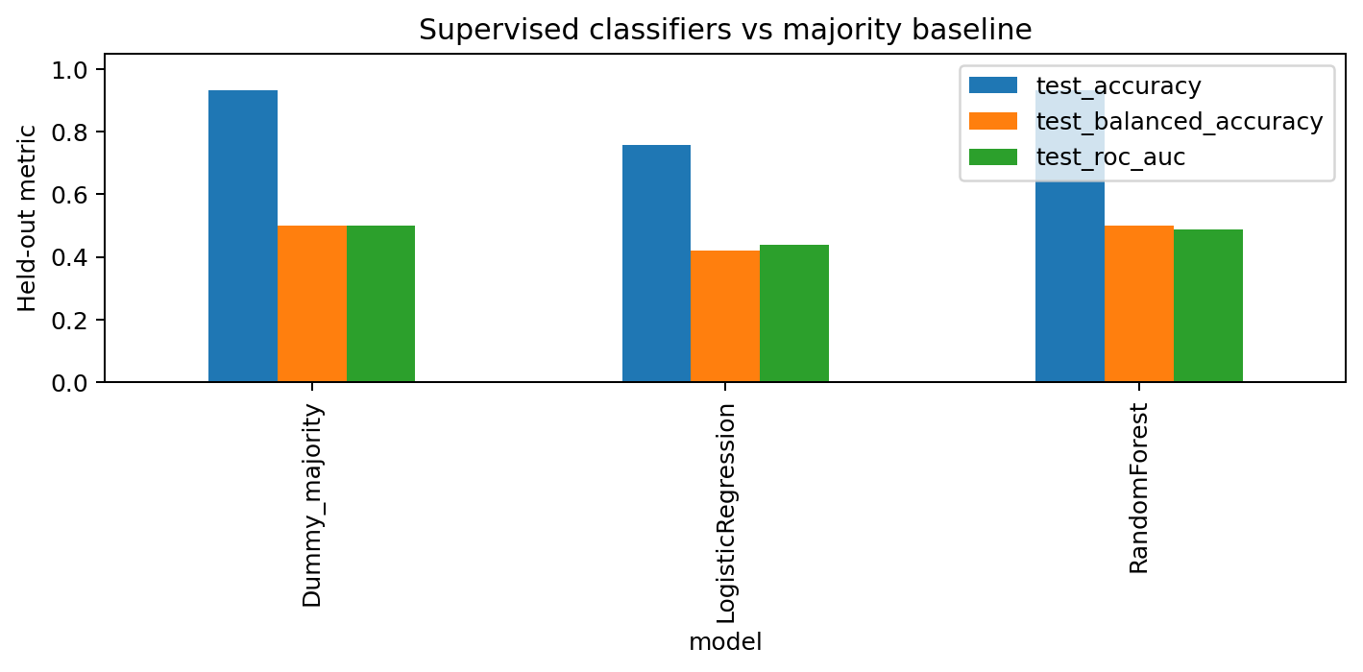
Model Metrics
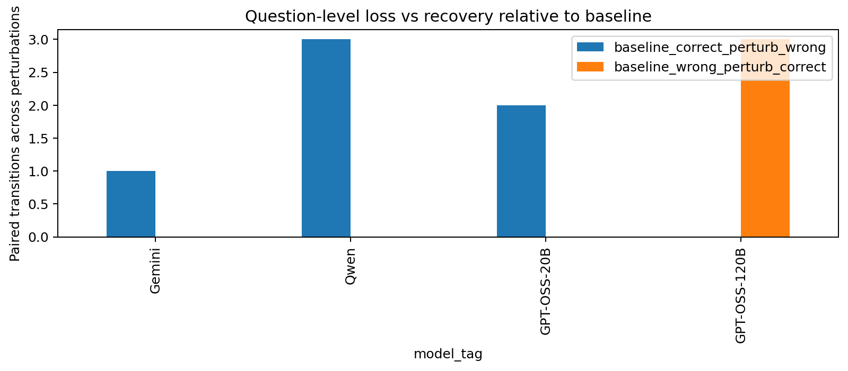
Paired Transitions

8. Recommendations, Limitations and Next Steps
Use stratified model × benchmark × condition reporting, explicit missingness, question-paired changes and tie-aware rankings. Treat any apparent inversion as a descriptive result in this 100-question A+B subset, not proof of universal superiority. Single response samples, provider differences, potential prompt-format effects and severe class imbalance limit generalization. Extend to C/D and multiple independent acquisitions for journal publication; do not delay the educational capstone for those experiments.

9. Reproducibility and Submission
The ZIP includes a complete analytical grid, machine-readable tables, provenance SHA-256 records, plots, and a Colab notebook that loads the entire submission ZIP with one upload. The notebook performs no provider API calls. Run all cells in a fresh runtime before GitHub upload and record the successful execution.

10. Figure-generation integrity audit
The authoritative notebook regenerates the descriptive plots from the frozen 2,000-row Blocks A+B analytical grid and saves the figures as PNG and SVG. The plotting code, source data, saved figures, and the results table are included together in the repository. Each plotted observation represents a model–question–prompt-condition response, whereas independent inference must account for repeated measurements on the same question.
Response-length histograms are descriptive and include zero-length records; acquisition and parsing failures are audited separately. The short-response and long-tail panels use different bin widths, so their histogram heights are not directly comparable. Ranking-trajectory plots show end-to-end accuracy by prompt condition, rather than independent rankings across separate samples.

11. Statistical interpretation safeguards
This is a completed educational capstone analysis of Blocks A+B, not a confirmatory journal study. Blocks C+D remain reserved. Four model systems, two benchmark families, and 100 distinct questions limit generalization. High overall accuracy produces ceiling effects, so small changes in model order should not be interpreted as robust statistical superiority. The machine-learning classifier is an illustrative diagnostic model trained on pre-response metadata and is not itself an LLM.

12. Deployment implications and future validation
A model-selection dashboard should display accuracy together with completion and parsing rates, paired perturbation effects, and uncertainty. The most defensible operational conclusion is that deployment teams should validate model rankings under the prompt conditions that matter to their application, rather than assume a single leaderboard score is stable. Future research can expand the number of questions, benchmark families and models while preserving untouched independent validation sets.

