When the Leaderboard Flips
M20 Initial Capstone Report — Executive Summary
Perturbation-Dependent Ranking in Large Language Model Evaluation

Research question
Can characteristics of large language models, tasks, and controlled evaluation conditions predict when performance remains stable or changes, including changes in relative model ranking?

Experimental design
Block A contains 50 frozen source questions (25 ARC-Challenge and 25 GSM8K), five controlled evaluation conditions, and four LLMs, yielding 1,000 production observations. Prompt identity, scoring, the experimental grid, and raw-to-final correspondence were jointly audited before analysis. All 50 Block-A source items passed the predeclared QA gate.
Model | Correct | Total | Accuracy
Gemini 3.5 Flash Lite | 250 | 250 | 100.0%
Qwen 3.8-27B | 249 | 250 | 99.6%
GPT-OSS-20B | 248 | 250 | 99.2%
GPT-OSS-120B | 243 | 250 | 97.2%

Initial findings
- Aggregate accuracy is near ceiling, but the ten errors are concentrated in three source questions rather than distributed uniformly.
- Perturbation effects are model dependent: some conditions introduce errors while others repair baseline errors.
- Relative model ranking/ties change across evaluation conditions, showing that model comparison can depend on how the evaluation is instantiated.
- The leakage-safe logistic-regression baseline achieves 86.5% ordinary accuracy but only 43.8% balanced accuracy and detects none of the three test-set errors. This reflects extreme class imbalance rather than strong failure prediction.
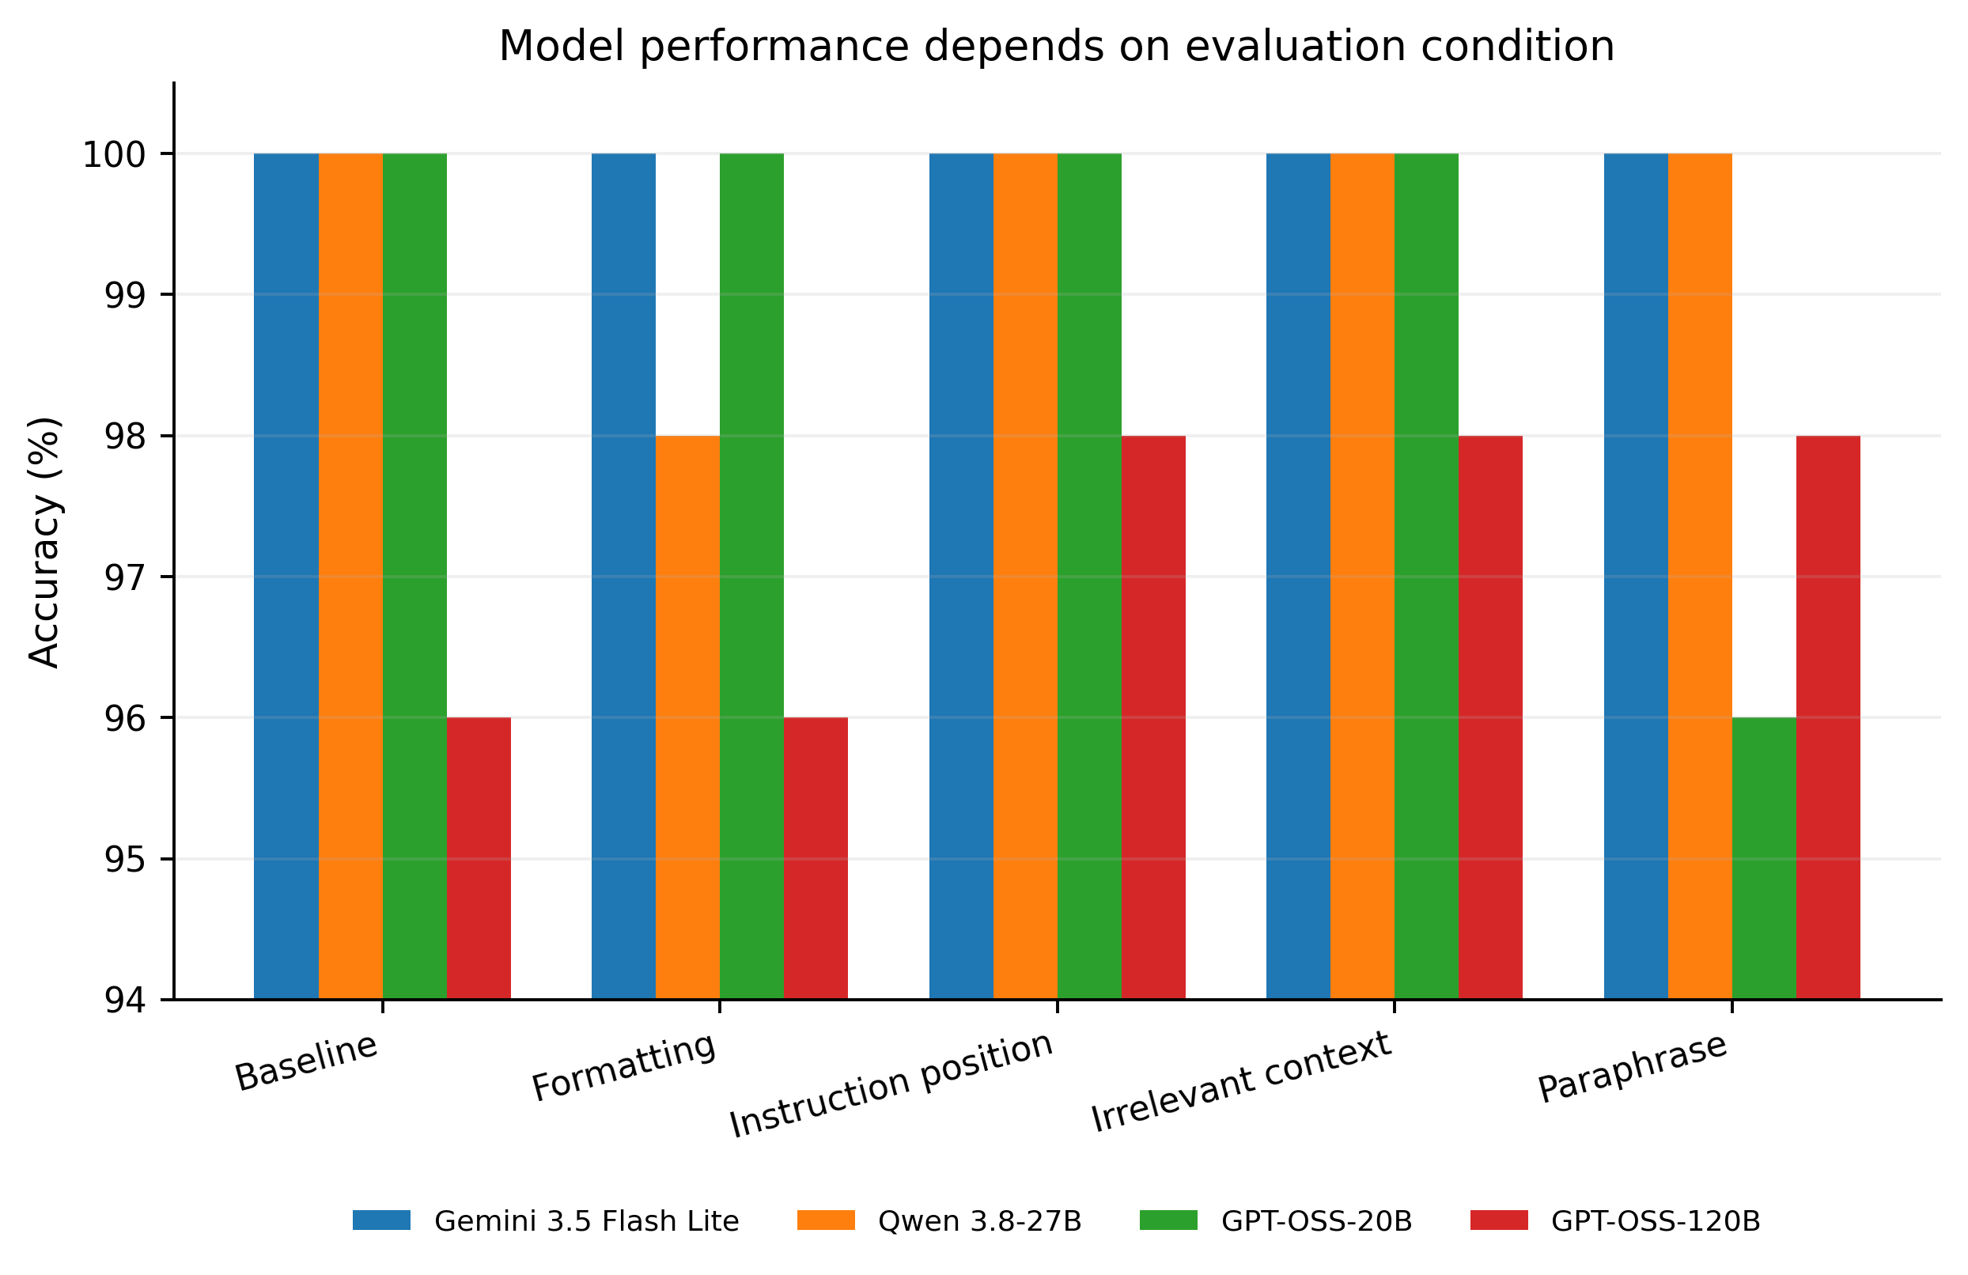
Figure 1. Accuracy by model and evaluation condition.

Interpretation and next step
Block A supports the capstone's central premise: a single aggregate benchmark score can conceal condition-dependent behavior relevant to model selection. However, only ten errors occur among 1,000 observations, so the supervised model is appropriately treated as a baseline workflow demonstration rather than a mature predictor. The pre-frozen Blocks B–D provide a principled M24 expansion without redefining the experiment after observing Block-A outcomes.

Submission artifacts
The package includes the final executable notebook, audited processed data, journal-quality PNG/PDF figures, reproducibility notes, and a repository README. No API keys or pilot/qualification observations are included.

