Md Ashraful Islam Buiya
Sprit2
- Product Vision
Student extremely need quite and available spaces to study. Students who offer to find a good as well as quite study place on campus the study space booker. That booking system helps student or user to easily find study place room in real time.
This system helps students for booking, smart recommendations for study environments.
Vision Breakdown
Product name: Study space booker
Category: booking system
Customer: SETU students
Customer need: finding available study spaces
Key differentiator: Real time availability with smart recommendations
Profile:
Name: Md Ashraful Islam Buiya
Role: student
Age:20
Primary device: Smartphone
Location: Waterford
Background:
Md Ashraful is a first-year student. He spends a long hour studying on SETU campus. He needs a good as well as quite place or room where students can study their free times.
Goals:
To find easily quite space to study.
Avoid wasting valuable time.
Pain points:
There is no clear booking system.
The study room always full.
Student waste their time to walk in the campus.
Benefits:
Very comfortable using apps
Quote:
I want to book a study room without wasting my times by walking all around the campus.
Another student Ali
Title: Booking a quiet Study room
Ali is a student of EEE who has a crucial exam coming up as well as needs a quiet place to study. He does not want to spend his valuable time of walking around the campus searching for an empty room to study. As a result, the open study space booking app on his mobile phone. On top of that, he easily finds a quiet room to study by using this app. Now, he is satisfied to find quit room easily.
Profile:
Name: Ali
Role: student
Age: 23
Device: mobile phone
Location: Tramore, Waterford
Background:
He doesn’t want to spend his time to walk in the campus. He wants a quit room to study were anyone will not disturb him.
Pain point:
Hard to find quit room to concentrate on task.
Spend huge time to find quite room to study.
Technical Ability:
Not too bed
Screenshots:

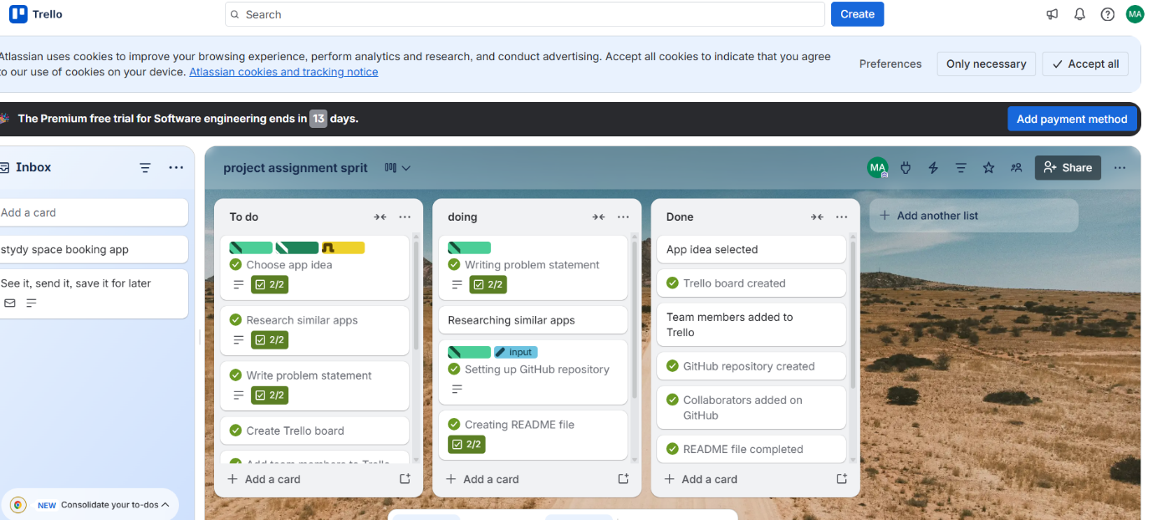

https://trello.com/invite/b/69eb6678184b08b1c7cfc1d0/ATTI65320651508744c28c508b3aefafa5539F19AA61/project-assignment-sprit

Section 5: AI Assistance Disclosure (Mandatory)
I done my assignment by myself, but I have taken leap of online resources also teacher unloaded format.
Contribution:
I done my work by myself anyone did not help me.
Only myself

