Md Ashraful Islam Buiya
Sprint 3
Functional Requirements (FR)
FR1: The system will allow users to book a study space room.
FR2: The system will provide real time availability of study space room.
FR3: The system will help students to book or cancel their bookings.
FR4: The system will allow students to choose room.
FR5: The system will allow students to book room for group.
USER STORIES ,FR ,MOSCOW
US1: As a student I would like to book a study space room to study. As a result, I want to reserve it in advance. FR1. (must)
US2: As a student I would like to see available quit study room. So, I would like to find a quit study room so quickly. FR2, (MUST)
US3: As a student I want to book quit study room or cancel my booking. This might be because I can adjust my schedule. FR3, (Must).
US4: As a student I would like to choose room. This should be because where its location. FR4, (Should).
US5: As a student I would like to book quit study space room for a group so that we can help each other’s to learn more. FR5, (MUST).
Non-Functional Requirements
NFR1: System must respond within 3 seconds. (must).
NFR2: The system must be easy to use. (must)
NFR3: The system will store user data. (must)
Trello Board (Before Sprit Starts)
Planning tasks: Define Sprit 3 goals.
User stories: Writing user stories as well as review user stories.
Functional requirements: Identify functional requirements (FR).
Prioritisation: Apply MOSCOW
Non-functional requirements: Define NFR also apply Moscow.
Documentation: prepare Traceability table as well as NFR.
Finalisation: Review also edit sprit 3 as well as upload to GitHub.
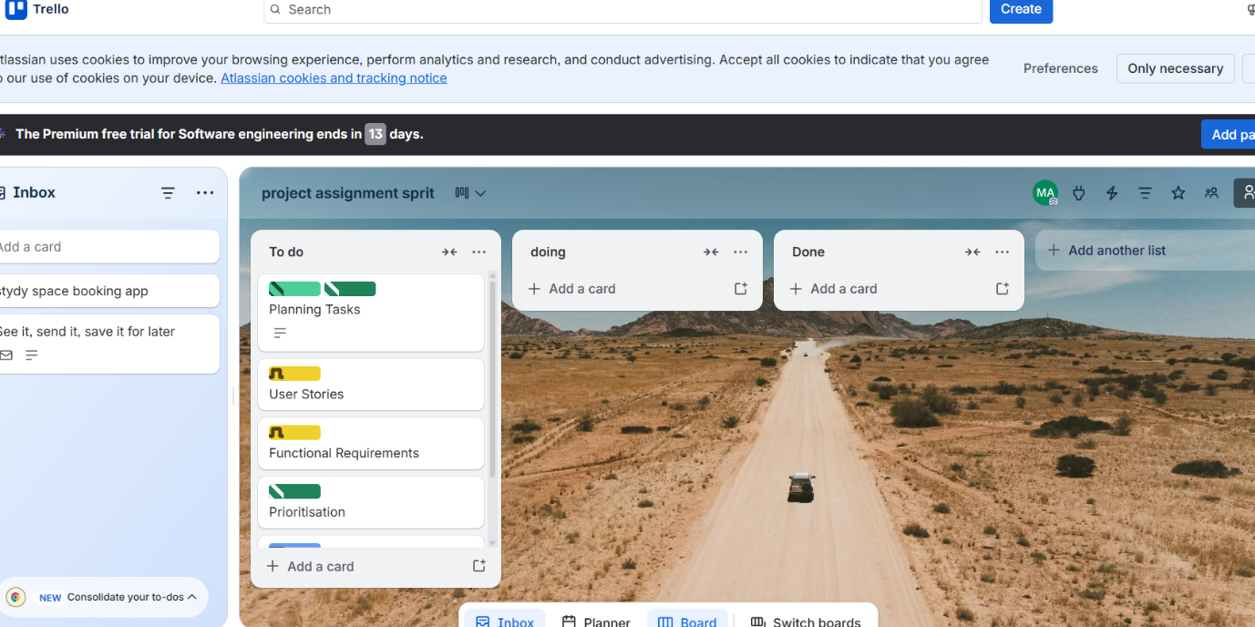

In progress:
Writing user stories, creating FR list
Building NFR table.

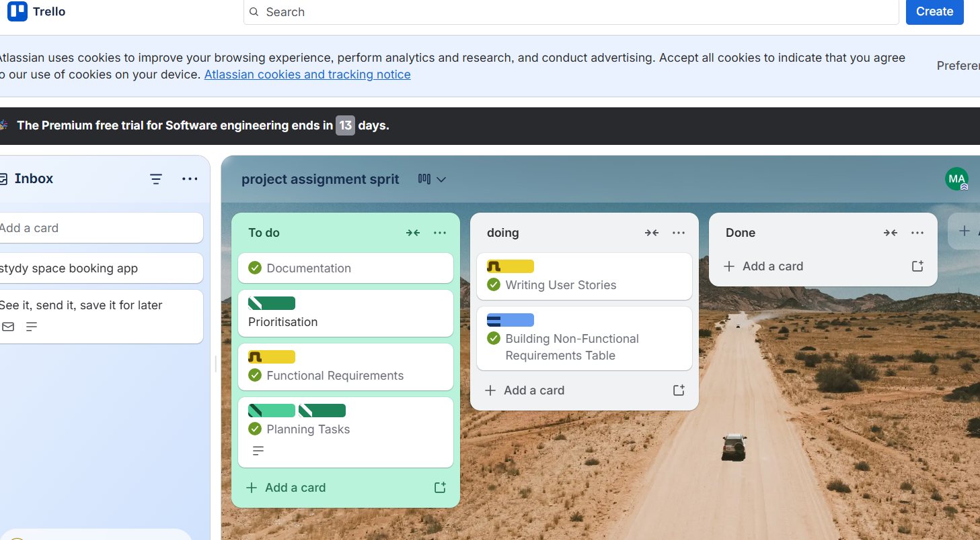
Done:
Final user stories completed
Functional requirements defined
Moscow prioritisation done
NFRs completed
Document uploaded to GitHub
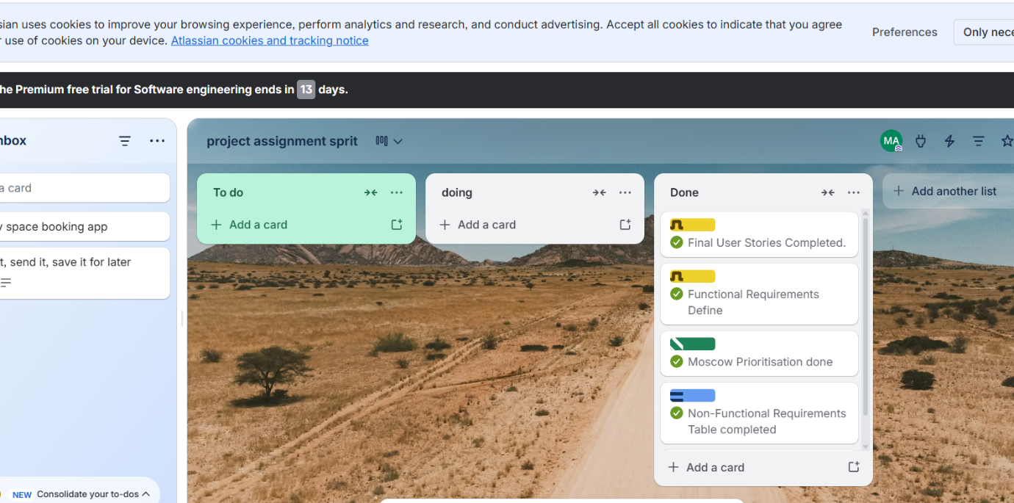
GitHub Submission: git@github.com:mdashraful733/Campus-room-booking-apps.git
Assistance Disclosure:
I complete the assignment by myself with help of online resources also use template.
Contribution:
I complete all work by myself. There is no member without me.

