Md Ashraful Islam Buiya
Sprit 1
- App Idea
Select an app: study space booking app
This app helps students to easily find books from study rooms or spaces on campus. It also reduces confusion even saves time when they are looking for a place to study.
- Problem Statement
Students usually face it difficult to find available study spaces on campus, during busy times. On top of that, this can lead to wasted valuable time searching for rooms. Besides lack of a simple booking system makes it harder to plan study sessions. This app helps students to find study space quickly.
- Trello Board setup
I created a Trello board to organise and manage my tasks for my project.
Board list
- To Do
- Doing
- Done
Board link:

https://trello.com/invite/b/69eb6678184b08b1c7cfc1d0/ATTI65320651508744c28c508b3aefafa5539F19AA61/project-assignment-sprit

Screenshot:
Please see next page
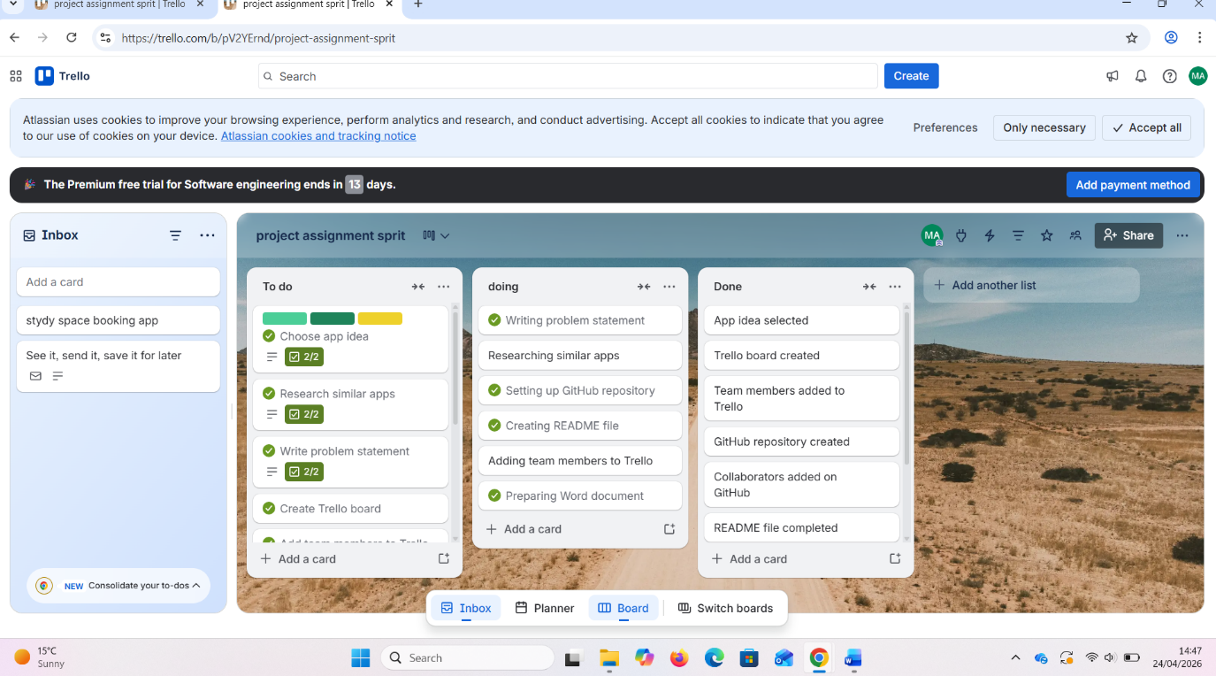

Git hub Repository:
I created git hub repository
Repository name:
Campus room booking apps
Git Hub Link

git@github.com:mdashraful733/Campus-room-booking-apps.git

Screenshot:

Team members:
All work doing by my self no team member without me but help of online resources also class teacher
I am responsible for all work
Md Ashraful Islam Buiya

