#### 1. What are the three stages to build the hypotheses or model in machine learning?

**SolutionScreenshot:-**

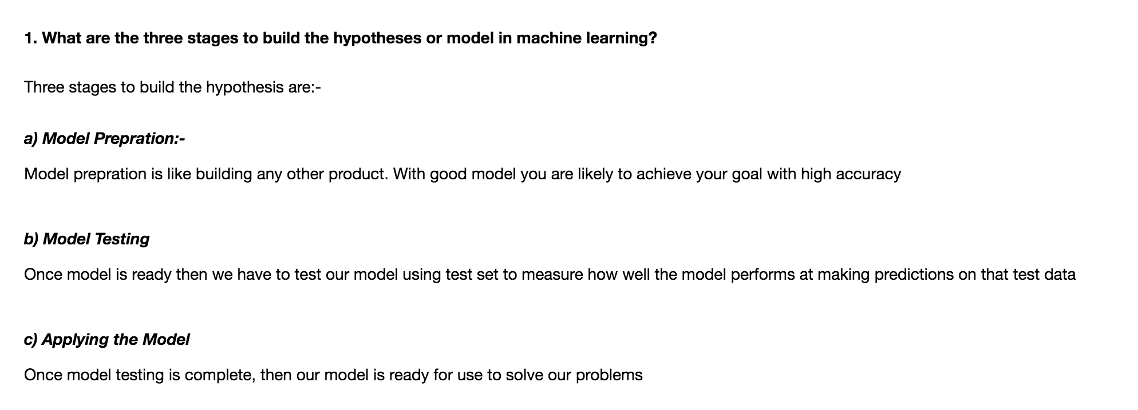

#### 2. What is the standard approach to supervised learning?

**SolutionScreenshot:-**

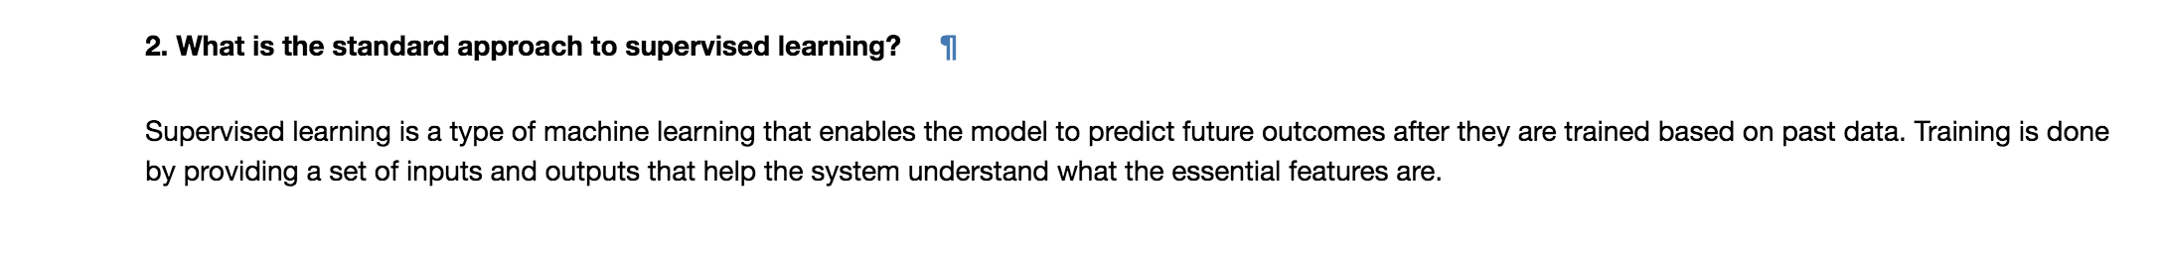

#### 3. What is Training set and Test set?

**SolutionScreenshot:-**

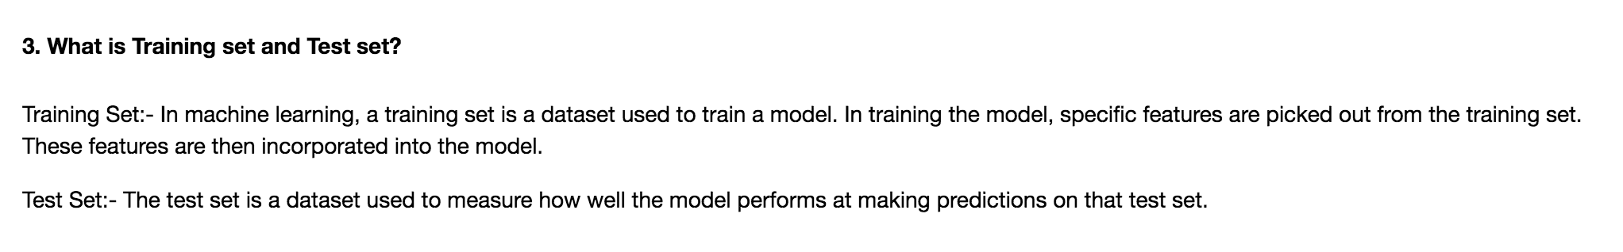

#### 4. What is the general principle of an ensemble method and what is bagging and boosting in ensemble method?

**SolutionScreenshot:-**

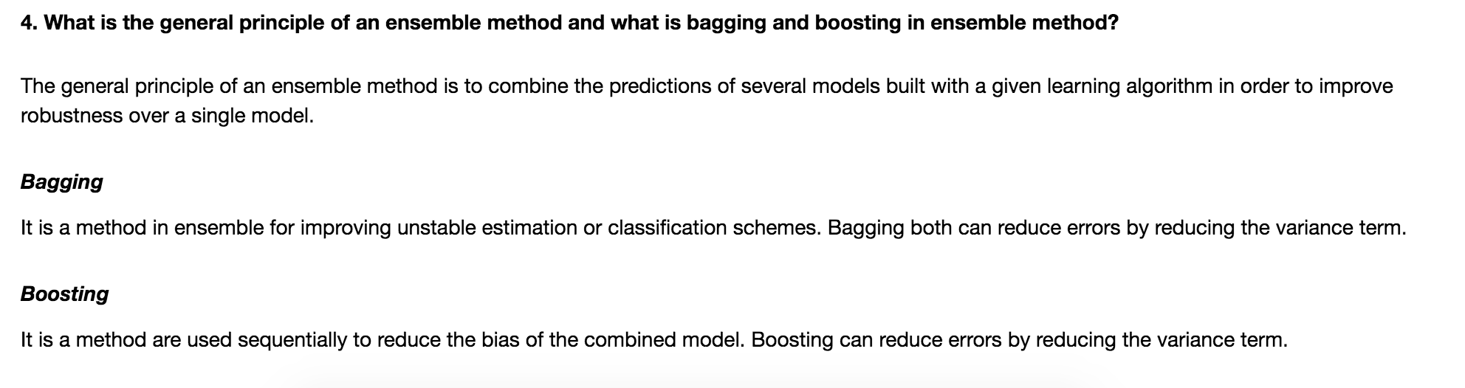

5. How can you avoid overfitting?

**SolutionScreenshot:-**

