**Read the dataset from the below link**

**https://raw.githubusercontent.com/guipsamora/pandas_exercises/master/06_Stats/US_Baby_Names/US_Baby_Names_right.csv**

###### *1) Delete unnamed columns.*

**SolutionScreenshot:-**

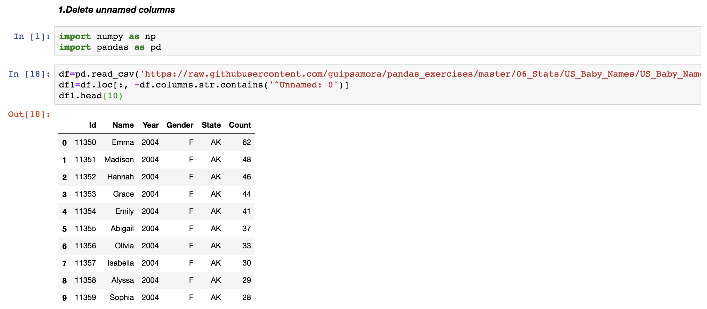

*2****) Show the distribution of male and female.***

**SolutionScreenshot:-**

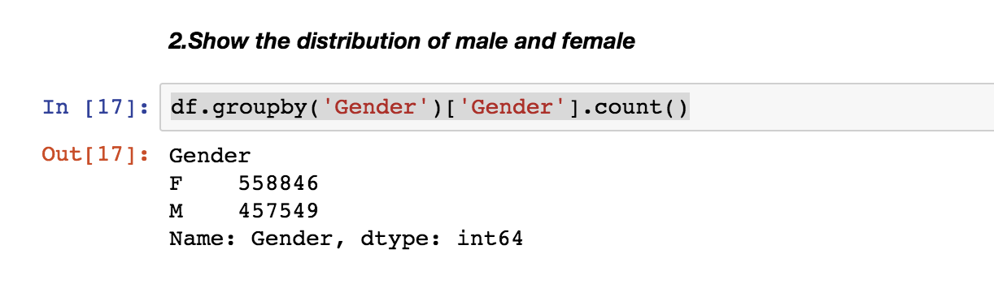

###### *3) Show the top 5 most preferred names*

**SolutionScreenshot:-**

###### 

***4) What is the median name occurence in the dataset***

**SolutionScreenshot:-**

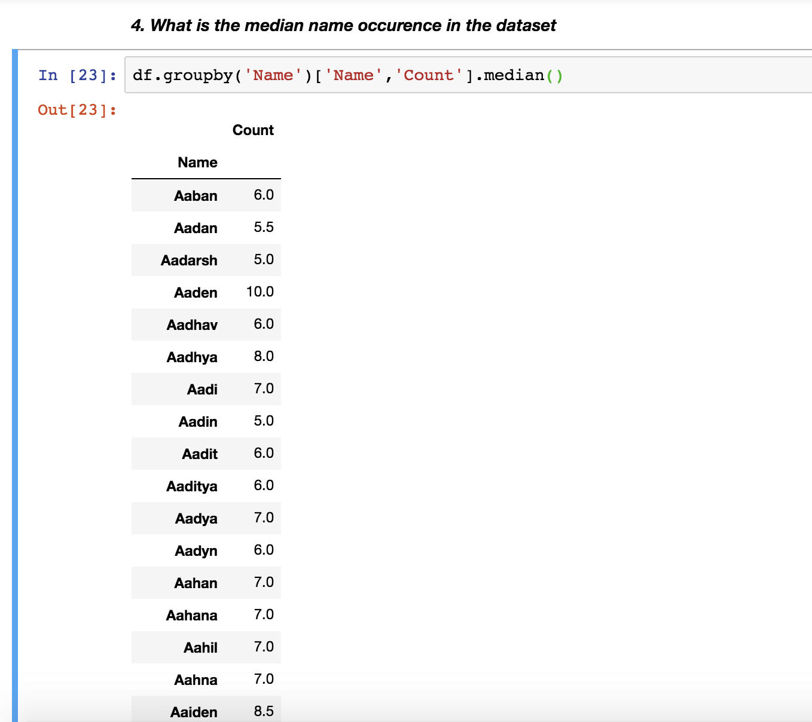

***5) Distribution of male and female born count by states.***

