* 1. ***Write a Python Program(with class concepts) to find the area of the triangle using the below formula.***

***area = (s(s-a)(s-b)*(s-c)) ** 0.5***

***Function to take the length of the sides of triangle from user should be defined in the parent class and function to calculate the area should be defined in subclass.***

**SolutionScreenshot:-**

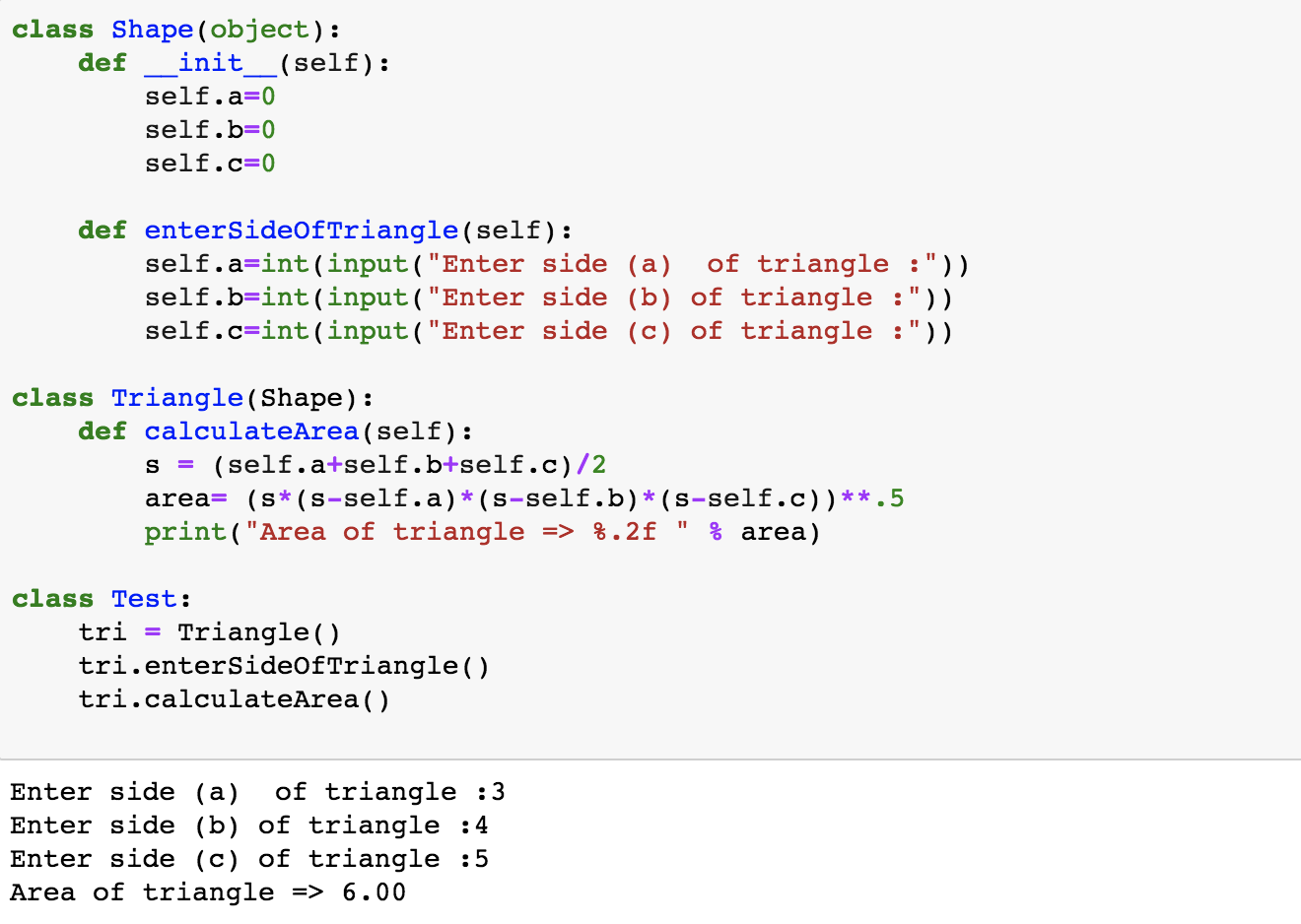

1.2 Write a function filter_long_words() that takes a list of words and an integer n and returns the list of words that are longer than n.

**SolutionScreenshot:-**

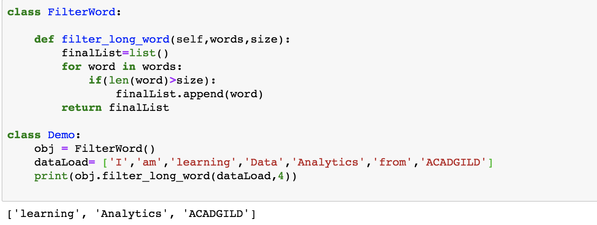

***2.1 Write a Python program using function concept that maps list of words into a list of integers representing the lengths of the corresponding words***

**SolutionScreenshot:-**

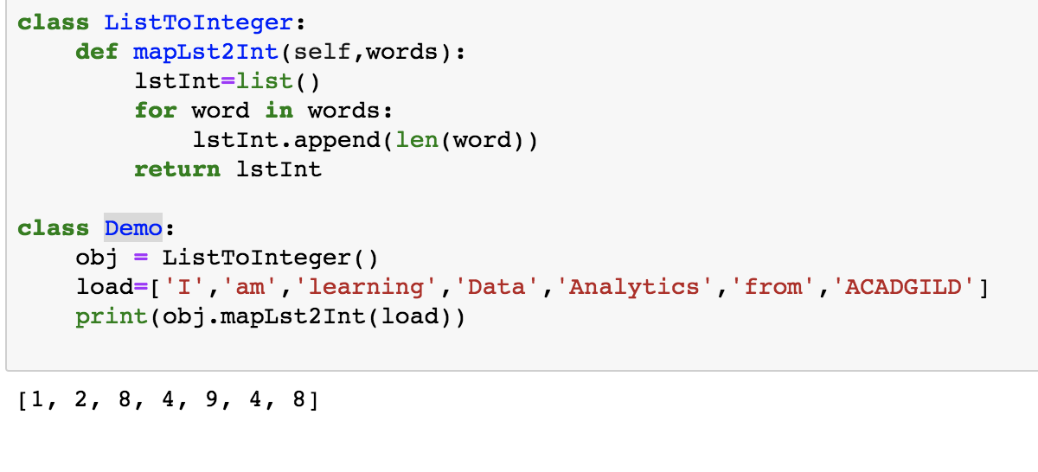

***2.2 Write a Python function which takes a character (i.e. a string of length 1) and returns True if it is a vowel, False otherwise.***

