***Read the following data set:***

***https://archive.ics.uci.edu/ml/machine-learning-databases/adult/***

***Rename the columns as per the description from this file:***

***https://archive.ics.uci.edu/ml/machine-learning-databases/adult/adult.names***

***Task:***

***Create a sql db from adult dataset and name it sqladb***

**SolutionScreenshot:-**

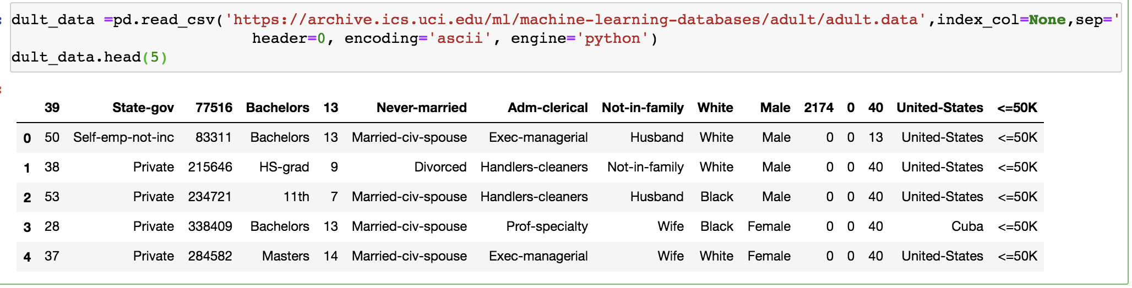

***Rename the columns as per the description from***

**SolutionScreenshot:-**

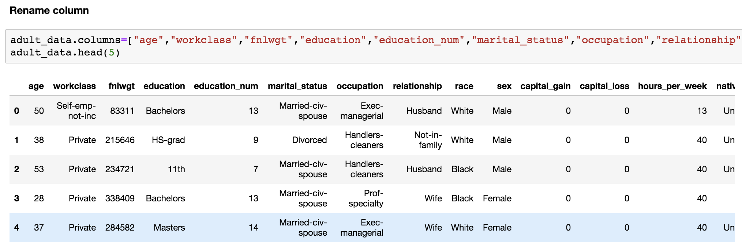

***1. Select 10 records from the adult sqladb***

**SolutionScreenshot:-**

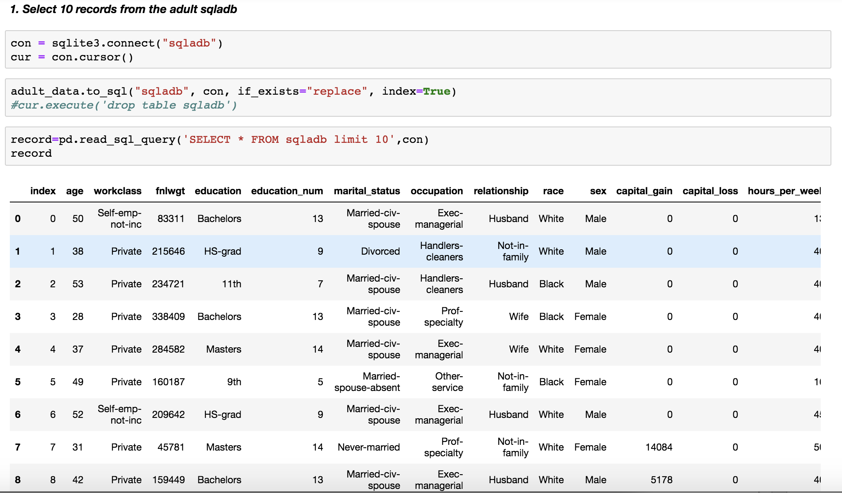

***2). Show me the average hours per week of all men who are working in private sector***

**SolutionScreenshot:-**

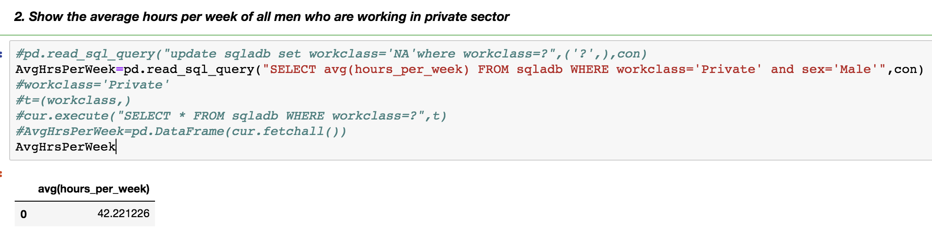

*3****)***  ***Show me the frequency table for education, occupation and relationship, separate***

**SolutionScreenshot:-**

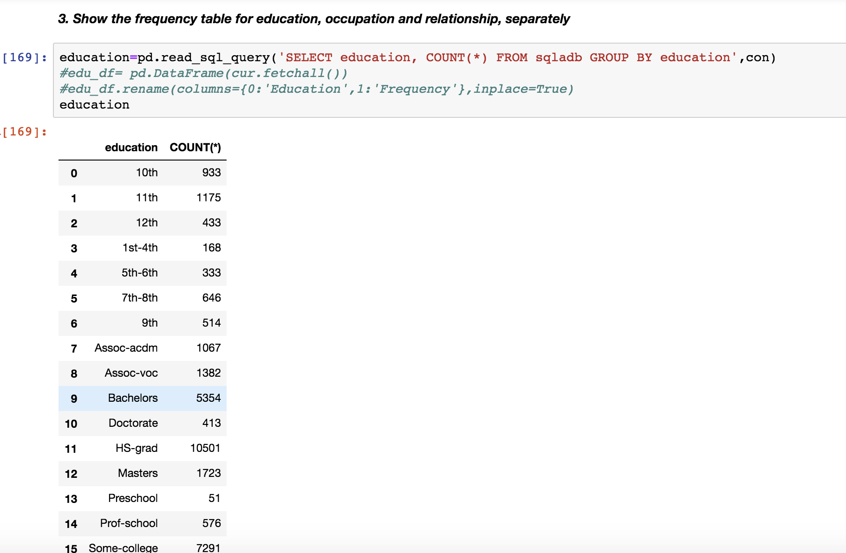

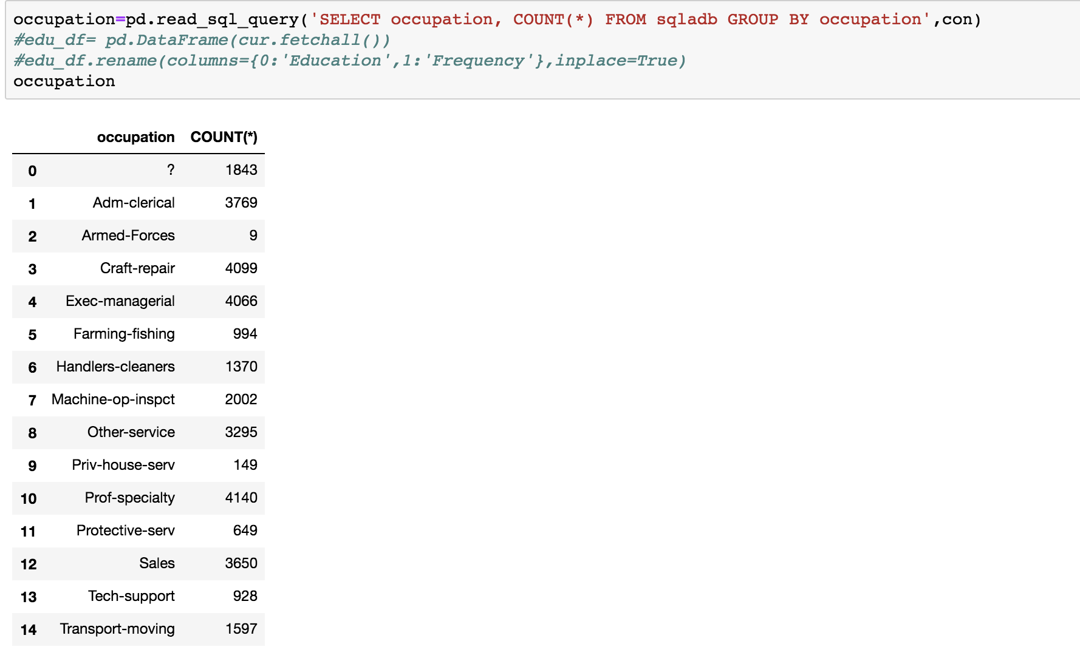

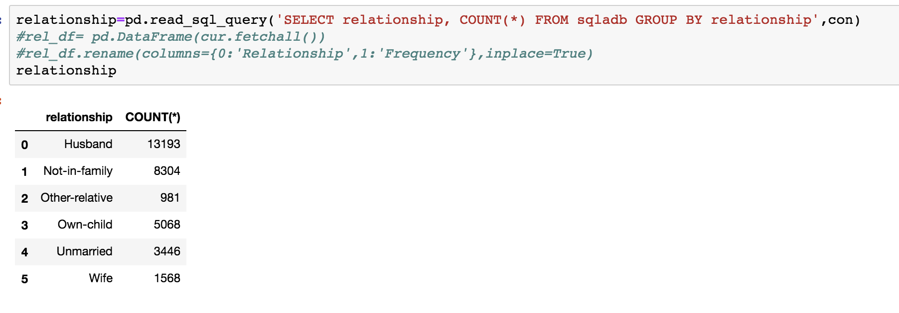

*4****) Are there any people who are married, working in private sector and having a masters degree***

**SolutionScreenshot:-**

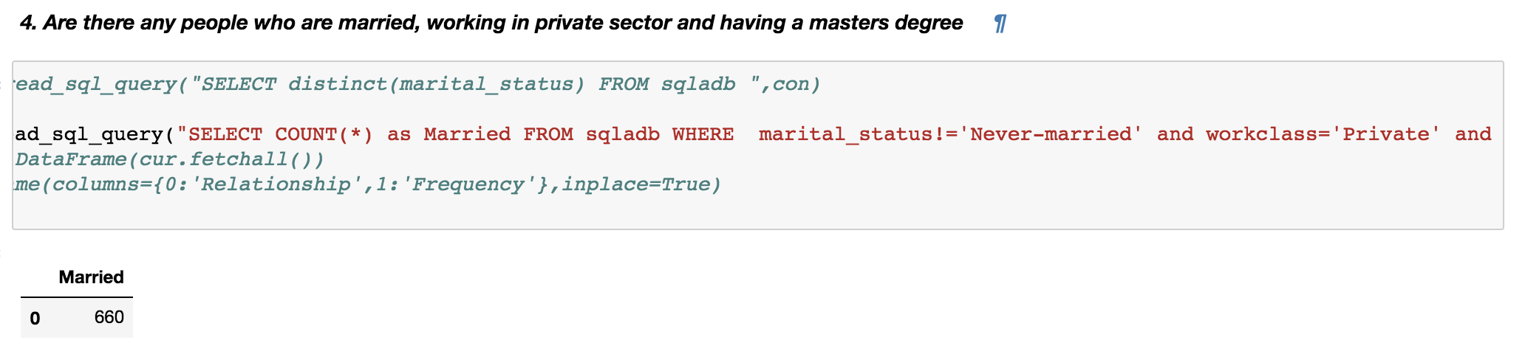

*5****) What is the average, minimum and maximum age group for people working in different sectors***

**SolutionScreenshot:-**

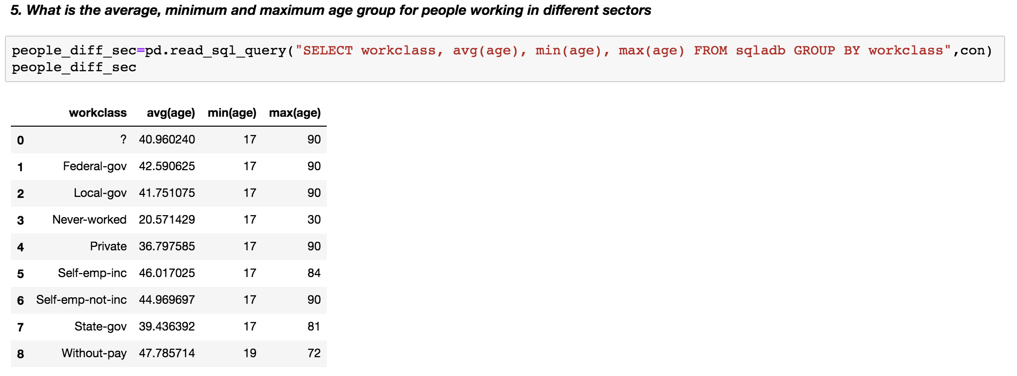

***6) Calculate age distribution by country***

**SolutionScreenshot:-**

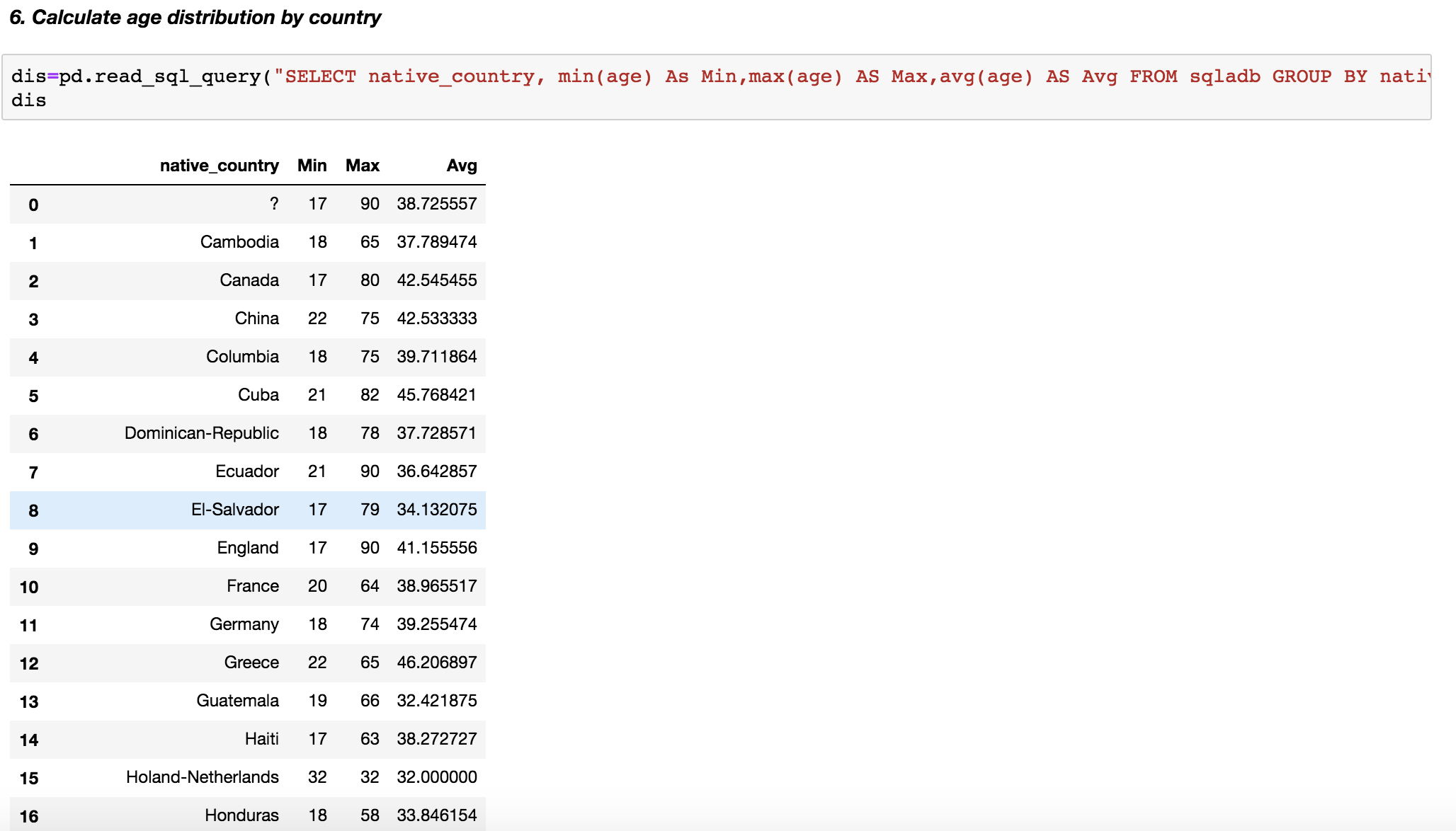

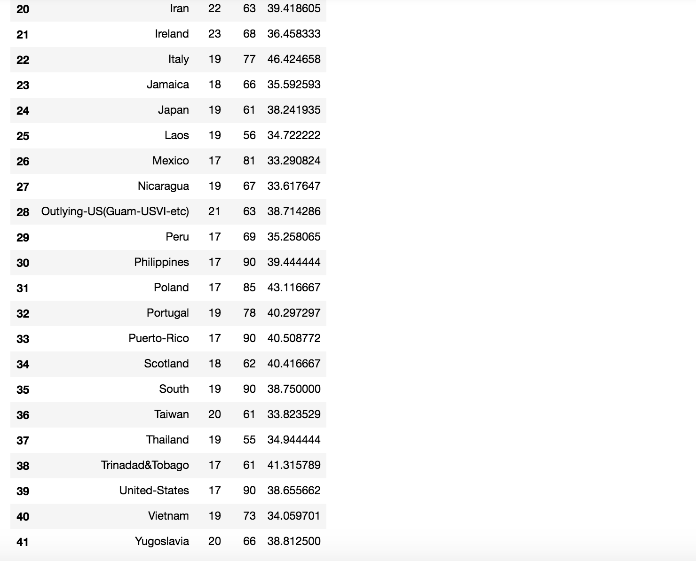

***7) Compute a new column as 'Net-Capital-Gain' from the two columns 'capital-gain' and 'capital-loss'***

**SolutionScreenshot:-**

