***Read the following data set:***

***https://archive.ics.uci.edu/ml/machine-learning-databases/adult/adult.data***

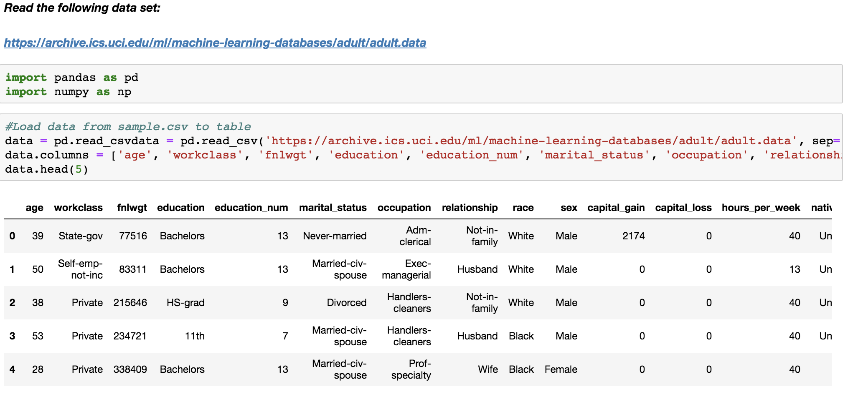

***1) Create an sqlalchemy engine using a sample from the data set***

**SolutionScreenshot:-**

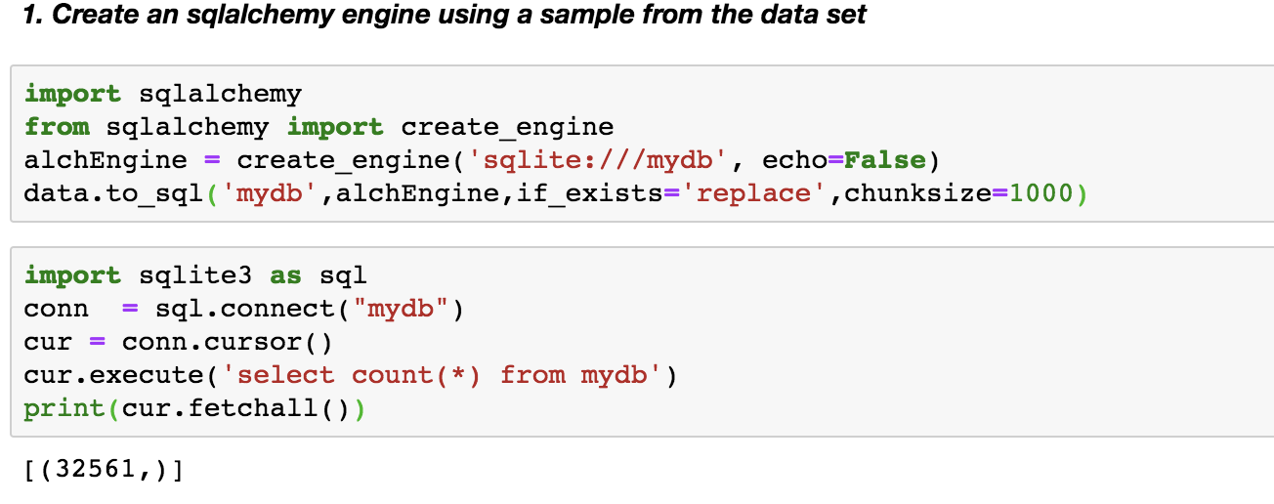

***2) Write two basic update queries***

**SolutionScreenshot:-**

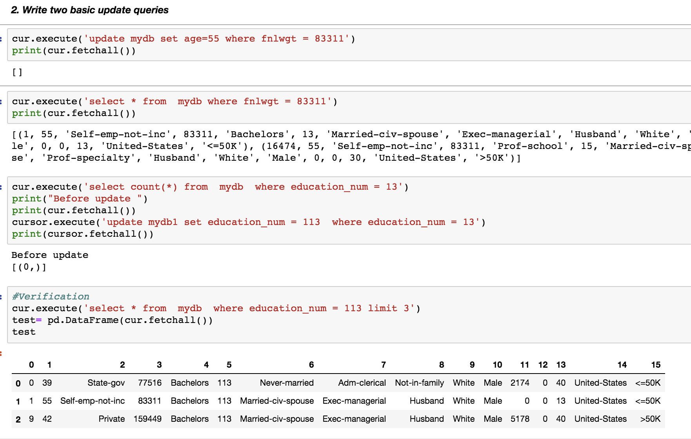

***3) Write two delete queries***

**SolutionScreenshot:-**

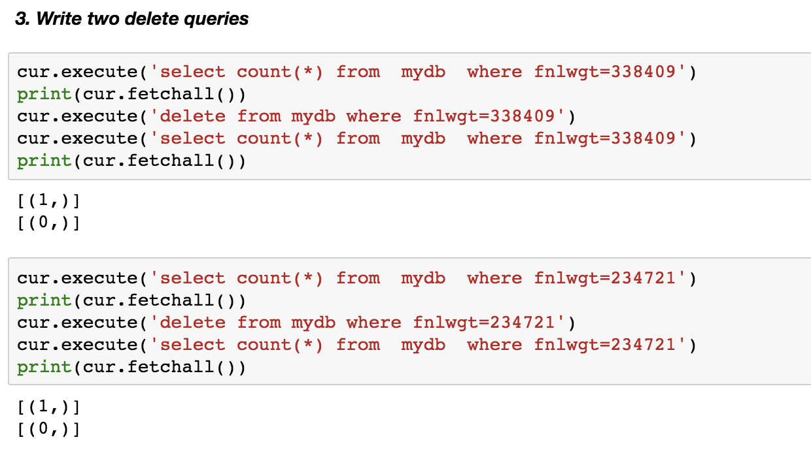

***4) Write two filter queries***

**SolutionScreenshot:-**

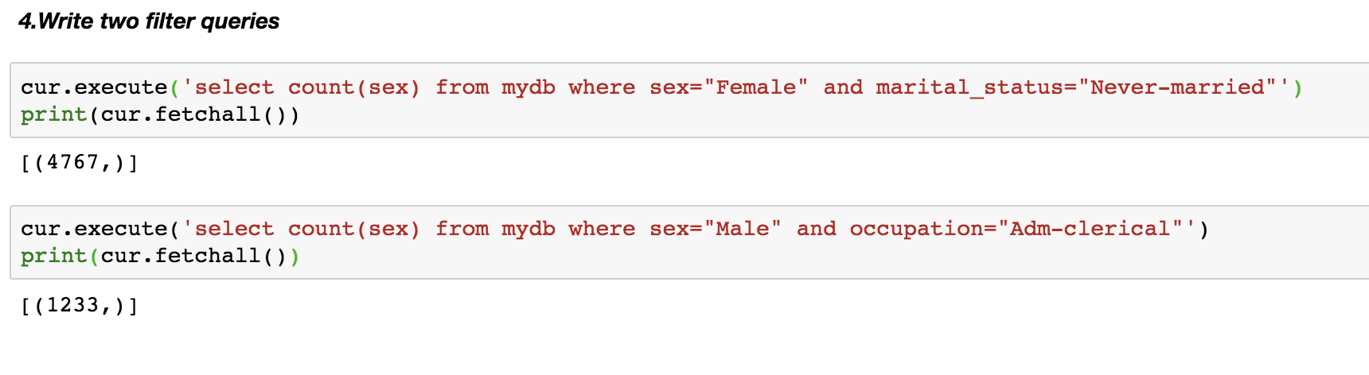

*5****) Write two function queries***

**SolutionScreenshot:-**

