***Scipy:***

***We have the min and max temperatures in a city In India for each months of the year.***

***We would like to find a function to describe this and show it graphically, the dataset***

***given below.***

***Task:***

***1. fitting it to the periodic function***

***2. plot the fit***

***Data***

***Max = 39, 41, 43, 47, 49, 51, 45, 38, 37, 29, 27, 25***

***Min = 21, 23, 27, 28, 32, 35, 31, 28, 21, 19, 17, 18***

***fitting it to the periodic function***

**SolutionScreenshot:-**

***1. fitting it to the periodic function***

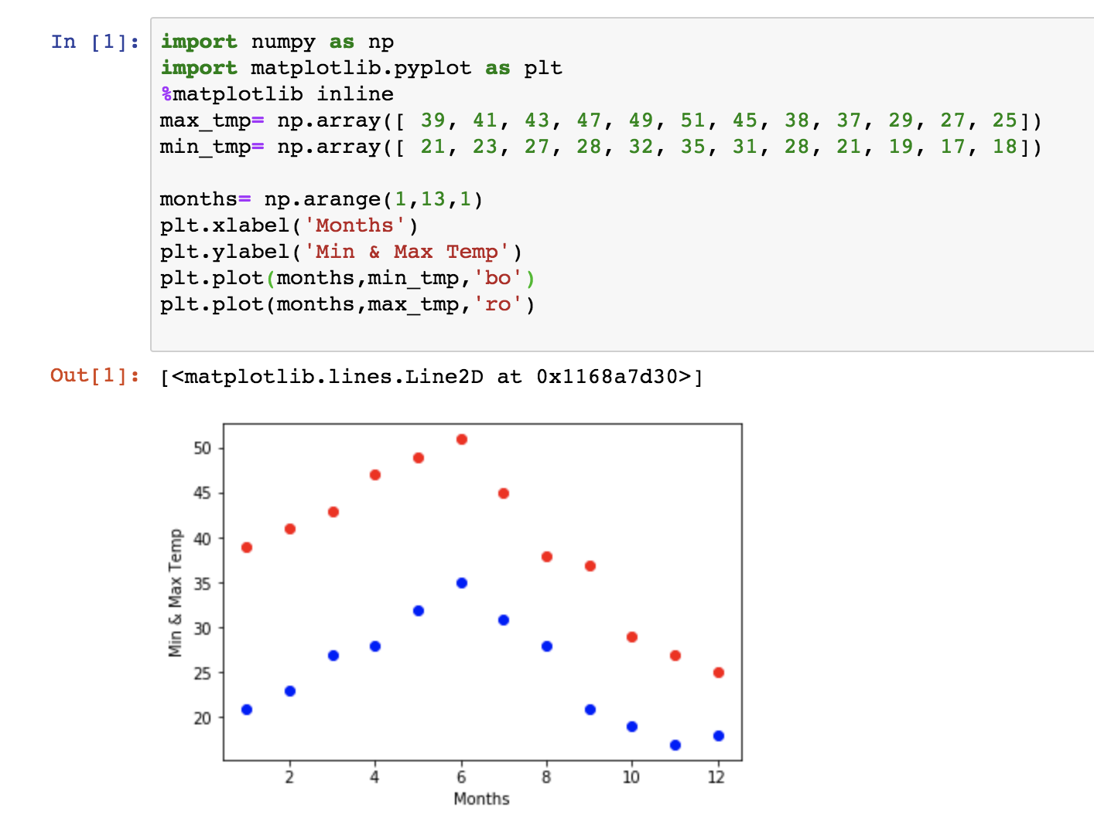

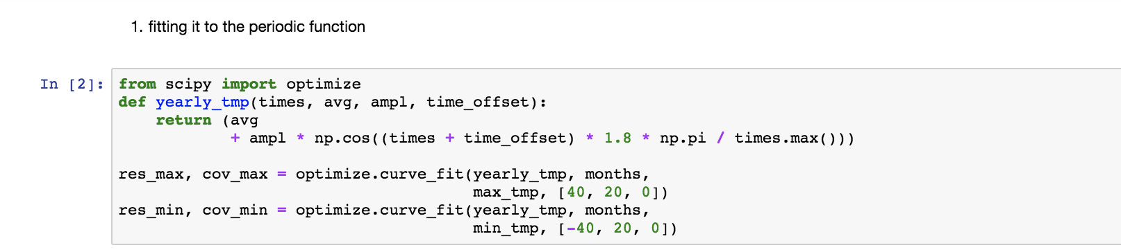

*2****) plot the fit***

**SolutionScreenshot:-**

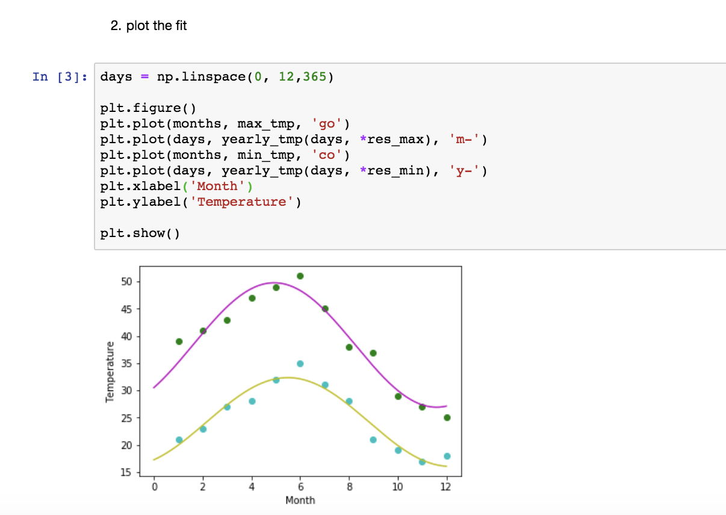

###### M*atplotlib*

###### *This†assignment†is†for†visualization†using†matplotlib∫*

###### *Data to use url -- httpS://rawÆgithubusercontent.com.Geoyi.Cleaning-Titanic-Data.master.titanicﬂoriginal.csv*

###### Titanic=pd.readﬂcsv(url)

###### *1.Create a pie chart presenting the male female proportion*

###### *2. Create a scatterplot with the Fare paid and the Age¨ differ the plot color by gender*

**SolutionScreenshot:-**

***1.Create a pie chart presenting the male female proportion***

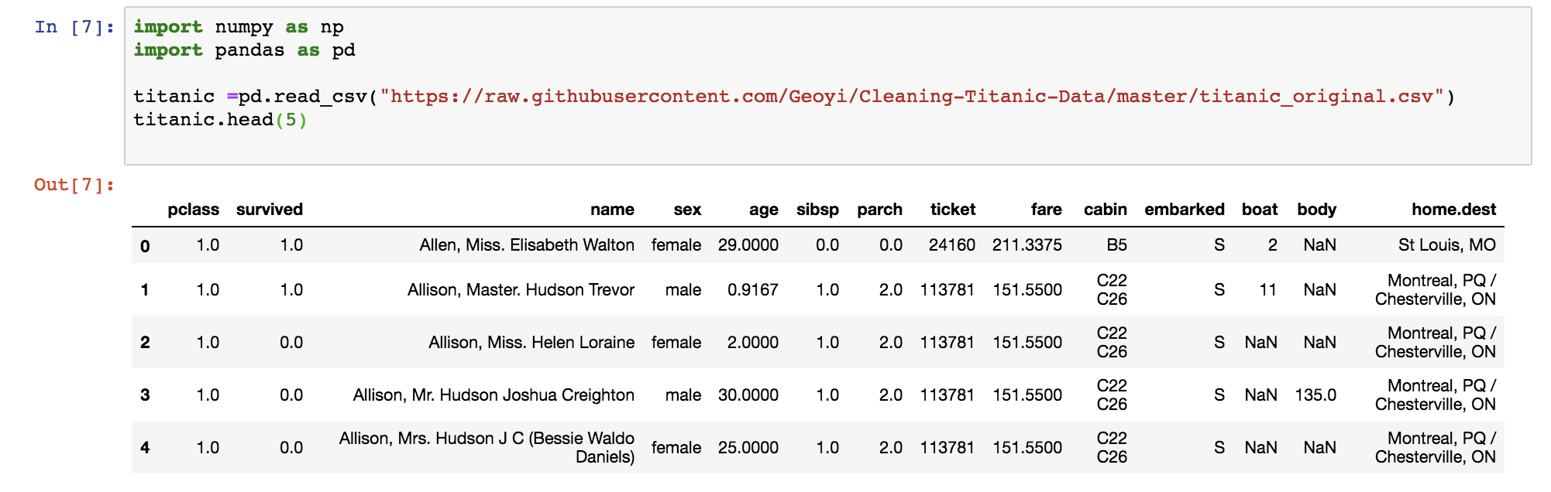

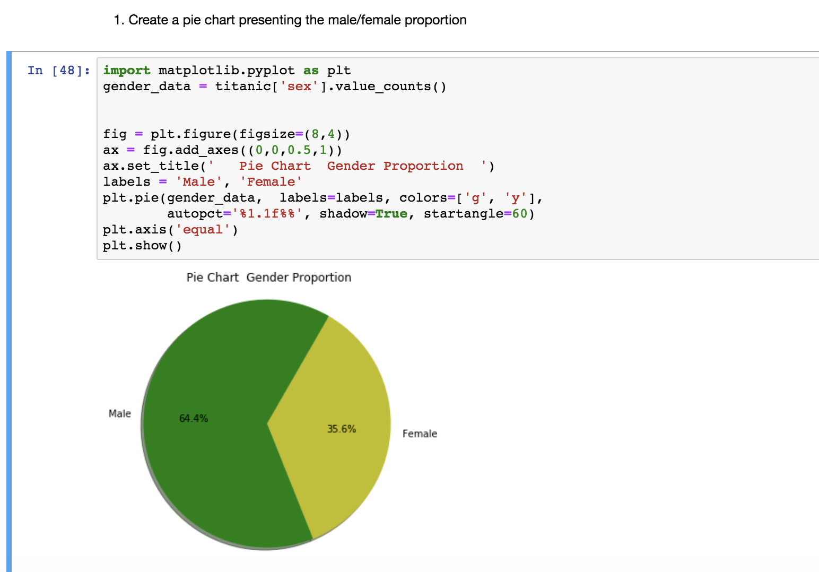

###### *2. Create a scatterplot with the Fare paid and the Age¨ differ the plot color by gender*

**SolutionScreenshot:-**

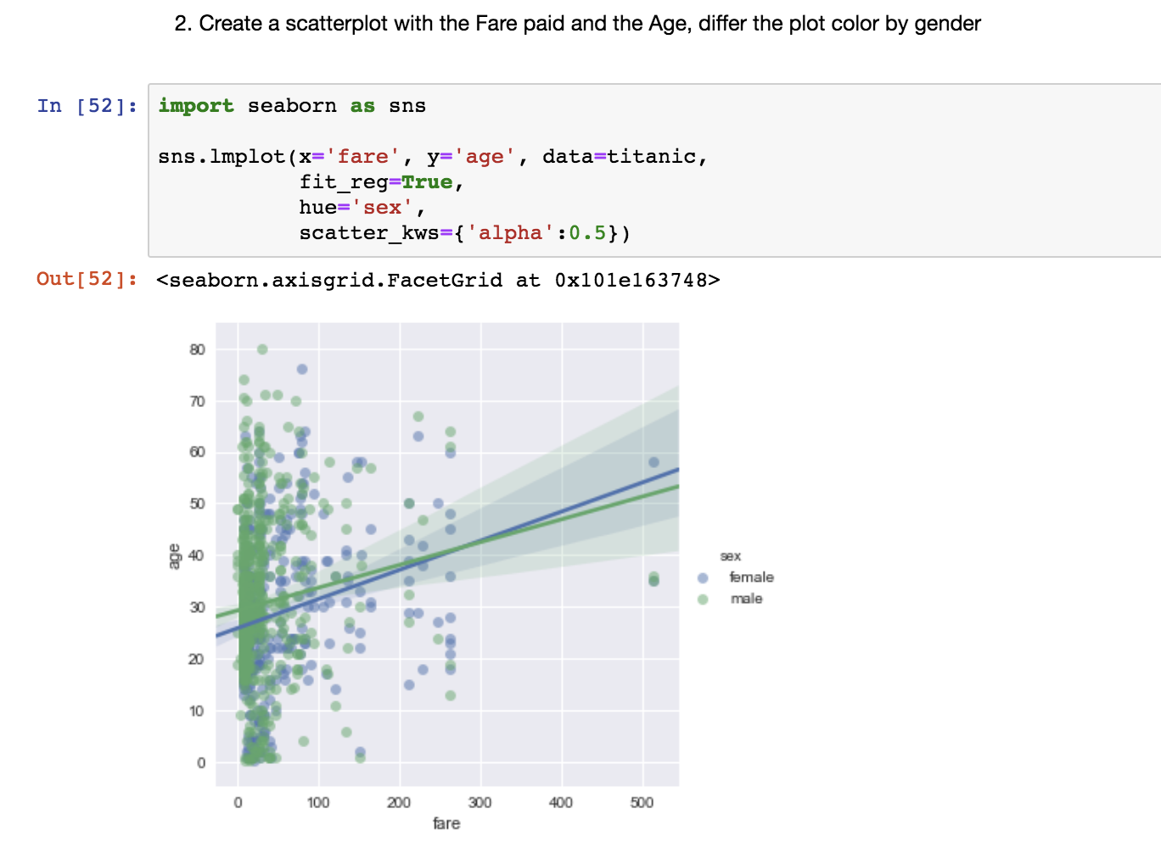

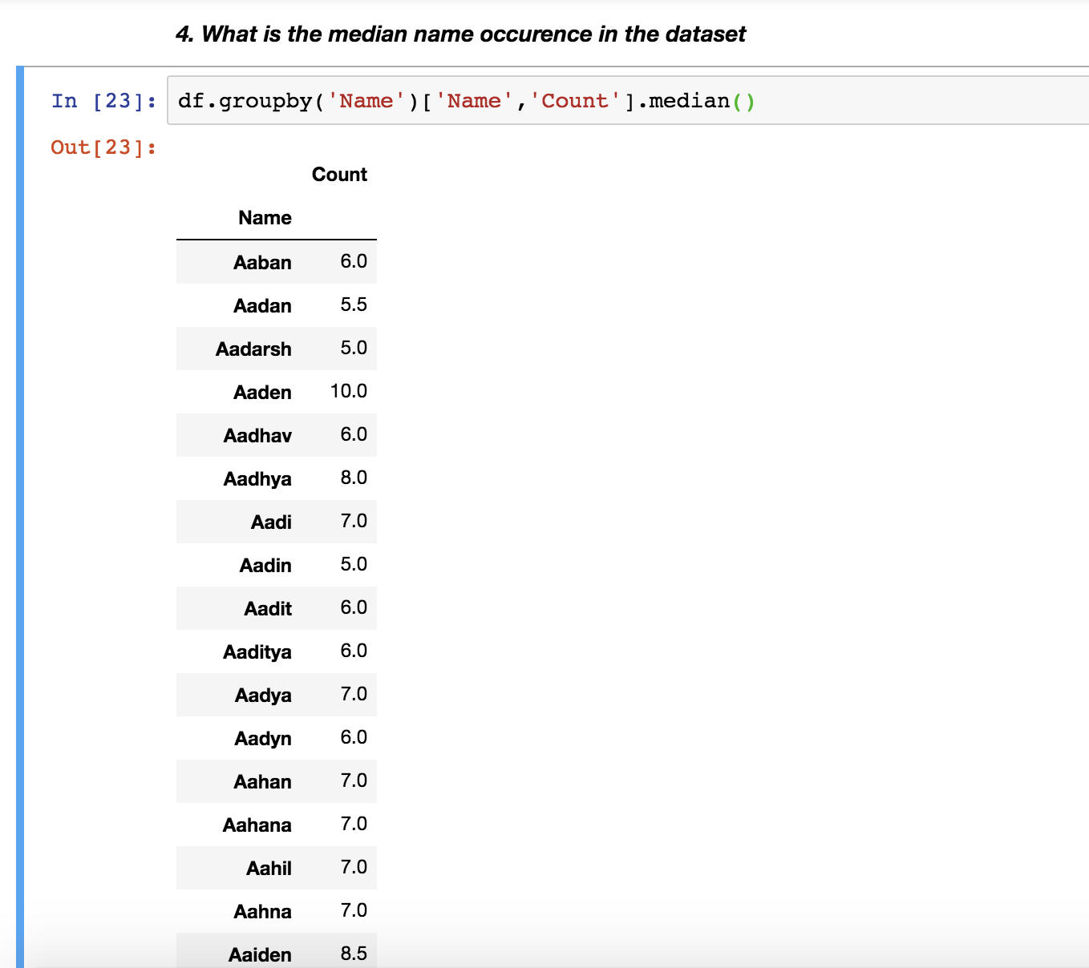

***5) Distribution of male and female born count by states.***

