Problem Statement 1:

You survey households in your area to find the average rent they are paying. Find the standard deviation from the following data: $1550, $1700, $900, $850, $1000, $950.

**SolutionScreenshot :-**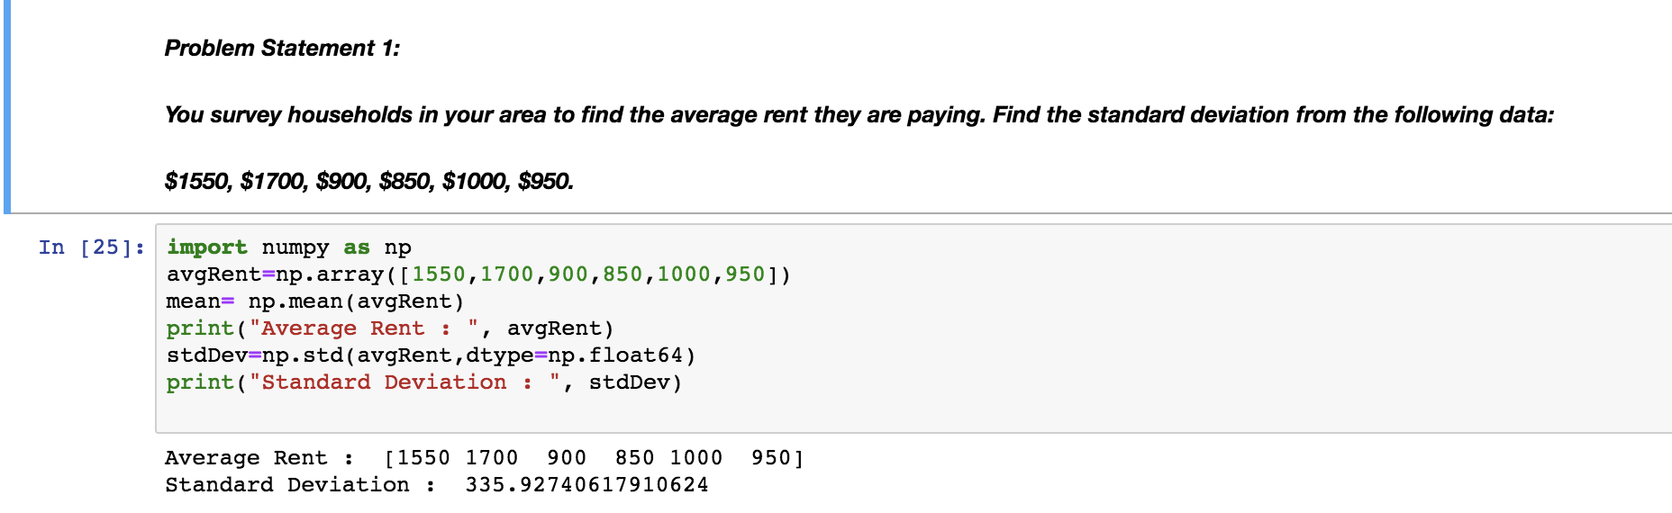

Problem Statement 2:

Find the variance for the following set of data representing trees in California (heights infeet):

3, 21, 98, 203, 17, 9

**SolutionScreenshot:-**

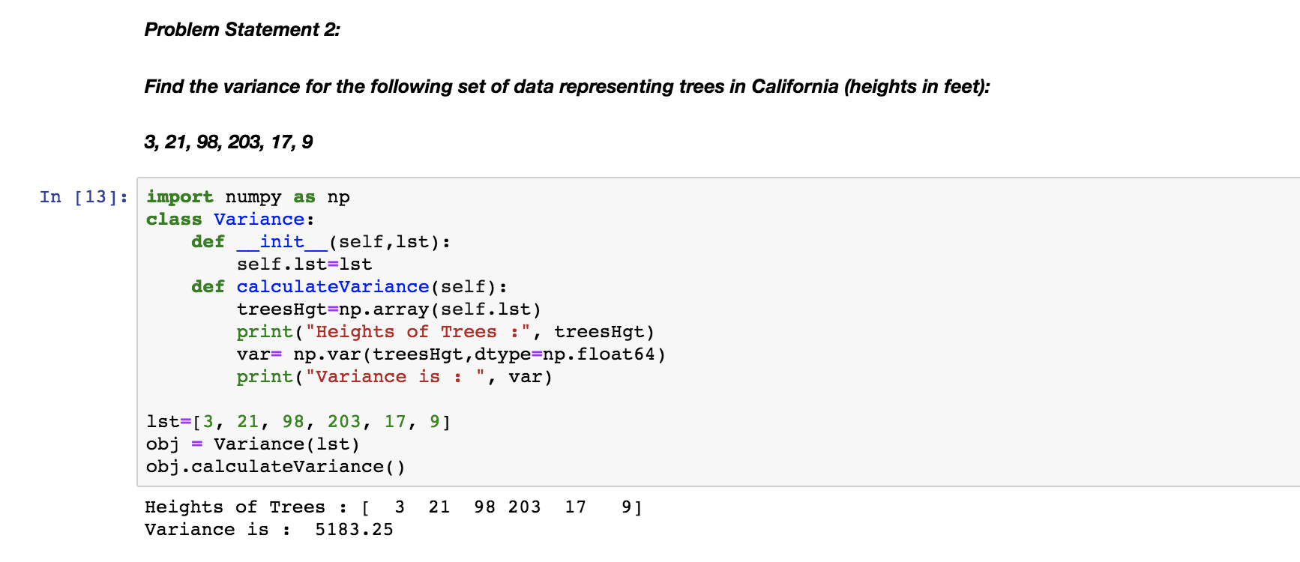

Problem Statement 3:

In a class on 100 students, 80 students passed in all subjects, 10 failed in one subject, 7 failed in two subjects and 3 failed in three subjects. Find the probability distribution of the variable for number of subjects a student from the given class has failed in..

**SolutionScreenshot:-**

