Problem Statement 1:

A test is conducted which is consisting of 20 MCQs (multiple choices questions) with every MCQ having its four options out of which only one is correct. Determine the probability that a person undertaking that test has answered exactly 5 questions wrong

**SolutionScreenshot :-**

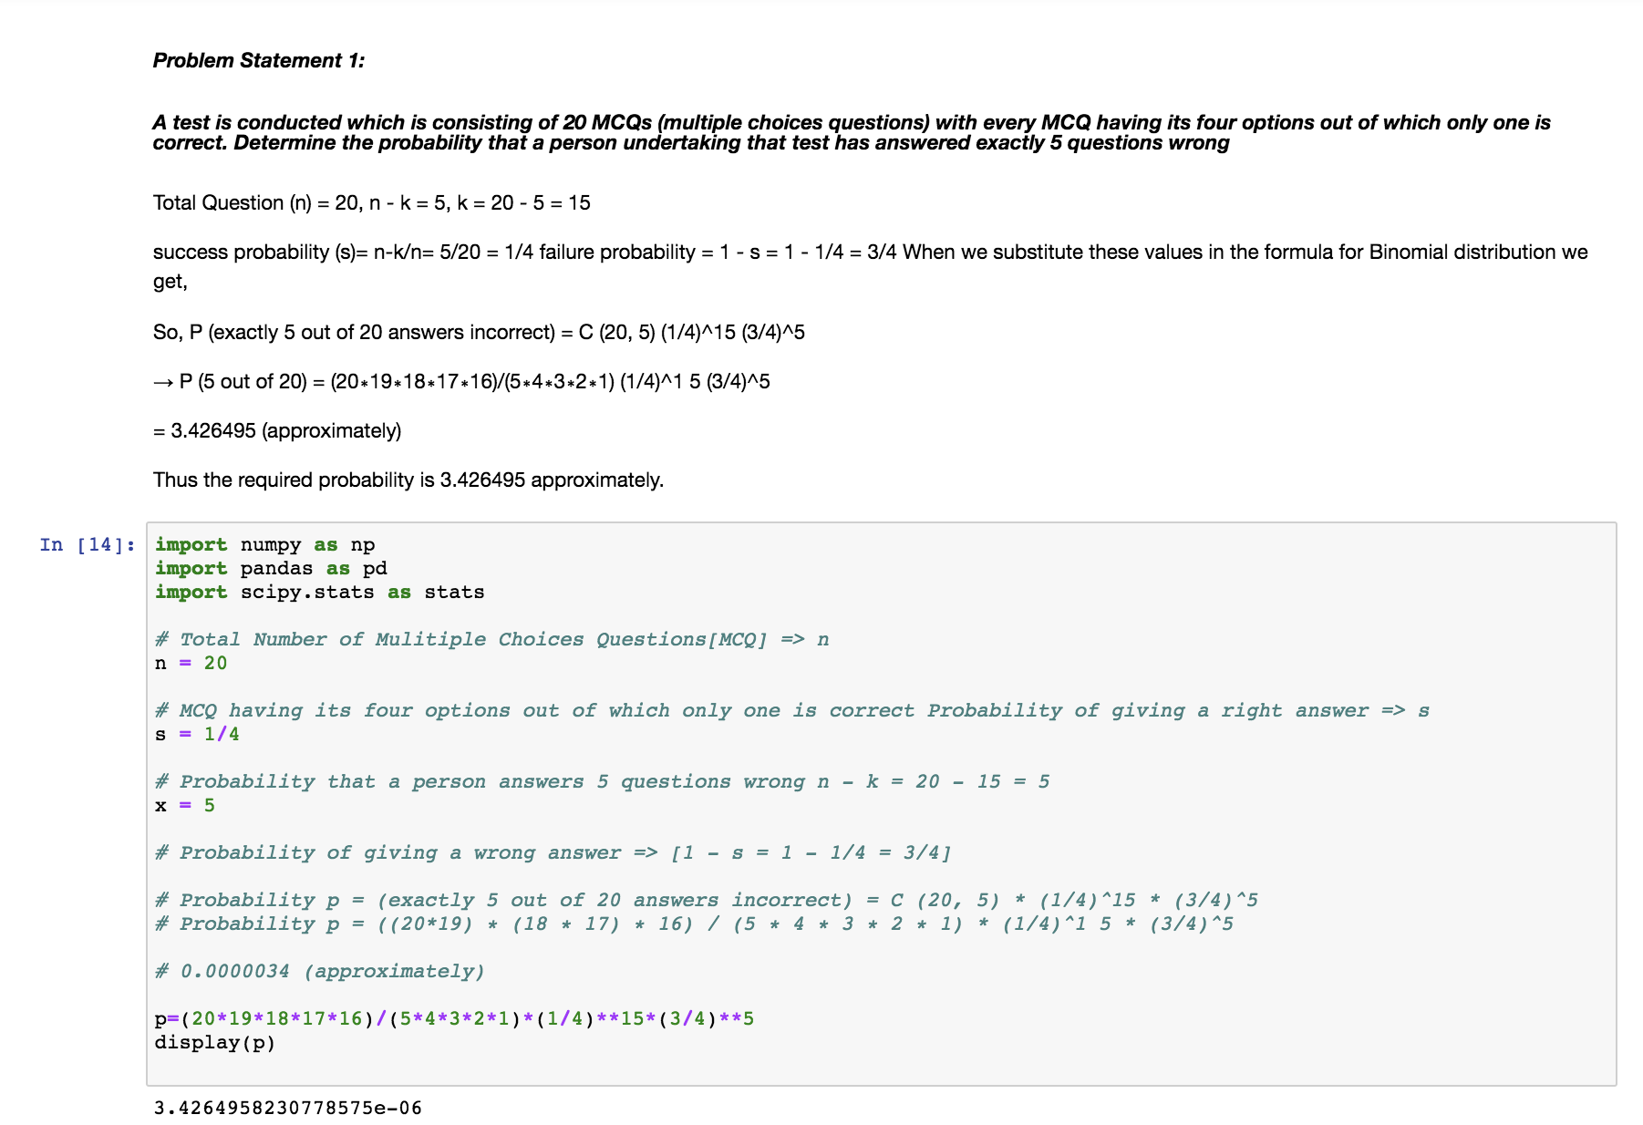

Problem Statement 2:

A die marked A to E is rolled 50 times. Find the probability of getting a “D” exactly 5 times.

**SolutionScreenshot:-**

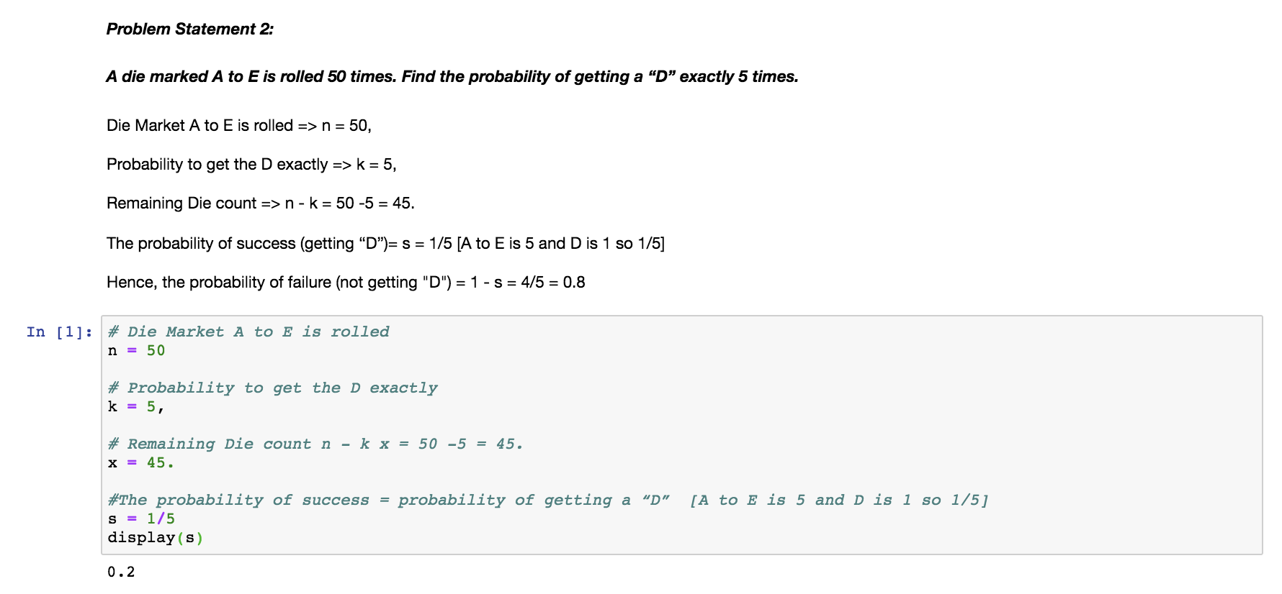

Problem Statement 3:

Two balls are drawn at random in succession without replacement from an urn containing 4 red balls and 6 black balls. Find the probabilities of all the possible outcomes

**SolutionScreenshot:-**

