Problem Statement 1:

YIs gender independent of education level? A random sample of 395 people were surveyed and each person was asked to report the highest education level they obtained. The data that resulted from the survey is summarized in the following table:

----------High School----Bachelors----Masters----Ph.d.----Total

Female-----60------------54------------46------------41------201

Male--------40------------44------------53------------57------194

Total -------100-----------98------------99------------ 98------395

Question: Are gender and education level dependent at 5% level of significance? In other words, given the data collected above, is there a relationship between the gender of an individual and the level of education that they have obtained?

**SolutionScreenshot :-**

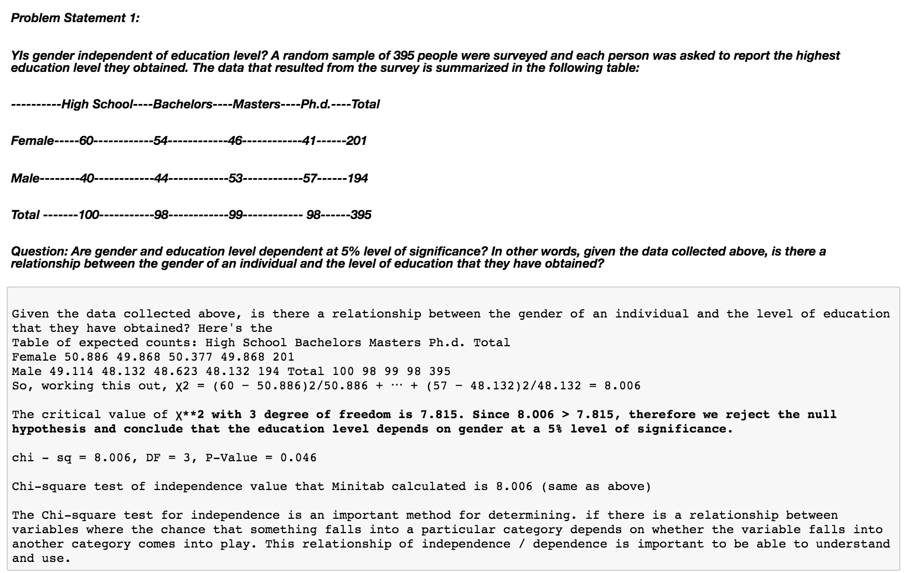

Problem Statement 2:

Using the following data, perform a oneway analysis of variance using α=.05. Write up the results in APA format.

[Group1: 51, 45, 33, 45, 67]

[Group2: 23, 43, 23, 43, 45]

[Group3: 56, 76, 74, 87, 56] ?

**SolutionScreenshot:-**

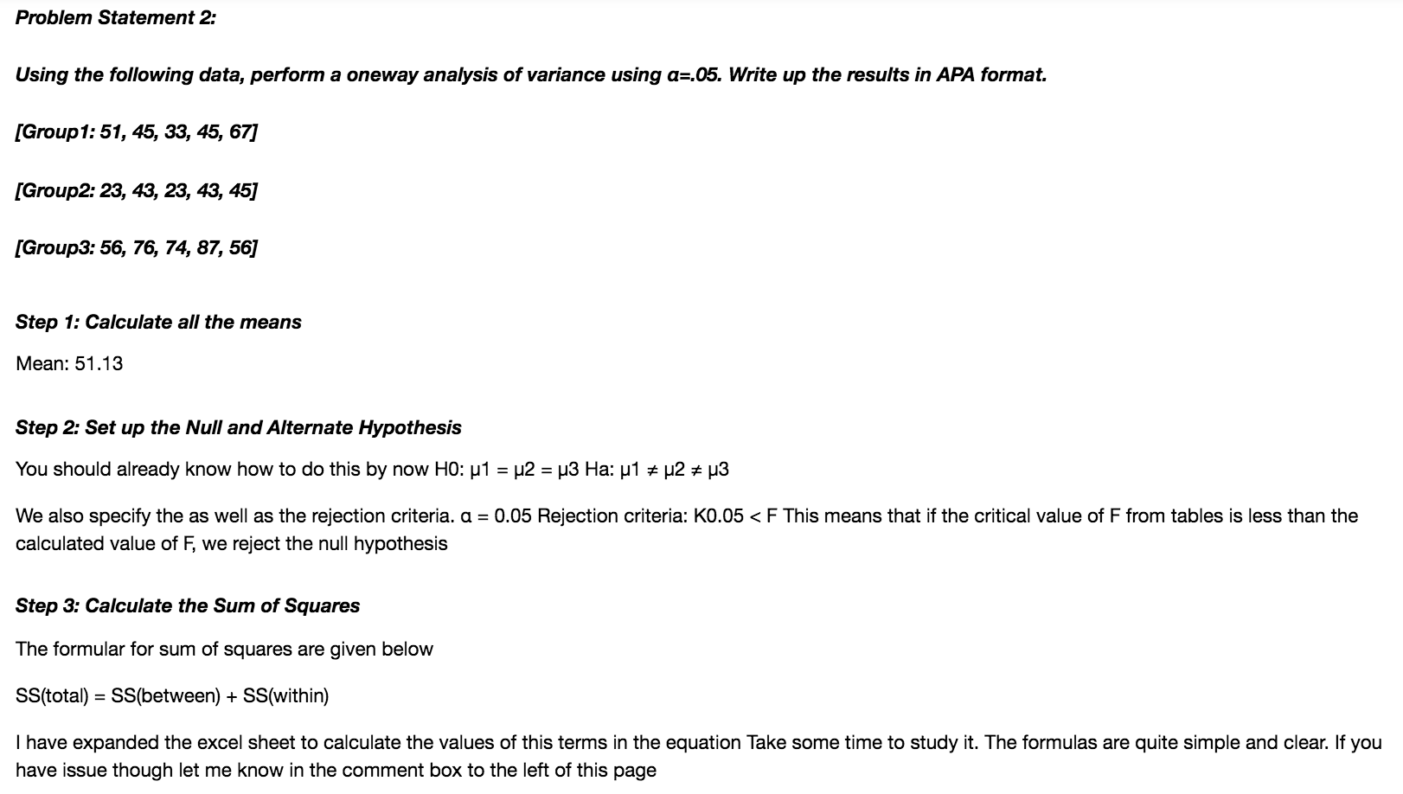

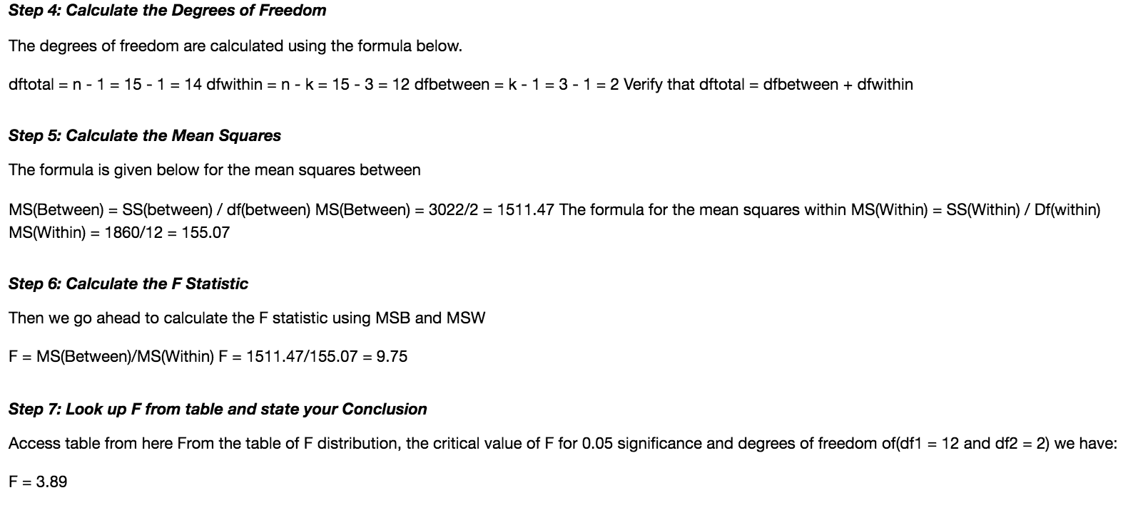

Problem Statement 3:

Calculate F Test for given 10, 20, 30, 40, 50 and 5,10,15, 20, 25. For 10, 20, 30, 40, 50: Note: Solution submitted via github must contain all the detailed steps.

**SolutionScreenshot:-**

