**Scrum in practice**

How I applied it in IPS & GPS

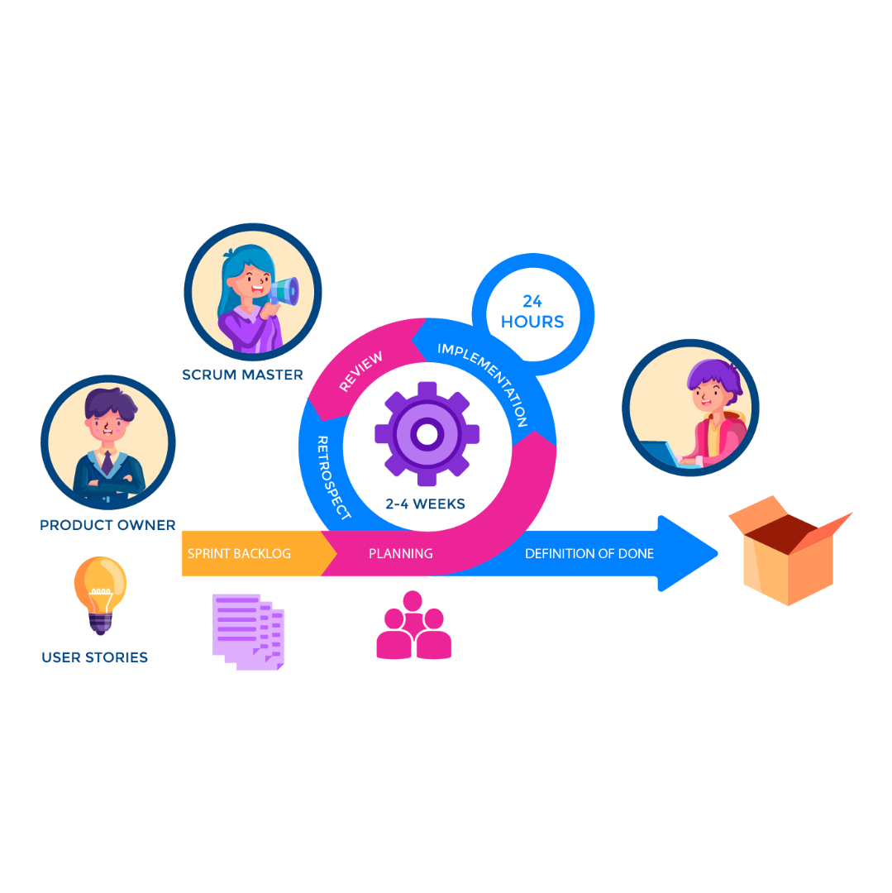

The Scrum lifecycle. (Google, n.d.)

Author: Maurice Schippers

Class: S3-DB03

Date published: 3rd of November 2022

Version: 1.0

# Scrum

I used Scrum for both the IPS and the GPS. Each section contains the reasoning (based on context and principles) behind my decision.

# Individual project

As it is my first time exercising Agile on a project, Scrum seemed to check the most boxes for a beginner like me. The sprints of three weeks seemed to overlap with the rest of the semester and the Scrum artifact ‘Increment’ fits right in with the iterative delivery of the portfolio; new (completed) work is added at the end of each sprint. Due to the extension of the burndown chart in Scrum, it made it easier for me to make a planning that is more reasonable and achievable.

I am using the project management tool Jira to pick the Backlog items for each Sprint.

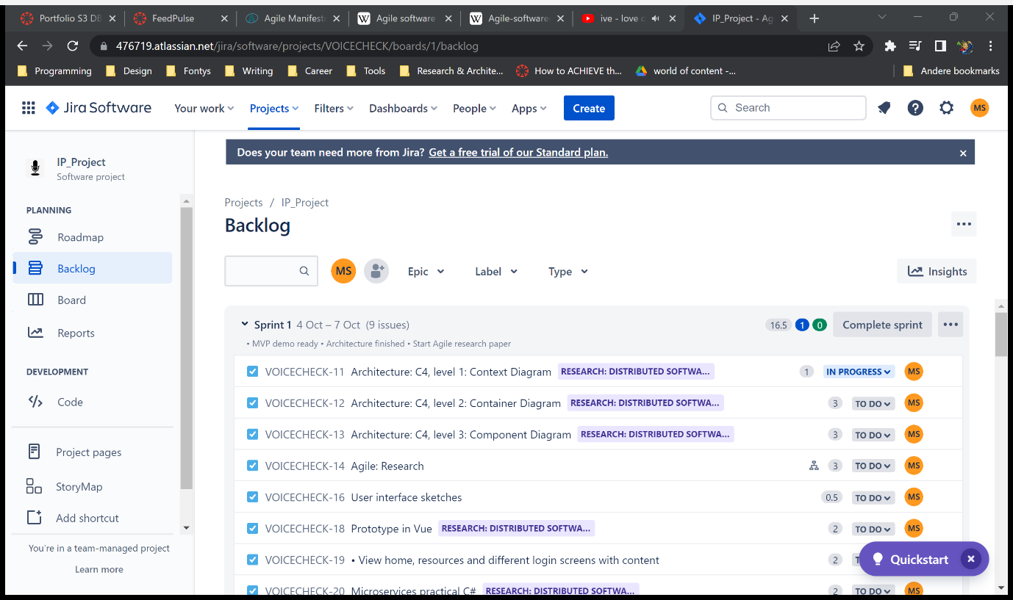

Screenshot of Jira, showing the Backlog items currently in Sprint 1

# Group project

I went out to research Scrum and finished a LinkedIn Learning course on the subject during the first week of the semester. Once the groups were created, my group members informed me that they did not have any experience with Agile. So, in the first week of the first sprint, I created recurring Daily Scrum stand-up meetings.

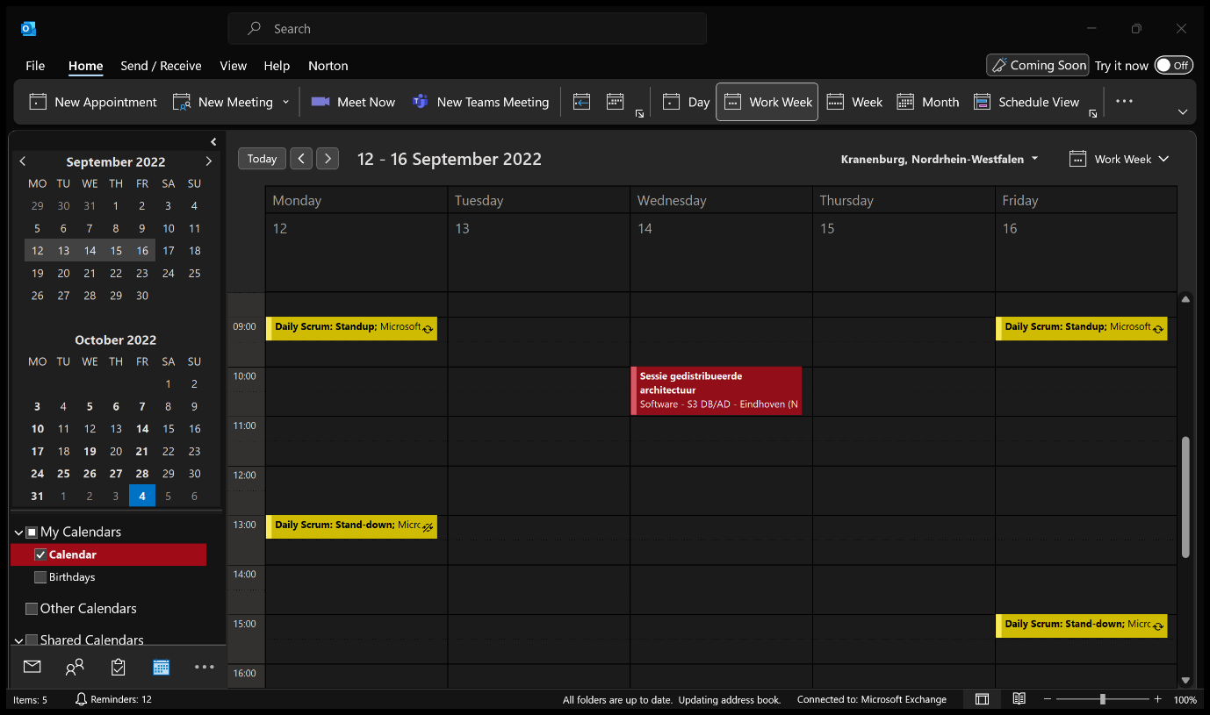

Screenshot of my calendar in Outlook.

After a little while, group members expressed their need for more meetings, especially during a day where we work remotely (all the time in my case). To react to their needs, I added the recurring stand-down meeting, which takes place every workday at 3 PM. It helps the team to easier remember what has been done that day, possible other topics and closing the day together.

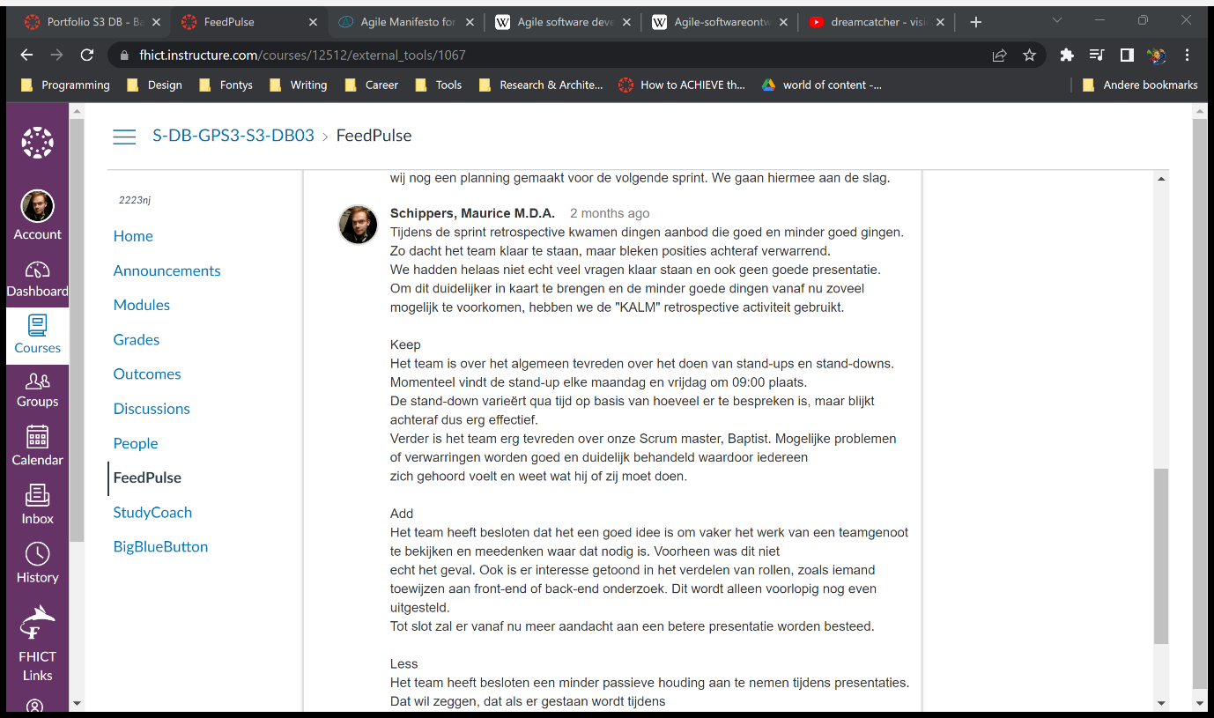

Screenshot of the Group feedback: Retrospective 0

While I and take care of the planning and writing summaries like the retrospective, I am not the Scrum Master. Instead, I try to aid the current Scrum Master during stand-up/down meetings and oversee the process.

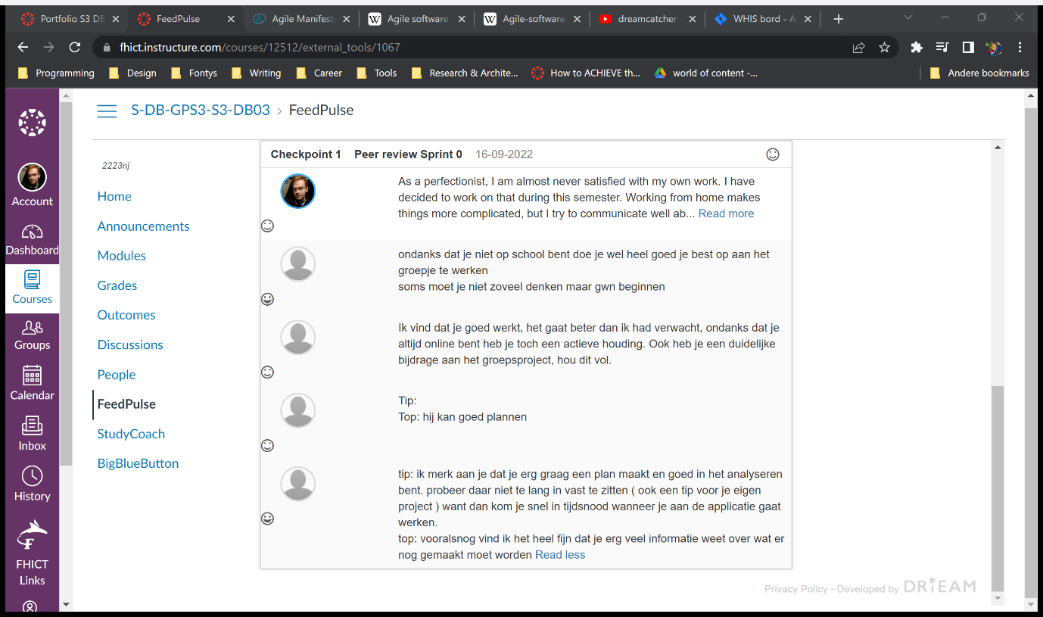

Screenshot of the peer reviews from Sprint 0.

Just like in my individual project, we work with Jira. The team can quickly view who is working on what and the status of that item. Additionally, we can add points for the burndown chart in this tool which also makes it easier to plan our working days (Monday and Friday).

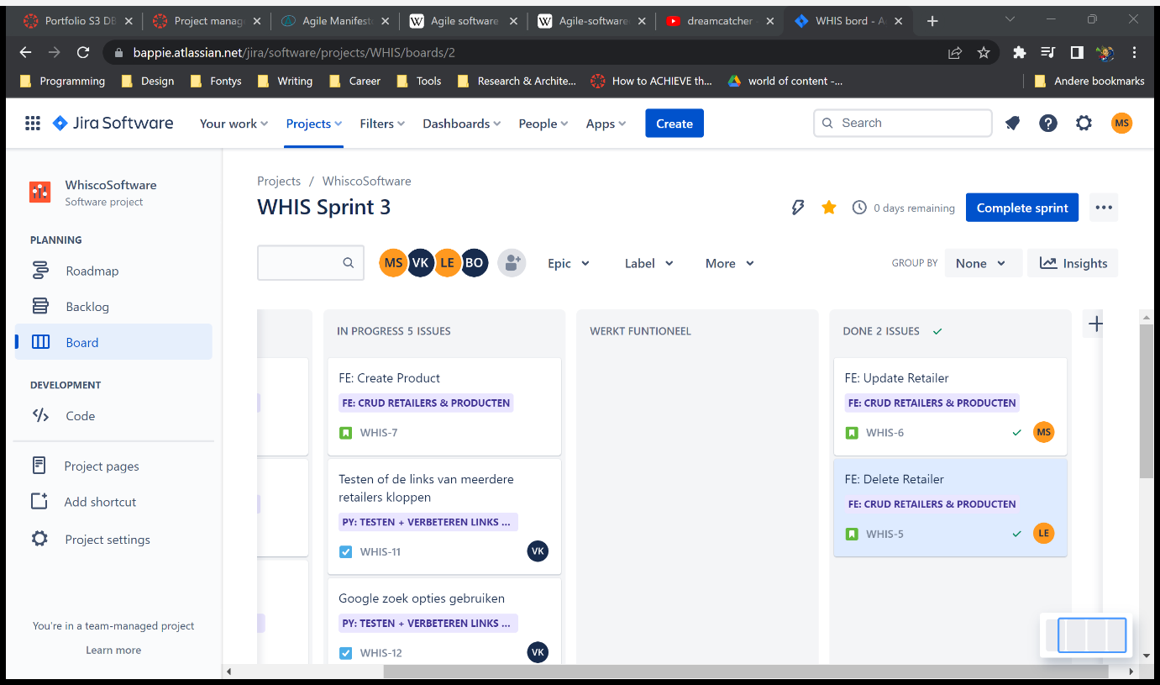

Screenshot of our board in Jira.