This is a test plan to show that the degrees listed below, fit accurately thus producing valid outputs. Below are the necessary information and outputs
Temperature: 200, 50 and 0 degree Celsius.
Outputs: Gas, Liquid and solid

water test 1
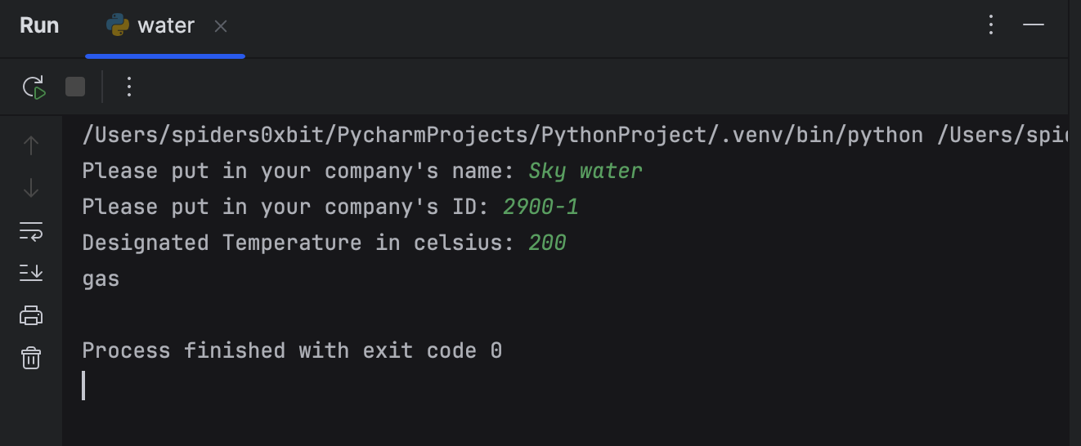
Water test 2
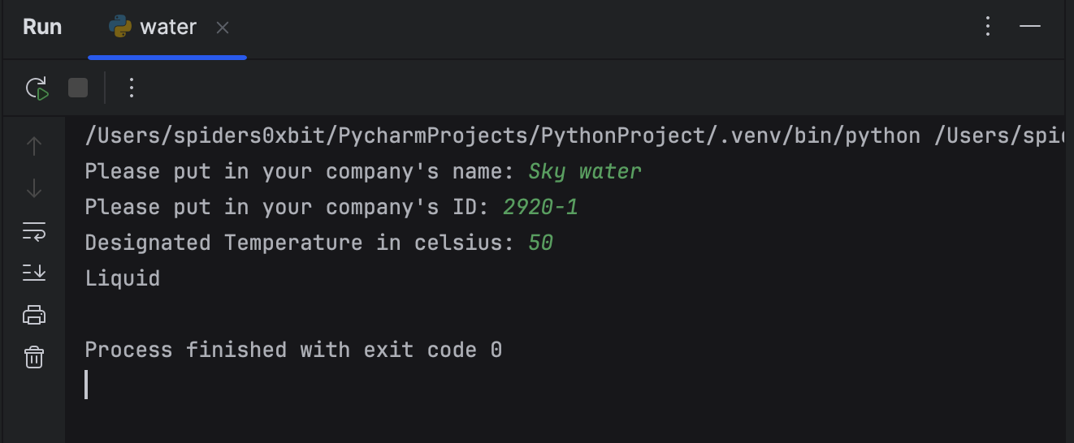

Water test 3
