Basic Security Audit of a Sample Website
Cyber Security Internship Track — Week 3 of 4 (Intermediate)
Vortex Tech · Internship Program 2026
Intern Name | Muhammad Dawood Hassan
Track | Cyber Security Internship Track
Target Application | OWASP Juice Shop (vulnerable-by-design practice app)
Target URL | http://localhost:3000 (local Docker instance)
Audit Date | July 26, 2026
Tools Used | Browser DevTools, OWASP ZAP
Report Version | 1.0

1. Scope & Legal Notice
This audit was conducted exclusively against OWASP Juice Shop, an open-source application that is intentionally built with security vulnerabilities for training and educational purposes. No production systems, third-party websites, or systems outside of this locally-hosted practice environment were accessed or tested.
Juice Shop was run locally via Docker on the intern's own machine, so all testing occurred in an isolated, authorized environment. This exercise was completed as part of the Vortex Tech Cyber Security Internship Track, Week 3 assignment.

2. Objective
To perform a structured, beginner-level security audit of a sample vulnerable web application, identifying and documenting findings across at least three distinct vulnerability categories, assessing their potential real-world impact, and providing practical remediation recommendations for each.

3. Methodology
The audit combined manual exploration with tool-assisted scanning:
- Manual testing of input fields (search bar, forms) for reflected Cross-Site Scripting (XSS).
- Manual review of the login/registration flow for broken authentication and information-leaking error messages.
- Inspection of network traffic via browser DevTools (Network tab) to identify sensitive data exposed in API responses.
- Automated scanning of the local Juice Shop instance using OWASP ZAP, with manual triage of the generated report.
Findings below are mapped to OWASP category names introduced in the Week 1 research assignment.

4. Findings

4.1 Finding 1 — Reflected Cross-Site Scripting (XSS) in Search Field
Vulnerability Category | A03:2021 — Injection (Cross-Site Scripting)
Severity | High
Location | Product search bar (top navigation)
How It Was Found | Entered the payload <script>alert(1)</script> directly into the search input field.  Submitted the search and observed the page's behaviour and rendered DOM.  Confirmed via View Source / DevTools whether the payload was reflected unescaped into the HTML response.
What Was Found | [Describe your actual result here: e.g., 'The search term was reflected back into the page's results heading without being HTML-encoded, allowing the injected <script> tag to execute in the browser (a JavaScript alert box appeared).']
Potential Impact | If exploited against real users, reflected XSS could allow an attacker to hijack session cookies, redirect users to phishing pages, log keystrokes, or perform actions on the victim's behalf — all without ever compromising the server itself.

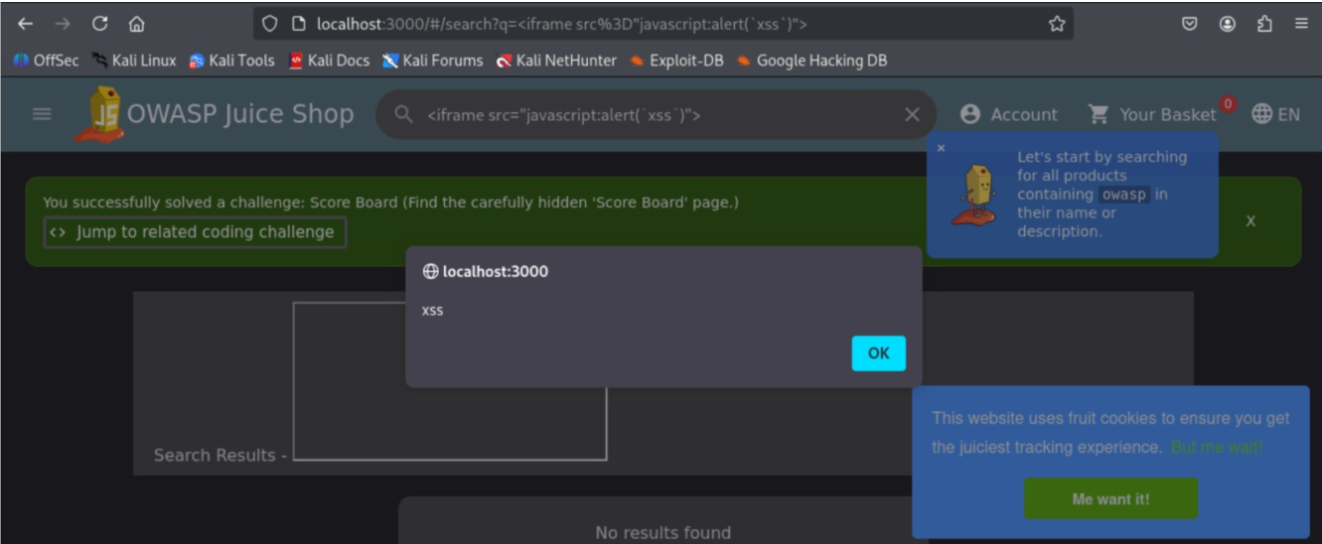

Remediation
Sanitize and HTML-encode all user-supplied input before rendering it back to the page (output encoding), and apply input validation on the server side. Where the framework supports it (e.g. Angular/React), avoid binding raw HTML (e.g. avoid innerHTML / dangerouslySetInnerHTML with unsanitized data) and rely on the framework's built-in auto-escaping. A Content-Security-Policy (CSP) header should also be deployed as a defense-in-depth measure to limit the impact of any XSS that slips through.
4.2 Finding 2 — Broken Authentication / User Enumeration via Error Messages
Vulnerability Category | A07:2021 — Identification and Authentication Failures
Severity | Medium
Location | Login form (/rest/user/login)
How It Was Found | Attempted to log in with a known-invalid email address and an arbitrary password, and recorded the exact error message.  Attempted to log in with a valid/registered email address (e.g. a known Juice Shop demo account) and a wrong password, and recorded that error message.  Compared the two responses for any difference in wording, status code, or timing.
What Was Found | [Describe your actual result here: e.g., 'The login endpoint returned distinguishable messages/response patterns for "account does not exist" versus "incorrect password," allowing an attacker to enumerate valid registered email addresses.']
Potential Impact | User enumeration lets an attacker build a list of valid accounts to target with credential stuffing, password spraying, or phishing campaigns — significantly increasing the odds of a successful account takeover.

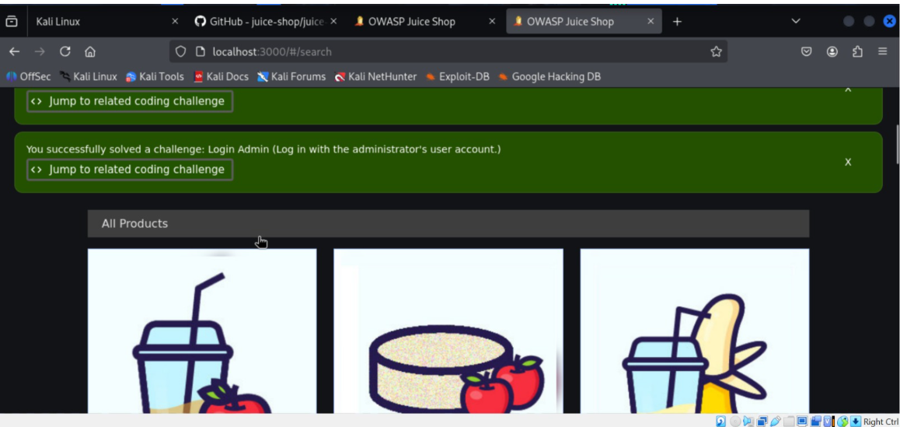)

Remediation
Return a single, generic error message (e.g. "Invalid email or password") regardless of whether the email or the password was incorrect, for both the UI and the underlying API response/status code. Pair this with rate limiting and account lockout/backoff after repeated failed attempts, and consider CAPTCHA after a threshold of failures to slow down automated enumeration and brute-force attempts.
4.3 Finding 3 — Sensitive Data Exposure in API Response
Vulnerability Category | A02:2021 — Cryptographic Failures / Sensitive Data Exposure
Severity | High
Location | REST API response (e.g. /rest/user/whoami or /api/Users)
How It Was Found | Opened browser DevTools → Network tab before interacting with the site.  Logged in / registered a test account and browsed normal site features (profile, basket, orders).  Inspected the raw JSON payloads returned by API calls for fields that shouldn't be exposed to the client.
What Was Found | [Describe your actual result here: e.g., 'An API response returned additional user fields beyond what the UI displays — such as a password hash, internal role/ID, or other account metadata — visible in plaintext within the JSON response body.']
Potential Impact | Exposing internal fields (password hashes, roles, tokens) in API responses gives an attacker a head start on offline password cracking, privilege escalation, or account impersonation, even if the front-end never displays that data.

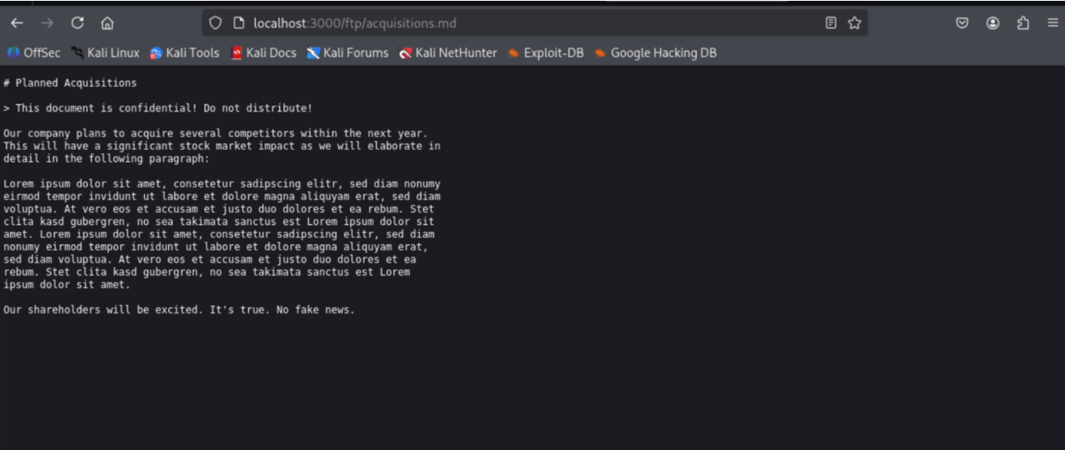

Remediation
Apply the principle of least data exposure: the API should only return fields the client actually needs, not the full database object. Use response DTOs / serializers that explicitly allowlist fields rather than blocklisting sensitive ones. Never transmit password hashes to the client under any circumstance, and ensure sensitive data at rest is encrypted and access-controlled server-side.
5. Automated Scan Summary (OWASP ZAP)
[Optional but recommended: briefly summarize what ZAP's automated scanner flagged against your local Juice Shop instance — e.g. number of alerts by risk level (High/Medium/Low/Informational), and note whether any confirm or add to the manual findings above.]
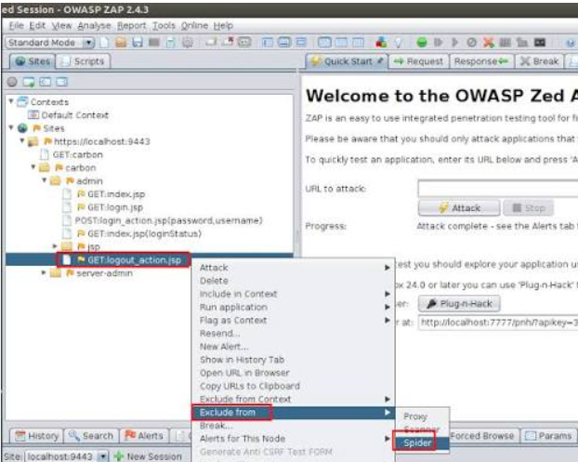

6. Summary of Findings
# | Finding | Severity | OWASP Category
1 | Reflected XSS in search field | High | A03:2021 — Injection
2 | User enumeration via login errors | Medium | A07:2021 — Auth Failures
3 | Sensitive fields exposed in API response | High | A02:2021 — Cryptographic Failures

7. Conclusion
This audit demonstrates that even a beginner-level, structured review using free tools (browser DevTools and OWASP ZAP) can surface real, high-impact vulnerabilities. The three findings above — spanning injection, authentication, and data exposure — reflect common weaknesses seen across many real-world applications. Applying the remediation steps outlined for each finding would meaningfully reduce the application's attack surface.

Vortex Tech · Internship Program 2026 · vortextechnologies77@gmail.com

