|  |  |  |  |  |
| --- | --- | --- | --- | --- |
| **Period:** Finals | **Subject:** 6OOPLANG | **Class Code:** 2097 | | **Score:** ____ |
| **Exercise:** | **Date:** 11 – 18 – 20 | **Day/Time:** Th (10:15am – 1:15pm) | | |
| **Topic:** | | **Instructor:** JR D. Casingal | | |
|  | |  |  | |
| Students Name: Sumang, Michael Dave C. | | | | |

Activity details**:**

OBJECTIVES:

To be able to create a program in Java.

INSTRUCTIONS:

Create a simple Java program that will solve each of the problem below. Then, copy the Java source code and paste it, then insert also the snippet of the program source code and output in the space provided. The grading will be based on the provided rubrics.

PROBLEMS:

**Exercise #: ______**

**Filename:** mainCase.java

***Source code:***

*import java.util.*;*

*public class mainCase*

*{*

*static Scanner input = new Scanner(System.in);*

*public static void main(String[] args)*

*{*

*//Initalization------------------------------------------------------------*

*int len,elem,odd=0,even=0;*

*System.out.print("Enter the number of integers to input: ");*

*len = input.nextInt();*

*capsuleCase[] mixedArr = new capsuleCase[len];*

*for (int i = 0;i<len;i++)*

*{*

*System.out.print("Enter element: ");*

*elem = input.nextInt();*

*mixedArr[i] = new capsuleCase(elem);*

*if(elem%2==0)*

*{*

*even++;*

*}*

*else*

*{*

*odd++;*

*}*

*}*

*capsuleCase[] evenArr = new capsuleCase[even];*

*capsuleCase[] oddArr = new capsuleCase[odd];*

*splitter(evenArr, oddArr, mixedArr);*

*capsuleCase[][] multiArr = {evenArr,oddArr};*

*//Process----------------------------------------------------------------------*

*sort(evenArr,oddArr,multiArr);*

*total(evenArr,oddArr,multiArr);*

*//Output-----------------------------------------------------------------------*

*printer(evenArr,oddArr,multiArr);*

*}*

*public static void splitter(capsuleCase[] evenArr, capsuleCase[] oddArr, capsuleCase[] mixedArr)*

*{*

*int n1 = 0, n2 = 0;*

*for (int i=0;i<mixedArr.length;i++ )*

*{*

*if(mixedArr[i].getElem()%2==0)*

*{*

*evenArr[n1]=new capsuleCase(mixedArr[i].getElem());*

*n1++;*

*}*

*else*

*{*

*oddArr[n2]=new capsuleCase(mixedArr[i].getElem());*

*n2++;*

*}*

*}*

*}*

*public static void sort(capsuleCase[] evenArr, capsuleCase[] oddArr, capsuleCase[][] multiArr)*

*{*

*int low;*

*for (int i = 0;i<evenArr.length;i++)*

*{*

*low = i;*

*for (int j = i+1;j<evenArr.length;j++)*

*{*

*if((multiArr[0][low].getElem()) > (multiArr[0][j].getElem()))*

*{*

*low = j;*

*}*

*}*

*capsuleCase swapper = multiArr[0][i];*

*multiArr[0][i] = multiArr[0][low];*

*multiArr[0][low] = swapper;*

*}*

*for (int i = 0;i<oddArr.length;i++)*

*{*

*low = i;*

*for (int j = i+1;j<oddArr.length;j++)*

*{*

*if((multiArr[1][low].getElem()) > (multiArr[1][j].getElem()))*

*{*

*low = j;*

*}*

*}*

*capsuleCase swapper = multiArr[1][i];*

*multiArr[1][i] = multiArr[1][low];*

*multiArr[1][low] = swapper;*

*}*

*}*

*public static void total(capsuleCase[] evenArr, capsuleCase[] oddArr, capsuleCase[][] multiArr)*

*{*

*int total1 = 0,total2 = 0;*

*for (int i = 0;i<evenArr.length;i++)*

*{*

*total1 += multiArr[0][i].getElem();*

*}*

*for (int i = 0;i<oddArr.length;i++)*

*{*

*total2 += multiArr[1][i].getElem();*

*}*

*if(oddArr.length>0 && evenArr.length>0)*

*{*

*evenArr[0].setTotal(total1);*

*oddArr[0].setTotal(total2);*

*}*

*else if(evenArr.length>0 && oddArr.length<=0)*

*{*

*evenArr[0].setTotal(total1);*

*}*

*else if(evenArr.length<=0 && oddArr.length>0)*

*{*

*oddArr[0].setTotal(total2);*

*}*

*}*

*public static void printer(capsuleCase[] evenArr, capsuleCase[] oddArr, capsuleCase[][] multiArr)*

*{*

*System.out.println("\nHighest to lowest: ");*

*System.out.println("Even: ");*

*for (int i = evenArr.length-1;i >= 0;i--)*

*{*

*System.out.print(multiArr[0][i].getElem()+" -> ");*

*}*

*System.out.println("\nOdd: ");*

*for (int i = oddArr.length-1;i >= 0;i--)*

*{*

*System.out.print(multiArr[1][i].getElem()+" -> ");*

*}*

*System.out.println("\n\nTOTAL:");*

*if(oddArr.length>0 && evenArr.length>0)*

*{*

*System.out.println("even: "+evenArr[0].getTotal());*

*System.out.println("odd: "+oddArr[0].getTotal());*

*}*

*else if((evenArr.length>0) && (oddArr.length<=0))*

*{*

*System.out.println("even: "+evenArr[0].getTotal());*

*System.out.println("odd: 0 ");*

*}*

*else if(evenArr.length<=0 && oddArr.length>0)*

*{*

*System.out.println("even: 0");*

*System.out.println("odd: "+oddArr[0].getTotal());*

*}*

*}*

*}*

**Source Code Snip:**

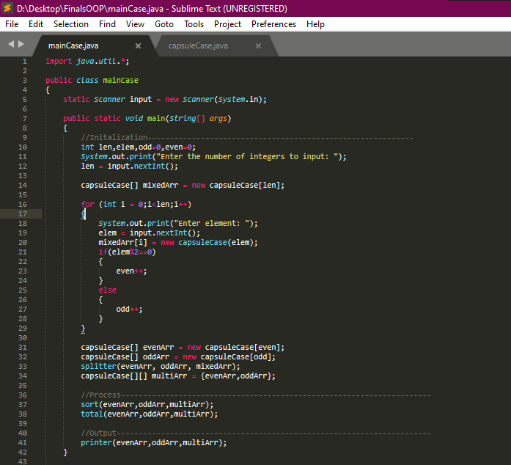

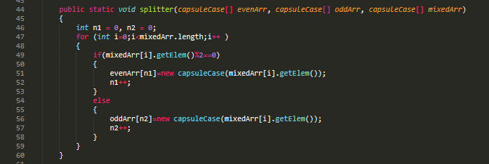

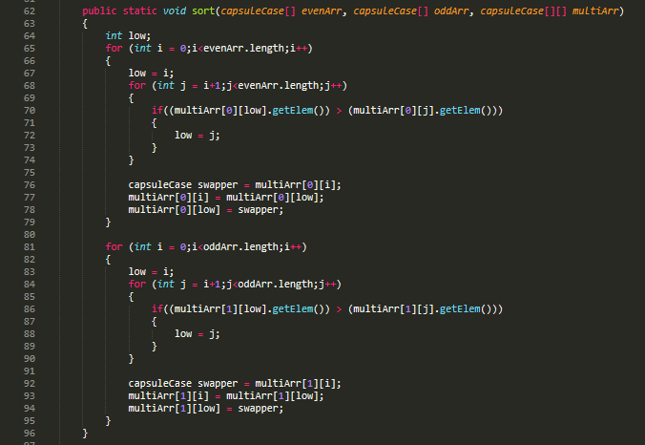

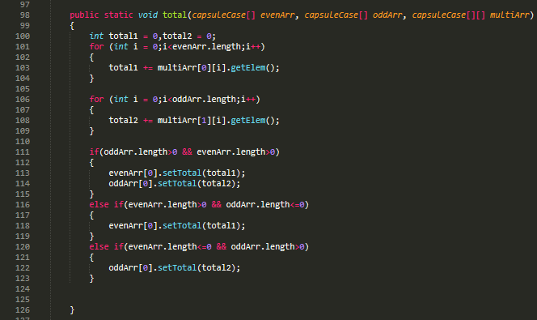

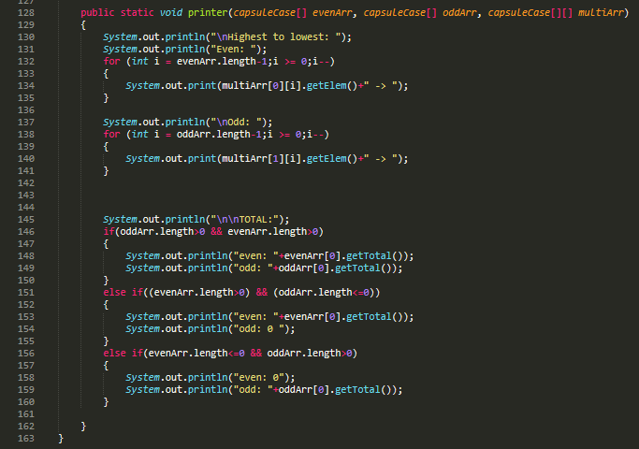

**Filename:** capsuleCase.java

***Source code:***

*public class capsuleCase*

*{*

*private int total;*

*private int elem;*

*capsuleCase(int x)*

*{*

*elem = x;*

*}*

*public int getElem()*

*{*

*return elem;*

*}*

*public void setTotal(int x)*

*{*

*total = x;*

*}*

*public int getTotal()*

*{*

*return total;*

*}*

*}*

**Source Code Snip:**

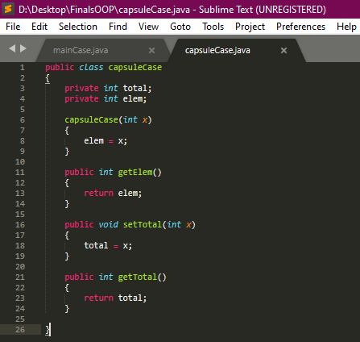

**Output Snip:**

