Install git

<https://git-scm.com/download/win>

create a repository on github

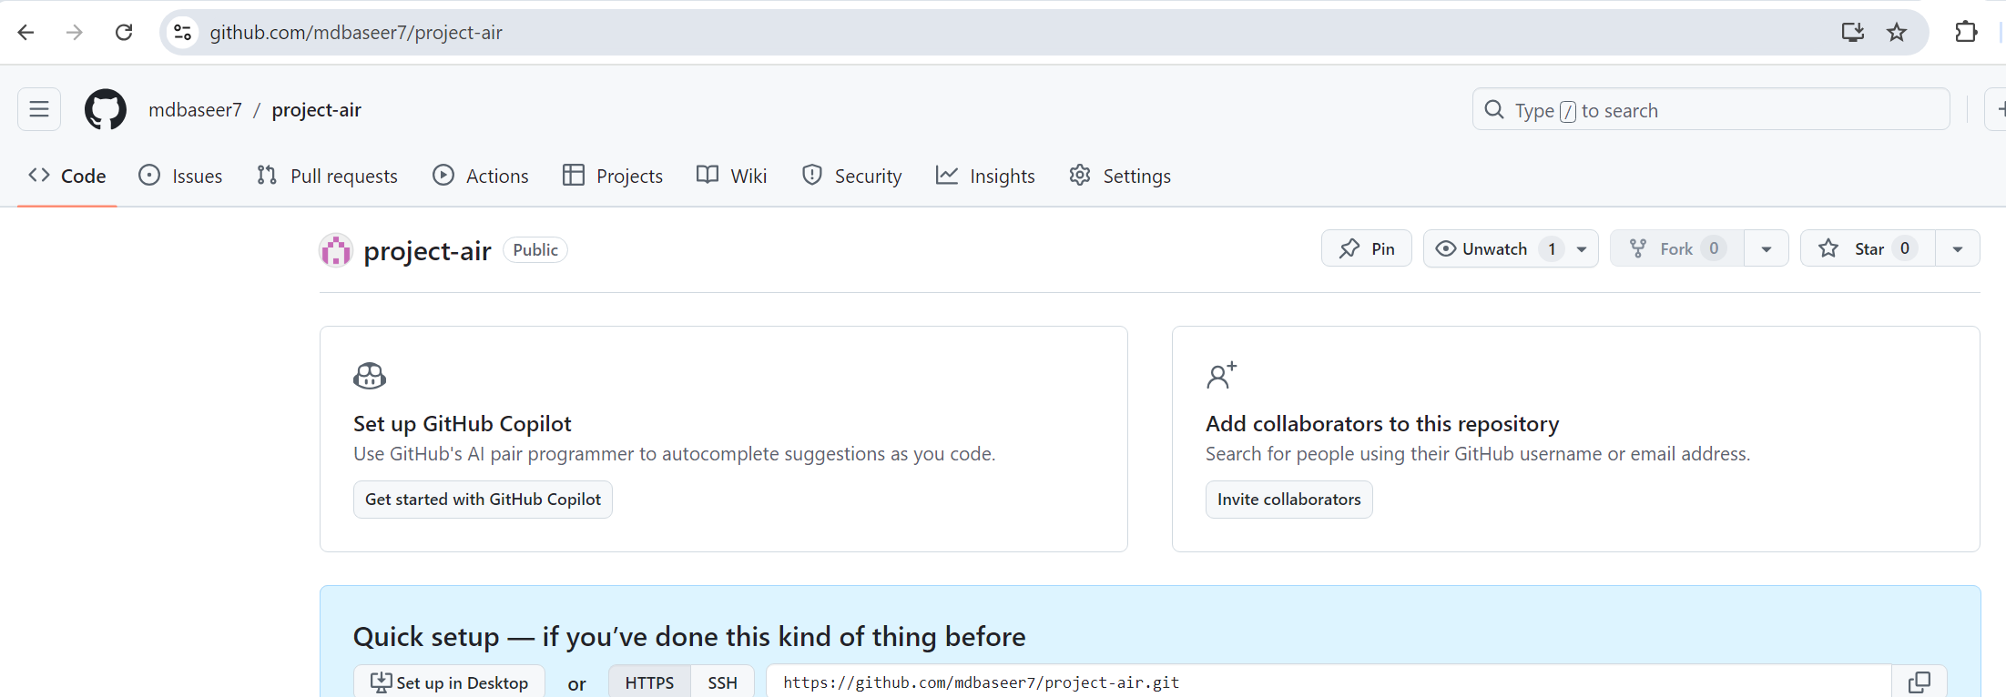

Clone the repository using below command

Git clone repo-url

Example: git clone <https://github.com/mdbaseer7/project-air.git>