Consider the data set and perform the Apriori Algorithm and FP algorithm support:3 and confidence=50%

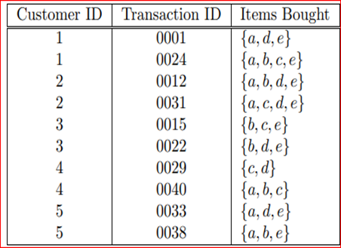

Consider the data set and perform the Apriori Algorithm and FP algorithm support:3 and confidence=50%

Consider the market basket transactions shown in the above table.

(a) What is the maximum number of association rules that can be extracted

from this data (including rules that have zero support)?

(b) What is the maximum size of frequent itemsets that can be extracted

(assuming minsup > 0)?

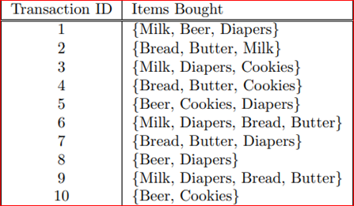

Bayes classification and descion tree (using training and test data)

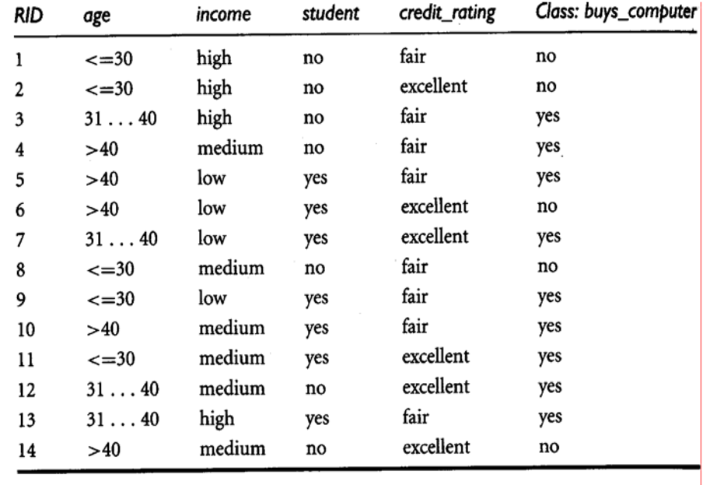

Analysis the dataset “diabetes. csv” how the diabetes trend is for different age people, using linear regression and multiple regression.

Implement using WEKA for the given Suppose a database has five transactions. Let min sup= 50%(2) and min con f = 80%.

**Transactions Items**

T1 (M, O, N, K, E, Y)

T2 (D, O, N, K, E, Y)

T3 (M, A, K, E)

T4 (M, U, C, K, Y)

T5 (C,O, O, K, I ,E)

* Find all frequent item sets using Apriori algorithm
* Also draw FP-Growth Tree

Prediction of Categorical Data using Decision Tree Algorithm through WEKA using any datasets. a) Tree b) Preprocess c) Logistic

Create the dataset using ARFF file format: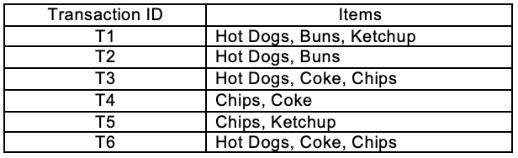

a.Find the **frequent itemsets** and generate **association rules** on this. Assume that minimum support threshold (s = 33.33%) and minimum confident threshold (c = 60%).

b.List the various rule generated by apriori and FP tree algorthim ,mention wheather accepted or rejcted.

Prediction of Categorical Data using Rule base classification and decision tree classification through WEKA using any datasets. Compare the accuracy using two algorithm and plot the graph