
 COMSATS University Islamabad, Lahore Campus
Lab 1 - POSTMAN
Course Title: | Software Testing |  |  |  | Course Code: | CSE 455 |  | Credit Hours: | 3(2,1)
Course Instructo: | Yella Mehroze |  |  |  | Theory/Lab Name: | Lab
Semester: | 8th | Batch: | SP21 | Section: | A | Depart | CS

Learning Outcomes
- Black Box Testing
- API Testing (Through Postman)
    - Learning API Basics
    - Learning the POSTMAN basics
    - Sending requests and response body
    - Different types of request methods
    - Sending requests to endpoints

Task 1

Send a request to ENDPOINT (status).

Methodology

- Install POSTMAN
- Learn the basics
- Start sending requests to various endpoints
- Status request
https://simple-books-api.glitch.me/status

(The above-mentioned address is using a hypertext transfer protocol , HTTPS (Secure Connection) )
Most APIs must use HTTPS, but we may use both.
- Make sure the API is available and working as expected.
- Is the API us working fine, send more requests.

Output //

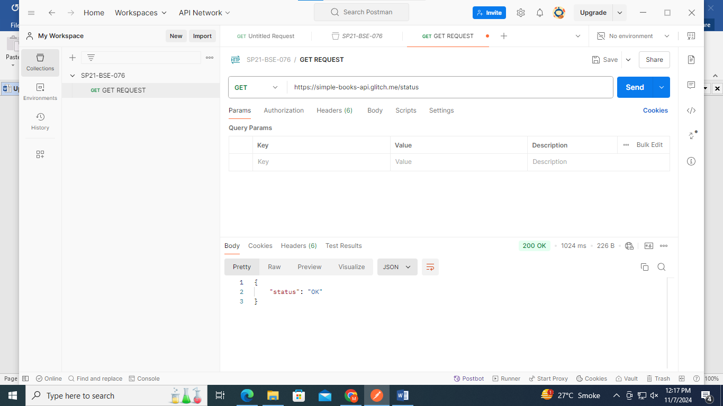

Sending A request | Respond Body
Sending the request mean initiating a communication with the server to send or receive data. | The respond body contain the data returned by the server after processing request.
Configure a request by selecting HTTP request method (GET, PUT, DELETE, POST) | Data format like JSON, XML, HTML, or simple text.

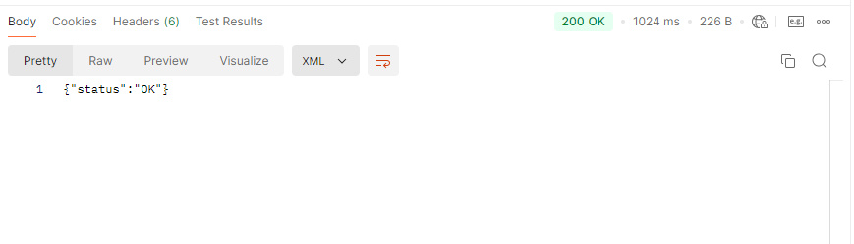

For any queries

yellamehroze@cuilahore.edu.pk

Office: H-Block – Room 25 (H – 25)

