COMP 596 - History of Computing - Fall 2019
8085 Computer

In this lab you will construct an 8085-based microcomputer from my own design that runs Microsoft BASIC.

The Intel 8085 is an 8-bit microprocessor that was used in many computers in the late 70s and early 80s. It uses the 8080/Z80 instruction set and 9 registers (A, B, C, D, E, H, L, PC, and SP). The 8085 chip contains the registers and the logic to execute instructions, but it does not contain any memory or I/O. In this lab you will interface the 8085 with a ROM, RAM, and serial port, and run vintage programs.

You will need:
Jameco breadboard / power supply unit
8085 microprocessor
28c256 32kb EEPROM
62256 (or equivalent) 32kb Static RAM
74273 - 8 bit D-flip-flop
74138 - 3 to 8 decoder
7474 - 2 D flip-flops
7400 - 4 nand gates
8251A UART
FTDI cable
2 MHz (or smaller) crystal
lots of wires
ROM programmer (TL866-II)

Step 1: Wiring the microprocessor
You should make the following connections to get the CPU working. Use as small wires as possible, and make sure they are flat against the board.

To 5V:
Vcc, Ready
To Ground:
Hold, Trap, Rst 7.5, Rst 6.5, Rst 5.5, Intr, Gnd (also called Vss)

X1 is the clock input. Connect X1 to the "TTL" pin on the function generator and set the frequency to anything above 100kHz.

Connect the RESET_IN line to one of the push-button switches. Make sure it is normally 5V except when the switch is pushed down.

Step 2: Separating the address and data buses.

Notice that the lower eight address lines and the data lines share the same pins (AD0 to AD7). Intel did this to save pins on the chip. The ALE (address latch enable) pin tells what the pins are currently used for. When ALE=0, AD0-AD7 are address bits 0-7. When ALE=1, AD0-AD7 are data bits 0-7. To use the 8085, you need to separate these lines. To do this you should use eight latches to capture the address when ALE goes to 0. The flip-flops outputs will continue to hold the address when AD0-AD7 contain the data.

A 74273 chip contains eight storage bits with a single clock. Place a 74273 on the board, connect its Vcc to 5V, its Gnd to ground, and the MR pin to 5V. Connect all of the D lines to the AD lines on the 8085. D0 should go to AD0, D1 to AD1 and so on.

You will use the ALE to capture the address. This line must be inverted first. Connect the ALE pin on the 8085 to the A and B inputs of a 7400 NAND gate. Then connect the appropriate Y output to the 74273's CP (clock) pin.

At this point, the D0-7 lines on the 74273 comprise your data bus, and the Q0-7 lines on the 74273 comprise your address bus.

Step 3. Wiring the ROM
Place the 28c256 EEPROM, connect its Vcc and WE (write) lines to 5V, and connect lines GND and CE (enable chip)to ground.

Connect the I/O0-I/O7 lines to the data bus. Connect AD0 on the 8085 to I/O0, AD1 to I/O1, and so on. Do not run any wires over the EPROM chip. You will need to be able to remove it to program it.

Connect the A0-A7 address pins to the O0-O7 outputs on the 74273. Connect the higher address lines, A8-A14, to the A8-A14 pins on the 8085.

Finally connect the OE (output enable, or read) on the EEPROM to the RD line on the 8085. When the 8085 wants to read from the ROM, it will make RD=0, and the EEPROM will put the data on the data bus for the CPU to read.

Step 4. Capturing output data

When the 8085 wants to write to a port (because of OUT), it does the following:
- it puts the port address (00) on pins AD0-7 and makes ALE=0 (your 74373 will store this address)
- it sets IO/M to 1, specifying that what is being written is not meant for memory, but for an I/O port
- it puts the data (the contents of A, or B5) on the AD0-7 lines and makes ALE=1
- it makes pin WR momentarily 0, meaning “write now”

We're going to use a 7474 D flip flop to capture writes and display them on the LEDs.

Place a 7474. Connect its 5v and Gnd, disable 1CLR and 1SET by setting them to 5v. Set the 1CLK to the WR (write) line on the 8085, and the 1Q line to an LED. Connect a long wire to the 1D input. You will use this wire to examine data, one bit at a time.

Step 5. Put a test program in the ROM
You should program your 28256 EEPROM with this following simple program:
0 3E MVI A, B5
1 B5
2 D3 OUT 00
3 00
4 C3 JMP 0000
5 00
6 00

This program first puts the binary pattern 10110101 (B5) into register A and then outputs it to I/O port 0. You can use this program to verify that your computer works.

Power on the circuit, press and release the switch connecting to Reset, and touch the long wire connected to the 7474's 1D momentarily to AD7 on the 8085. Do you see the light turn on, signifying a 1 was written? Now go through each pin from AD7 down to AD0. The lights should follow the pattern 10110101 (B5).

Debugging
If you do not see the pattern, the most likely reason is a wiring error. Use a multimeter set to continuity (beep) mode, and check each connection by touching each leads to the pins of chips. Check:
- that 5v goes to the Vcc on each chip, as well as everything else that should be 5v
- do the same for Ground
- the control lines on the processor (Read, ALE, Write) are connected correctly
- the ALE is inverted correctly before going to the 74273.
- the eight data lines (AD0-AD7) each connect to the ROM and the 74273 inputs
- address lines (A8-A14) on the ROM go to 74273 outputs

Crystal
The 8085 has an internal clock circuit so we do not have to use the board's clock generator. On the 8085, connect a crystal between X1 and X2 and disconnect the TTL output from X1. Check that your circuit still works.

Step 6. Relocate the ROM using memory bank switching
When the 8085 is reset it jumps to address 0000 and starts running the program there. Currently this is the ROM. The programs we want to run on this computer, however, expect to see RAM at address 0000. We can't run these programs until we relocate the ROM to upper memory. Unfortunately, if we move the ROM away from address 0000 and put RAM there instead, the 8085 will start up by running whatever garbage is in RAM on powerup, and will never get to our program.

The solution we will use it to create a memory bank switch using the other flip-flop on the 7474. When we reset the computer, the ROM will be located at address 0000 and the RAM will be disabled. When the bank switch is activated, the ROM will jump to address 8000 and the RAM will appear at 0000. We will activate this bank switch by writing to memory.

First wire the second D-flip-flop on the 7474. Connect 2CLR to the RESET-IN pin on the 8085, and 2SET to the WR pin on the 8085. Leave the 2D and 2CLK pins disconnected. This flip-flop will now store "0" on powerup, but will permanently switch to "1" when the 8085 does its first memory write operation.

Now place two new chips: a 74138 decoder, and a 7400 nand gate. Connect the Vcc and GND on both chips. Then connect pins E1, E2, and E3 on the 74138 to Gnd, Gnd, Vcc respectively.

Now go to the 74138 and connect the A0 pin to the 2Q output on the 7474, the A1 pin to the A15 line on the 8085, and the A2 pin to the IO/M line on the 8085.

Look at the truth table for the 74138 decoder and see how it works. Each possible combination of inputs activates (sets to 0) a unique output. By hooking each device's enable line to a different output, we can choose choose which device -- ROM, RAM, or I/O -- the processor talks to.

This table shows how our system will behave:

A2 (IO/M) A1 (A15) A0 (bank)
decoder output behavior
startup:
0 0 0 0 read from low memory (0000-7fff): enable ROM
did a write, now bank is switched and RAM is active
0 0 1 1 access low memory (0000-7ffff): enable RAM
0 1 1 3 read high memory (8000-ffff): enable ROM
later we will put in an I/O device
1 0 1 5 talking to an I/O port: enable UART

Notice we want to ROM to be active on two conditions: 000 and 011. We'll use a NAND gate to ties these together so that either condition will enable it. Connect 74138 outputs "0" and "3" to the two inputs of a NAND gate. Connect the output of that NAND gate to the two inputs of a second NAND gate. Disconnect the CE line on the ROM from ground and connect it to the output of that second NAND gate.

Step 7. Test the bank switching circuit

Reprogram your ROM with this:

;set the stack pointer. the next stack push will write to address 0 and switch banks
0 31 LXI SP,0
1 00
2 00
;jump to address 8006. the write to the stack will move the ROM to 8000, so 8006 is the
; next instruction
3 CD CALL 8006
4 06
5 80
; even though we're putting this line at address 6 in the ROM, the 8085 will be running at
; address 8006
; now we run the same program as before
6 3E MVI A,B5
7 B5
8 D3 OUT 00
9 00
A C3 JMP 8006
B 06
C 80

If you did everything correctly, you should be able to see the same 10110101 pattern

Step 8. RAM
The 62256 RAM chip is wired almost identically to the EEPROM. Place it and connect its A0-A14 lines to the same A0-A14 on the EEPROM, the D0-D7 to the I/O0-7 on the EEPROM, and the OE and R/W pins to the RD and WR on the 8085. Connect the Vcc and GND to 5V and ground, respectively. Finally connect the CE enable line to "1" on the 74138.

Run the Step 7 program again and make sure it still produces the pattern.

Step 9. UART
The 8251 is a Universal Asynchronous Receiver/Transmitter, or UART, a device that implements a serial port to communicate with your computer. The 8251 will let your laptop act as your computer's keyboard and screen, making it interactive.

Place the 8251, connect its Vcc and Gnd (careful: they're not in the usual place), and connect CTS to ground. Then connect the eight data wires -- D0 to D7 -- to your data bus. Connect RD to the 8085's RD pin, WR to the 8085's write pin, RESET to the 8085's RESET OUT pin (this is different from the reset-in you've used before), and CLK to the 8085's CLK OUT pin. Then connect CS (chip select) to output "5" on the 74138.

The UART uses two I/O ports. Connect the C/D pin to the same line as the A0 pin on the RAM. Reads or writes to Port 1 will configure and query the UART, and reads/writes to Port 0 will receive and send from your laptop.

You should have an FTDI cable to connect the UART to your computer. Connect the GND on the cable (black on my cable) to ground on your board, the transmit cable (green on my cable) to RxD on the UART, and receive (white on my cable) to TxD.

The UART will need a precise timing signal that will determine the bits-per-second (or baud rate) of the serial port. Since your lab board only has one frequency generator, we will repurpose it for the UART and control the 8085 with its built-in clock. Disconnect the frequency generator from the 8085 and connect it instead to the 8251's TxC and RxC pins.

Step 10. Test the UART

If you have the Arduino IDE you can use its Serial Monitor as the keyboard/screen for your computer. Set the baud rate to 1200, and set the frequency generator on your board as close as you can to 1200 Hz.

Program the ROM with this test program:
0 31 LXI SP,8002
1 02
2 80
3 CD CALL 8006
4 06
5 80
; configuration for UART - first byte
6 3E MVI A,4d
7 4D
; send to UART control port
8 D3 OUT UART_CONTROL
9 01
; configuration for UART - second byte
a 3E MVI A,15
b 15
c D3 OUT UART_CONTROL
d 01
; now the UART is ready to go
; is there a character pressed?
e DB IN UART_CONTROL
f 01
10 E6 ANI 2
11 02
; if not, go back and try again
12 CA JZ 800E
13 0E
14 80
; read the character
15 DB IN UART_DATA
16 00
; add two to it
17 3C INC A
18 3C INC A
; print it back out
19 D3 OUT UART_DATA
1A 00
; and do it again
1B C3 JMP 800E
1C 0E
1D 80

This loopback program will show whether your serial connection is working. Every letter you press on your computer will be printed back to you two letters higher. For example, if you type 12345 it should echo 34567, and hello should echo back jgnnq.

Step 11. BASIC

The binary image posted with this assignment is the original 8k Microsoft BASIC, Microsoft's very first product, developed for the Altair computer. I modified it in two ways: to use the 8251 UART (the Altair UART is difficult to obtain) and I added a loader at the beginning that will copy BASIC to address 0000 and jump to it. Flash it to your ROM. If everything is correct, you should get this dialog (responses are in italics):

MEMORY SIZE? 8192
TERMINAL WIDTH?
WANT SIN-COS-TAN-ATN? YES

1668 BYTES FREE
ALTAIR BASIC REV. 4.0
[EIGHT-K VERSION]
COPYRIGHT 1976 BY MITS INC.
OK

10 FOR I=1 TO 3
20 PRINT I
30 NEXT I
RUN
1
2
3
OK

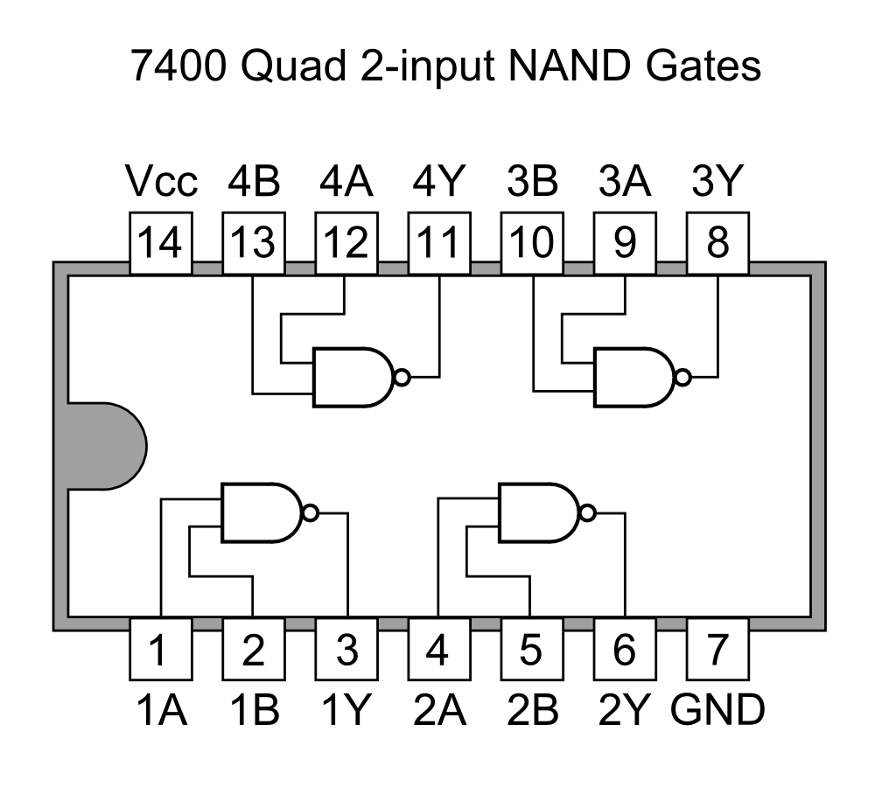
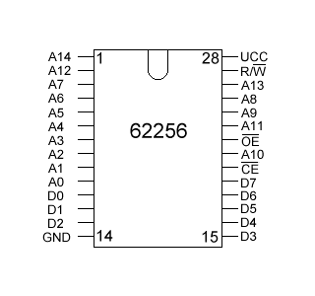
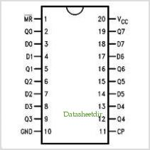
74273 eight-bit flip-flop
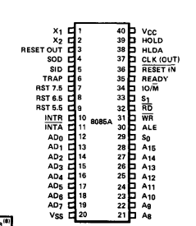
8085 Processor
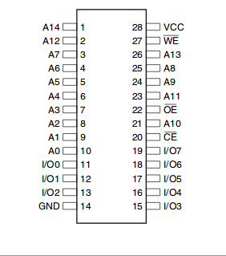
28256 EEPROM
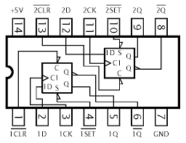
7474 two D-flip flops
62256 Static RAM
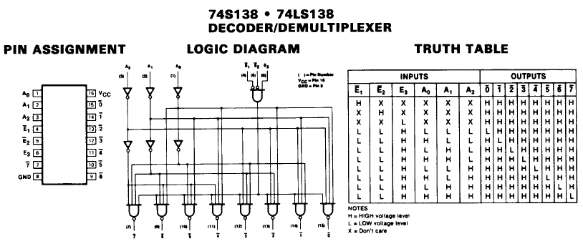
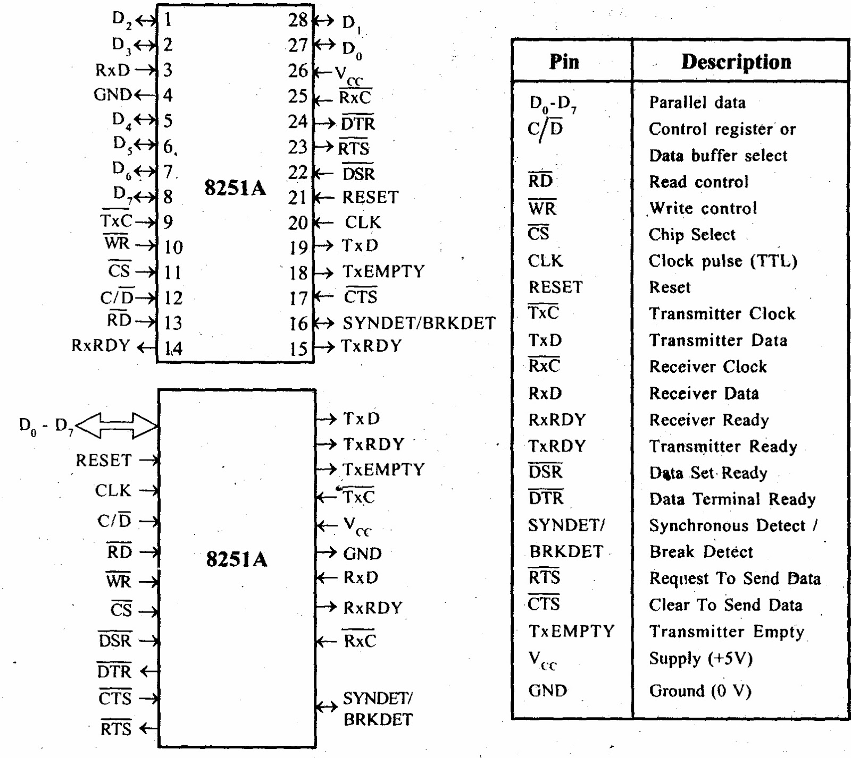
8251 UART

