COMP 407 Spring 2018
Lab 2: Voice-activated kitchen timer

Parts
Arduino Uno
Breadboard & wires
Two 7-segment LED displays
14 1k resistors
Two 74595 shift registers
Speaker or buzzer
Electret microphone
A button and 1k resistor

Objective:

In this lab you will, essentially, make one of these:
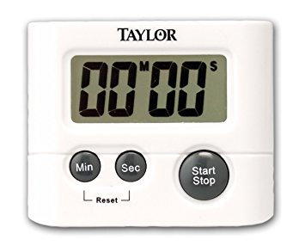
Make a 60-second timer that responds to a loud voice. When activated it counts down, using one-second timer interrupts, from 60 to 0, showing the current time on two LED seven-segment displays. When it reaches 0 it should stop counting and beep.

Step 1. Try out the seven-segment displays
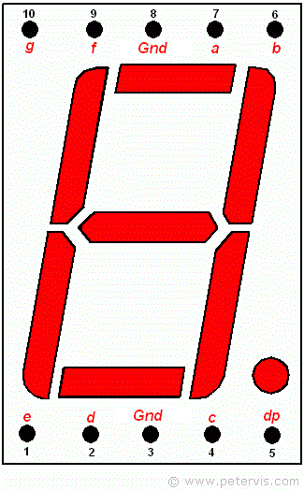
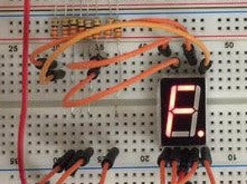

You will need two displays. Connect the seven segments of each display (a-g) to a resistor and the common display grounds to GND on the arduino. Your display pinouts may differ from the one shown. Google your part number! Momentarily touch the other side of each resistor to 5 volts and see what happens.

Step 2. Connect the displays to shift registers

There aren't enough pins on the Arduino to drive each segment of two displays. The 74595 shift register will allow you to send out a number one bit at a time. It will collect eight bits and display them.

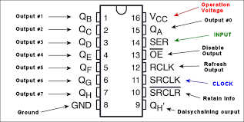
Start with one shift register and one display. Connect outputs Qa through Qg to the corresponding resistors on the display. Connect SRCLR' to 5 volts and OE' to GND. Then connect SER (data input), RCLK (latch data), and SRCLK (clock) to arduino pins 4, 5, and 6, respectively.

Now try putting the following in setup() and see what happens:

int datapin=4, latchpin=5, clockpin=6;
int code = 0b11111100;

digitalWrite(latchpin, LOW); //enable 74595 to receive data
//send 1 bit at a time, starting at the low bit
shiftOut(datapin, clockpin, LSBFIRST, code);
digitalWrite(latchpin, HIGH); //show the result

Do this for the second display, using pins 7, 8, and 9.

Step 3. Output numbers

Here are the segment codes for 0 through 9:

// 0, 1, 2, 3, 4, 5, 6, 7, 8, 9
{ 0b11111100, 0b00110000, 0b11011010, 0b11110010, 0b01100110, 0b10110110, 0b10111110, 0b11100000, 0b11111110, 0b11110110 }

Write a function void displayNumber(int number) that will:

- take a two digit decimal integer, for example displayNumber(37)
- break it into component digits: 3 7 (use the mod % operator)
- get the segment codes for each digit using the table given
- send them to the appropriate displays

Test it with 37 and see if it shows.

Step 4. Reset input

Connect pin 2 to one side of a button. Connect a 1k resistor from the same side to 5V. Connect the other side of the button to GND.

Make two global variables:
volatile int count=0;
volatile int countEnabled=0;

Make a function void resetCounter() that will:
set count=60
set countEnabled=1
call displayNumber(count)

Now in setup, call
attachInterrupt(0, resetCounter, FALLING);

If your program works, when you press the button the display should show 60

Step 5. Use TIMER 1 to count down

Make an interrupt service routine for TIMER 1:

ISR (Timer1_COMPA_vect)
{
}

In your routine, if countEnabled==1, then:
- subtract 1 from count
- call displayNumber(count)

- if count is 0, set countEnabled=0

Now, in resetCounter, initialize Timer 1 to interrupt every second. This is a good resource:

https://oscarliang.com/arduino-timer-and-interrupt-tutorial/

1. call cli() to disable interrupts

2. clear the timer: set the three timer registers TCCR1A, TCCR1B, TCNT1 to 0

3. choose a 3-bit prescalar (CS12, CS11, CS10) and 4-bit counting mode (WGM13, WGM12, WGM11, WGM10):

This is the bit meanings for timer register TCCR1B:
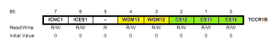
Here they are for timer register TCC1A:
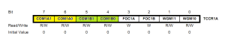
We only care about the CS and WGM bits. The rest of them can stay 0.

CS 2, 1, 0 specify a prescalar. This is will divide 16 MHz down to a smaller number.

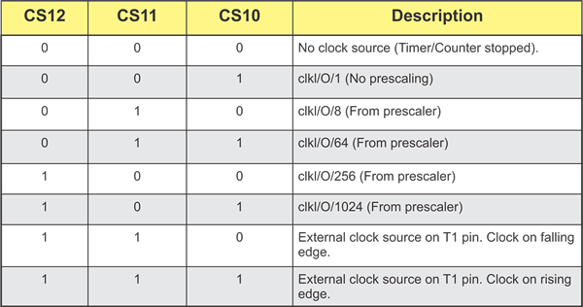
Pick the three bit pattern for a prescalar of 256.

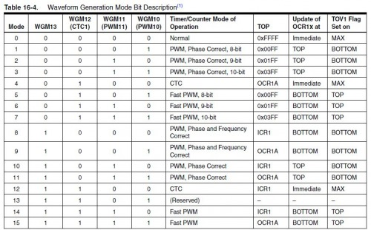
WGM 3, 2, 1, 0 sets the timer mode as shown in the above table. We want a timer mode of CTC (clear timer on compare match). This means that it will count up from 0 until it hits our "compare number", interrupt, then reset and do it again. Pick the four bit patten for mode CTC.

4. Now, using the bit meanings, set TCC1A and TCC1B. Note that some of the mode bits fall in one register and some in the other.

5. Use the following formula to figure out TCNT1:

16000000 / 256 / TCNT1 = 1 second

solve for TCNT1 and set it.

6. set TIMSK1 to (1 << OCIE1A) This will allow the timer to call the interrupt routine.

7. call sei() to turn interrupts back on.

If this works, your timer should start counting down when you press the button.

Step 6. Voice-activated

Connect the microphone: GND to GND, VCC to 5V, and OUTPUT to analog pin 0.

In loop, read from the microphone int reading = analogRead(0) and print out the reading. If the room is quiet it should stay around the same value.

Now, instead of printing out the value, call resetCounter if the value is bigger than some volume threshold. Choose a threshold so that it starts counting on a moderately loud noise.

Step 7. Beep

Hook a speaker up to pin 10, and have the timer interrupt routine make a beeping noise for 5 seconds when the count hits 0. (You may need to adjust the microphone if the beep restarts the timer.)

Grading:

The grade is based on the number of steps completed. You should demonstrate your circuit to your professor on the next class.

