COMP 407 Spring 2018
Project 2: Assembly Display Driver

Objective:
Write a program for the Arduino Uno, entirely in AVR assembly, that reads characters from a serial port and displays them on a LCD display.

Learning outcomes:
AVR assembly, LCD interface, UART interface, standalone Atmega328

Parts
Arduino Uno
LCD display, HD44780 compatible
Breadboard & wires
10k potentiometer

Resources

Getting started with the display:

http://www.instructables.com/id/How-to-use-an-LCD-displays-Arduino-Tutorial/
https://www.sparkfun.com/datasheets/LCD/HD44780.pdf

UART:
https://sites.google.com/site/qeewiki/books/avr-guide/usart (just for the tables: please don't look at the sample code)

Assembly:
http://academy.cba.mit.edu/classes/embedded_programming/doc1022.pdf

Step 1: Get the display connected and working

Follow the directions in the instructables link to wire the display to the Arduino. If you don't have a potentiometer, connect Vo to GND. Run the test program and make sure "Hello World" prints out.

Step 2: Serial read

Now make a program that will repeatedly check if Serial.available(), call Serial.read(), and print the letter on the display. When done, you should be able to type in the Serial monitor and see the text on the display. Don't forget to put Serial.begin(9600) in your setup.

Step 3: Display without library calls

Now get letters printing without using the Liquid Crystal library. Instead you must use only digitalWrite and delay commands.

For setting up the display mode, set RS to 0, set the command on the D7 to D4 pins, and use R/W as a clock: the display will do a command at the moment R/W goes from 0 to 1. Follow the instructions in Table 12 of the HD44780 data sheet on page 42.

To write characters, first set RS to 1. Then output the higher four bits of the ASCII character to D7 to D4, pulse R/W, then the lower four bits, and pulse R/W again.

You may want to put this into a writeCharacter function.

Step 4 (challenge): Scroll and newline

Currently the display will only produce text until it gets to the end of the line, at which point you'll have to reset it. Using the datasheet (page 29, especially), try to figure out how to scroll your text to the left when you reach the end of the line. This may require multiple control operations.

Additionally, when a newline '\n' character is received, make the display clear and rehome itself.

Note: if you can't figure out this step in a reasonable time, proceed to step 5 and return to it later.

Step 5 and 6: Remove all Serial commands and directly communicate with the UART

Step 5. Initialize the UART

The UART is a component inside the Atmega328 chip that handles serial communication with your computer. In this step you will replace Serial.begin(9600) with initialization calls

These are the hardware registers you should use:

UCSR0A tells whether a letter is ready to read
 | 7 | 6 | 5 | 4 | 3 | 2 | 1 | 0
UCSR0A | RXC0 | TXC0 | UDRE0 | FE0 | DOR0 | PE0 | U2X0 | MPCMn

UCSR0B enables the serial port
 | 7 | 6 | 5 | 4 | 3 | 2 | 1 | 0
UCSR0B | RXCIE0 | TXCIE0 | UDRIE0 | RXEN0 | TXEN0 | UCSZ02 | RXB80 | TXB80

UCSR0C sets the serial parameters
 | 7 | 6 | 5 | 4 | 3 | 2 | 1 | 0
UCSR0C | UMSEL01 | UMSEL00 | UPM01 | UPM00 | USBS0 | UCSZ01 | UCSZ00 | UCPOL0

UBBR0H and UBBR0L control the baud rate

UDR0 receives the character.

Here's how you should handle the commands:

1. Serial.begin(9600)
First set UCSR0A to 0 to clear the port

Second, set the baud rate to 9600. Use this formula:

ubrr = 16000000 / (baudrate * 16) - 1
Since this is a 16-bit number, you'll need to break into a high 8 bits and a low 8 bits. Chances are in this case that the high 8 bits will be 0.

Now write the high bits to UBRR0H and the low bits to UBRR0L

Third, set the parameters. You should use the following tables to set UCSR0C. You want your serial mode to be asynchronous, parity disabled, 1 stop bit, 8 character bits, rising clock edge.

UMSEL1 | UMSEL0 | MODE
0 | 0 | Asynchronous Operation
0 | 1 | Synchronous Operation
1 | 0 | (Reserved)
1 | 1 | Master SPI Mode

UPM1 (UPMn1) | UPM0 (UPM00) | PARITY MODE
0 | 0 | Disabled
0 | 1 | Reserved
1 | 0 | Enabled, Even Parity
1 | 1 | Enabled, Odd Parity

USBS (USBS0) | Stop Bit(s)
0 | 1 bit
1 | 2 bit

UCSZ2 (UCSZ02) | UCSZ1 (UCSZ01) | UCSZ0 (UCSZ00) | CHAR SIZE
0 | 0 | 0 | 5-bit
0 | 0 | 1 | 6-bit
0 | 1 | 0 | 7-bit
0 | 1 | 1 | 8-bit
1 | 0 | 0 | Reserved
1 | 0 | 1 | Reserved
1 | 1 | 0 | Reserved
1 | 1 | 1 | 9-bit

UCPOL (UCPOL0) | TX Data Change | RX Data Sampled
0 | Rising XCK Edge | Falling XCK Edge
1 | Falling XCK Edge | Rising XCK Edge

Fourth, set the RXEN0 in UCSR0B to a 1 to enable the serial port.

Step 6. Get a character from the UART

Now you can replace these commands:

1) replace Serial.available() with a read from the UART's status port
2) replace Serial.read() with a read from the UART's data port

Serial.available():

When a character is received, the RXC0 bit of UCSR0A becomes a 1. You can detect this by reading from UCSR0A, masking all bits except the RXC0 bit to 0 (use the & operator), and checking if the resulting number is 0. If it is 0, and no character is available, just keep looping.

Serial.read():

Read UDR0. That's your character.

Step 7. Assembly test program

Here is a short assembly program lighton.asm to get started with. It should make pin 13 light up.

.equ PORTB, 0x05
.equ DDRB, 0x04

.org 0000h
rjmp main
main:
;set up stack
ldi r16, RAMENDL
out SPL, r16
ldi r16, RAMENDH
out SPH, r16

sbi DDRB, 5 ; pinMode(13, OUTPUT)
sbi PORTB, 5 ; digitalWrite(13, HIGH)

hangup: ; stop program
rjmp hangup

Assemble this program as follows:

avr-as -o lighton.o lighton.asm
avr-ld -o lighton.elf lighton.o
avr-objcopy -O ihex lighton.elf lighton.hex

Transfer it to the arduino using avrdude.

avrdude -C avrdude.conf -v -p atmega328p -c arduino -P COM1 -b 115200 -D -U flash:w:lighton.hex

COM1 will be replaced with whatever port your arduino is connected to. You may need to copy these commands and configuration file to your current directory before you can call them.

Step 8. Rewrite display code in AVR Assembly

Rewrite your program from Step 2 into AVR assembly. Replace digitalWrite calls with sbi/cbi writes to the appropriate ports. Make sure a character prints out to the display successfully before continuing.

Step 9. Rewrite UART code in AVR assembly

Rewrite your Step 5 and 6 code to assembly. Use the sts and lds instructions to read and write from the UART ports, and include the following at the top of your program.

.equ UCSR0A , 0xc0
.equ UCSR0B , 0xc1
.equ UCSR0C , 0xc2

.equ UDR0 , 0xc6
.equ UBRR0L , 0xc4
.equ UBRR0H , 0xc5

Step 10. Stand-alone atmega328p

Remove the Atmega chip from the Arduino Uno and place it in the breadboard. Then connect it as shown:

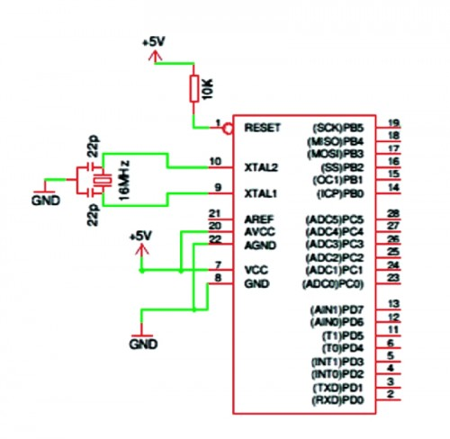
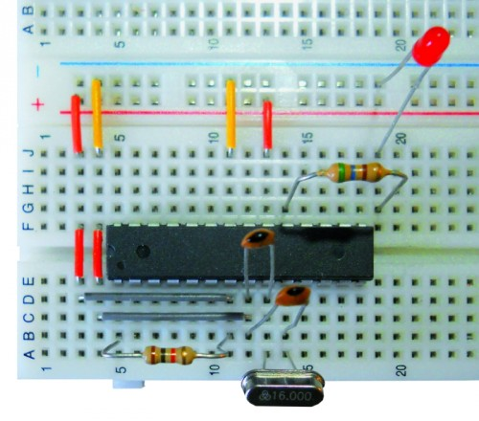
https://www.open-electronics.org/arduino-isp-in-system-programming-and-stand-alone-circuits/
Connect the appropriate pins to the display, and connect the TxD and RxD to your computer. You may either use an FTDI cable and connect to the serial monitor, or you may use two XBEE, one of them connected to your computer, and the other to the TxD and RxD pins.

Grading

Steps 1 and 2 40%
Step 3 10%
Step 4 +10% bonus
Steps 5 and 6 10%
Steps 7 and 8 15%
Step 9 15%
Step 10 10%

Submission

By the deadline you should upload the following to Blackboard:

1. A statement of which steps you completed and who you worked with
2. Your arduino C code
3. Your AVR assembly code
4. A picture showing your circuit working

You make work on this solo or in groups of two. If two, both members of the group should upload the solutions.

