SUMMARY: YOLO to identify books, Damage model identifies damage (yes/no), and HTML file displays which books are damaged; currently labeling more images and retraining model for better results & text identification.

Current Progress:
- Ran dataset of images through Yolo and cropped each image classified as a book
- Labeled each of these images as “damaged” or “not damaged” (or skipped if image wasn’t actually a book)
- Trained the model on these images and labels (put all data into a csv file and turned into a tensor object to train)
- Built an HTML file/script that shows the user which books are damaged and which aren’t.

User Workflow:
- User takes a picture of a bookshelf with multiple books (Fig.1)
- YOLO will identify individual books (Fig.2)
- The damage model will classify each as damaged or not
- The individual, cropped images of the books and their corresponding labels are displayed in the html file on a browser (Fig.3).
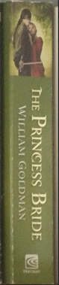
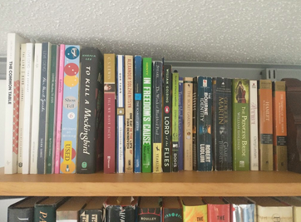
Figure 2: An example of a cropped image YOLO identified.

Figure 3: An example of what the html file looks like to the user. Note that damaged books have red text to highlight that they require care from the librarian.

Figure 1: An example of an image taken by a user.
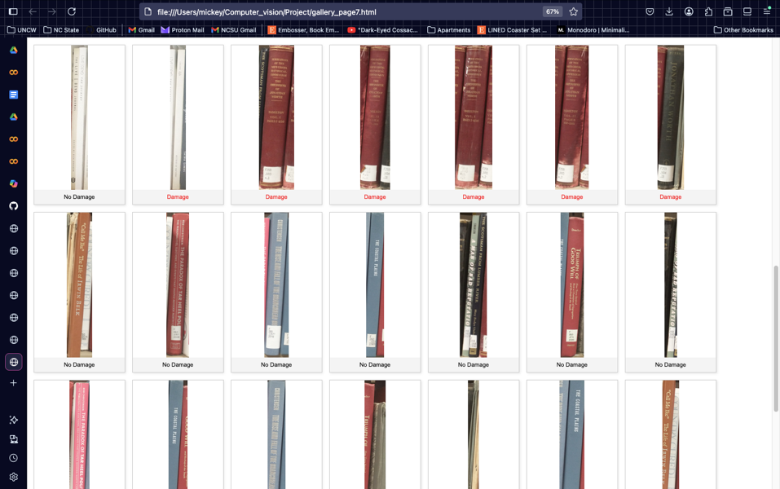
Proposed Scope Changes
- Dataset does not include images of the front cover of books.
  - The reasoning for this was that it would be better to build the original model with only one type of book (spine or front) to reduce potential confusion.
  - Because the idea behind this project is that a librarian could snap a picture of a shelf and get damage labels for all the books on the shelf, I chose to only do spines.
- I wanted to do text identification so that I could have the book title, author, and published year as info beneath each book in the HTML page. Yet, I’m having trouble finding a library that performs well on the data (or how I need to preprocess the data).
  - Pytesseract doesn’t perform well at all (both with original spine, rotated spine, or gaussian-blurred-canny-edges images), but I’ve heard of an Amazon model that does well identifying text, so I want to try that.
- I also wanted to plug in the GPT API to identify similar books for each, but I will not have time to do this because of the text-identification issue.
  - I definitely want to do this sometime, but it might not be for this project (I will have a lot of time this summer).
- Also, I wanted to make this a mobile app with Flask and have a SQL backend, but this will also have to be pushed to this summer due to time constraints.
  - I want to focus on strengthening my damage detection model and trying the text identification.

