Cataloguing a Library’s Book Damage with Computer Vision: Progress Report 1
SUMMARY: working on identifying cover damage with AI models
- Tried using Canny edges and contours to get book titles and see how rough the edges are, but I got stuck with how to identify individual books
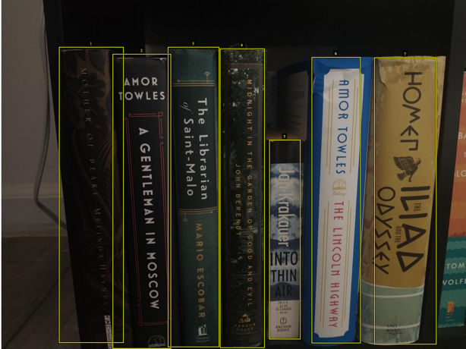
- Built a very tiny model with tensorflow that categorizes a book cover as “no damage” or “cover damage”.
Figure 1: Labeling each book as "no damage" or "cover damage" for my damage detection model.
  - While it is trained on images with bounding boxes around each book (Figure 1), it currently only identifies whether there is cover damage in the entire image.
- SO: I’m going to run YOLO over each image to identify individual books and then send each of those bounding boxes to my damage-detection model
  - YOLO does quite well without me having to train it on my own dataset (Figure 2)
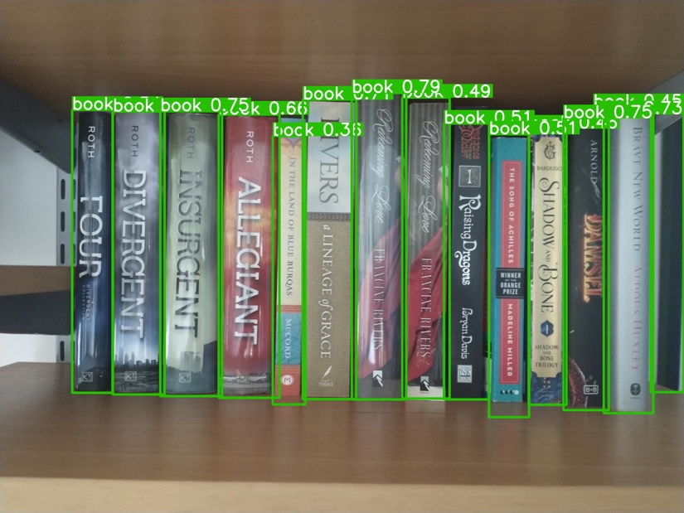
  - I will have to filter out any other identifications it makes (like people) just in case.
Figure 2: YOLO's result when passed the image. I did not do any additional training on YOLO and do not think I have to, since it seems to be doing pretty well.
- NEXT STEPS:
  - Train my damage detection model on more images
  - Feed YOLO books into damage detection model
  - Identify book titles and authors, add to database
  - Potentially plug in GPT for publish year and such for more info for database
  - Potentially make this into an app…maybe a summer thing

