**FreeSurfer Quality Control**

**Text in BLUE represent commands you need to type into terminal**

**Text in GREEN represent file names**

**Text in RED represent column names**

**STEP 1: Getting FreeSurfer started**

1. Open Terminal

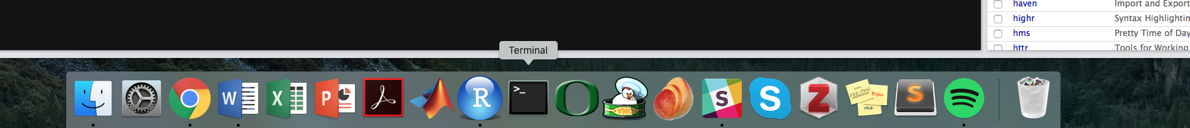

3. Load Freesurfer: export FREESURFER_HOME=/Applications/freesurfer

source $FREESURFER_HOME/SetUpFreeSurfer.sh

4. Open Freeview: freeview

* Note * If Freeview does not open, exit out of the server by typing exit Then log on again from scratch.

** If you ever need to quit out of a command that is running in terminal, type Control+C

*For further info on how to use Freeview:*

*https://surfer.nmr.mgh.harvard.edu/fswiki/FreeviewGuide/FreeviewGeneralUsage/FreeviewQuickStart*

**STEP 2: Quality control the raw T1 images**

6. Load the following volumes into freeview (File > Load Volume): orig.mgz, aparc+aseg.mgz

* You load the images by going into a participant’s “mri” folder, which is located in:

/gpfs/projects/dsnlab/tag/bids_data/derivatives/freesurfer6/sub-TAGXXX/mri

* orig.mgz is loaded as Grayscale
* aparc+aseg.mgz is loaded as Lookup Table

7. Scroll through the images and note where you see motion artefact in the Quality Control spreadsheet:

* Note the participant’s ID.
* Note if any motion is present in column titled motion_present options: yes/no
* Note overall motion severity: motion_severity options: 1 - none; 2 - some; 3 - severe
* Note where the motion is located: where_motion options: number of parcel in aparc+aseg.mgz
  + You can note the motion location by toggling the opacity of the aparc+aseg.mgz volume and clicking on the location of the motion. Look down at the bottom of freeview to see the number of the parcel as it corresponds to aparc+aseg.mgz (for example, here it is 1022).

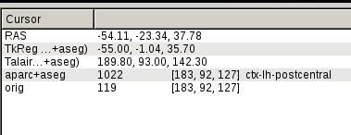

8. Write any notes in the notes column and provide your initials in the rater_initials column.

**STEP 3: Quality control the FreeSurfer processed images**

9. After checking all the images for motion, now let’s return to checking the cortical reconstruction. Load the following volumes into freeview: brainmask.mgz; aparc+aseg.mgz

* You load the image the same way as you loaded the participant’s other volumes from the previous steps.
* brainmask.mgz is loaded as Grayscale
* aparc+aseg.mgz is loaded as Lookup Table

10. Now, load the participants white and pial surfaces.

* You load these surfaces by going into the participant’s “surf” folder (rather than the participant’s “mri” folder).
* File > Load Surface >
* Load lh.pial; lh.white; rh.pial; rh.white
* Use Control to select more than one surface at a time.
* You can change the colors if it is helpful.

11. Now, toggle off the pial surfaces and aparc+aseg.mgz volume so that only the white surfaces are visible on the brainmask.mgz volume:

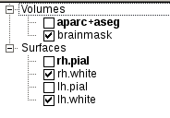

12. Scroll through the images and note where the white surface does not seem to follow the boundary between the white matter and the grey matter. You can toggle the surfaces on and off to

* Note the overall rating of the correspondence (how well the surface follows the boundary) in the column titled white_surface options: 1 - perfect; 2 - okay; 3 - bad
* Note the location of the issues where the white matter surface does not correspond with the boundary in the column titled where_white_surface (it may help to toggle on the aparc+aseg.mgz volume) options: number of parcel in aparc+aseg.mgz

13. Now, toggle off the white surfaces and aparc+aseg.mgz volume so that only the pial surfaces are visible on the brainmask.mgz volume.

14. Scroll through the images and note where the pial surface does not seem to follow the boundary between the grey matter and the pia mater. You can toggle the surfaces on and off to

* Note the overall rating of the correspondence (how well the surface follows the boundary) in the column titled pial_surface options: 1 - perfect; 2 - okay; 3 - bad
* Note the location of the issues where the pial surface does not correspond with the boundary in the column titled where_pial_surface options: number of parcel in aparc+aseg.mgz

15. Write any notes in the notes column and provide your initials in the rater_initials column.

*Additional info on QCing on the FreeSurfer Wiki: https://surfer.nmr.mgh.harvard.edu/fswiki/Edits*