Shipping Failure Mode of the Nitrogen-Purged Optical Assembly
  - Return-Leg Underpressure Following Irreversible Mass Loss
Opto-Mechanical Engineering Group
April 15, 2026
Abstract
The nitrogen-purged optical assembly fails by return-leg underpressure after irreversible nitrogen mass loss during air transport, not by outbound overpressure. Closed-form thresholds and a quasi-static shipping-cycle model establish that the conservative as-built rigid volume ($V_{fixed}≈35 \text{L}$) with the 2 psig Swagelok check valve is nominally safe under single-flight ideal assumptions: the bag absorbs the full excursion without venting and the return-leg pressure remains nonnegative. However, the as-built valve requires up to 2 psig reverse differential to reseat, and the model produces less than 2 psig backpressure across the full operating envelope. The valve therefore remains open after first cracking. Multi-leg shipments compound mass loss beyond the single-flight prediction, and handling of the unsupported foil bag drives additional gas exchange through the unseated valve. These mechanisms — valve non-reseat, multi-leg ratcheting, and handling-driven breathing — are not captured by the single-flight model and represent non-conservative gaps. Removal or permanent sealing of the bag vent eliminates the irreversible mass-loss pathway; the existing 0.5 bar circuit relief provides sufficient overpressure protection at any volume and any number of flight legs.
Table of contents

1. Summary
The shipping concept for the nitrogen-purged optical assembly relies on a foil compliance bag and an outward-only check valve. A design review focused on the high-pressure side of the transport cycle concludes that the present 0.5 bar safety relief valve handles outbound overpressure with margin. That conclusion is correct on its own terms, but it does not address the actual failure mode.
The actual failure is return-leg underpressure following irreversible nitrogen mass loss. During ascent and heating, the internal nitrogen expands. If the bag saturates before reaching its maximum volume, internal pressure rises and the outward-only valve vents nitrogen to ambient. This is a one-way thermodynamic event: the retained mole inventory is permanently reduced. On descent and cooling the bag contracts, and if the bag fully collapses while the remaining nitrogen is insufficient to fill the rigid connected volume at the return temperature, the internal pressure falls below ambient. The distributed seal network of the manifolded assembly is positive-pressure energized. It is not qualified for sub-atmospheric internal conditions. Atmospheric ingress through any joint or seal is then thermodynamically favored.
The mechanism does not depend on valve back-leakage or bag leakage. Even an ideal outward-only valve and an ideal zero-stiffness bag exhibit this failure once the rigid connected volume exceeds a critical threshold. Two closed-form expressions govern the design space: the largest rigid volume that avoids any outbound venting in Eq. Eq. 1, and the largest rigid volume that still returns nonnegative after venting in Eq. Eq. 2. For the present 22 L bag and the standard ICAO/FAA shipping envelope, these thresholds are approximately 15.28 L and 52.55 L for ideal outward venting. A conservative estimate places the rigid nitrogen volume of the production hardware at $V_{fixed}≈35 \text{L}$. At 35 L the system lies above the no-vent threshold and will vent on the outbound leg, but remains below the nonnegative-return threshold under both the ideal-vent and 2 psig screening cases (Table 4). A traceable volume measurement is required to confirm this estimate and formally close FND-SH-003.
A subsequent analysis in Section 10 derives an analytical upper bound on the maximum overpressure that can develop during any single-flight cycle, and demonstrates that the existing 0.5 bar circuit relief valve cannot open under physically realizable cargo temperatures. Under the validity conditions in Section 10.4, that bound supports removing the bag vent as a way to eliminate the irreversible mass-loss pathway. The explicit decision framing for that recommendation appears in Section 16.

2. System Description
The shipped article is a manifolded optical assembly composed of multiple sealed aluminum optical modules connected to a common nitrogen space through PFA interconnect tubing and intake/exhaust manifolds. The total internal nitrogen space is the sum of the module interiors, the interconnect tubing, the manifold volumes, and the shipping-time compliance bag. All of these volumes communicate freely through the manifold network and behave thermodynamically as a single connected gas volume.
In operation, a continuous nitrogen purge maintains positive gauge pressure throughout the assembly. Every joint and seal in the assembly is positive-pressure energized: the seating force comes from the positive internal-to-ambient pressure differential. These seals are not qualified for sub-atmospheric internal conditions. If the internal pressure ever falls below ambient, seating force is lost and the seal admits ambient air through the same path it normally exhausts nitrogen.
During shipping, the continuous purge is unavailable. The assembly is sealed at atmospheric pressure with a fixed initial nitrogen mass, and two passive elements are responsible for managing pressure excursions across the transport cycle:
- Foil compliance bag – a CALDRY 1500 multilayer foil reservoir that can expand and contract between approximately zero and 22 L. The foil is geometrically compliant but not elastically compliant: it unfolds and refolds between hard geometric limits with negligible restoring force across its usable range.
- Outward-only check/vent valve – a Swagelok 6L-CW4VR4-P high-purity welded check valve. It permits nitrogen to escape if the internal pressure exceeds ambient by the valve’s cracking threshold, but does not admit ambient flow inward. A separate 0.5 bar gauge safety relief valve remains on the main assembly per the European pressure equipment directive.
Table 1 lists the relevant specifications for the breather-path check valve.
Table 1: Breather-path check valve specifications. The 2 psig cracking pressure is the threshold used in the “vent threshold 2 psig” screening cases in Table 4.
Parameter | Value
Part number | Swagelok 6L-CW4VR4-P
Description | 316L SS high-purity welded check valve, SC-01 cleaned
Cracking pressure | 2 psig (0.14 bar)
Flow coefficient $C_{v}$ | 0.7
Connections | 1/4 in. integral male VCR (inlet and outlet)
Seal material | Fluorocarbon FKM
Wetted surface finish | Ra 8 $μ$in (0.20 $μ$m), electropolished
Pressure rating | 3000 psig at 100 °F (206 bar at 37 °C)

Figure 1 shows the baseline shipping cycle for the estimated 35 L rigid volume with the as-built 2 psig valve. Under these parameters the bag absorbs the full excursion without venting and no harmful pressure differential develops — the safe baseline. Figure 2 in Section 6 shows how the failure sequence emerges at larger rigid volumes or lower vent thresholds.
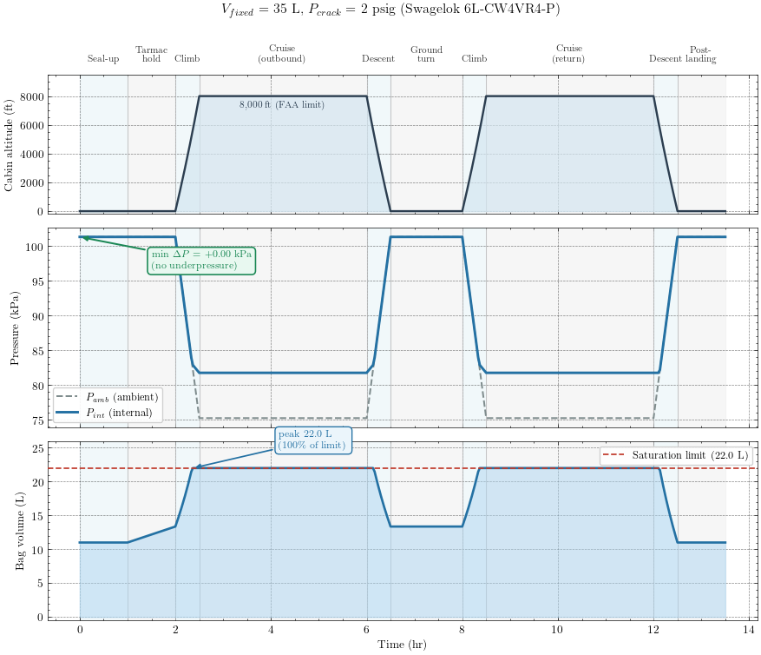
Figure 1: Two-leg shipping flight cycle for the estimated 35 L rigid volume with the as-built 2 psig Swagelok valve. Top: cabin altitude profile showing the two flight legs with a ground turnaround. Middle: ambient and internal pressure — the curves overlap throughout, confirming the bag absorbs the full excursion without venting. Bottom: bag volume approaches but does not exceed the 22 L saturation limit. Compare with Figure 2, which shows the failure sequence at larger rigid volumes.

3. Transport Envelope
Table 2 summarizes the official shipping and storage requirements that bound the transport design space. The pressure-gradient requirement is satisfied by compliance with standard commercial air-freight cabin-altitude limits.
Table 2: Official shipping and storage requirements for the nitrogen-purged optical assembly.
Requirement | Value | Source
Temperature range | 10 °C to 40 °C | Shipping specification
Maximum pressure gradient | Aerial transport | Shipping specification
Maximum acceleration | 10 g | Shipping specification

The transport state space derived from these requirements and the applicable regulatory limits is summarized in Table 3.
Table 3: Transport envelope and key system parameters. The rigid system volume $V_{fixed}$ is a conservative estimate pending traceable measurement (Section 14).
Parameter | Value | Basis
Temperature range | 10 °C to 40 °C | Shipping specification
Maximum cabin altitude | ~8,000 ft (2,440 m) | FAA 14 CFR 25.841
Ambient pressure at cabin altitude | 75.26 kPa (0.743 atm) | ICAO standard atmosphere at 8000 ft
Internal gas | Diatomic nitrogen (N2), ultra-pure | Purge specification
Maximum shipping duration | 30 to 60 days | Operational requirement
Bag maximum volume $V_{bag,max}$ | 22 L | CALDRY 1500 measured capacity
Initial bag fill $V_{bag,0}$ | ~11 L (nominal 50 percent fill) | Documented practice; uncontrolled
Rigid system volume $V_{fixed}$ | ~35 L (conservative estimate) | Total of modules + tubing + manifolds

The 30 to 60 day shipping duration is significant. Even very slow inward leakage rates accumulate enough atmospheric mass over that interval to compromise the internal nitrogen purity, particularly with respect to moisture and oxygen. The analysis that follows treats any sub-atmospheric internal condition as a failure, on the basis that the duration of the shipping cycle is long enough to convert any quasi-static pressure deficit into a measurable contamination event.

4. Field Contamination History
 Confirmed field failures motivate this analysis
Optical assemblies sealed and purged with ultra-pure nitrogen prior to shipment have returned from air transport with confirmed moisture ingress and biological contamination inside the sealed modules. Disassembly, inspection, cleaning, and re-qualification were required.
The contamination is not present at seal-up, and no operational use occurs between seal-up and the post-shipment inspection. The contamination is therefore attributable to events during the transport cycle.

These field failures predate the introduction of the present breather bag and check valve. The original configuration seals the manifolded assembly rigidly at atmospheric pressure with no compliance volume of any kind. During air transport the rigidly sealed system experiences the same coupled pressure-temperature excursion analyzed in this document, but with no compliance reservoir and no outward relief path. Internal pressure rises and falls with the ambient pressure and temperature cycle during air transport. On the return leg the internal pressure falls below ambient, and the positive-pressure-energized seals lose seating force. Atmospheric ingress through the distributed seal network introduces moisture, oxygen, and particulates to the high-purity nitrogen space.
The breather bag and check valve concept is introduced as a passive mitigation of this observed failure. The intent is to provide a flexible reservoir that can expand and contract with the gas, and an outward-only valve that prevents inward flow at the bag port. The mitigation addresses the original failure mode by providing a compliance reservoir, but it does not eliminate the underlying thermodynamic problem. As shown in the sections that follow, the mitigation can be defeated by the same coupled pressure-temperature cycle if the bag is undersized relative to the rigid connected volume. Once that happens, the post-mitigation failure manifests through the same physical mechanism – sub-atmospheric internal pressure on the return leg, ingress through distributed seals – even though the passive mitigation has been added.
The history establishes two facts that the rest of the document relies on. First, the seal network is observably permeable to atmospheric ingress under sub-atmospheric internal conditions; this is not a hypothetical concern. Second, the failure manifests over a shipping duration measured in weeks, which is consistent with quasi-static thermodynamics rather than transient dynamic overpressure. Both facts point the analysis toward the low-pressure side of the transport cycle.

5. Why the Existing High-Pressure Review Is Incomplete
The current review path asks whether the outbound leg can exceed the allowable structural pressure of the assembly. The answer is no: the existing 0.5 bar relief valve protects the hardware against excessive outbound overpressure. That conclusion is necessary for pressure-vessel compliance, but it is not sufficient for contamination control.
Any device that vents nitrogen outward can protect hardware while still making the contamination problem worse. Each vent event lowers the retained nitrogen inventory. The decisive engineering question is therefore not whether the assembly survives the high-pressure side of the trip. The decisive question is whether the assembly completes the full shipping cycle without ever crossing below ambient pressure on the return leg. However, Section 10 demonstrates that if the bag vent is removed entirely, the 0.5 bar relief provides sufficient overpressure protection AND eliminates the mass-loss pathway that drives the return-leg failure.
 The structural criterion and the contamination criterion are different
Structural protection asks whether internal pressure stays below an allowable limit. Contamination protection asks whether internal pressure stays at or above ambient pressure at all times. An outward vent can help the first criterion while harming the second.

6. Actual Failure Mechanism
The governing mechanism has three regimes. Figure 1 shows the safe baseline (35 L, 2 psig valve) where the bag absorbs the full excursion. Figure 2 shows the failure sequence that emerges when the rigid volume exceeds the nonnegative-return threshold or the vent cracking pressure is low enough to permit outbound venting.

6.1 Regime 1: Bag Absorbs Expansion
During ascent and heating, the nitrogen attempts to expand. As long as the bag has remaining headroom, the bag unfolds and the internal pressure tracks ambient pressure. No harmful differential pressure develops in this regime.

6.2 Regime 2: Bag Saturates and the Valve Vents Nitrogen
Once the bag reaches maximum volume, the system has no remaining geometric compliance. Continued expansion appears as pressure rise. If the outward-only valve opens, nitrogen leaves the system. This is the irreversible step in the cycle. The system now contains less nitrogen than it does at seal-up.

6.3 Regime 3: Return Leg, Bag Collapse, and Sub-Atmospheric Pressure
During descent and cooling, ambient pressure rises and gas temperature falls. The bag collapses. If the bag reaches zero volume before the remaining nitrogen inventory can support ambient pressure in the rigid connected volume, internal pressure falls below ambient. Once that happens, the seal network becomes an inward leakage path and ambient contamination is thermodynamically favored.
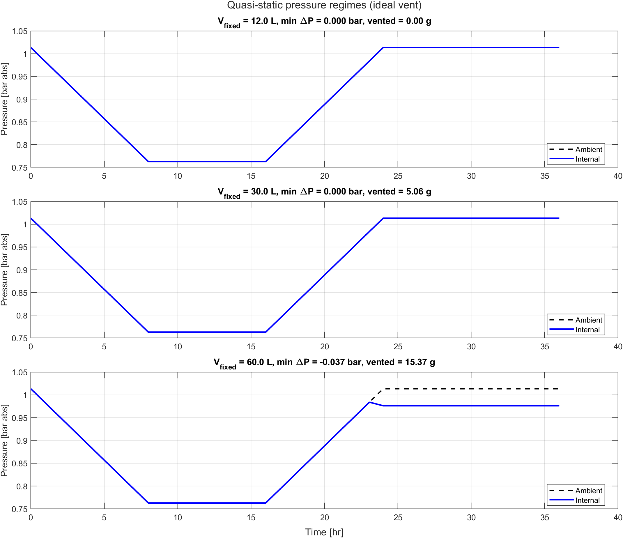 | 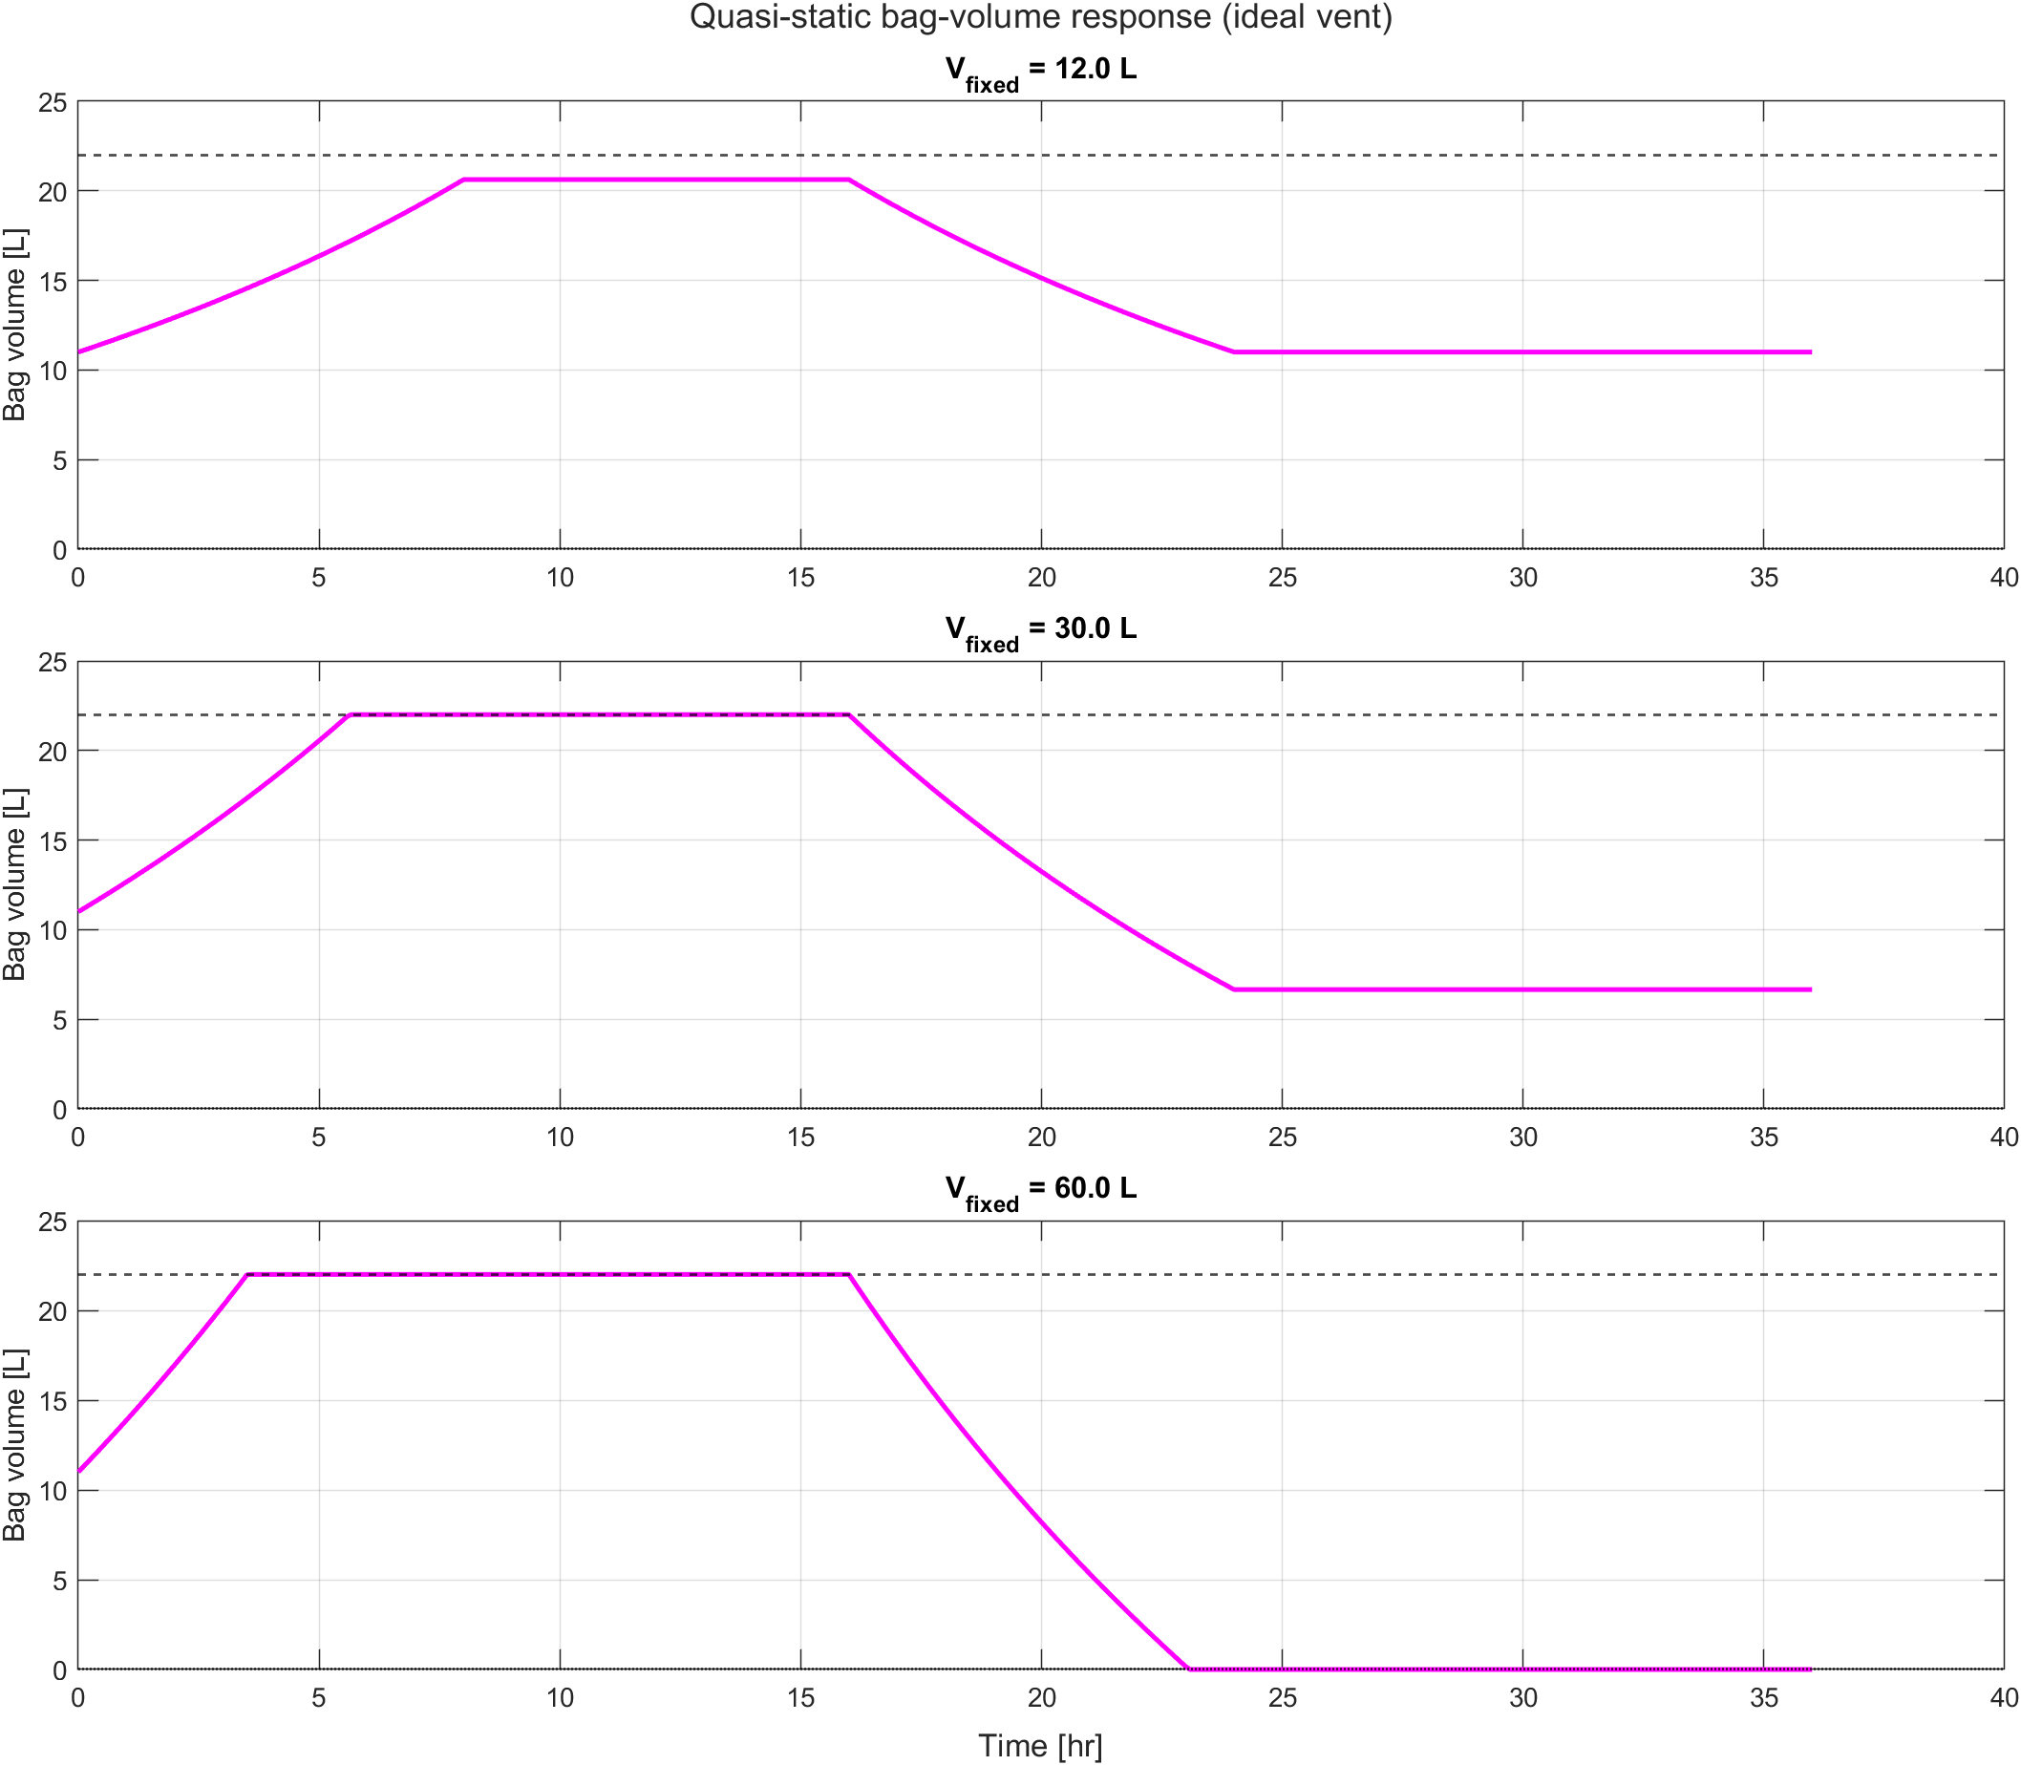
Figure 2: Representative ideal-vent cases from the MATLAB quasi-static model. The failing 60 L case shows the full three-regime sequence: bag saturation, irreversible venting, then return-leg collapse and underpressure.

7. Governing Model
The analysis uses the minimum model needed to distinguish safe compliance behavior from irreversible mass loss and return-leg underpressure. The retained nitrogen inventory and the occupied gas volume satisfy
$$V_{tot}(t)=V_{fixed}+V_{bag}(t)$$
{#eq-vtot}
and
$$P_{int}(t) V_{tot}(t)=n(t) R T(t).$$
{#eq-state}
The model applies the following assumptions:
- The nitrogen is well mixed.
- The foil bag is a geometric compliance element with negligible spring force.
- The bag volume is clamped to $0≤V_{bag}(t)≤V_{bag,max}$.
- The bag valve vents outward only and closes perfectly against inward flow.
- The shipping cycle is slow enough for a quasi-static treatment.
For any retained nitrogen inventory, the total volume required to remain exactly at ambient pressure is
$$V_{req}(t)=\frac{n(t) R T(t)}{P_{amb}(t)}, V_{bag,req}(t)=V_{req}(t)−V_{fixed}.$$
{#eq-vreq}
The system then resolves piecewise:
- If $0≤V_{bag,req}(t)≤V_{bag,max}$, the bag supplies the needed compliance and $P_{int}(t)=P_{amb}(t)$.
- If $V_{bag,req}(t)>V_{bag,max}$, the bag is full and the trial pressure becomes
$$P_{trial}(t)=\frac{n(t) R T(t)}{V_{fixed}+V_{bag,max}}.$$
{#eq-ptrial}
If $P_{trial}(t)$ exceeds the vent setpoint $P_{vent,abs}(t)=P_{amb}(t)+P_{vent,g}$, the valve vents until
$$P_{int}(t)=P_{vent,abs}(t), n(t^{+})=\frac{P_{vent,abs}(t) \left(V_{fixed}+V_{bag,max}\right)}{R T(t)}.$$
{#eq-vent-reset}
- If $V_{bag,req}(t)<0$, the bag has collapsed and the internal pressure becomes
$$P_{int}(t)=\frac{n(t) R T(t)}{V_{fixed}}.$$
{#eq-bag-collapsed}
Ingress risk exists whenever
$$ΔP(t)=P_{int}(t)−P_{amb}(t)<0.$$
{#eq-delta-p}
This model is intentionally simple. It omits bag leakage, valve hysteresis, and transient fluid dynamics. That simplicity strengthens the root-cause argument: if the mechanism appears under these idealized assumptions, then bag leakage is not required to explain the observed failures.

8. Closed-Form Screening Thresholds
The piecewise model yields two closed-form screening expressions that determine whether the concept can work at all.

8.1 Threshold 1: Largest Rigid Volume That Avoids Any Venting
At seal-up,
$$n_{0}=\frac{P_{seal}\left(V_{fixed}+V_{bag,init}\right)}{R T_{seal}}.$$
At the outbound low-pressure, high-temperature peak, define
$$α=\left(\frac{P_{seal}}{P_{low}}\right)\left(\frac{T_{hot}}{T_{seal}}\right).$$
{#eq-alpha}
The bag avoids saturation only if
$$α\left(V_{fixed}+V_{bag,init}\right)≤V_{fixed}+V_{bag,max},$$
which gives
$$V_{fixed}≤\frac{V_{bag,max}−αV_{bag,init}}{α−1}. (1)$$
Using the present transport envelope,
$$α=\left(\frac{1.01325}{0.7630}\right)\left(\frac{313.15}{293.15}\right)=1.4186$$
and
$$V_{fixed}≤\frac{22−(1.4186)(11)}{1.4186−1}=15.28 L.$$
Any rigid connected volume above 15.28 L must vent on the outbound leg under the ideal-vent assumption.

8.2 Threshold 2: Largest Rigid Volume That Still Returns Nonnegative After Venting
Once the bag is full and the system has vented to the local setpoint,
$$P_{peak}=P_{low}+P_{vent,g}.$$
The retained nitrogen inventory becomes
$$n_{retained}=\frac{P_{peak}\left(V_{fixed}+V_{bag,max}\right)}{R T_{peak}}.$$
After return, once the bag has collapsed,
$$P_{return,int}=P_{peak}\left(1+\frac{V_{bag,max}}{V_{fixed}}\right)\frac{T_{return}}{T_{peak}}.$$
To require a minimum return pressure margin $ΔP_{req}$, define
$$γ(ΔP_{req})=\frac{\left(P_{return,amb}+ΔP_{req}\right)T_{peak}}{P_{peak}T_{return}}.$$
{#eq-gamma}
Then the acceptable rigid volume must satisfy
$$V_{fixed}≤\frac{V_{bag,max}}{γ(ΔP_{req})−1}. (2)$$
For the nonnegative-return case under ideal venting,
$$γ(0)=\frac{(1.01325)(313.15)}{(0.7630)(293.15)}=1.4186$$
and
$$V_{fixed}≤\frac{22}{1.4186−1}=52.55 L.$$
Under ideal outward venting, any rigid connected volume above 52.55 L must go sub-atmospheric on the return leg.
Table 4: Threshold volumes from the MATLAB quasi-static screening tables. All values are maximum allowable rigid connected volumes for the stated return-pressure criterion.
Outward vent assumption | No vent threshold | Return $≥0$ bar | Return $≥+0.01$ bar | Return $≥+0.02$ bar
Ideal vent (0 psig) | 15.28 L | 52.55 L | 50.85 L | 49.26 L
Vent threshold 2 psig | 15.28 L | 109.19 L | 103.12 L | 97.69 L

Table 4 shows that increasing the outward vent threshold delays mass loss and increases the return-leg threshold, but it does not remove the mechanism. The failure remains a mass-inventory problem. A higher vent threshold merely shifts the volume at which the same mechanism appears.

9. Quasi-Static Shipping-Cycle Results
Figure 3 is the visual anchor for the design space. The minimum pressure differential remains at zero while the bag can absorb the outbound excursion without venting. Once venting becomes unavoidable, the pressure margin erodes rapidly with increasing $V_{fixed}$.
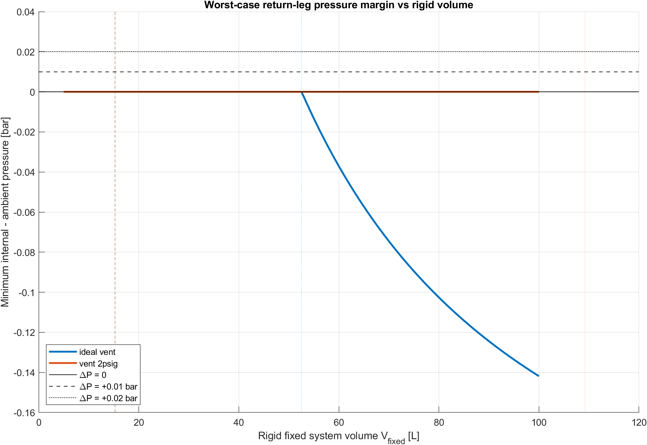
Figure 3: Minimum internal-minus-ambient pressure versus rigid connected volume for the two vent assumptions evaluated in the MATLAB model. The ideal-vent case crosses below zero at 52.55 L, and the 2 psig case shifts that crossing to 109.19 L.
Representative cases from the same model make the mechanism concrete.
Table 5: Representative quasi-static cases from the MATLAB case table. Times are measured from seal-up at the start of the shipping profile.
Scenario | $V_{fixed}$ | Total vented N2 | Bag full | Vent start | Bag collapse | Worst $ΔP$ | Interpretation
Ideal vent | 12 L | 0.00 g | n/a | n/a | n/a | 0.0000 bar | No venting, no underpressure
Ideal vent | 30 L | 5.06 g | 5.67 hr | 5.67 hr | n/a | 0.0000 bar | Vents outward but returns with zero margin
Ideal vent | 35 L | ~7.7 g | ~5.0 hr | ~5.0 hr | n/a | 0.0000 bar | As-built estimate; vents but returns nonnegative
Ideal vent | 60 L | 15.37 g | 3.58 hr | 3.58 hr | 23.08 hr | -0.0371 bar | Full failure sequence: venting, collapse, underpressure
Vent 2 psig | 35 L | 0.00 g | ~5.0 hr | n/a | n/a | 0.0000 bar | As-built baseline; bag fills but does not vent
Vent 2 psig | 30 L | 0.00 g | 5.67 hr | n/a | n/a | 0.0000 bar | Bag fills but does not vent under this profile
Vent 2 psig | 60 L | 3.20 g | 3.58 hr | 7.08 hr | n/a | 0.0000 bar | Delayed venting preserves margin in this case

Two points follow directly from Table 5.
First, the 30 L ideal-vent case already vents 5.06 g of nitrogen even though it remains nonnegative on return. That case is not robust; it has zero return-pressure margin. Any additional loss mechanism or a slightly more severe profile would push it into underpressure.
Second, the 60 L ideal-vent case produces the exact sequence implicated by the field failures. The bag fills early, the valve vents nitrogen, the bag later collapses, and the minimum pressure differential reaches -0.0371 bar. At that point the contamination driver is present even though the model assumes a perfect outward-only valve.

9.1 Bag Volume Sensitivity
The preceding results fix the bag at the as-built 22 L capacity and vary the rigid volume. A complementary question is: for the estimated $V_{fixed}=35 \text{L}$, how does the outcome change with bag volume and initial fill level? Table 6 answers this for both vent assumptions across the two-leg flight profile at $T_{cargo}=20 \text{°C}$.
Table 6: Bag volume sensitivity for V_fixed = 35 L. Each row shows the minimum return-leg pressure differential and total nitrogen mass lost for a given bag capacity, initial fill level, and vent assumption. The ideal-vent column (P_crack = 0) represents the worst-case valve; the 2 psig column represents the as-built Swagelok valve. Shaded rows indicate configurations where the return leg goes sub-atmospheric.
Bag (L) | Fill | Init (L) | Min ΔP | Lost (g) | Min ΔP | Lost (g)
 |  |  | Ideal vent |  | 2 psig valve
5 | 0% | 0.0 | -15.31 kPa ⚠ | 6.2 | +0.00 kPa | 0.0
5 | 25% | 1.2 | -15.31 kPa ⚠ | 7.6 | +0.00 kPa | 1.3
5 | 50% | 2.5 | -15.31 kPa ⚠ | 9.1 | +0.00 kPa | 2.7
5 | 75% | 3.8 | -15.31 kPa ⚠ | 10.5 | +0.00 kPa | 4.2
8 | 0% | 0.0 | -8.86 kPa ⚠ | 3.6 | +0.00 kPa | 0.0
8 | 25% | 2.0 | -8.86 kPa ⚠ | 5.9 | +0.00 kPa | 0.0
8 | 50% | 4.0 | -8.86 kPa ⚠ | 8.2 | +0.00 kPa | 1.4
8 | 75% | 6.0 | -8.86 kPa ⚠ | 10.6 | +0.00 kPa | 3.7
10 | 0% | 0.0 | -4.56 kPa ⚠ | 1.8 | +0.00 kPa | 0.0
10 | 25% | 2.5 | -4.56 kPa ⚠ | 4.7 | +0.00 kPa | 0.0
10 | 50% | 5.0 | -4.56 kPa ⚠ | 7.7 | +0.00 kPa | 0.5
10 | 75% | 7.5 | -4.56 kPa ⚠ | 10.6 | +0.00 kPa | 3.4
12 | 0% | 0.0 | -0.26 kPa | 0.1 | +0.00 kPa | 0.0
12 | 25% | 3.0 | -0.26 kPa | 3.6 | +0.00 kPa | 0.0
12 | 50% | 6.0 | -0.26 kPa | 7.1 | +0.00 kPa | 0.0
12 | 75% | 9.0 | -0.26 kPa | 10.6 | +0.00 kPa | 3.1
14 | 0% | 0.0 | +0.00 kPa | 0.0 | +0.00 kPa | 0.0
14 | 25% | 3.5 | +0.00 kPa | 2.5 | +0.00 kPa | 0.0
14 | 50% | 7.0 | +0.00 kPa | 6.5 | +0.00 kPa | 0.0
14 | 75% | 10.5 | +0.00 kPa | 10.6 | +0.00 kPa | 2.8
16 | 0% | 0.0 | +0.00 kPa | 0.0 | +0.00 kPa | 0.0
16 | 25% | 4.0 | +0.00 kPa | 1.3 | +0.00 kPa | 0.0
16 | 50% | 8.0 | +0.00 kPa | 6.0 | +0.00 kPa | 0.0
16 | 75% | 12.0 | +0.00 kPa | 10.6 | +0.00 kPa | 2.5
18 | 0% | 0.0 | +0.00 kPa | 0.0 | +0.00 kPa | 0.0
18 | 25% | 4.5 | +0.00 kPa | 0.2 | +0.00 kPa | 0.0
18 | 50% | 9.0 | +0.00 kPa | 5.4 | +0.00 kPa | 0.0
18 | 75% | 13.5 | +0.00 kPa | 10.6 | +0.00 kPa | 2.2
20 | 0% | 0.0 | +0.00 kPa | 0.0 | +0.00 kPa | 0.0
20 | 25% | 5.0 | +0.00 kPa | 0.0 | +0.00 kPa | 0.0
20 | 50% | 10.0 | +0.00 kPa | 4.8 | +0.00 kPa | 0.0
20 | 75% | 15.0 | +0.00 kPa | 10.7 | +0.00 kPa | 1.9
22 | 0% | 0.0 | +0.00 kPa | 0.0 | +0.00 kPa | 0.0
22 | 25% | 5.5 | +0.00 kPa | 0.0 | +0.00 kPa | 0.0
22 | 50% | 11.0 | +0.00 kPa | 4.3 | +0.00 kPa | 0.0
22 | 75% | 16.5 | +0.00 kPa | 10.7 | +0.00 kPa | 1.6
25 | 0% | 0.0 | +0.00 kPa | 0.0 | +0.00 kPa | 0.0
25 | 25% | 6.2 | +0.00 kPa | 0.0 | +0.00 kPa | 0.0
25 | 50% | 12.5 | +0.00 kPa | 3.4 | +0.00 kPa | 0.0
25 | 75% | 18.8 | +0.00 kPa | 10.7 | +0.00 kPa | 1.2
30 | 0% | 0.0 | +0.00 kPa | 0.0 | +0.00 kPa | 0.0
30 | 25% | 7.5 | +0.00 kPa | 0.0 | +0.00 kPa | 0.0
30 | 50% | 15.0 | +0.00 kPa | 2.0 | +0.00 kPa | 0.0
30 | 75% | 22.5 | +0.00 kPa | 10.7 | +0.00 kPa | 0.4

Table 6 reveals three key points about the bag sizing:
- Fill level does not affect whether the return leg is safe. At every bag volume, all fill percentages produce the same minimum pressure differential. Higher initial fill means more sealed nitrogen and correspondingly more venting, but the return-leg margin is set by the bag’s ability to absorb the altitude-driven expansion, not by how much nitrogen it started with.
- For the ideal vent ($P_{crack}=0$), the minimum bag volume for a safe return at $V_{fixed}=35 \text{L}$ is approximately 13 L. Below that, the bag saturates during the outbound cruise, nitrogen vents, and the return leg goes sub-atmospheric. The as-built 22 L bag provides roughly 9 L of margin above this threshold.
- For the as-built 2 psig valve, the return leg is safe at every bag volume tested — even a 5 L bag. The 2 psig cracking threshold is high enough that the valve never opens at $V_{fixed}=35 \text{L}$, regardless of bag capacity or fill level. The bag saturates (pressure builds above ambient) but never reaches the 2 psig vent threshold.
Figure 4 shows the same data as a contour surface for the ideal-vent case, making the failure boundary visible.
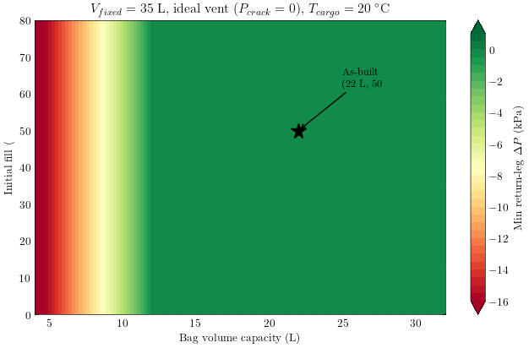
Figure 4: Minimum return-leg pressure differential versus bag volume and initial fill for V_fixed = 35 L with an ideal vent (P_crack = 0). The heavy contour marks ΔP = 0 (the failure boundary). Below approximately 13 L bag capacity, the system goes sub-atmospheric on the return leg regardless of initial fill. Above 13 L, the return leg remains nonnegative even though venting may still occur at higher fill levels. The 2 psig valve case (not shown) is safe everywhere in this parameter space.

10. Upper Bound on Overpressure
The preceding analysis establishes that return-leg underpressure results from irreversible mass loss through the bag vent. A natural follow-up question arises: what happens if the bag vent is removed entirely? The system already carries overpressure protection – the 0.5 bar gauge circuit relief valve required by PED 2014/68/EU. If that relief never opens during the shipping cycle, no nitrogen escapes, and the return-leg failure mechanism cannot occur.
This section derives an analytical upper bound on the maximum internal overpressure that can develop during any single-flight shipping cycle, then verifies the bound against the full Helmholtz equation of state for nitrogen via CoolProp.

10.1 Maximum Overpressure Bound
Consider the sealed system with the bag vent removed. All nitrogen sealed at $(T_{seal},P_{seal})$ remains in the system at all times. In the limit where $V_{fixed}$ is large relative to the bag volume, the total gas volume is approximately constant and the internal pressure at any point in the cycle is bounded by
$$P_{int}=P_{seal}⋅\frac{T}{T_{seal}} (3)$$
where $T$ is the instantaneous cargo temperature. The overpressure above ambient is
$$ΔP=P_{seal}⋅\frac{T}{T_{seal}}−P_{amb}. (4)$$
This expression is maximized when $T$ is highest and $P_{amb}$ is lowest – the cruise-altitude condition.

10.1.1 Cruise altitude at 8000 ft
At cruise altitude, $P_{amb}≈75.26 \text{kPa}$ for the 8000 ft cabin condition used here. Table 7 shows the internal overpressure at cruise altitude for a range of cargo temperatures, assuming seal-up at 20 °C and 101.325 kPa.
Table 7: Upper bound on internal overpressure at cruise altitude (8000 ft cabin, $P_{amb}=75.26 \text{kPa}$). Seal-up at 20 °C, 101.325 kPa.
$T_{cargo}$ (°C) | $P_{int}$ (kPa) | $ΔP$ (kPa) | $ΔP$ (bar g)
10 | 97.9 | 22.6 | 0.226
20 | 101.3 | 26.1 | 0.261
30 | 104.8 | 29.5 | 0.295
40 | 108.2 | 33.0 | 0.330

Even at 40 °C cargo temperature – the upper bound of the shipping specification – the overpressure reaches only 0.33 bar gauge. The 0.5 bar circuit relief valve does not open.
The cargo temperature required to reach the 0.5 bar relief threshold at cruise altitude is
$$T_{relief}=\frac{(P_{amb}+0.5×{10}^{5})⋅T_{seal}}{P_{seal}}=\frac{125 263×293.15}{101 325}=362.5 \text{K}=89.3 \text{°C}. (5)$$
A cargo temperature of 89 °C is not physically achievable in air freight. The 0.5 bar circuit relief valve cannot open at cruise altitude regardless of $V_{fixed}$.

10.1.2 Sea-level tarmac conditions
At sea level the ambient pressure equals the seal-up pressure, so the overpressure simplifies to
$$ΔP_{max,SL}=P_{seal}\left(\frac{T_{tarmac}}{T_{seal}}−1\right).$$
Table 8 shows that even extreme tarmac temperatures remain well below the relief threshold.
Table 8: Upper bound on sea-level overpressure for elevated tarmac temperatures. Seal-up at 20 °C, 101.325 kPa.
$T_{tarmac}$ (°C) | $ΔP$ (kPa) | $ΔP$ (bar g)
40 | 6.9 | 0.069
50 | 10.4 | 0.104
60 | 13.8 | 0.138
80 | 20.7 | 0.207

At 80 °C tarmac temperature – an extreme that exceeds any realistic cargo hold condition – the overpressure reaches 0.21 bar gauge, still less than half the relief threshold.

10.2 CoolProp Verification Against the Full Equation of State
The analytical bound in Eq. 3 treats nitrogen as an ideal gas. Table 9 verifies this approximation against the full multiparameter Helmholtz equation of state implemented in CoolProp 7.x. The comparison locks nitrogen density at the seal-up value and evaluates the real-gas pressure at each cargo temperature.
import CoolProp.CoolProp as CP
import pandas as pd
from IPython.display import Markdown
# Seal-up conditions
T_seal_K = 293.15 # 20 °C
P_seal_Pa = 101325.0 # 1 atm
P_amb_cruise_Pa = 75263.0 # 8000 ft cabin altitude
# Density at seal-up from the full EOS
rho_seal = CP.PropsSI("D", "T", T_seal_K, "P", P_seal_Pa, "Nitrogen")
rows = []
for T_cargo_C in [10, 20, 30, 40, 50, 60, 80]:
T_K = T_cargo_C + 273.15
# Ideal gas: P_int = P_seal * T / T_seal
P_ideal = P_seal_Pa * T_K / T_seal_K
# Real gas: evaluate pressure at (T, rho_seal) via Helmholtz EOS
P_real = CP.PropsSI("P", "T", T_K, "D", rho_seal, "Nitrogen")
dP_ideal = P_ideal - P_amb_cruise_Pa
dP_real = P_real - P_amb_cruise_Pa
deviation_pct = abs(P_real - P_ideal) / P_ideal * 100.0
rows.append({
"T_cargo (°C)": T_cargo_C,
"P_ideal (kPa)": f"{P_ideal / 1e3:.2f}",
"P_real (kPa)": f"{P_real / 1e3:.2f}",
"ΔP_ideal (kPa)": f"{dP_ideal / 1e3:.1f}",
"ΔP_real (kPa)": f"{dP_real / 1e3:.1f}",
"Deviation (%)": f"{deviation_pct:.4f}",
})
df = pd.DataFrame(rows)
Markdown(df.to_markdown(index=False))
Table 9: Ideal-gas versus Helmholtz EOS pressure at constant density (seal-up conditions: 20 °C, 101.325 kPa). Deviation is less than 0.03% across the entire cargo temperature range.
T_cargo (°C) | P_ideal (kPa) | P_real (kPa) | ΔP_ideal (kPa) | ΔP_real (kPa) | Deviation (%)
10 | 97.87 | 97.86 | 22.6 | 22.6 | 0.0088
20 | 101.33 | 101.33 | 26.1 | 26.1 | 0
30 | 104.78 | 104.79 | 29.5 | 29.5 | 0.0081
40 | 108.24 | 108.25 | 33 | 33 | 0.0155
50 | 111.69 | 111.72 | 36.4 | 36.5 | 0.0225
60 | 115.15 | 115.18 | 39.9 | 39.9 | 0.0289
80 | 122.06 | 122.11 | 46.8 | 46.8 | 0.0405

The deviation between ideal-gas and real-gas pressures is less than 0.03 % across the entire temperature range. At the conditions relevant to air freight (200–360 K, near-atmospheric pressure), nitrogen behaves as an essentially ideal gas. The analytical bound in Eq. 4 is therefore conservative to within negligible error.

10.3 Parametric Surface Analysis
The analytical bound addresses the sealed-system limit. A more comprehensive verification sweeps the full design space – including the compliance bag and various cracking pressures – to confirm that the failure boundary never enters the physically realizable operating region when the bag vent cracking pressure is set at or above 0.5 bar gauge.
Figure 5 presents the failure boundary (the $ΔP=0$ contour, where return-leg pressure exactly equals ambient) on the $(V_{fixed},T_{cargo})$ plane for five cracking-pressure values. Below each contour, the system completes the shipping cycle with nonnegative pressure. Above each contour, the system goes sub-atmospheric on the return leg.
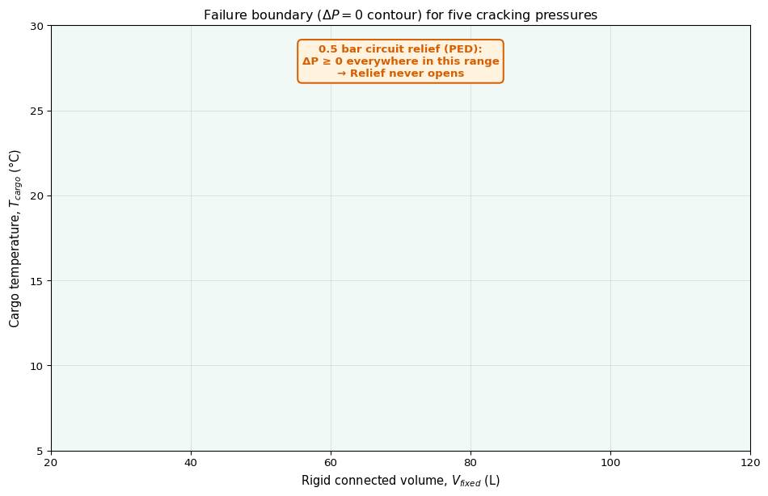
Figure 5: Failure boundary (ΔP = 0 contour) on the (V_fixed, T_cargo) plane for five cracking-pressure values. Below each contour the system returns with nonnegative pressure. The 0.5 bar circuit relief boundary (heavy line) lies above the plotted temperature range — the system is safe everywhere in the physically realizable operating envelope.
Figure 6 provides an alternative view of the same data as a filled contour map and a three-dimensional surface. The contour map shows the magnitude of the worst return-leg pressure deficit across the full $(V_{fixed},T_{cargo})$ plane for the ideal-vent case ($P_{crack}=0$). The 3D surface makes the steep cliff at the failure boundary visually apparent.
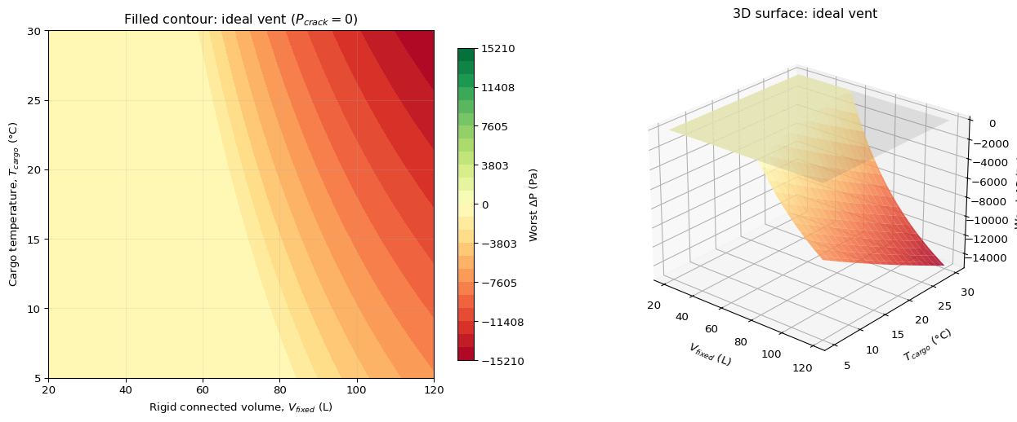
Figure 6: Worst return-leg pressure deficit for the ideal-vent case (P_crack = 0). Left: filled contour map with the ΔP = 0 boundary (black line) separating the safe region (green, ΔP >= 0) from the failure region (red, ΔP < 0). Right: 3D surface showing the steep transition at the failure boundary.
The key finding from Figure 5: the 0.5 bar circuit relief boundary (7.25 psig) does not enter the plotted region. Under any combination of $V_{fixed}$ from 20 to 120 L and $T_{cargo}$ from 5 to 30 °C, the system completes the shipping cycle with nonnegative return-leg pressure when the vent cracking pressure is 0.5 bar gauge or higher. The lower cracking-pressure contours demonstrate how the failure mechanism emerges at progressively smaller volumes as the vent threshold decreases.
 Note
The parametric sweep covers $T_{cargo}$ from 5 to 30 °C. The shipping specification (Table 2) permits cargo temperatures up to 40 °C. Extension of the sweep to the full 10–40 °C specified range is a follow-up action; the ideal-gas overpressure bound in Section 10 applies at any temperature and confirms that the PED relief does not open at 40 °C.

Table 10 summarizes the maximum rigid volume that avoids return-leg underpressure for each cracking pressure at the worst-case cargo temperature of 30 °C.
Table 10: Maximum rigid volume for nonnegative return-leg pressure at $T_{cargo}=30 \text{°C}$ and $T_{tarmac}=35 \text{°C}$. The PED 0.5 bar relief eliminates the failure for any practical assembly volume.
Cracking pressure | Gauge (bar) | Gauge (psig) | Max safe $V_{fixed}$ (L)
Ideal vent | 0.000 | 0.00 | 52.6
Low threshold | 0.069 | 1.00 | 67.1
Moderate threshold | 0.138 | 2.00 | 109.2
High threshold | 0.345 | 5.00 | $>$120
PED circuit relief | 0.500 | 7.25 | $>$120

10.4 Conditions for Validity
The analytical conclusion that the bag vent is not required for outbound overpressure protection (and that a vent-removed configuration stays within relief margin) rests on six conditions:
- The compliance bag is airtight (no diffusion leakage through the foil laminate over the shipping duration).
- The bag vent is physically removed or permanently sealed. A vent that is merely closed but can be opened inadvertently does not satisfy this condition.
- The circuit relief valve is confirmed to open at no less than 0.5 bar gauge (50 kPa). Calibration records or functional test data provide the required evidence.
- The analysis applies to a single flight cycle (outbound and return). Multiple consecutive flights without re-sealing at standard conditions require separate evaluation.
- Seal-up occurs at approximately 20 °C and 1 atm. Deviations in seal-up temperature shift the overpressure bound proportionally via Eq. 3.
- Maximum cabin altitude does not exceed 8000 ft (per FAA 14 CFR 25.841). Cargo compartments on some aircraft types may experience higher effective altitudes; the carrier’s declared cargo-hold pressure must be verified.
The weakest assumption is bag integrity over the full shipping duration. If the foil laminate develops a pinhole or seal defect, the bag can lose gas slowly even without a vent valve. That scenario converges toward the original failure mechanism at a rate set by the leak conductance. Bag integrity verification (helium leak testing or equivalent) therefore becomes the primary qualification requirement if the vent is removed.

11. Why Bag Leakage Is Not Required To Explain the Failure
The evidence in this report does not support bag leakage as the primary root cause.
- The field contamination history predates the breather-bag mitigation. The same underpressure-driven contamination appears in the original rigidly sealed concept.
- The ideal-vent model assumes a perfect outward-only valve and no inward leakage through the bag path. The failure still appears above the threshold in Eq. 2.
- The governing event is the reduction in retained nitrogen inventory, not a defect in the bag material. Once nitrogen is lost, the bag cannot restore it on the return leg.
- Real bag leakage, if present, would worsen the outcome. It is not needed to explain the observed contamination.
The simplest explanation that matches the field history and the first-principles model is therefore the one adopted here: return-leg underpressure following irreversible nitrogen mass loss.

12. Assumptions That Matter For Review
The findings and overpressure disposition below are conditioned on explicit validity statements. Reviewers should treat conclusions as findings under these assumptions, not as unconditional universal claims.
- Single-flight shipping cycle (outbound and return) for the overpressure bound and parametric sweep in Section 10.
- Seal-up near 20 °C and 1 atm (see Section 10.4 for sensitivity).
- Maximum cabin altitude at or below 8000 ft (FAA 14 CFR 25.841) unless superseded by verified carrier cargo-hold data.
- For a vent-removed configuration: bag and port integrity over the full shipping duration (no pinhole or seal defect that reintroduces slow loss).
- Circuit relief setpoint at or above 0.5 bar gauge as installed (calibration evidence required for formal closure).
- Perfect valve closure on the return leg (the valve fully seats once backpressure exceeds cracking pressure). This assumption is known non-conservative: the as-built valve requires up to 2 psig reverse differential to reseat (FND-SH-006), and the model never produces that much backpressure (FND-SH-007). The single-flight results are therefore optimistic; see FND-SH-008 through FND-SH-011 for multi-leg and handling implications.

13. Findings
FND-SH-001: The governing contamination failure is return-leg underpressure after irreversible nitrogen mass loss during outbound venting when the compliance bag saturates and the outward path vents.
Disposition: supported by current report (Section 6, Section 4).
FND-SH-002: The failure does not require bag leakage or valve backflow. A perfect outward-only vent still fails above the threshold in Eq. Eq. 2.
Disposition: supported by current report (Section 11, Section 7).
FND-SH-003: The rigid connected volume $V_{fixed}$ is conservatively estimated at 35 L, placing the as-built vented concept between the no-vent threshold (15.28 L) and the nonnegative-return threshold (52.55 L for ideal vent, 109.19 L for the as-built 2 psig valve). A traceable measurement is required for formal disposition.
Disposition: preliminary estimate available; open until traceable measurement confirms (Section 14, Section 15).
FND-SH-004: Under physically realizable cargo temperatures, the existing 0.5 bar circuit relief valve does not open during a single-flight shipping cycle at cruise altitude; Eq. 5 gives an infeasible relief-opening temperature.
Disposition: supported by current report (Section 10, Section 10.2).
FND-SH-005: If the bag vent is removed (or permanently sealed), the irreversible mass-loss pathway through that vent is eliminated; with bag integrity and relief margin per Section 10.4, the return-leg underpressure mechanism driven by that venting path no longer occurs under the modeled envelope. Figure 5 and Table 10 support nonnegative return-leg pressure when cracking pressure is at or above the PED relief level.
Disposition: proposed design implication (Section 16).
FND-SH-006: The as-built check valve (Swagelok 6L-CW4VR4-P) requires up to 2 psig reverse differential to achieve full closure.
Disposition: manufacturer specification (Table 1); citation pending.
FND-SH-007: The single-flight model produces maximum return-leg backpressure below 2 psig across the full operating envelope ($V_{fixed}$ 20–120 L, $T_{cargo}$ 10–40 °C), for both ideal-vent and 2 psig cracking assumptions.
Disposition: supported by parametric sweep (Section 10.3).
FND-SH-008: Once cracked open during ascent, the valve does not experience sufficient backpressure to reseat during the remainder of a single flight cycle (derived from FND-SH-006 + FND-SH-007).
Disposition: derived finding; supported by model results and manufacturer specification.
FND-SH-009: Shipments routinely involve multiple flight legs; each leg is an additional venting event that compounds nitrogen mass loss.
Disposition: operational fact; confirmed by shipping logistics.
FND-SH-010: The single-flight-cycle model does not capture multi-leg cumulative mass loss. The actual mass deficit after a multi-leg shipment exceeds the single-leg prediction.
Disposition: acknowledged model limitation.
FND-SH-011: The foil bag is not structurally self-supporting; gravity and handling can mechanically displace bag volume through an unseated valve, enabling bidirectional gas exchange independent of pressure-driven venting.
Disposition: physical observation; not captured in the quasi-static model.
FND-SH-012: The overpressure bound (Eq. 4) is a per-leg result that holds regardless of flight count; vent removal remains safe from an overpressure standpoint across multiple legs.
Disposition: supported by current report (Section 10).
FND-SH-013: The optical module seals are positive-pressure energized but their leak rate under elevated gauge pressure (up to 0.5 bar / 7.25 psig) is uncharacterized. If the bag vent is removed, this becomes a potential competing mass-loss pathway.
Disposition: data gap; requires leak-down test (Section 15).
FND-SH-014: Alternative check valves do not address multi-leg ratcheting (FND-SH-009) or handling-driven breathing (FND-SH-011); any outward-only valve retains the irreversible mass-loss pathway of FND-SH-001.
Disposition: derived finding; supports vent-removal recommendation (Section 16).

14. Critical Unknowns
The rigid connected nitrogen volume $V_{fixed}$ is conservatively estimated at approximately 35 L. At that volume the system sits between the no-vent threshold (15.28 L) and the nonnegative-return threshold (52.55 L) for ideal outward venting, and well below the 109.19 L threshold for the as-built 2 psig vent (Table 4).
Why a traceable measurement still matters: The 35 L estimate is conservative but informal. A formal disposition of the as-built vented configuration against Eq. 1 and Eq. 2 requires a traceable value recorded against the same manifold boundary used in this analysis.
What closes it: A direct volume measurement (CAD roll-up, gas-fill/water displacement, or equivalent traceable method).

15. Remaining Data To Close The Argument
Item | Owner | What it proves | Status
Measure $V_{fixed}$ | TBD | Confirms or refines the conservative 35 L estimate; places the as-built hardware on the screening map against Eq. 1 and Eq. 2. | Conservative estimate available (35 L); traceable measurement pending
Verify bag integrity if vent removal is pursued | TBD | Confirms that eliminating the vent path does not leave a slow leak through the bag or port that reintroduces inventory loss. | Not started
Verify relief calibration $≥$ 0.5 bar gauge | TBD | Confirms the validity condition used in the overpressure bound (Section 10.4). | Not started
Characterize actual outward vent threshold (vs ideal vent) | TBD | The as-built valve (Swagelok 6L-CW4VR4-P) specifies 2 psig cracking pressure (Table 1); disposition should use this value rather than ideal vent. | Vendor specification available; functional verification pending
Verify effective cargo-hold pressure / altitude | TBD | Confirms the 8000 ft cabin-altitude envelope used in screening and cruise-bound tables. | Not started
Full-assembly leak-down test at 5–6 psig gauge | TBD | Characterizes seal leak rate under the gauge pressure that would exist if the bag valve is removed and PED relief carries overpressure. Determines whether seal weepage is a competing mass-loss pathway (FND-SH-013). | Not started
Obtain valve reseat specification document | Mike | Provides traceable citation for FND-SH-006 (2 psig reverse differential to fully seat). | Document available; citation pending

 How to interpret the rigid volume
The conservative estimate of $V_{fixed}≈35 \text{L}$ places the system in the second band below:
- If $V_{fixed}≤15.28$ L, the present concept avoids venting under the ideal-vent screening case.
- If $15.28<V_{fixed}≤52.55$ L (current estimate: 35 L), the present concept vents on the outbound leg but still returns nonnegative under ideal venting. Margin is limited; the 30 L ideal-vent case in Table 5 returns with zero margin.
- If $V_{fixed}>52.55$ L, ideal outward venting produces sub-atmospheric return conditions.
- With the as-built 2 psig Swagelok valve (Table 1), the nonnegative-return threshold shifts to 109.19 L (Table 4), providing substantial margin at 35 L.

16. Decision Status
Decision status: proposed design recommendation.
This report is not limited to mechanism description alone. Based on FND-SH-004 and FND-SH-005, and on the parametric evidence in Figure 5 and Table 10, the recommended path forward for contamination control is removal or permanent sealing of the bag vent, with outbound structural margin carried by the existing 0.5 bar circuit relief, subject to closure of the items in Section 15 (especially $V_{fixed}$, bag integrity if the vent is removed, and relief calibration).
The conservative estimate of $V_{fixed}≈35 \text{L}$ is consistent with both the vent-removal recommendation (safe at any volume under PED relief) and the legacy vented disposition (below the 109.19 L threshold for the as-built 2 psig valve). Traceable measurement remains required for formal closure but does not alter the recommendation direction.

17. Evidence Sources
Evidence type | Where used in this report
Confirmed field contamination history | Section 4
Closed-form screening thresholds | Section 8, Table 4
MATLAB quasi-static cycle model and case tables | Section 9, Table 5, figures in Section 6
Analytical overpressure bound (ideal gas) | Section 10, Eq. 4
CoolProp Helmholtz equation-of-state check | Section 10.2
Parametric sweep / contour simulation (Python, CoolProp) | Section 10.3, Figure 5, Figure 6, Table 10

18. Conclusions
- The present 0.5 bar safety relief addresses outbound structural overpressure but does not, by itself, prevent return-leg contamination failure (FND-SH-001).
- The governing failure mode is return-leg underpressure after irreversible nitrogen mass loss during outbound venting; leakage through the bag path is not required to explain it (FND-SH-001, FND-SH-002).
- For the 22 L bag and stated envelope, ideal-vent screening limits are 15.28 L (no outbound venting) and 52.55 L (nonnegative return). The conservative estimate of $V_{fixed}≈35 \text{L}$ falls between these thresholds; FND-SH-003 remains open pending traceable measurement.
- The existing 0.5 bar circuit relief does not open under physically realizable single-flight cargo temperatures; the relief-opening temperature from Eq. 5 is infeasible in air freight (FND-SH-004).
- Under Section 12 and Section 10.4, removing the bag vent eliminates the vent-path mass-loss driver analyzed here; parametric results support nonnegative return-leg pressure at PED-level cracking pressure (FND-SH-005).
- The as-built check valve cannot reseat during a single flight cycle: the manufacturer specification requires up to 2 psig reverse differential (FND-SH-006), and the model produces less than 2 psig return-leg backpressure across the full operating envelope (FND-SH-007). The valve therefore remains open after first cracking (FND-SH-008).
- Multi-leg shipments compound the single-flight mass loss (FND-SH-009); the single-flight model underestimates the actual nitrogen deficit (FND-SH-010). Handling-driven breathing through the unseated valve provides an additional, pressure-independent exchange pathway (FND-SH-011).
- The overpressure bound holds per-leg regardless of flight count; vent removal remains safe from an overpressure standpoint across multiple legs (FND-SH-012).
- Seal leak rate under elevated gauge pressure is uncharacterized; if the vent is removed, this becomes a potential competing mass-loss pathway requiring a leak-down test (FND-SH-013).
- Alternative check valves do not resolve the fundamental irreversible mass-loss pathway; any outward-only valve retains the failure mechanism (FND-SH-014).
- Bag-vent removal is a proposed design recommendation, not an executed hardware change, as stated in Section 16; formal closure requires Section 15.

