Figure 2-. Groucho-regulated genes are significantly enriched for Groucho binding within introns. Genes that become differentially expressed in Groucho LoF or overexpressing embryos are specifically enriched for Groucho binding within introns. This effect is most strongly seen in the 2x and 4x overexpression lines, in which genes that become less transcribed are enriched 4- to 5-fold for Groucho binding compared to genes exhibiting no response.
Fig. 2-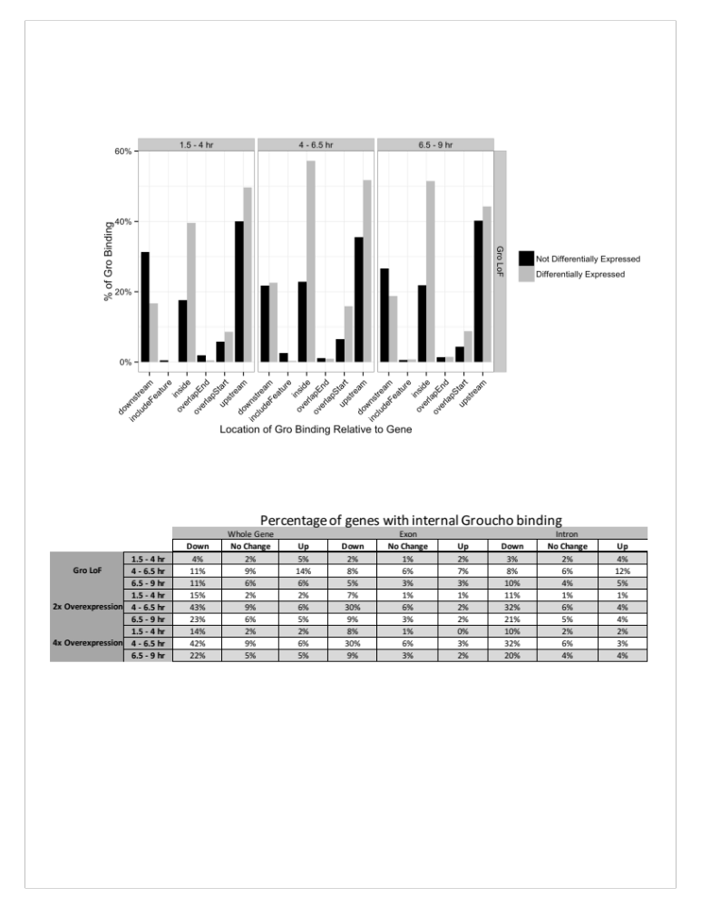
Figure 2-. Groucho binds a large fraction of both Dorsal-dependent and independent CBP binding sites in the early embryo. Overlap between Groucho binding across three time windows was calculated against two dCBP ChIP-seq data sets generated from 2 – 4 hour old embryos from embryos with normal (dCBP wt) or Dorsal-deficient embryos (dCBP gd7) {Holmqvist, 2012 #3115}. dCBP is recruited by Dorsal to sites throughout the ventral portions of the embryo to activate expression of several target genes, including twist. While Gro is recruited by Dorsal to facilitate gene repression also in ventral regions, it is unexpected by the proposed model that Dorsal would recruit both factors. In support of this, we see that Groucho colocalization with Dorsal-dependent dCBP is low during the first timepoint, while colocalization with Dorsal-independent dCBP binding is quite high (an > 8-fold enrichment).
Fig. 2-
