Figure 3-1.

Fig. 3-1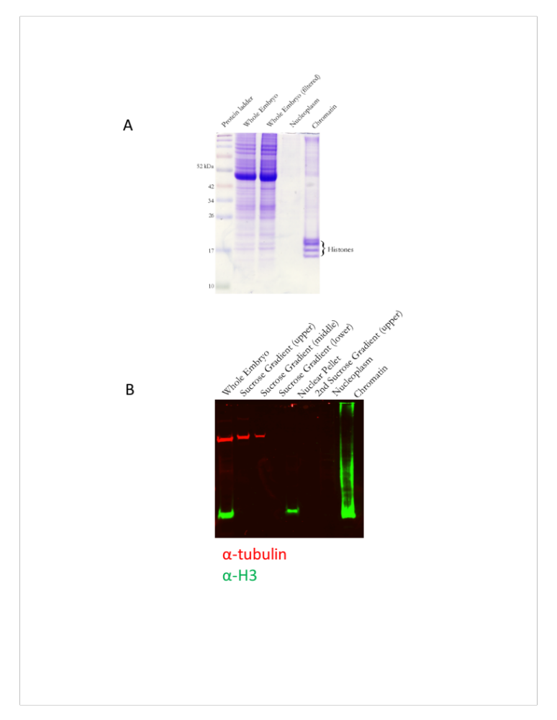

Figure 3-2.

Fig. 3-2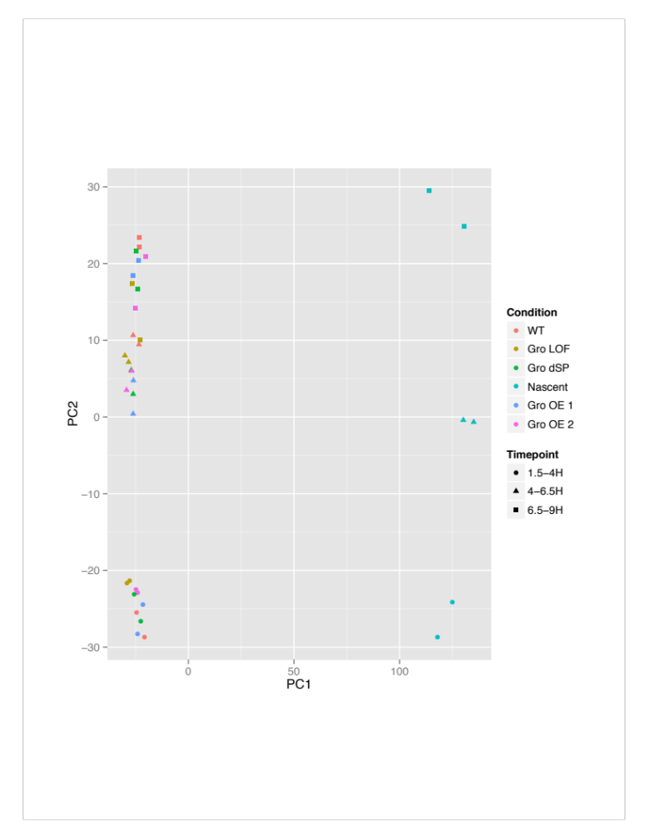

Figure 3-3.

Fig. 3-3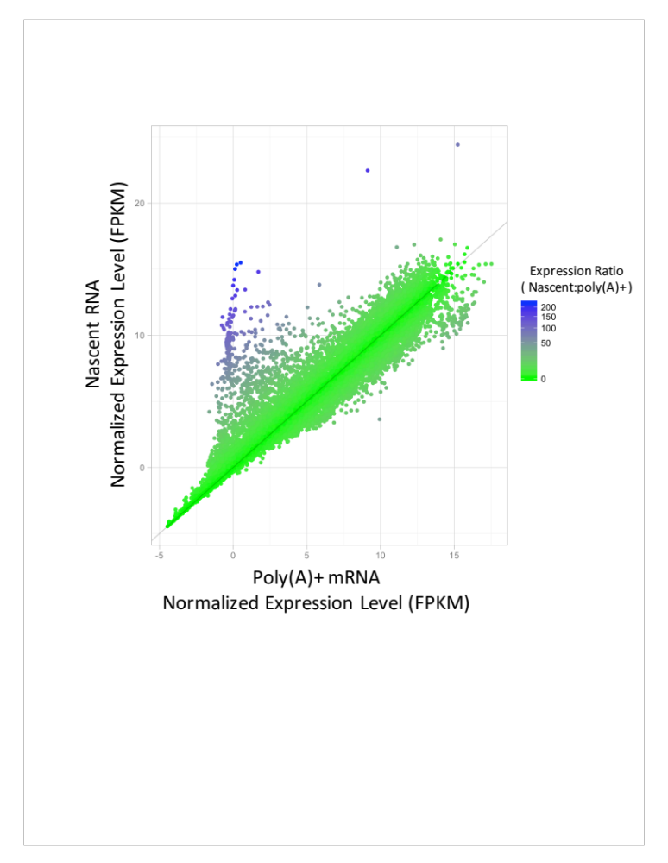

Figure 3-4.

Fig. 3-4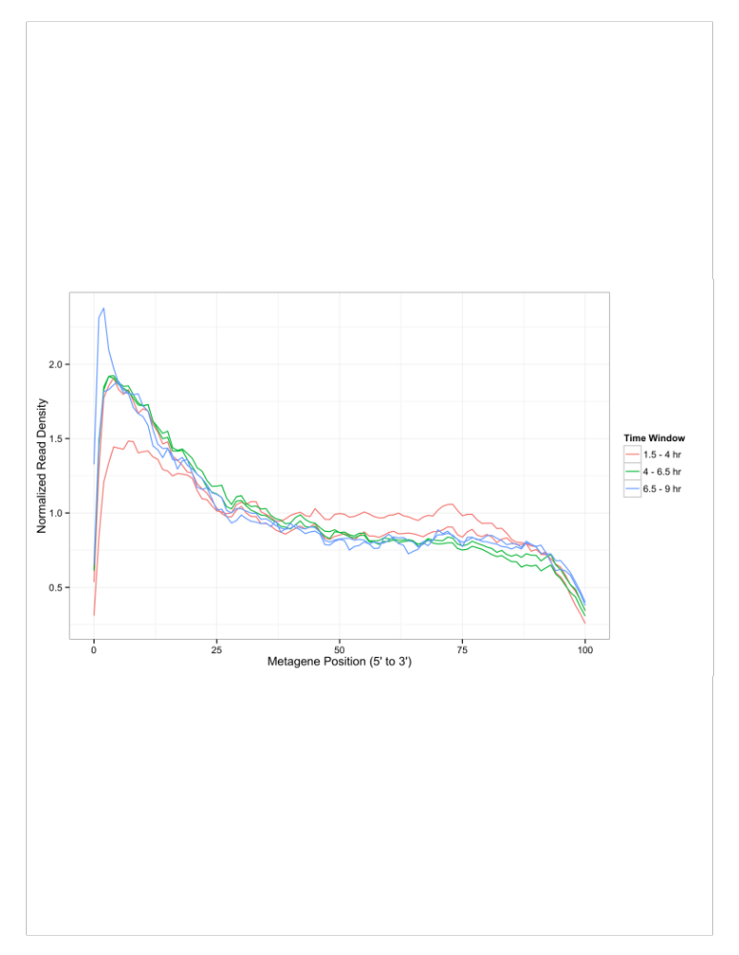

Figure 3-5.

Fig. 3-5