/api/dashboard/{userId}

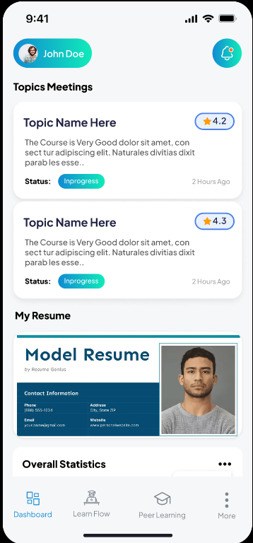

/api/group/CreateGroup

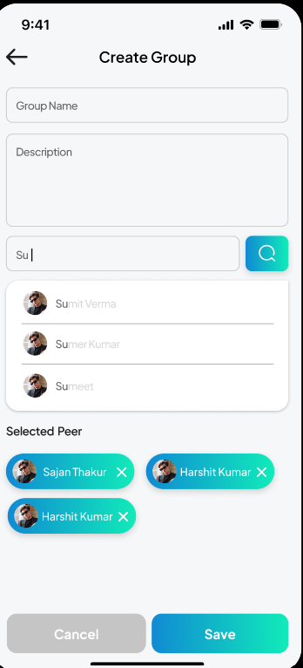

/api/group/UpdateGroup/{userId}

/api/group/GetAllGroups

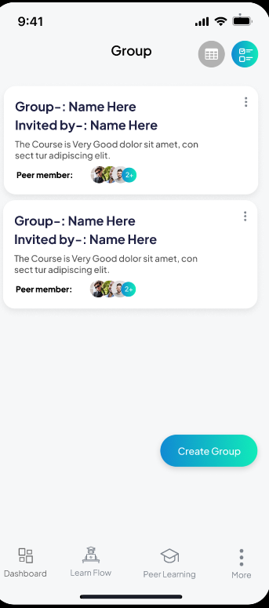

/api/group/DeleteGroup/{userId}

/api/group/SearchGroups

/api/SelfLearning/GetSelfLearningFlow

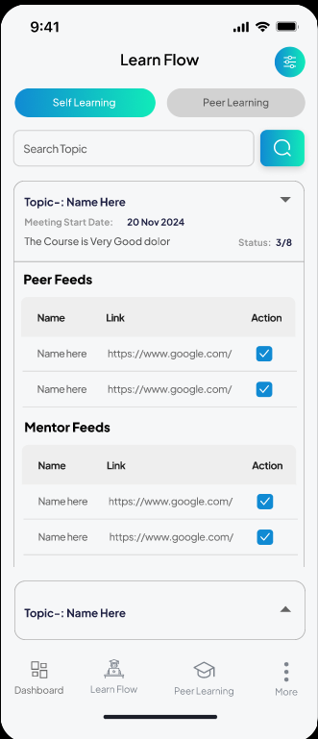

/api/Peer2Peer/GetPeer2PeerLearning

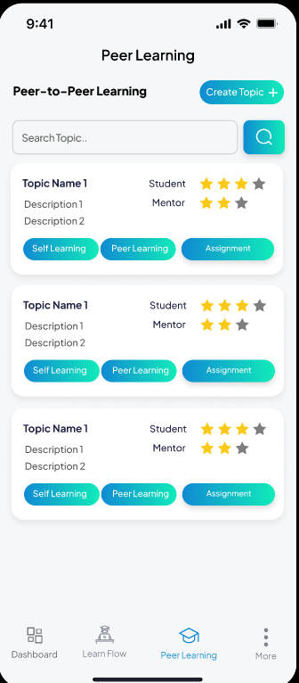

/api/topic/CreateTopic

/api/topic/UpdateTopic/{userId}

/api/topic/DeleteTopic/{userId}

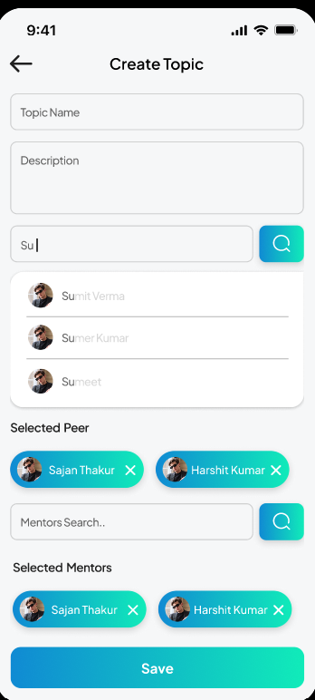

/api/topic/GetAllTopics

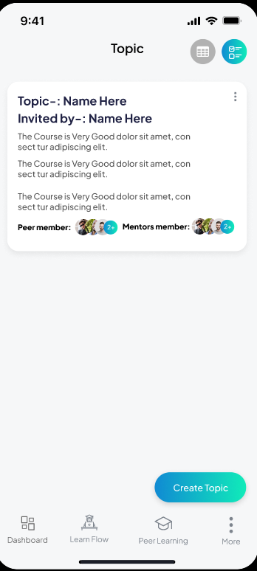

/api/Mentor/AddFeed

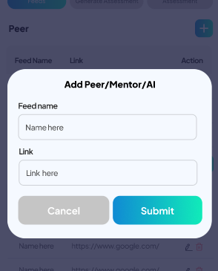

/api/Mentor/BookMentor

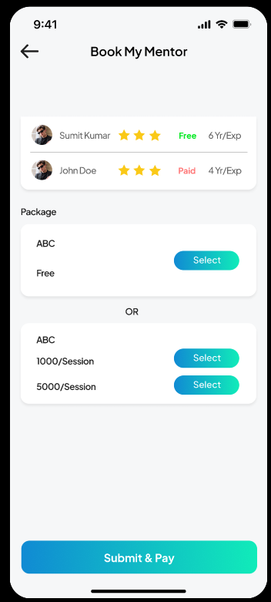

/api/Resume/GetResume/{userId}

