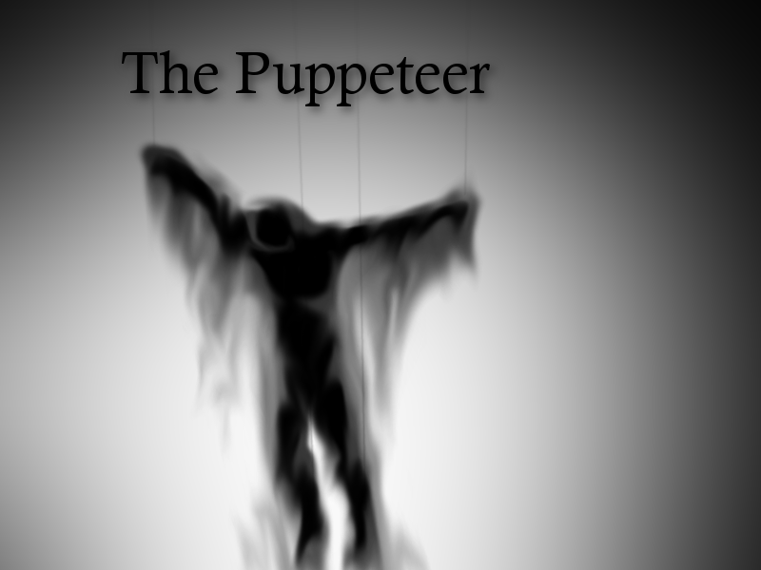

1: Creaky Floorboards : Marco Duran, Jean Marc Touma, Zackery Mason, Matthew Thompson

2: The Puppeteer

3: What would you do if you were the one pulling the strings?

4: Bryant Day’s average lifestyle just got turned upside down, bent out of shape, or just nudged to the side, whatever you choose! While in pursuit of a perfectly average lifestyle, Bryant Day inadvertently becomes the victim of a puppeteer’s curse, and finds himself at the mercy of your impulses! He needs your help to unravel the mystery of the curse and its eccentric inflictors, but will you? Save the day, rob a bank, or just eat burgers till time runs out; you control the strings, and your puppet is ready and (un)willing.

5:

* Compelling storyline involving wizards, gangsters, and a whole bunch of stupid cops
* ‘Intelligent’ characters that react to / remember the choices you make / made
* A linear plotline, but potentially sandbox-like gameplay
* A maze mini-game as you advance through the plot
* Multiple endings depending on your decisions during the game

6: The overall feeling our game was going for, the feeling of having more control over what the protagonist does / how he acts, carried through to the final prototype from the original concept, though not to the same degree we had originally envisioned. The feeling of freedom carried through fine: every available option provides something the player wouldn’t normally expect from a similar visual novel. The option to make the main character do something he hates, the option to completely ignore the plotline in favor of various distractions, the option to punch the head villain in the middle of a monologue: all choices are meant to be something a player normally doesn’t get but always desired, a chance to rewrite a linear plotline in the way they felt would be “cooler” or “better”, or maybe just “funnier”. The only thing that was downgraded from the original concept was the total number of choices: making a branching number of options for each choice grew progressively difficult to organize / code, so as the game progresses there are more and more sections of linear storyline that could / should be presenting more options if not for deadline issues. For those more focused on story / dialogue, the option to force the main character to do something against his better judgment is also a prominent feeling one can get from the game; Bryant will often say his opinion on things you forced him to do. This carries through more of the freedom we were trying to provide, due to how most stories center around the path the main character forged for himself; in this one, the story can’t even start until you break the main character from his average lifestyle by force.

7: We don’t have any unoriginal art. For music, Marco mixed loops from Shok, Peace Love Productions, DJ Puzzle.