**Dielectric Performance of HIGH PERMITIVITY nanocomposites: Impact of polystyrene grafting on batio3 and tio2**

Christopher A. Grabowski1,2, Scott P. Fillery1, Hilmar Koerner1,Maxim Tchoul1, Lawrence Drummy1, Christopher W. Beier3,Richard L. Brutchey3, Michael F. Durstock1, and Richard A. Vaia*,1

1 Materials and Manufacturing Directorate, Air Force Research Laboratory, Wright-Patterson Air Force Base, Ohio 45433, United States

2 UES, Inc, Dayton, Ohio 45324, United States

3 Department of Chemistry, University of Southern California, Los Angeles, CA 90089, United States

Contents

Polystyrene-grafted BaTiO3 particle preparation 2

Small angle X-ray analysis 3

**Figure S1.** Hard sphere volume fraction as function of BaTiO3 volume fraction 3

**Figure S2.** Example fit to SAXS data of 3% v/v blend sample 3

**Figure S3.** Real and imaginarydielectric permittivity for PS/BaTiO3 nanocomposites 4

**Figure S4.** Real and imaginary dielectric permittivity for PS/TiO2 nanocomposites 5

**Figure S5.** Probability of failure for PS@TiO2 HNP films 6

**Figure S6.** Polarization loop measurements for PS/BaTiO3 nanocomposites 7

*Address Correspondence to [richard.vaia@us.af.mil](mailto:richard.vaia@us.af.mil)

**Polystyrene-grafted BaTiO3 particle preparation**

**Materials.** The azide-functionalized BaTiO3 nanoparticles were synthesized according to Beier *et al.* [*Langmuir* **26**, 5067 (2010)]. The alkyne-functionalized polystyrene (PS-azide) (Mn = 104,000 g/mol, MW/MN = 1.20) was synthesized by the previously reported procedure [Tchoul *et al.*, *Chem Mater* **22**, 1749 (2010)]. N,N’-dimethylformamide (DMF) and N,N,N’,N’,N”-pentamethyldiethyl-enetriamine (PMDTA) were obtained from Aldrich and used as received. Copper (II) Bromide (CuBr) was obtained from Aldrich and purified as reported before (same ref.)

**Instruments.** Low speed centrifugation was performed in an Allegra X 22 centrifuge from Beckman Coulter. High-speed centrifugation was carried out in a Sorvall WX Ultra 80 centrifuge with T-647.5 rotor and 90 mL polyallomer tubes, all from ThermoFisher Scientific. IKA T-18 mixer equipped with mixing tools S18N-10G and S18N-19G operating at 10,000 rpm was used for high shear mixing. Thermogravimetric analysis was performed in a Q5000 TGA analyzer from TA Instruments in air in the range of 20-800°C.

**Synthesis.** 0.7 g of BaTiO3 NPs were added to the solution of 1.1 g of PS-azide in 70 mL of DMF and dispersed by 30 min high-shear mixing. The dispersion was transferred into a 100 mL Schlenk flask equipped with stir bar and septum and was purged with argon for 30 min via syringe. The septum was opened, 70 mg of CuBr and 0.07 mL of PMDTA were added, the septum was closed and the flask was immersed into an oil bath at 85 °C and was stirred under nitrogen protection. The initially cyan-green solution turned brown during the first 2 days of the synthesis. The mixture was stirred in total for 6 days (140 hours). The mixture was cooled down, homogenized by high shear mixer for 30 min, and centrifuged at 6,000 rpm for 30 min. The supernatant was separated, the solid was added to 80 mL of DMS and was subjected to two more cycles of homogenization-centrifugation. The combined supernatant was centrifuged at 45,000 rpm (2x105 g) for 2 hours. The precipitate was redissolved in 20 mL of DMF, precipitated in 30 mL of methanol, collected and dried, yielding 50 mg of greenish powder. The synthesis was repeated 2 more time to collect 165 mg of the material.

**Sample preparation.** The functionalized BaTiO3 (BT) particles were dissolved in DMF to the concentration of 80 mg/mL. For samples with the highest content of BT the solution was used directly. To prepare the samples with the lower content of BT, the nanoparticles solution was mixed with the appropriate amount of the 80 mg/mL solution of the same polystyrene that was used for grafting.

The solution was deposited on a metalized glass slide by 3 portions of 15 μL each. The sample was dried on the hot plate at 60 °C after each portion. When all portions were applied (3.6 mg of solid), the picture frame cut out of 30 um aluminum foil was placed around the deposited material, the piece of aluminum foil was place on the top, then the glass slide was placed on it, and the sandwich was placed into the hot press, heated up to 130 °C, and carefully pressed at 500 kg load. The heat was turned off and the sample was slowly cooled under pressure (30 min to reach temperature below 40 °C), giving the uniform film with the diameter of 7-8 mm.

**Small angle X-ray analysis**

Small angle X-ray Scattering (SAXS) experiments were carried out on a Rigaku S-MAX 3000 3 pinhole SAXS system in transmission mode using CuKα at a sample to detector distance of 150 cm. Data was corrected for dark current, background and transmission. Qualitatively, a broad Guinier knee of the samples reveals an average particle diameter of 7 nm, consistent with TEM images. No Bessel oscillations in the form factor at higher scattering angles are present in the SAXS patterns in agreement with a broad size distribution, also observed in TEM. Overall the scattering curves between blends and HNPs are very similar in appearance. One distinction is a more pronounced Guinier knee (0.07 Å-1) of the blends (Fig. 2 g,h) compared to HNP samples. To further elucidate this observation the SAXS data for BaTiO3 blends and HNPs was further analyzed using the Irena analysis package [J. Ilavsky and P.R. Jemian *J. Appl. Cryst.* **42,** 347-353 (2009**)**], employing a combination of sphere form factor (lognormal distribution), relative volume fraction, breadth of the size distribution σ ~ 0.35 and sphere radius r0 = 3.5 nm, and a Percus and Yevick hard sphere model [J.K. Percus and G.J. Yevick *Phys. Rev.* **110***,* 1 (1958)] to determine trends as a function of loading and architecture (see Fig S1 for an example fit). The low q power law is caused by agglomerates and cluster formation which are apparent in the TEM with the appearance of a fractal morphology of connected strings at low magnification and smaller clusters and strings at higher magnification and has been set as a constant aggregate in the fitting of the SAXS data. Form factor and low q power law were kept constant and the fitting reveals the difference in structure present in the Guinier knee. While the hard sphere radius is close to particle size (r = 3.5 nm), implying that the observed structure contributions are caused by a small fraction (<2%) of closed packed particles consistent with TEM, the hard sphere volume fraction, although very small in either case, is higher for the blends compared to HNP samples (Fig. S2). This small difference can be explained by the fact that clustering for HNP samples must occur at hard sphere radii that are much larger than particle size due to the covalently attached polymer chains.



**Figure S1.** Example fit to SAXS data of 3% blend sample using sphere form factor, structure factor and aggregate population.

**Figure S2.** Hard sphere volume fraction as function of BTO volume fraction for PS+BaTiO3 blends (grey) and PS@BaTiO3 HNPs (black). The hard sphere volume fraction is obtained from fits to the SAXS data. The hard sphere radius of all samples is close to particle size at r ~ 3.5 nm. The absolute volume fraction is < 2% for the highest value.

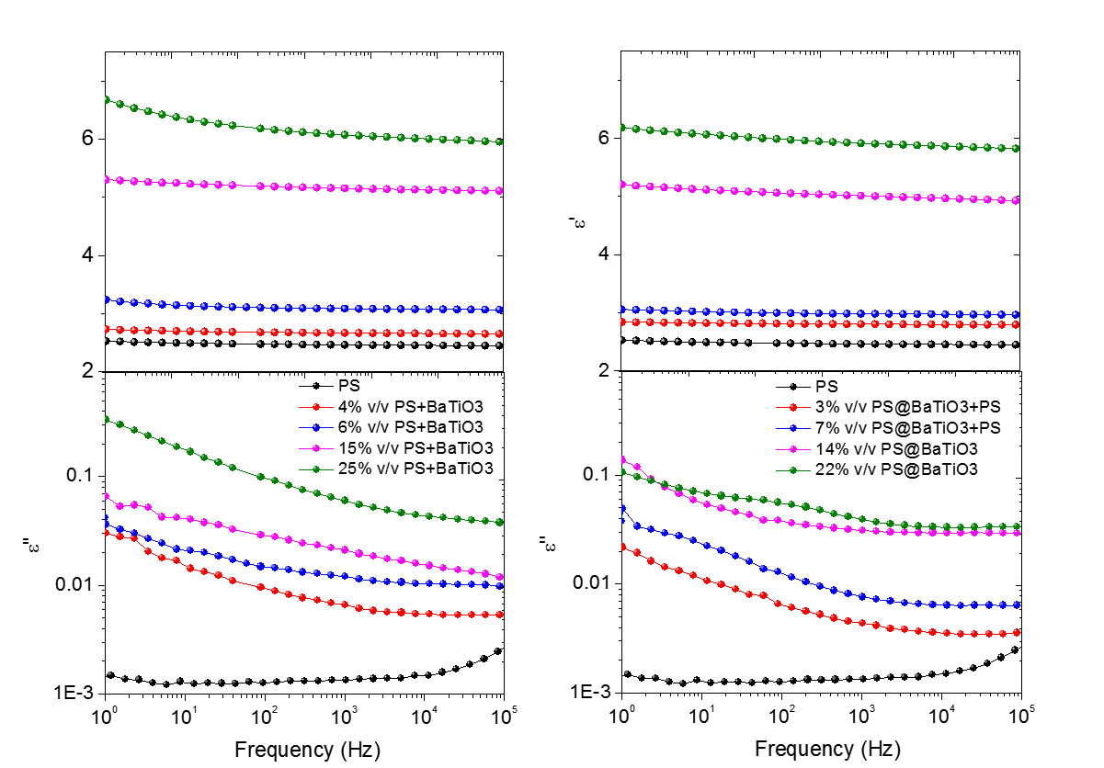

Figure S3. Real and imaginary dielectric permittivity for PS+BaTiO3 blend (left) and PS@BaTiO3 HNP (right) nanocomposite films. Measurements were performed at 1 VAC with discrete frequencies in the range of 1 to 105 Hz.

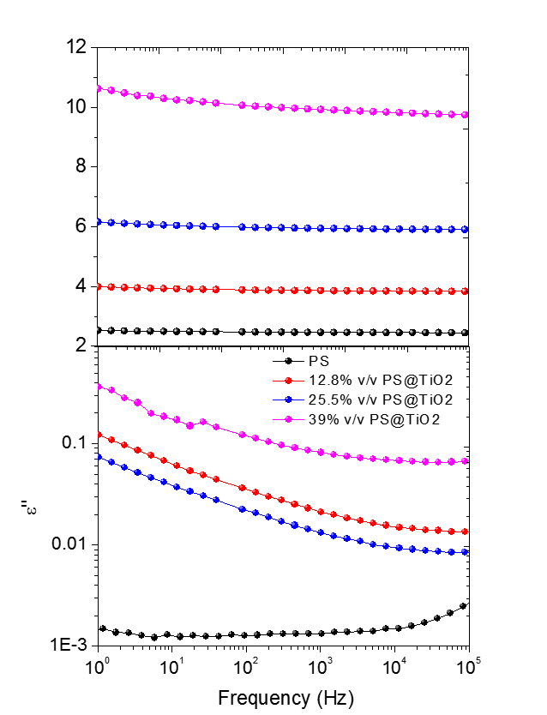

Figure S4. Real and imaginary dielectric permittivity for HNP PS@TiO2 nanocomposite films. Measurements were performed at 1 VAC with discrete frequencies in the range of 1 to 105 Hz.



Figure S5. Probability of failure for PS@TiO2 HNP films with different TiO2 content. Tests were performed using a probe contact experimental geometry. At least 20 individual breakdown tests were conducted for each loading.

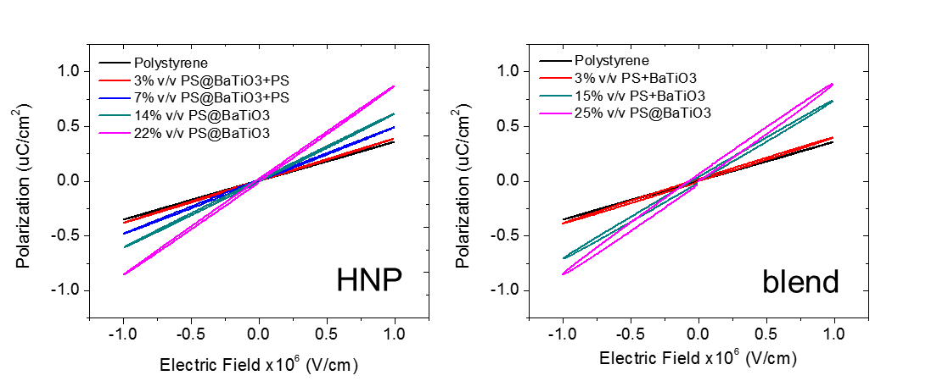

Figure S6. Polarization loop measurements for PS@BaTiO3 HNPs (left) and PS+BaTiO3 blends (right) for a range of inorganic volume fractions. The energy storage efficiency data shown in Figure 6, main text, is calculated by extracting the charge and discharge energies from the polarization loops.