**Entities and relationship sentences**

1. Customers

**Relationship Sentences:**

* A customer owns many phones/phone numbers.
* A customer owns many payment methods.
* Many Customers have a rental history consisting of many transactions. (Rental history joins customers and transactions)

1. Payment Information

**Relationship Sentences:**

* + Many Payment methods are owned by a customer.

1. Phone number

**Relationship Sentences:**

* + Many Phone numbers are owned by a customer.

1. Rental History

**Relationship Sentences:**

* + Rental History joins customers to transactions… or a customer has a rental history which contains many transactions.

1. Transaction Details

**Relationship Sentences:**

* Many Transactions are contained in the rental history.
* A Transaction can apply many different charges.
* One Transactions removes/replaces many items in inventory (movie).

1. Charges

**Relationship Sentences:**

* + Many Charges are applied by a Transaction.

1. Items in inventory

**Relationship Sentences:**

* One Transaction removes many items from inventory.
* Item by distributor joins inventory and distributors.
* Item in Inventory lists many movies.

1. Item by Distributor

**Relationship Sentences:**

* Item by Distributor joins many *Item in Inventory* to many *Distributors*.
* Item by Distributor has many discounts.

1. Distributors

**Relationship Sentences:**

* Distributor are joined to item in inventory via inventory by Distributors.
* One Distributors sells many different types of genres.
* Distributors own many phone numbers.

1. Distributor Phone Number

**Relationship Sentences:**

* + Many phone numbers can be owned by a distributor.

1. Discounts

**Relationship Sentences:**

* + Many discounts are applied to Items by distributor.

1. Genres

**Relationship Sentences:**

* + - One movie is one genre (assumption).
    - A distributor sells many types of genres

1. Movie

**Relationship Sentences:**

* + - Many movies are items in inventory.
    - A movie is a genre.
    - A movie can have many awards.
    - A movie has a director.
    - A movie has many performers.

1. Director

**Relationship Sentences:**

* + - A movie is directed by a Director (assumption: a movie only has one billed director).
    - Director joins Director List to movies.

1. Performer

**Relationship Sentences:**

* + - A movie has many performers.
    - Performer joins *movie* to *Performer List.*

1. Award list

**Relationship Sentences:**

* + - Each director has a list of academy awards.
    - Each performer has a list of academy awards.
    - Each movie can have many awards.
    - Awards list joins movies, performers, and directors to Academy Awards.

1. Performer List

**Relationship Sentences:**

* + - Performer joins *movie* to *Performer List.*
    - A performer can win many awards.

1. Director List

**Relationship Sentences:**

* + - Director joins *movie* to *Director List.*
    - A director can win many awards.

1. Academy awards

**Relationship Sentences:**

* + - Many directors, movies, and performers win many academy awards. Therefore, award list joins awards to movies directors and performers.

**Create an ERD**

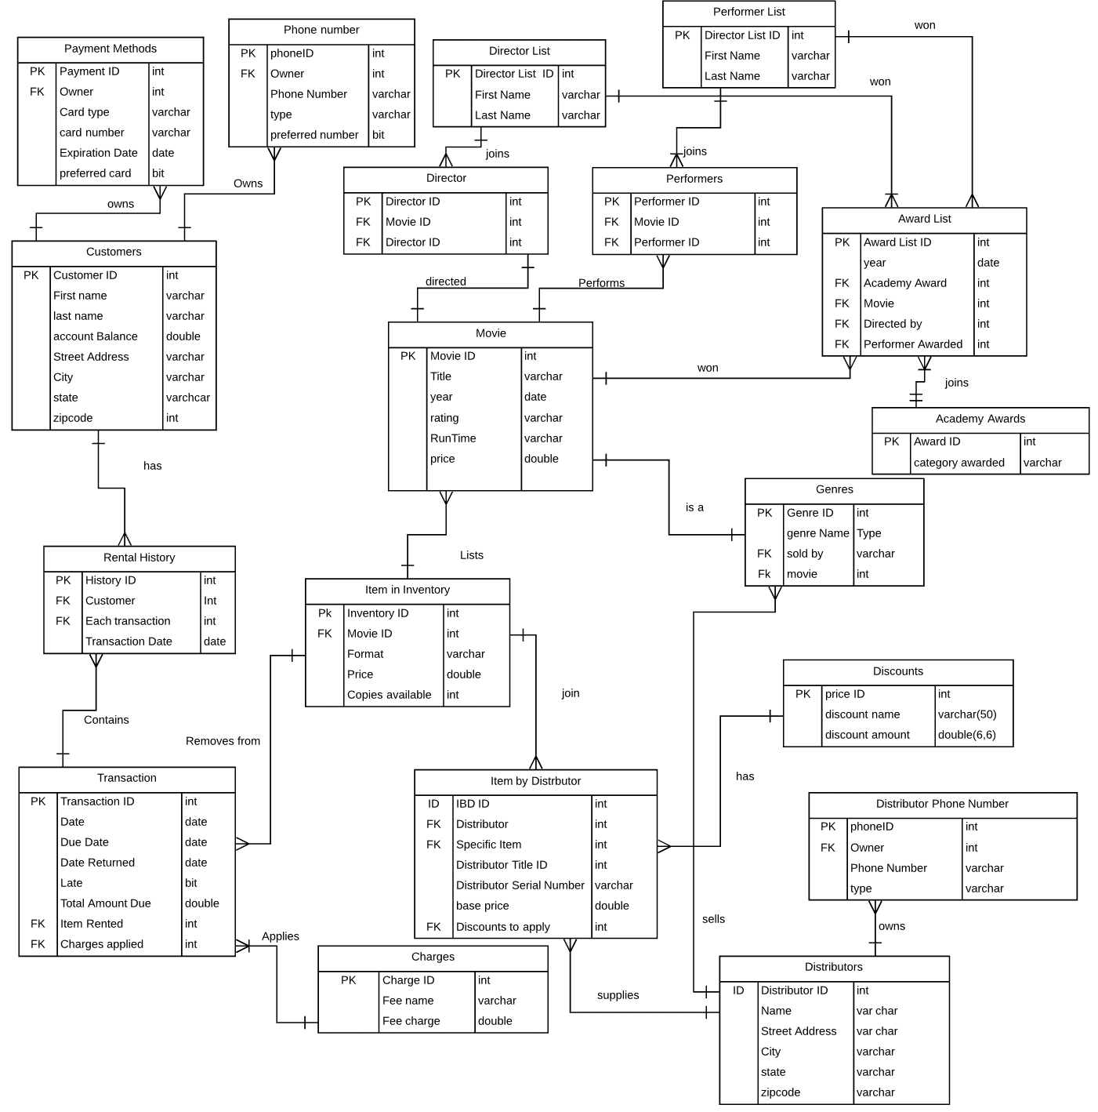

**Create Metadata:**

All keys have no width specification. This was intentional since the size of the table should be unlimited.

Table 1.

|  |  |  |  |  |
| --- | --- | --- | --- | --- |
| **Title** | **KEY** | **Column Title** | **Datatype** | **Nullible** |
| **Customer** |  |  |  |  |
|  | PK | Customer ID | int | no |
|  |  | First name | varchar(50) | no |
|  |  | Last name | varchar(50) | no |
|  |  | Account Balance (derived) | double(4,6) | yes |
|  |  | Street Address | varchar(150) | no |
|  |  | City | varchar(50) | no |
|  |  | State | varchar(2) | no |
|  |  | zipcode | int(5) | no |

The account balance is a derived attribute of transaction details.

Table 2.

|  |  |  |  |  |
| --- | --- | --- | --- | --- |
| **Title** |  | **Column Title** | **Datatype** | **Nullible** |
| **Phone number** |  |  |  |  |
|  | PK | Phone ID | int | no |
|  | FK | Customer ID | int | no |
|  |  | Phone Number | varchar(20) | no |
|  |  | Type | varchar(10) | yes |
|  |  | preferred Number | bit | yes |

The type domain is home, work, or mobile. The preferred Number domain is 0 for no, 1 for yes.

Table 3.

|  |  |  |  |  |
| --- | --- | --- | --- | --- |
| **Title** | **KEY** | **Column Title** | **Datatype** | **Nullible** |
| **Payment Methods** |  |  |  |  |
|  | PK | Payment ID | int | no |
|  | FK | Customer ID | int | no |
|  |  | Card type | varchar(20) | no |
|  |  | Card number | varchar(20) | no |
|  |  | Expiration date | date | no |
|  |  | Preferred method | bit | yes |

The type domain is Visa, Mastercard, or American express. The preferred card domain is 0 for no, 1 for yes.

Table 4.

|  |  |  |  |  |
| --- | --- | --- | --- | --- |
| **Title** | **KEY** | **Column Title** | **Datatype** | **Nullible** |
| **Rental History** |  |  |  |  |
|  | PK | History ID | int | no |
|  |  | transaction date | date | no |
|  | FK | Customer ID | int | no |
|  | FK | Transaction ID | int | no |

Table 5.

|  |  |  |  |  |
| --- | --- | --- | --- | --- |
| **Title** | **KEY** | **Column Title** | **Datatype** | **Nullible** |
| **Transaction** |  |  |  |  |
|  | PK | Transaction ID | int | no |
|  |  | date (derived) | date | no |
|  |  | date due | date | no |
|  |  | date returned | date | no |
|  |  | late (derived) | int | no |
|  |  | total amount due (derived) | double (4,6) | no |
|  | FK | Inventory ID | int | no |
|  | FK | Charges ID | int | no |

The date is derived from the rental history, late is derived from both date due and date returned, total amount due is derived from price of item and charged applied.

Table 6.

|  |  |  |  |  |
| --- | --- | --- | --- | --- |
| **Title** | **KEY** | **Column Title** | **Datatype** | **Nullible** |
| **Charges** |  |  |  |  |
|  | PK | Charge ID | int | no |
|  |  | Fee Name | varchar(20) | no |
|  |  | Fee Charge | double(4,6) | no |

The domain of Fee Name is late, damaged, failure to rewind, damaged, and taxes. I included this table in case the store added more fees later on. There will always be at least once charge since taxes are included on this page.

Table 7.

|  |  |  |  |  |
| --- | --- | --- | --- | --- |
| **Title** | **KEY** | **Column Title** | **Datatype** | **Nullible** |
| **Item in Inventory** |  |  |  |  |
|  | PK | Inventory ID | int | no |
|  |  | Format | varchar(3) | no |
|  |  | Price (derived) | double(4,6) | no |
|  |  | copies available | int(3) | no |
|  | FK | Movie ID | int | no |

The domain of format if DVD, VHS. The price is derived from the movie price and format.

Table 8.

|  |  |  |  |  |
| --- | --- | --- | --- | --- |
| **Title** | **KEY** | **Column Title** | **Datatype** | **Nullible** |
| **Inventory by Distributor** |  |  |  |  |
|  | PK | IBD ID | int | no |
|  | FK | Distributor ID | int | no |
|  | FK | Item ID | int | no |
|  |  | Distributor Title ID | varchar | no |
|  |  | Distributor Serial ID | varchar | no |
|  |  | base Price (derived) | double(5,6) | no |
|  | FK | Discounts to apply | int | no |

Price is partially derived from discounts and partially derived from the price of the movie.

Table 9.

|  |  |  |  |  |
| --- | --- | --- | --- | --- |
| **Title** |  | **Column Title** | **Datatype** | **Nullible** |
| **Discounts** |  |  |  |  |
|  | PK | Discount ID | int | no |
|  |  | name | var char(20) | no |
|  |  | amount | double(4,6) | no |

The domain of name is quantity of shipment, and past business.

Table 10.

|  |  |  |  |  |
| --- | --- | --- | --- | --- |
| **Title** | **KEY** | **Column Title** | **Datatype** | **Nullible** |
| **Distributor** |  |  |  |  |
|  | PK | Distributor ID | int | no |
|  |  | Name | varchar(50) | no |
|  |  | Street Address | varchar(150) | no |
|  |  | City | varchar(50) | no |
|  |  | State | varchar(2) | no |
|  |  | zipcode | int(5) | no |

Table 11.

|  |  |  |  |  |
| --- | --- | --- | --- | --- |
| **Title** |  | **Column Title** | **Datatype** | **Nullible** |
| **Distributor Phone number** |  |  |  |  |
|  | PK | Phone ID | int | no |
|  | FK | Owner | int | no |
|  |  | Phone Number | varchar(20) | no |
|  |  | Type | varchar(10) | yes |

Type domain is mobile, office, fax, or contact name.

Table 12.

|  |  |  |  |  |
| --- | --- | --- | --- | --- |
| **Title** |  | **Column Title** | **Datatype** | **Nullible** |
| **Genre** |  |  |  |  |
|  | PK | Genre ID | int | no |
|  |  | Genre type | varchar(20) | no |
|  | FK | Distributor ID | int | no |
|  | FK | Movie ID | int | no |

Type domain is suspense, horror, mystery, comedy, and romance. The assumption is that one movie is linked to only one genre.

Table 13.

|  |  |  |  |  |
| --- | --- | --- | --- | --- |
| **Title** | **KEY** | **Column Title** | **Datatype** | **Nullible** |
| **Movie** |  |  |  |  |
|  | PK | Movie ID | int | no |
|  |  | Title | varchar(200) | no |
|  |  | Year | date | no |
|  |  | Rating | varchar(5) | no |
|  |  | Runtime | varchar (10) | no |
|  |  | price (derived) | double (2,6) | no |

Domain of Rating is G, PG, PG-13, R, NC-17. Price is derived from distributor’s base price and discounts.

Table 14.

|  |  |  |  |  |
| --- | --- | --- | --- | --- |
| **Title** |  | **Column Title** | **Datatype** | **Nullible** |
| **Director** |  |  |  |  |
|  | PK | Director ID | int | no |
|  | FK | Movie ID | int | no |
|  | FK | Director List ID | int | no |

Table 15.

|  |  |  |  |  |
| --- | --- | --- | --- | --- |
| **Title** |  | **Column Title** | **Datatype** | **Nullible** |
| **Director List** |  |  |  |  |
|  | PK | Director List ID | int | no |
|  |  | First Name | varchar (100) | yes |
|  |  | Last Name | varchar (100) | no |

Table 16.

|  |  |  |  |  |
| --- | --- | --- | --- | --- |
| **Title** |  | **Column Title** | **Datatype** | **Nullible** |
| **Performers** |  |  |  |  |
|  | PK | Performer ID | int | no |
|  | FK | Movie ID | int | no |
|  | FK | Director List ID | int | no |

Table 17.

|  |  |  |  |  |
| --- | --- | --- | --- | --- |
| **Title** |  | **Column Title** | **Datatype** | **Nullible** |
| **Performer List** |  |  |  |  |
|  | PK | Performer List ID | int | no |
|  |  | First Name | varchar (100) | yes |
|  |  | Last Name | varchar (100) | no |

Table 18.

|  |  |  |  |  |
| --- | --- | --- | --- | --- |
| **Title** |  | **Column Title** | **Datatype** | **Nullible** |
| **Award List** |  |  |  |  |
|  | PK | Award List ID | int | no |
|  |  | year | date | no |
|  | FK | Academy Award | int | no |
|  | FK | Movie | int | no |
|  | FK | Directed By | int | yes |
|  | FK | Performer awarded | int | yes |

The idea is that the director/ performer primary key will only be added if they are the one to win the award.

Table 19.

|  |  |  |  |  |
| --- | --- | --- | --- | --- |
| **Title** |  | **Column Title** | **Datatype** | **Nullible** |
| **Academy Awards** |  |  |  |  |
|  | PK | Award ID | int | no |
|  |  | Category Awarded | varchar(100) | no |
|  |  | Award year (derived) | date | yes |

The date is derived from award list.