Rlliance EC010 HD Video Capture
Quick Start Guide
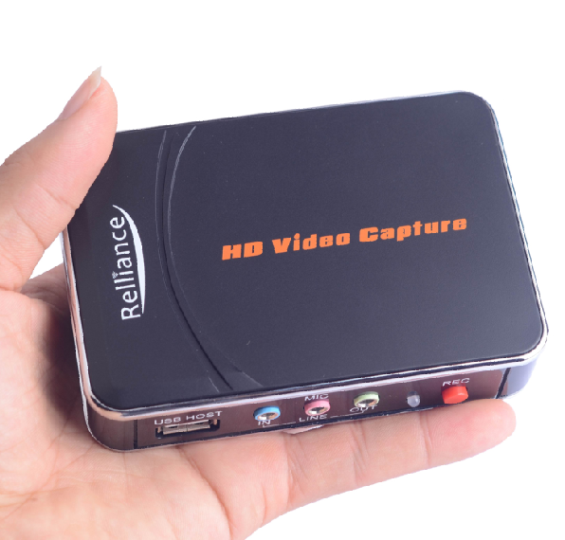

Thanks for purchasing Rlliance EC010(M) HD Video Capture. The following guides you how to set up the device. Hope this device will bring you nice digital experience.

With this Rlliance EC010 (M) HD Video Capture, you can capture 1080P video from HDMI or YPbPr(Component Video) port, such as blue ray, set-top-box, computer, game box, etc.

Note: Please check the sticker on the box to see if the device you got is Rlliance EC010 or Rlliance EC010, the difference is Rlliance EC010 only support microphone input recording with YPbPr input. Rlliance EC010 support both with component and HDMI input.

Features/ports and buttons:

1. OUTPUT—HDMI output, pass through display HDMI or YPbPr video.

2. INPUT—HDMI input.

3. YPBPR INPUT—YPbPr component input.

4. PWR—DC 5V power supply.

5. USB HOST—For plug USB flash drive or USB HDD for saving record files.

6. LINE IN—Work with YPbPr input only.

7. MIC—For connect a microphone and record voice comments when play game (Rlliance EC010 only work with component input. Rlliance EC010 MIC work both for component and HDMI input)

8. LINE OUT—Audio output.

9. LED indicator—Color be green when standby, be red when recording.

10. REC button—Press to record/stop.

How to play:

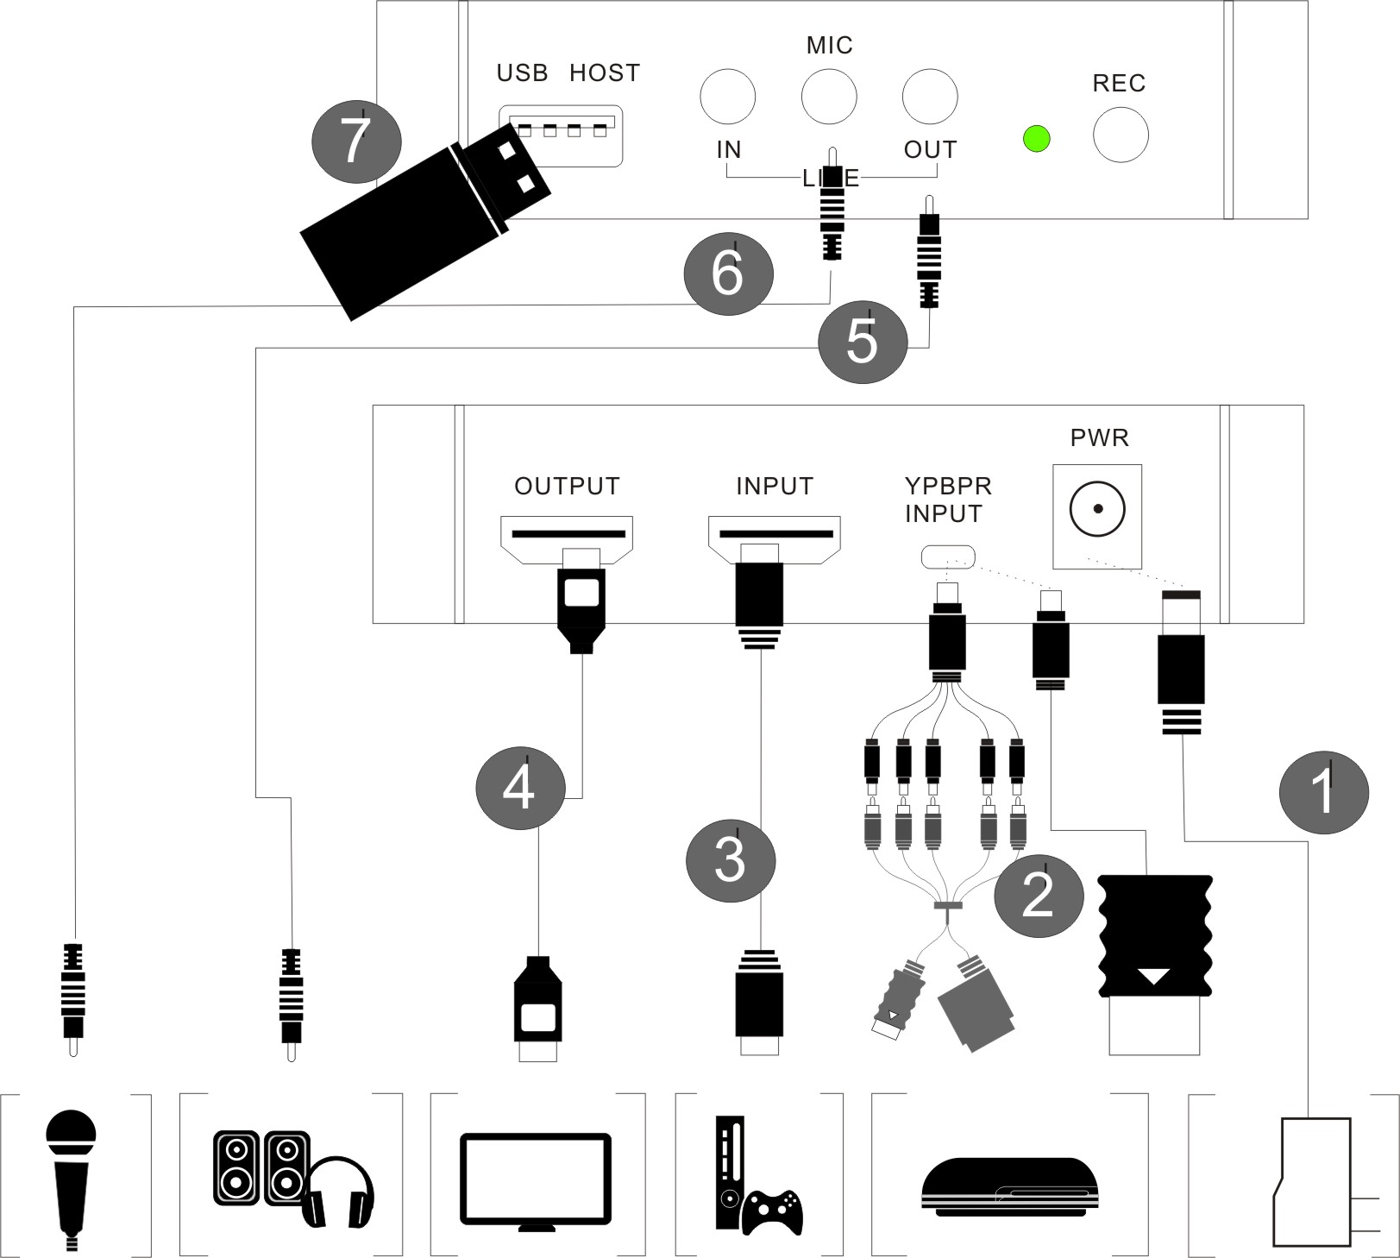
1, Connect power with DC adaptor

2, With component cable connect to PS3 or other source

3, Use HDMI cable connect Xbox or other source.

4, With HDMI cable connect to monitor

5, The “LINE OUT” is for connect to speaker or earphone.

6, You can connect your microphone to record your comment when play game.

7, Plug an USB disk on.

Most important: Use “safety remove” option to remove your USB flash or HDD after format from computer, DO NOT just plug out without click “safety remove” option, otherwise you will cause problem during recording.

8, If you want record from computer (game or video) with DVI port, you can use a DVI to HDMI cable to connect (Note: Only can record video), like following picture:
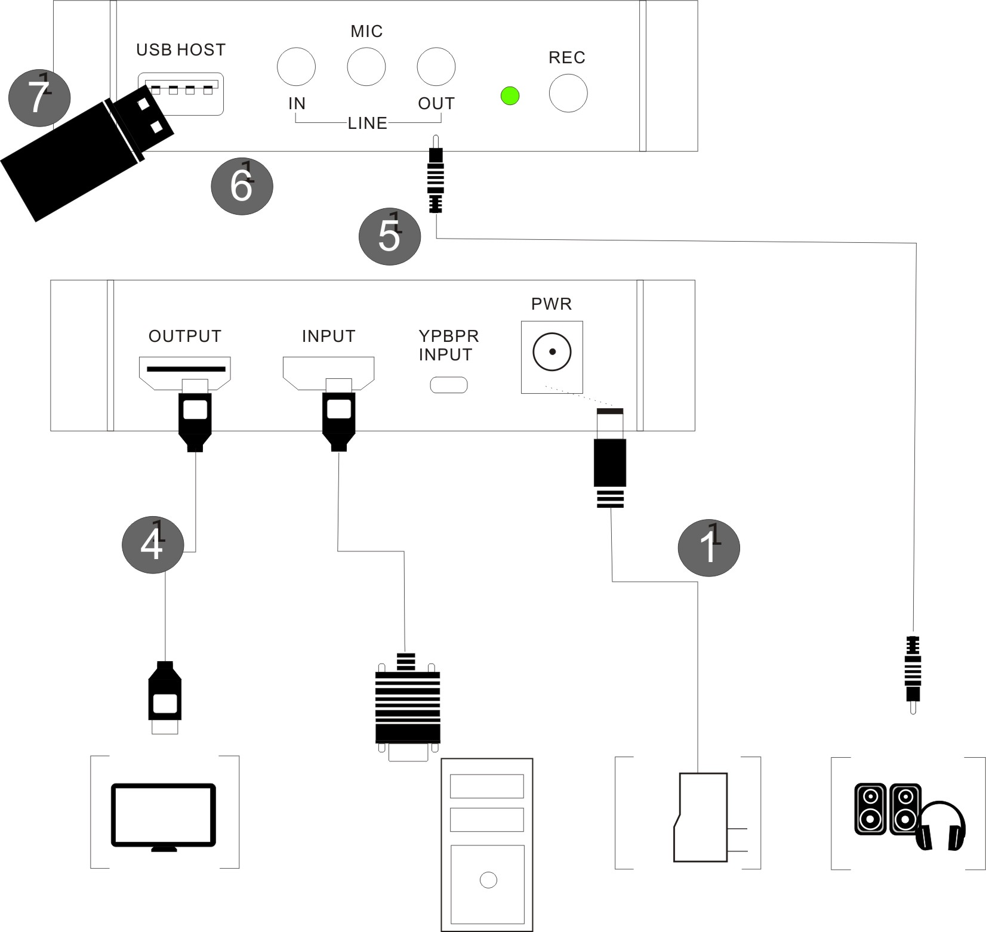

9, Press the REC button to capture the playing video, you will see the LED indicator turn red from green. Press REC button again to stop capturing, will see LED indicator flash few seconds then turn green.

The recording will be stopped automatically if the USB memory is full, or the input video signal is lost during recording.

Note: If you use USB HDD, and there is more than 1 partition, then the video only saved on first partition, when the first partition memory is full, the recording will be stopped. So, please check and set up your USB HDD firstly according to your demand.

10, After you stop recording, connect the USB flash to computer, will see the recorded files: for 1080P recording, file will be Encode_1080P_1, for 720 or 480p recording, file will be Encode_1.
Every record/stop operation will create a different recording file: Encode_1080P_1, Encode_1080P_2, Encode_1080P_3… and so on.

The max size per file will be around 1.95GB (around 15 minutes for 1080p video), when you record a video more than 1.95GB(15 minutes), Rlliance EC010 will partition it in more than 1 file, for example: if you record a 45 minutes 1080p video by one click recording, you will see 3 files: Encode_1080P_1, Encode_1080P_1_1, Encode_1080P_1_2…and so on

If you like use a media player to playback the recorded video, make sure it support MPEG4 video and AAC audio decode.

11, Update firmware: you may need update firmware for this device for some reason. Copy the firmware file into USB disk, power off the device (unplug power jack), plug USB disk to device, power on, the indicator will flash 7~8 seconds, then the update is finished.

12, Reset: After long time using, you will see the number of recording file become too big, for example Encode_1080P_234, but you want it be start from Encode_1080P_0, to do it you just keep press record button (before power on), then plug the power jack to power on the device, after 3 seconds, the file number will start from 0.

Edit/Convert recorded files:

The Rlliance EC010 comes with a video edit software—Arcsoft ShowBiz 3.5, you can edit your video file with it.
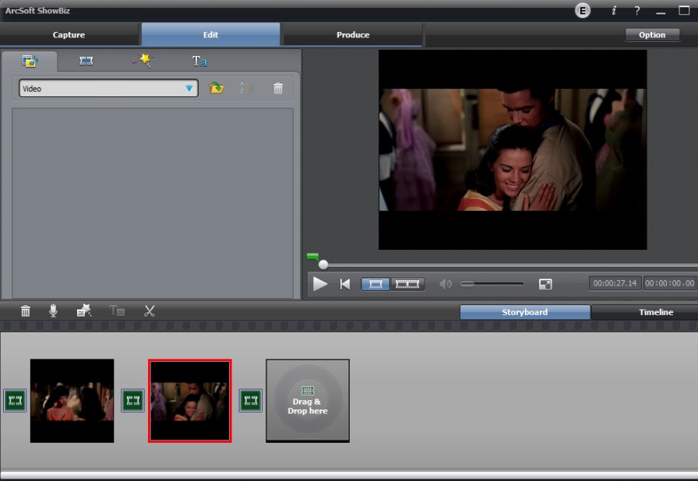
After install it on computer, and open it.

1, You can combine two or more video in one, just drag them into Showbiz:
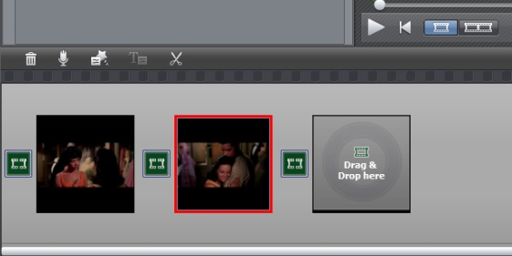

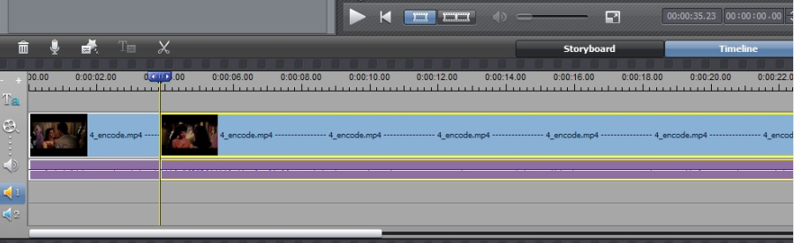

2, You can cut a video to two or more:
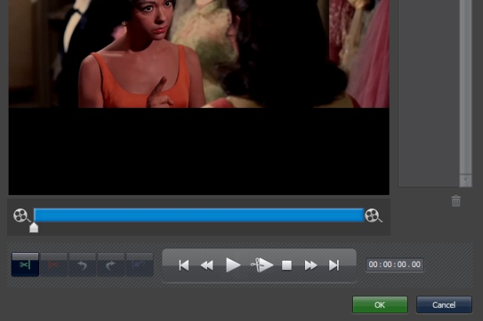

3, Click “Produce” after editing, you can create DVD or upload video to YouTube:
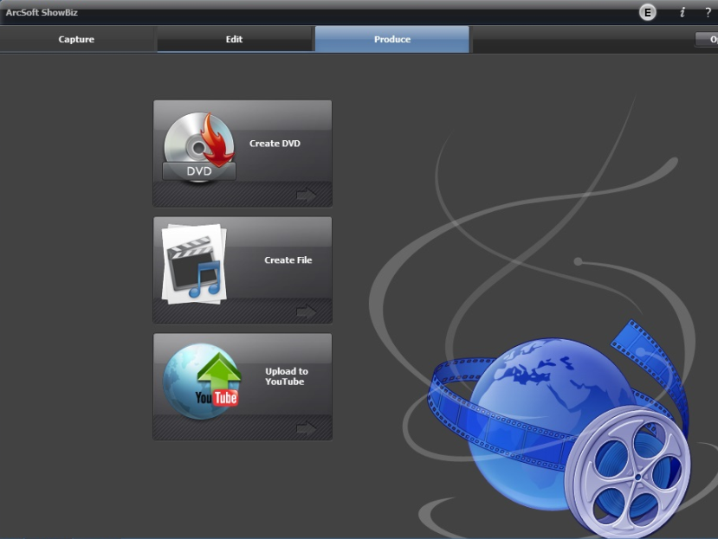

4, Please click “Create file” to create multiple files for different devices, such as apple, PSP, mobile phone, etc:

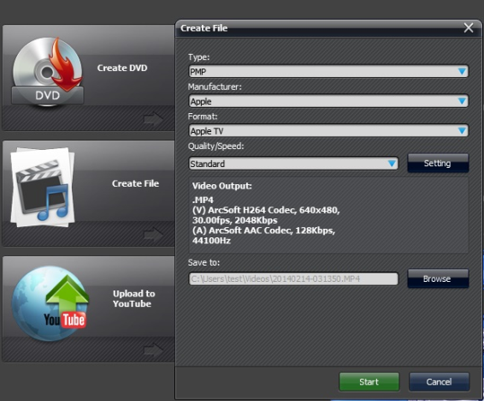
Please click the “?” key on the software panel to get the more information and help.

Specifications:

Connections
Interface |  |  | USB 2.0 Host
Video Input |  |  | Digital: HDMI
 |  |  | Analog: Component Video
Audio Input |  |  | Digital: HDMI
 |  |  | Analog: RCA L/R, 3.5mm Line In, 3.5mm Micro Phone In
 |  |  | Note: 3.5mm Line In is only for Component Video Input
Video Output |  |  | Digital: HDMI (Pass-through from HDMI or Component Input)
Audio Output |  |  | Digital: HDMI (Pass-through from HDMI or Audio RCA L/R Input)
 |  |  | Analog: 3.5mm Stereo (Pass-through from HDMI or Audio RCA L/R Input)
Package Contents
Device |  |  | HD Video Capture
Others |  |  | HDMI cable, Component Video cable, DC adapter, Software CD, User Manual
Hardware Extra
Codec |  |  | Hardware MPEG4 encoder
User Interface |  |  | On-board Hot Button for one-click recording / stop
 |  |  | LED indicator for working status
Dimensions |  |  | 110(L) × 75(W) × 27(H) mm
Weight |  |  | 135g
Standards
Storage Media |  |  | USB Flash Disk, Portable Hard Disk
 |  |  | Note: The exFAT format is not supported.
Resolution |  |  | Input / Pass-through: 720 x 480 (60p), 720 x 576 (50p), 1280 x 720p (50p), 1280 x 720p(60p), 1920 x 1080 (50i), 1920 x 1080 (60i), 1920 x 1080 (24p), 1920 x 1080 (25p), 1920 x 1080 (30p), 1920 x 1080 (50p), 1920 x 1080 (60p)
 |  |  | Capture: 720 x 480 (60p), 720 x 576 (50p), 1280 x 720p (50p), 1280 x 720p(60p), 1920 x 1080 (50i), 1920 x 1080 (60i), 1920 x 1080 (24p), 1920 x 1080 (25p), 1920 x 1080 (30p), 1920 x 1080 (25p), 1920 x 1080 (30p)
 |  |  | Note: Up scaling is not supported.
Record Format |  |  | Video: AVI MPEG4, Audio: AAC Stereo
Record Quality |  |  | Max: 18Mbps@1080P 30fps
Record File |  |  | Max: 2GB / Per File
Record Place |  |  | Max: 140MB / Minute, 8GB / Hour
Power Supply |  |  | DC 5V / 2A
Capture Format |  |  | Video: AVI MPEG4, Audio: AAC Stereo
Applications
Software |  |  | Arcsoft Showbiz
Video Editing |  |  | Timeline / Storyboard edit, Split / Divide Scenes, Multi Trim Scenes …
Video Export |  |  | Upload to YouTube
 |  |  | Portable Device: iPod, iPhone, iPod Touch, Apple TV, PSP, PS3, Xbox
 |  |  | File: MPEG 1 / 2 / 4, WMV HD, QuickTime (MOV) …
Operating System |  |  | Windows 8 (32 / 64 bit), Windows 7 (32 / 64 bit), Windows Vista (32 / 64 bit)
CPU |  |  | Intel Core 2 Duo 2.8GHz, AMD Athlon 64X2 Dual Core 3.0GHz
Memory |  |  | 4 GB RAM
Graphics Card |  |  | VGA card with support for DirectX 10.0c or above

