# Page Prototype

## Step 1: Design an Event

### Competitor site 1: UberEATS

* Price of delivery
* Approximate time it takes to get there
* Address
* Name of restaurant
* Image of the food

### Competitor site 2: GrubHub

* Rating
* Name of restaurant
* Comments/Reviews
* Name of restaurant
* Approximate time
* Name of restaurant
* Address
* Picture of food
* Link to the menu

### My Site:

* Rating
* Name of restaurant
* Comments/Reviews
* Name of restaurant
* Approximate time
* Name of restaurant
* Address
* Picture of food

## Step 2: Prototype an Event Area

Here is a prototype of how the Event area will look

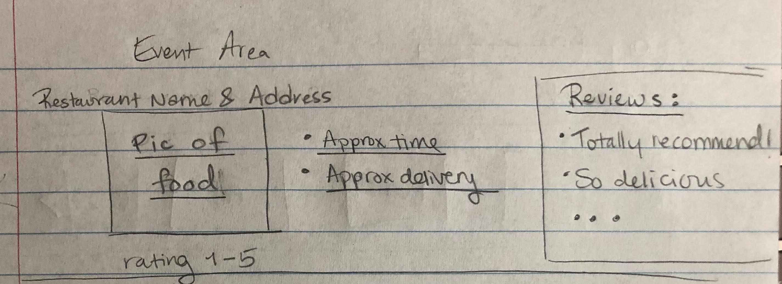

## Step 3: Prototype the Event Page

Here is a prototype that shows how the Event area fits in a wider page

