Product Overview:
Pluto+ is a software-defined radio platform that supports 2TX 2RX, supports Gigabit Ethernet and Micro SD card. The design draws on the well-known ADI ADALM-PLUTO and improves its shortcomings.
2.Features：
ADC/DAC：AD9363(Can hack to AD9361 or AD9364)
2 Transmit, 2 Receive channel
RF Range：70MHZ~6GHZ
Ref Clock：VCTCXO 40MHZ 0.5ppm
SOC：Zynq7010 FPGA：28k
RAM：512M
FLASH：32M
USB：2.0 support OTG
Ethernet：1000Mb
Micro SD can use to boot
DC IN：5V +-0.5V-2A microUSB

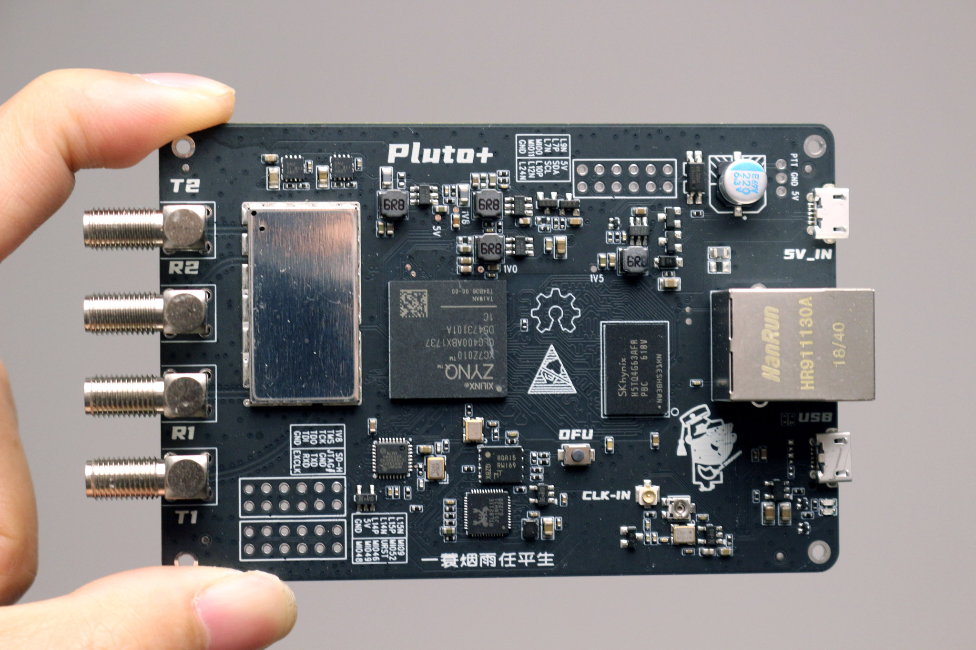

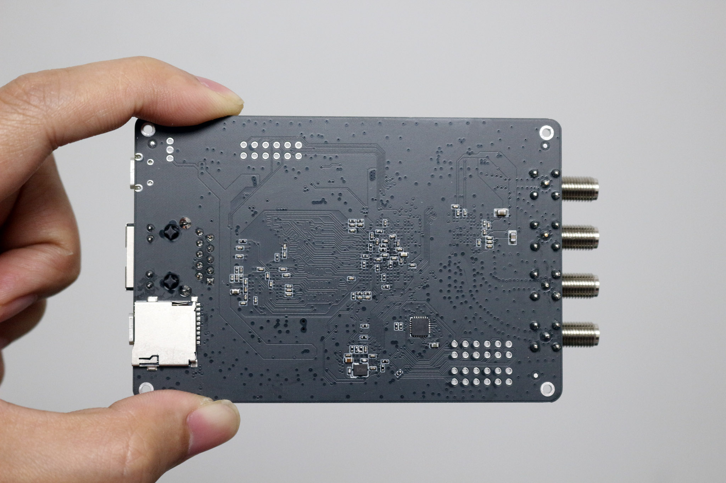

Interface Description
Please note that all IO levels are 1.8V.
3.1 When using the official ADI-PlutoSDR firmware, please connect to URST-MI052.
3.2 When using Pluto+ firmware and need to support Ethernet, please connect URST-MIO46
3.3 When using SD card to boot, please connect SD-H to 1V8
3.4 When using JTAG to debug, please connect JTAG# to GND
3.5 Please connect EXCLK to GND when using external reference clock input
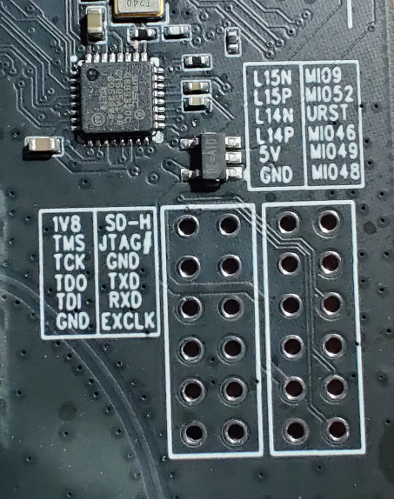

PTT port
PTT drives optocouplers through GPIO0 (MI00), which requires an external relay or control circuit.
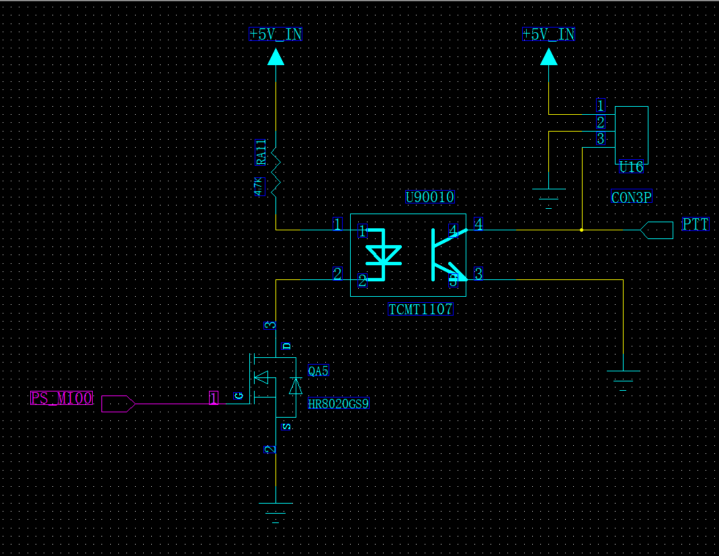
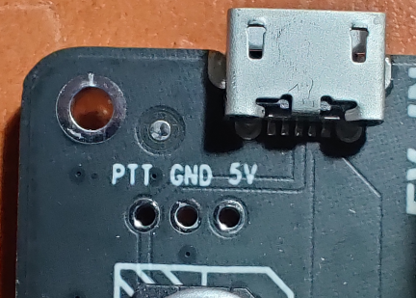

DFU KEY
At any time, you can press the DFU button and power on PLUTO+ again to enter the DFU mode, but you need to connect the URST jumper to MI052

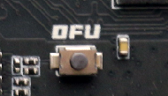
- REF CLK input IPEX
You can connect a cable to input an external high-precision reference clock for AD9363 through the IPEX interface.
The main level should not exceed 3.3V, and the EXCLK jumper needs to be connected to GND to turn off the built-in clock
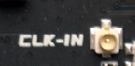
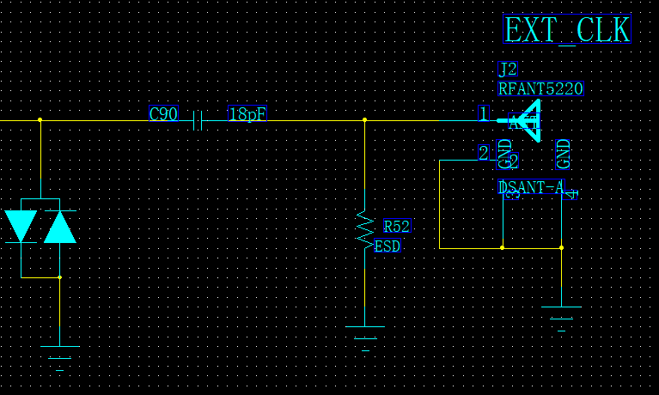
- Calibrate the frequency of the built-in VCTCXO
The frequency of the 40M clock can be fine-tuned by adjusting the adjustable resistor next to the VCTCXO, provided that you have a reference signal source
- Micro-SD
Support booting via SD card, need to connect SD-H jumper to 1V8
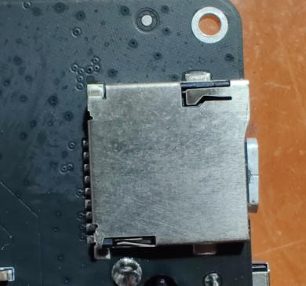

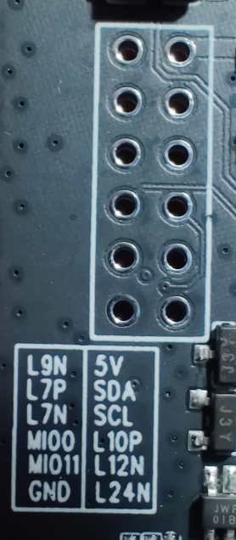

7.Enable 2T2R process：

To enable 2r2t, you need : fw_setenv mode 2r2t and fw_setenv compatible ad9361 and reboot.
8.SATSAGEN:
If you need to use SATSAGEN, please re-flash the firmware, because once it is cracked into AD9361 and 2T2R is enabled, SATSAGEN cannot be used
9:Fixed Ethernet IP
Need to edit [USB_ETHERNET] of config.txt in the memory
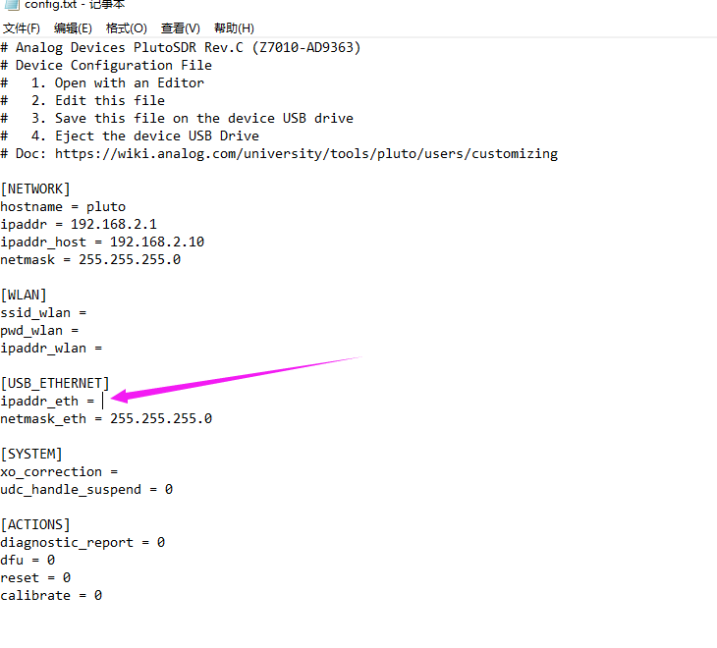
10.Firmware source code address
https://github.com/plutoplus

