Implementation of the Presentation layer:

Created three interfaces:

1. Login – The login functionality has not been created for this project. It will show the ability to move from one presentation class to another:

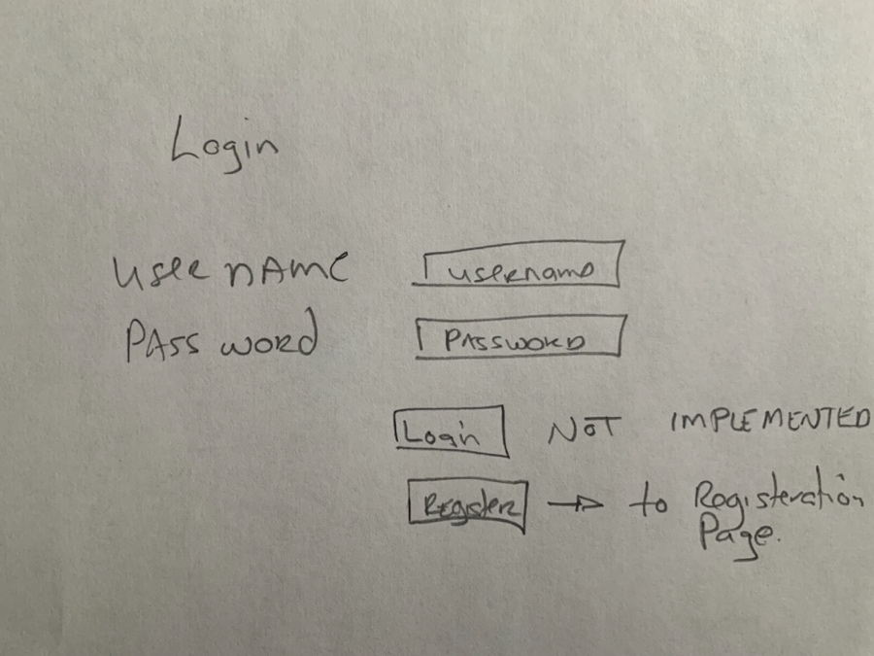

TravlerLogin.java

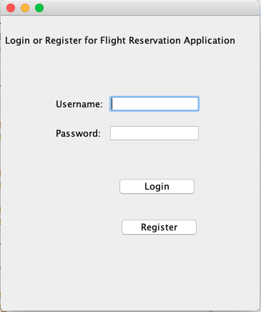

Button Push ‘Login’

Enter ‘username’ in username field returns:

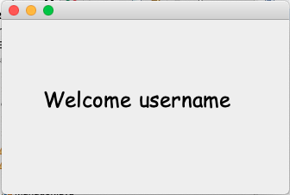

Button Push ‘Register’

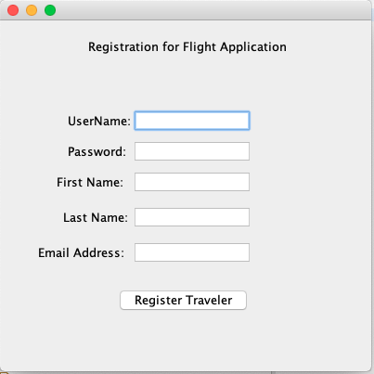

1. Register Traveler – will implement the call to the Business class to insert a travelers information into the file

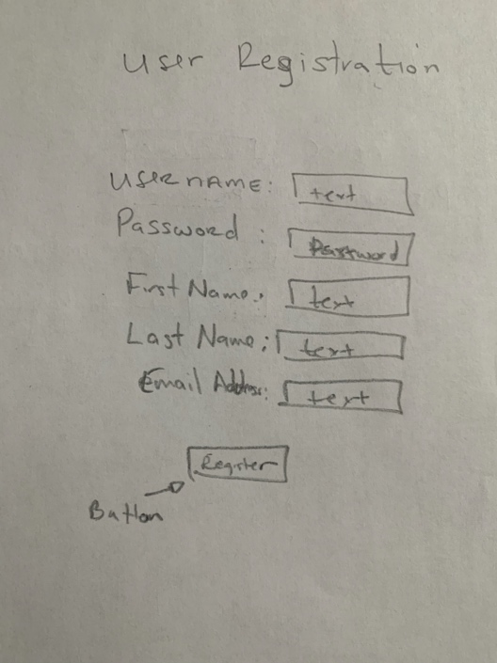



Traveler.out file is empty:

Enter Data in form and Button Push Register Traveler

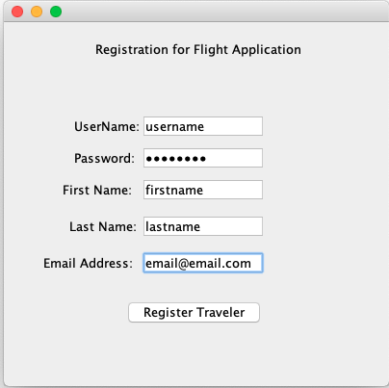

Data entered into Traveler.out and message of update completed.

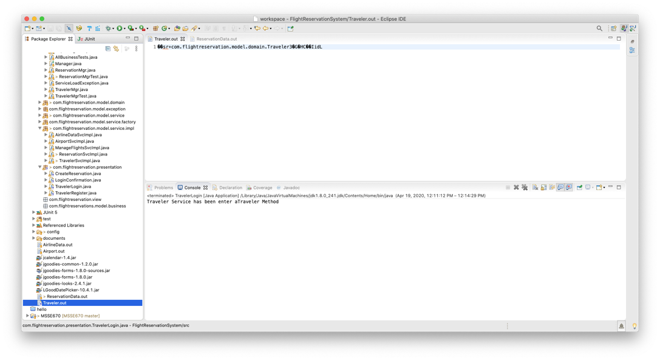

1. Reservation – Implements the business layer class to insert information into the Reservation file.

Launch the ‘CreateReservation’ class: Run As Java Application

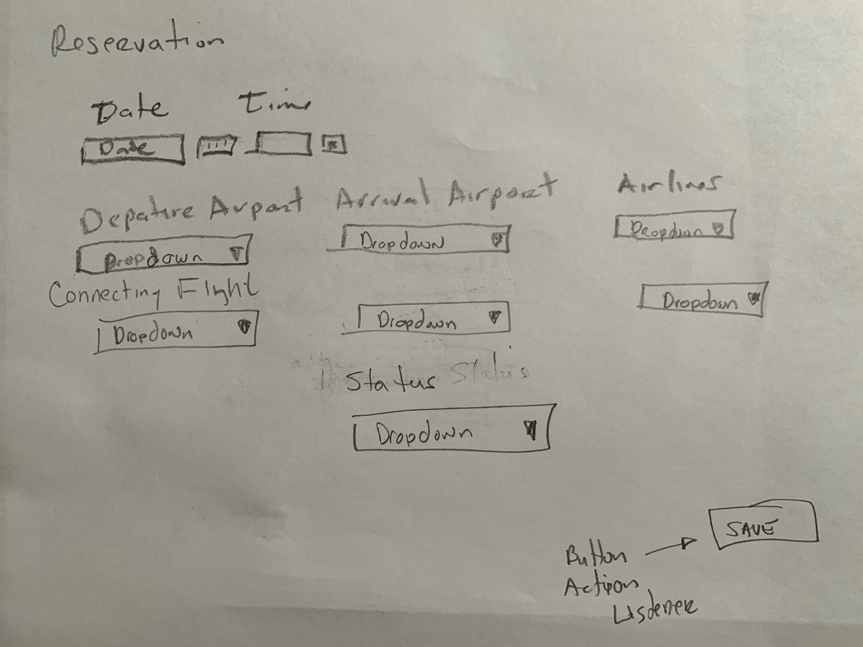

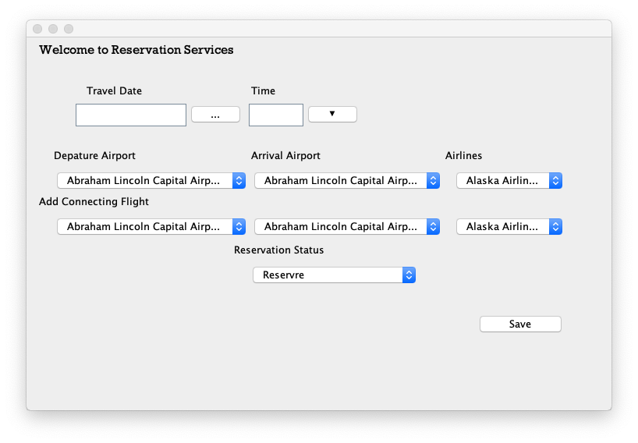

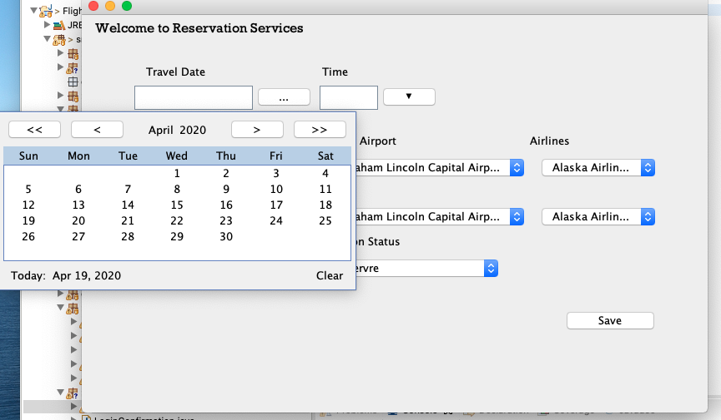

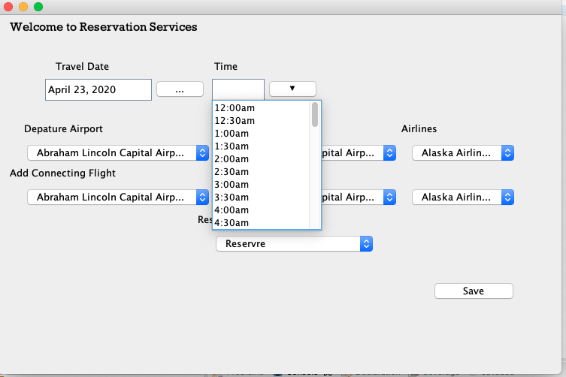

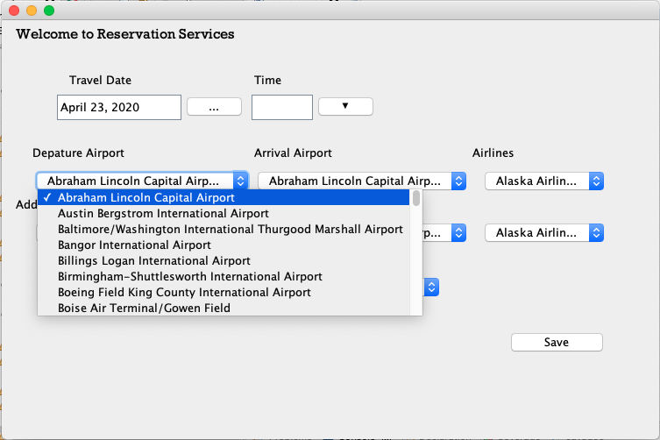

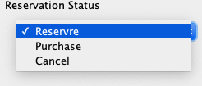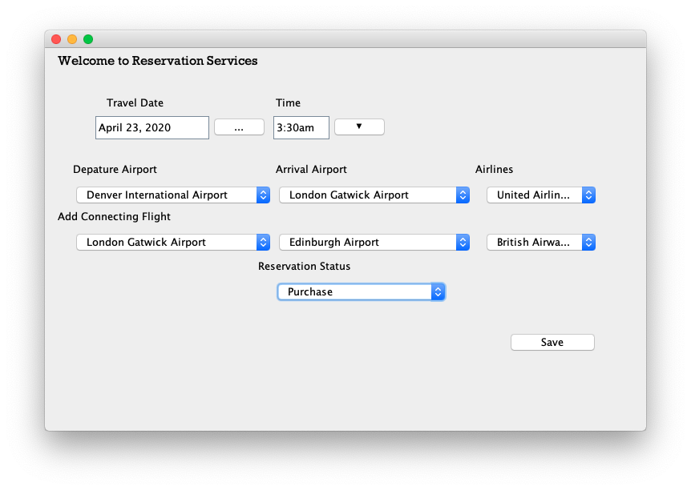

Data populated in the Reservation File by the Business layer implementation

