Analysis, Design, Implementation and Test
Deliverables

CO2006 Software Engineering and System Design
University of Leicester, UK
Autumn 2007

Project: ESIAL

Date | Author | Contribution in % | Signature
11/12/08 | Martin DELEMOTTE | 100
11/12/08 | Thomas KLEIN | 100
11/12/08 | Antoine PISSOT | 100
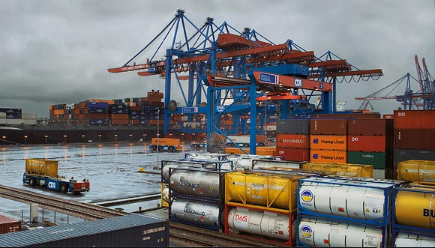
Project: Smallport Port Management
Client: Smallport
Contractors: 7

System Analysis/Design

Software Architecture

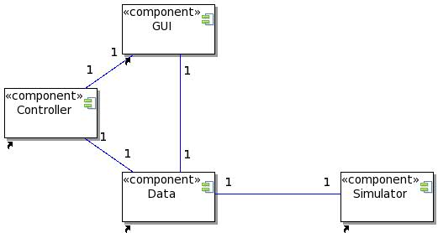Illustration 1: Software architecture
The Small Port management software is based on an 3-tier architecture following the Model Vue Controller Pattern.
The GUI component is composed of the GUI used at the Logistics Department and the GUIs used by the port operators (crane operator, unloading supervisor, lorry driver, etc). The controller is in charge of repsonding to GUI events and dispatching the stradlle carriers where needed. It operates based on data provided by the hardware sensors of the straddle carriers, which are for demo purposes simulated by the simulator.

Analysis Sequence Diagrams
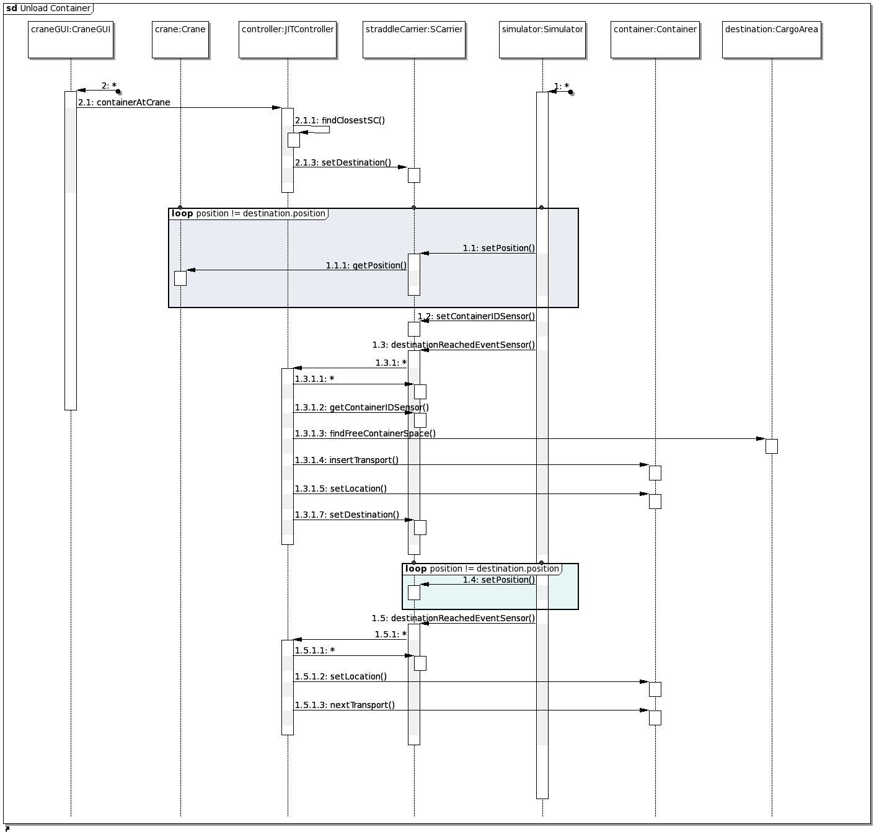Illustration 2: Unload Container Sequence diagram

Design Class Diagram
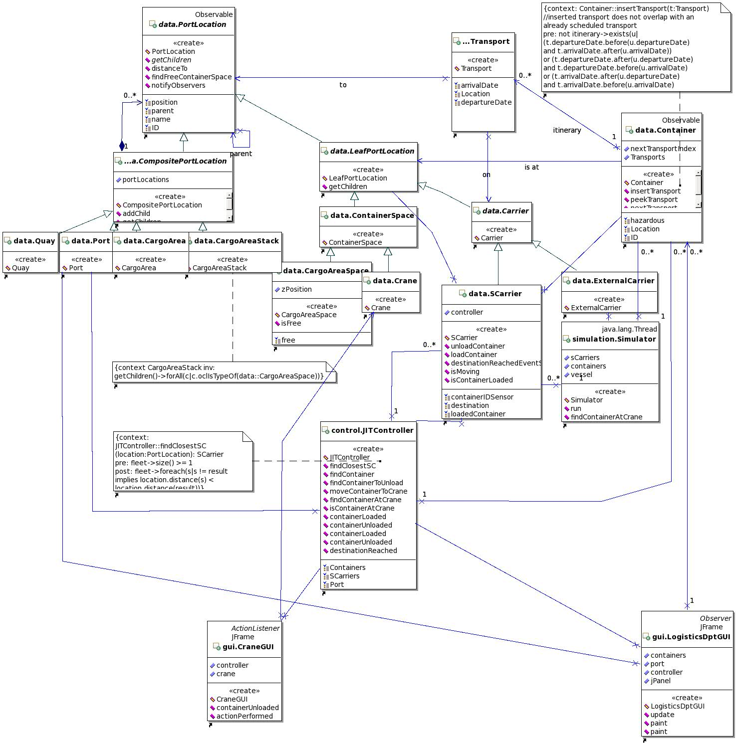Illustration 3: Design Class Diagram
The Design Class Diagram of the project follows the Model View Controller pattern described in the software architecture's component diagram. To implement this architecture it relies on the Observer pattern with the GUI being the observers and the data classes being Observable.
To represent the port in a extensible an powerful way, the Composite design pattern has been used : some elements of the port like the CargoArea are composite elements which means they can contain other elements whereas some other elements like the straddle carriers are leafs. Leafs can only contain containers. One interesting thing to notice is that the port itself is a Composite element.

State Machines
The two following state machines look simplistic. We consider this a success since the purpose of our design is to keep things simple for the programmers. The more states there are, the more difficult is the implementation and therefore we tried to keep the number of states as low as possible.
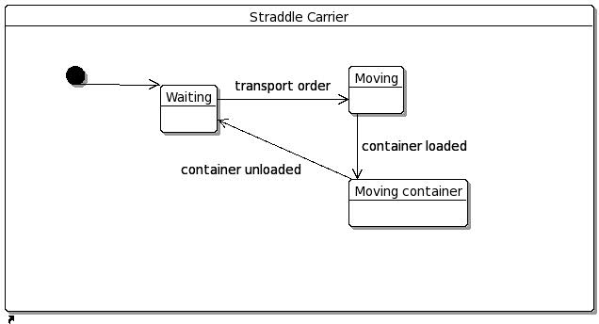Illustration 4: Straddle Carrier statechart diagram
As shown on Illustration 4 and in accordance to the sequence diagram, straddle carriers have have only 3 states : either there are waiting for the controller to give the a destination, either there are moving with no load, either there are moving a container.

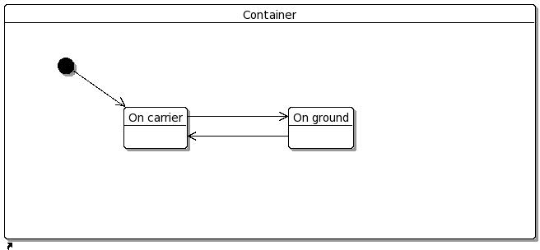Illustration 5: Container statechart diagram
The container statechart diagram is even more simple : either a container is on a carrier (vessel, barge, straddle carrier, etc), either is it on the ground (cargo area, crane, etc).

Design by contracts

context: Container::insertTransport(t:Transport)
//inserted transport does not overlap with an already scheduled transport
pre: not itinerary->exists(u|
(t.departureDate.before(u.departureDate)
and t.arrivalDate.after(u.arrivalDate))
or (t.departureDate.after(u.departureDate)
and t.departureDate.before(u.arrivalDate)
or (t.arrivalDate.after(u.departureDate)
and t.arrivalDate.before(u.arrivalDate)
)
post: this.peekTransport() = t

context: JITController::findClosestSC(location:PortLocation): SCarrier
pre: fleet->size() >= 1
post: fleet->foreach(s|s != result implies location.distance(s) < location.distance(result))

context CargoAreaStack inv:
getChildren()->forAll(c|c.oclIsTypeOf(data::CargoAreaSpace))

Prototype
The prototype can be found at:
http://code.google.com/p/bestport/

Tests

System Level Tests
Based on your requirements document, specify system level tests. The Actual Result column specifying the outcome of the test, should say whether the test was successful, and if not, what was the result.

Test Name | User Action/Input | Expected Result | Actual Result

<< Please complete table >>

Figure 3.1: System Level Test Cases

Unit Tests
The unit tests should be submitted electronically with the corresponding java classes. You should submit one complete Eclipse project with java class- and JUnit code (see above). All course code submitted must compile without syntax errors.

Please write JUnit test classes for two or three crucial Java classes, to test up to 6 methods in total.

