Mark Demore II

CSCE523

Assignment #3

1. The Cheshire Cat uses inference in this argument, simplifying with transitivity and negation, but it is not entirely sound because the behavior is extrapolated from the dog as representative of sanity, using transitivity. The Cheshire Cat essentially says “A dog is not mad AND a dog behaves this way. Because I behave the opposite way, I am mad”. Whereas a more direct result would be that the Cheshire Cat is simply not a dog.
2. KNOWLEDGE BASE:

HB(x) = is hummingbird

C(x) = is richly colored

L(x) = is large

H(x) = eats honey

DERIVED STATEMENTS:



CNF:

1. a) {x/cat, y/dog, z/x}

b) {x/Hearts, y/Cheshire}

c) If Jack is the brother of Mary and Mary is the sister of Jack, they cannot be applied to Son or Daughter, and there are no other variables which can be used for x, y, z or f(x).

1. KB in CNF:

S1:

S2:

S3:

S4:

S5:

S6:

S7:

S8:

S9:

S10:

S11:

S12:

S13:

1. 14. Goal:

15. [4,7] {x/Jack, y/Amy}

16. [1,9,15] {x/Amy, y/Jack, z/John}

17. [2,11,16] NULL {x/John, y/Amy, z/Mary}

b) 18. Goal:

19. [1,12,17,18] NULL {x/John, y/Jack, z/Mary}

c)

20. GOAL:

21. [9,20] NULL {x/Jack, z/John}

1. a) 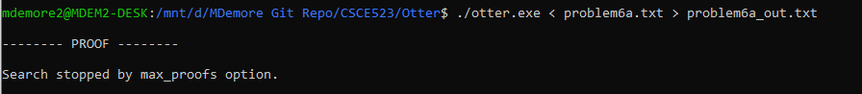

b) 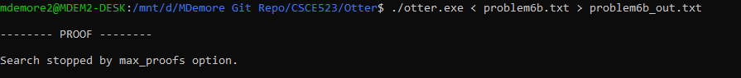

c)

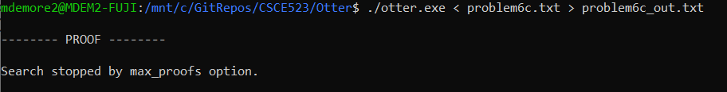

d)

This problem cannot be solved using the existing knowledge base. One rule needs to be added so that it can be deduced that because Amy is siblings with Jack and Jack is siblings with Bill then Amy and Bill are also siblings. This would not invalidate the knowledge base.

e)

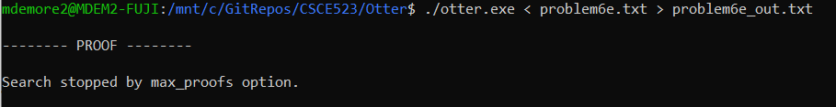



|  |  |  |  |  |  |  |
| --- | --- | --- | --- | --- | --- | --- |
|  | Zelda | Link | Ganondorf | Poe | Iron Knuckle | Octorock |
| Bow | = | ! | ! |  |  |  |
| Sword | ! |  |  |  |  |  |
| Magic | ! |  |  |  |  |  |
| Octorock |  |  |  |
| Iron Knuckle |  |  |  |
| Poe |  |  |  |

|  |  |  |  |  |  |  |
| --- | --- | --- | --- | --- | --- | --- |
|  | Zelda | Link | Ganondorf | Poe | Iron Knuckle | Octorock |
| Bow | = | ! | ! |  |  |  |
| Sword | ! | = | ! |  |  |  |
| Magic | ! | ! |  |  |  |  |
| Octorock |  |  |  |
| Iron Knuckle |  |  |  |
| Poe |  |  |  |

|  |  |  |  |  |  |  |
| --- | --- | --- | --- | --- | --- | --- |
|  | Zelda | Link | Ganondorf | Poe | Iron Knuckle | Octorock |
| Bow | = | ! | ! |  |  |  |
| Sword | ! | = | ! |  |  |  |
| Magic | ! | ! | = |  |  |  |
| Octorock |  |  |  |
| Iron Knuckle |  |  |  |
| Poe |  |  |  |

|  |  |  |  |  |  |  |
| --- | --- | --- | --- | --- | --- | --- |
|  | Zelda | Link | Ganondorf | Poe | Iron Knuckle | Octorock |
| Bow | = | ! | ! |  |  |  |
| Sword | ! | = | ! |  |  |  |
| Magic | ! | ! | = |  |  |  |
| Octorock | = | ! | ! |
| Iron Knuckle | ! |  |  |
| Poe | ! |  |  |

|  |  |  |  |  |  |  |
| --- | --- | --- | --- | --- | --- | --- |
|  | Zelda | Link | Ganondorf | Poe | Iron Knuckle | Octorock |
| Bow | = | ! | ! |  |  |  |
| Sword | ! | = | ! |  |  |  |
| Magic | ! | ! | = |  |  |  |
| Octorock | = | ! | ! |
| Iron Knuckle | ! | = | ! |
| Poe | ! | ! |  |

|  |  |  |  |  |  |  |
| --- | --- | --- | --- | --- | --- | --- |
|  | Zelda | Link | Ganondorf | Poe | Iron Knuckle | Octorock |
| Bow | = | ! | ! |  |  |  |
| Sword | ! | = | ! |  |  |  |
| Magic | ! | ! | = |  |  |  |
| Octorock | = | ! | ! |
| Iron Knuckle | ! | = | ! |
| Poe | ! | ! | = |

|  |  |  |  |  |  |  |
| --- | --- | --- | --- | --- | --- | --- |
|  | Zelda | Link | Ganondorf | Poe | Iron Knuckle | Octorock |
| Bow | = | ! | ! | = | ! | ! |
| Sword | ! | = | ! | ! |  |  |
| Magic | ! | ! | = | ! |  |  |
| Octorock | = | ! | ! |
| Iron Knuckle | ! | = | ! |
| Poe | ! | ! | = |

Violated: Ganondorf fought Poe and Ganondorf does not have the bow.

|  |  |  |  |  |  |  |
| --- | --- | --- | --- | --- | --- | --- |
|  | Zelda | Link | Ganondorf | Poe | Iron Knuckle | Octorock |
| Bow | = | ! | ! | ! |  |  |
| Sword | ! | = | ! | = | ! | ! |
| Magic | ! | ! | = | ! |  |  |
| Octorock | = | ! | ! |
| Iron Knuckle | ! | = | ! |
| Poe | ! | ! | = |

Violated: Link has the sword and did not fight Poe.

|  |  |  |  |  |  |  |
| --- | --- | --- | --- | --- | --- | --- |
|  | Zelda | Link | Ganondorf | Poe | Iron Knuckle | Octorock |
| Bow | = | ! | ! | ! |  |  |
| Sword | ! | = | ! | ! |  |  |
| Magic | ! | ! | = | = | ! | ! |
| Octorock | = | ! | ! |
| Iron Knuckle | ! | = | ! |
| Poe | ! | ! | = |

|  |  |  |  |  |  |  |
| --- | --- | --- | --- | --- | --- | --- |
|  | Zelda | Link | Ganondorf | Poe | Iron Knuckle | Octorock |
| Bow | = | ! | ! | ! | = | ! |
| Sword | ! | = | ! | ! | ! |  |
| Magic | ! | ! | = | = | ! | ! |
| Octorock | = | ! | ! |
| Iron Knuckle | ! | = | ! |
| Poe | ! | ! | = |

Violated: Zelda has the bow and did not fight the Iron Knuckle.

|  |  |  |  |  |  |  |
| --- | --- | --- | --- | --- | --- | --- |
|  | Zelda | Link | Ganondorf | Poe | Iron Knuckle | Octorock |
| Bow | = | ! | ! | ! | ! |  |
| Sword | ! | = | ! | ! | = | ! |
| Magic | ! | ! | = | = | ! | ! |
| Octorock | = | ! | ! |
| Iron Knuckle | ! | = | ! |
| Poe | ! | ! | = |

|  |  |  |  |  |  |  |
| --- | --- | --- | --- | --- | --- | --- |
|  | Zelda | Link | Ganondorf | Poe | Iron Knuckle | Octorock |
| Bow | = | ! | ! | ! | ! | = |
| Sword | ! | = | ! | ! | = | ! |
| Magic | ! | ! | = | = | ! | ! |
| Octorock | = | ! | ! |
| Iron Knuckle | ! | = | ! |
| Poe | ! | ! | = |