Mark Demore II

CSCE523

Assignment #4

1.

2.

3.

4.

Problem 2 Verification:

FS & A observed:

probability ( "TS" ) { //1 variable(s) and 2 values

table

0.8836824696802645 // p(true | evidence )

0.11631753031973541; // p(false | evidence ); }

FS & !A observed:

probability ( "TS" ) { //1 variable(s) and 2 values

table

0.8531368821292775 // p(true | evidence )

0.14686311787072245; // p(false | evidence ); }

!FS & A observed:

probability ( "TS" ) { //1 variable(s) and 2 values

table

0.41497678964085016 // p(true | evidence )

0.5850232103591498; // p(false | evidence ); }

!FS & !A observed:

probability ( "TS" ) { //1 variable(s) and 2 values

table

0.4820381231671554 // p(true | evidence )

0.5179618768328446; // p(false | evidence ); }

Edited Rain Values, FL observed:

probability ( "TS" ) { //1 variable(s) and 2 values

table

0.8036196650459212 // p(true | evidence )

0.1963803349540789; // p(false | evidence ); }

Edited Rain Values, FL NOT observed:

probability ( "TS" ) { //1 variable(s) and 2 values

table

0.401 // p(true | evidence )

0.599; // p(false | evidence ); }

5.

Because it was much harder to compare V(s) for the larger grids, I observed the convergence of values on a simple 5x5 grid. The issue with comparing the two is that TD lambda has initial randomness and then sticks to a particular path once it has observed values for familiar states, as shown in the contrast between table values where the bottom path to the goal is taken more often for TD Lambda, resulting in very similar state values along that path. The number of episodes also greatly varies the results on the smaller grids and presents issues when comparing.

Conversely, the decrease in steps per iteration was not noticeable for TD Lambda on smaller grids, given the randomness. However, it was significantly noticeable on the larger grids, despite the vastly larger number of states for the 25x25 and 50x50 grids. With so many states, it was difficult to compare V(s) between the two methods.

|  |  |  |  |  |
| --- | --- | --- | --- | --- |
| 0 | 0 | 0 | 0 | 0 |
| G: 100 | 83.22 | 69.25 | 57.64 | 48.19 |
| 83.23 | 0 | 0 | 0 | 40.10 |
| 69.58 | 57.90 | 48.19 | 40.10 | 33.53 |
| 0 | 0 | 0 | 33.53 | S: 28.033 |

**Table 1: Value Iteration for 5x5**

|  |  |  |  |  |
| --- | --- | --- | --- | --- |
| 3.52 | 5.07 | 4.46 | 0.99 | -0.20 |
| G: 0 | 20.87 | 14.35 | 1.17 | 1.45 |
| 82.38 | 3.79 | 1.87 | 5.84 | 4.14 |
| 60.44 | 46.29 | 34.68 | 25.92 | 17.27 |
| 3.02 | 0 | 4.23 | 8.77 | S: 7.38 (random after initial) |

**Table 2: TD Lambda for 5x5**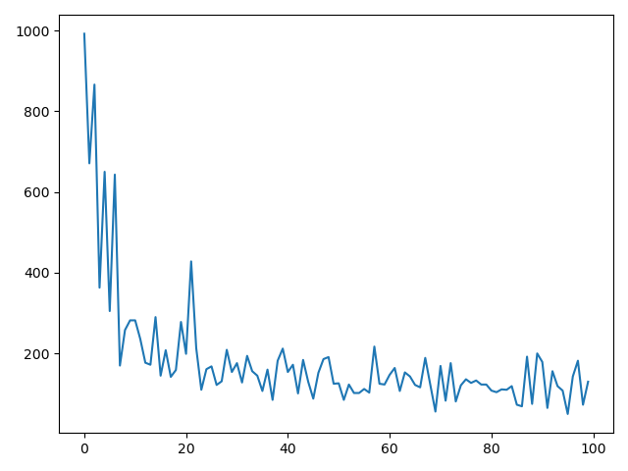

**Fig. 1: Steps Taken vs. # of Iterations for 25x25**

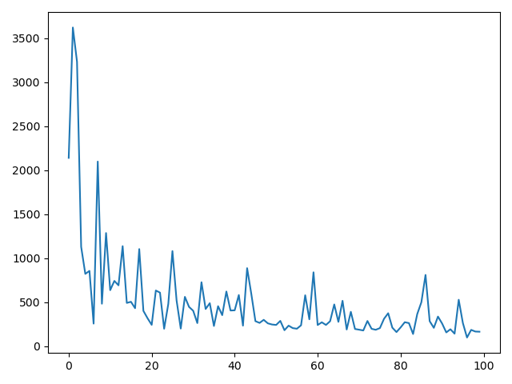

**Fig. 2: Steps Taken vs. # of Iterations for 50x50**