# CSCE 593 Homework 1 – Due 11 Oct at 0930 (WPAFB time)

This assignment will create a simple virtual world and let events, such as a key press, set the position of the object. The intent is to become familiar with an AftrBurner Module and its basic layout (this is a framework for rapidly creating visualizations of multidimensional data over time).

## Setup Instructions to begin HW1

1. Browse to the location where the usr repository is checked out. Create a folder based on your username firstname.lastname, as shown below:

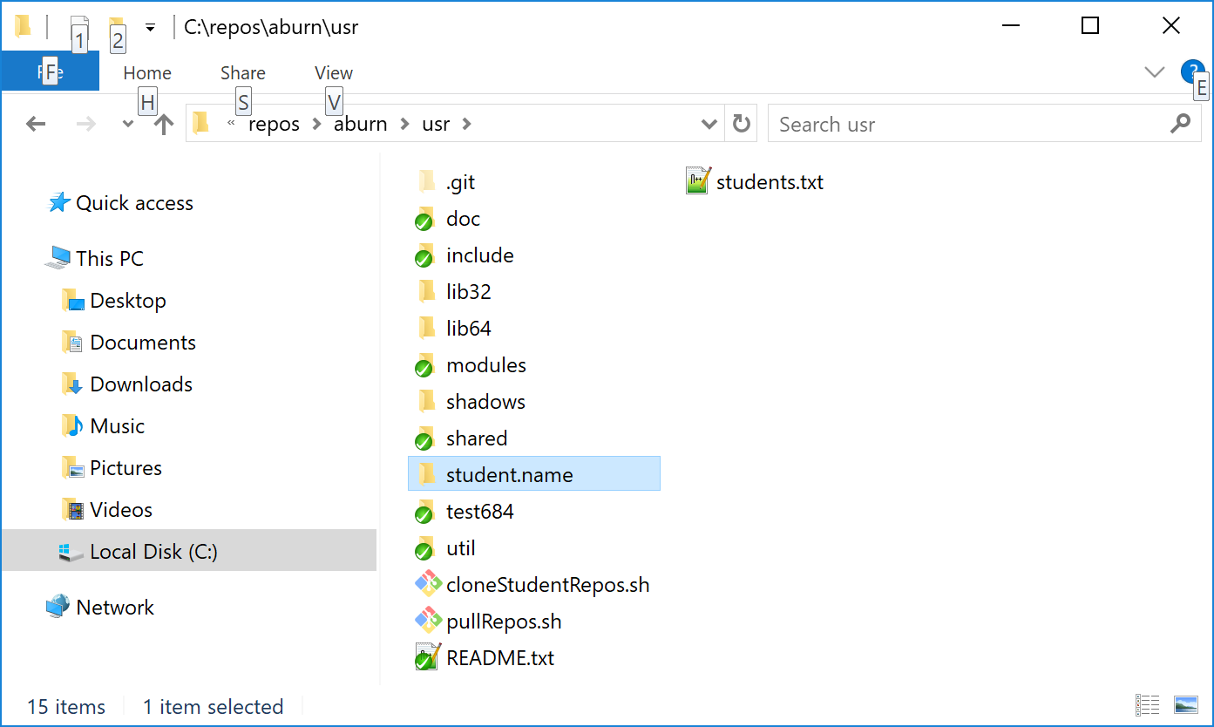

1. For simplicity, move your CSCE593 repo (with the remote set) inside this directory. After this move is complete, the contents should look like this:

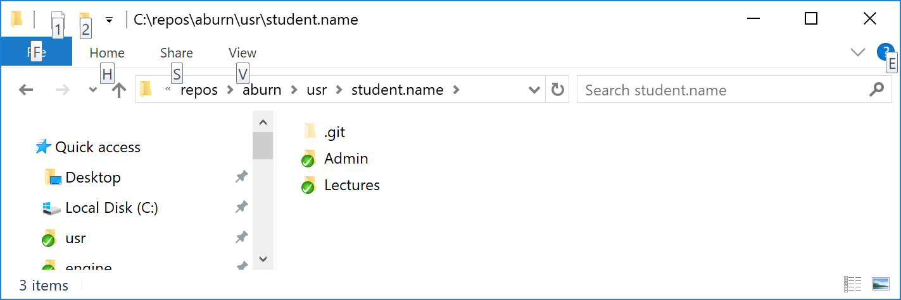

1. Execute a “git pull upstream master” to ensure you pull the latest posting from the CSCE593.git master repo. This should make a folder called HW1 appear as shown below:
2. Open the “HW1” folder and double click “BUILD 64 BIT MSVC 2019.bat”.
3. Run CMake, generate an MSVC 2019 solution.
4. Browse into the cwin64 folder and double click the .sln solution file. MSVC 2019 should open.
5. Within the “Solution Explorer” Window, ensure the “HW1” project is “Set as default project”. You may have to right click on it and select “Set as default project”.

## HW1 Objective

* Load a 3D model from file.
* Encapsulation the 3D model as a World Object (WO)
* Bind key presses to move the WO around the virtual world
* See HW1Nykl.exe as an example.
* Key “Up arrow” (SDLK_UPARROW) will move the object “forward” 1 meter
* Key “Down arrow” (SDLK_DOWNARROW) will move the object “backward” 1 meter
* Key “Left arrow” will rotate the object “left” by 15 degrees
* Key “Right arrow” will rotate the object “right” by 15 degrees
* Key “T” will teleport the object back to the origin at location (0,0,10) and face the WO along the +X axis

