Mark Demore II, 2d Lt

CSCE686 - Dr. Lamont

Spr 2020 - Homework 3

1. For the MIS and Clique problems, the size of the graph does not directly correlate to the speed in which an algorithm can solve the problem to optimality. In particular, graphs with more cycles will require much more time to solve to optimality than a Turan graph, a multipartite graph. Even with state-of-the-art exact optimization methods, the MIS and Clique problems require exhaustive searches that become cumbersome with backtracking on graphs with many cycles. This is demonstrated in problem 2.
2. Experimental Design:

The goal of this experiment is to evaluate the *graphprogram* for the maximum independent set problem on graphs of varying sizes (small, medium, and large) and types (planar and nonplanar).

Measurement:

To accomplish the aforementioned experiment, 3 graphs of each size will be run 3 times through the algorithm and the average calculation time will be used to compare. For each size, a Turan graph, single cycle (or ring) graph, and a random graph. The sizes will be defined as: small – 10 vertices, medium – 20 vertices, and large – 30 vertices.

A small ring graph:

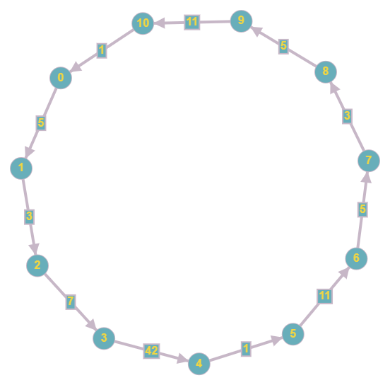

A small Turan graph:

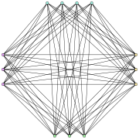

Reporting:

The table below shows the raw results from the experiment.

|  |  |  |  |  |  |  |
| --- | --- | --- | --- | --- | --- | --- |
| Vertices | Ring | Turan | Time 1 | Time 2 | Time 3 | Avg |
| 10 | Y | N | 0.029 | 0.027 | 0.022 | 0.026 |
| 10 | N | N | 0.014 | 0.014 | 0.012 | 0.013333 |
| 10 | N | Y | 0.006 | 0.005 | 0.005 | 0.005333 |
| 20 | N | N | 0.08 | 0.074 | 0.082 | 0.078667 |
| 20 | Y | N | 1.181 | 1.188 | 1.184 | 1.184333 |
| 20 | N | Y | 0.009 | 0.009 | 0.01 | 0.009333 |
| 30 | N | Y | 0.012 | 0.013 | 0.012 | 0.012333 |
| 30 | N | N | 0.251 | 0.25 | 0.251 | 0.250667 |
| 30 | Y | N | 9.133 | 9.012 | 7.808 | 8.651 |

In the figure below, the data is plotted with time, relative to graph size.

The plot shows that for most cases, even the large graph completes the MIS calculation in comparable time to the other graph sizes, although slightly larger. However, for one of the three graph types, a significant cost is incurred for the larger graph sizes. This is highlighted in the figure below.

This plot highlights the disparity between the Turan graph and the cyclic ring graph when completing the MIS calculation. For smaller cyclic cases, like the medium size graph, the algorithm cannot solve for optimality as quick as it can for the Turan graph of large size.

A search tree example of DFS with backtracking on a graph is shown below, with edges in black and search steps in red with numbered order:

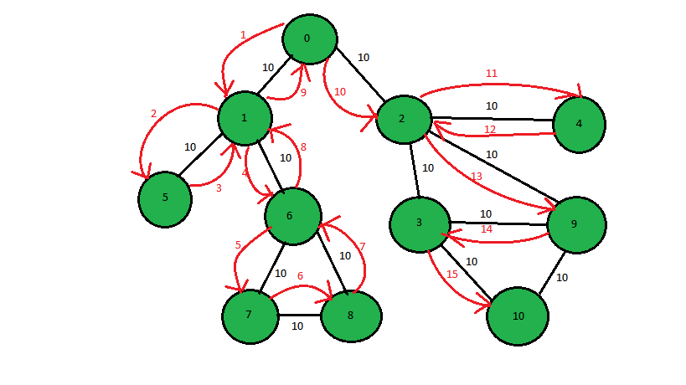

References:

https://en.wikipedia.org/wiki/Tur%C3%A1n_graph

https://en.wikipedia.org/wiki/Independent_set_(graph_theory)

https://en.wikipedia.org/wiki/Clique_problem

https://www.geeksforgeeks.org/print-the-dfs-traversal-step-wise-backtracking-also/

*Barr, et al*, Guidelines for Designing and Reporting on Computational Experiments with Heuristic Methods, 2001

Talbi, El-Ghazali. *Metaheuristics: from Design to Implementation*. Wiley, 2009.