C2C Mark Demore II

ECE 321

Dr. Dudevoir

22 September 2017

Diode Lab Analysis and Conclusions

**Part A. Device Characterization**

When characterizing the diode, the relationship between voltage and current are expected to be linear, based on the Shockley equation. This assumption is echoed in the simulation shown in Fig. 1 below.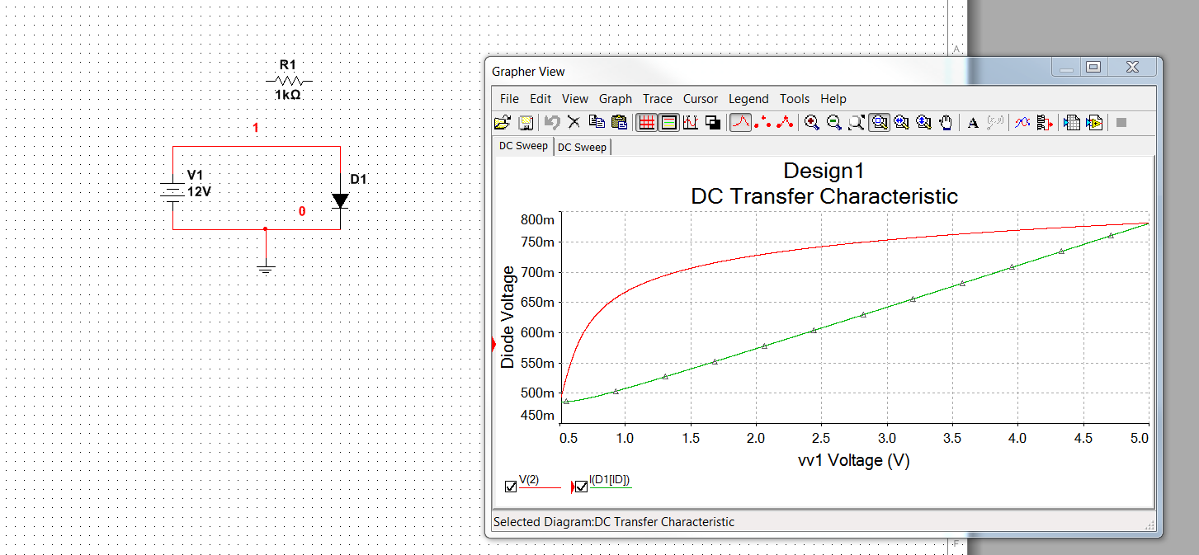  
**Figure 1: Simulation of Voltage-Diode Relationship**

The circuit shown in Fig. 1, with the addition of a load resistor, was the basis for testing in determining the characteristics of the given diode, to be used for further experimentation of small signal modeling in Part B of the lab. The results of lab measurements are shown below in Table 1.

**Table 1: Lab Measurements of Diode Characteristics**

|  |  |  |  |
| --- | --- | --- | --- |
| **Vsrc (V)** | **R (Ω)** | **ID (A)** | **VD (V)** |
| 1.2 | 10k | 76.5u | 0.467 |
| 1.2 | 5.1k | 145.3u | 0.492 |
| 1.2 | 2k | 343.2u | 0.528 |
| 1.3 | 1k | 0.82m | 0.567 |
| 1.3 | 510 | 1.55m | 0.596 |
| 1.6 | 270 | 3.78m | 0.637 |
| 1.3 | 100 | 6.84m | 0.663 |
| 1.3 | 51 | 12.68m | 0.690 |
| 1.7 | 27 | 33.79m | 0.732 |
| 1.4 | 10 | 53.97m | 0.751 |

With these results, a linear plot of the current through and voltage across the diodes was created, shown in Fig. 2. The regression of this plot is also featured in the plot below and provides the saturation current and ideality constant of the resistor, according to the Shockley equation. The ideality constant of 1.756 makes sense, with a typical value between 1 and 2. The saturation current for the diode from this plot is 1.945 nA, which is also on the typical scale for a traditional diode.

**Figure 2: Plot of Lab Measured Results for Characteristic of Diode**

**Part B. Small Signal Diode Modeling**

In order to recognize the small signal model for the diode in the forward and reverse bias, a traditional and Zener diode were compared as voltage regulators. The simulations shown in Fig. 3 and Fig. 4 emphasize the difference between the traditional diode in serial and the Zener diode with a large input voltage; the Zener providing a significantly greater voltage regulation.

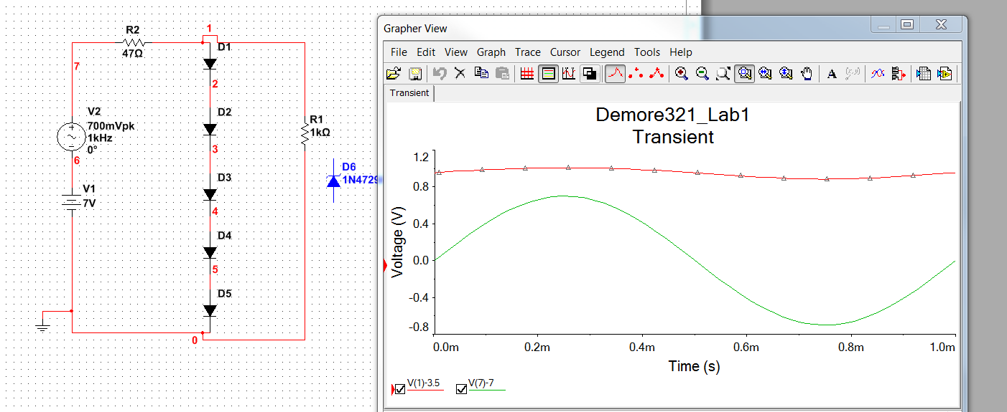

**Figure 3: Simulation of Serial Diode Voltage Regulation**

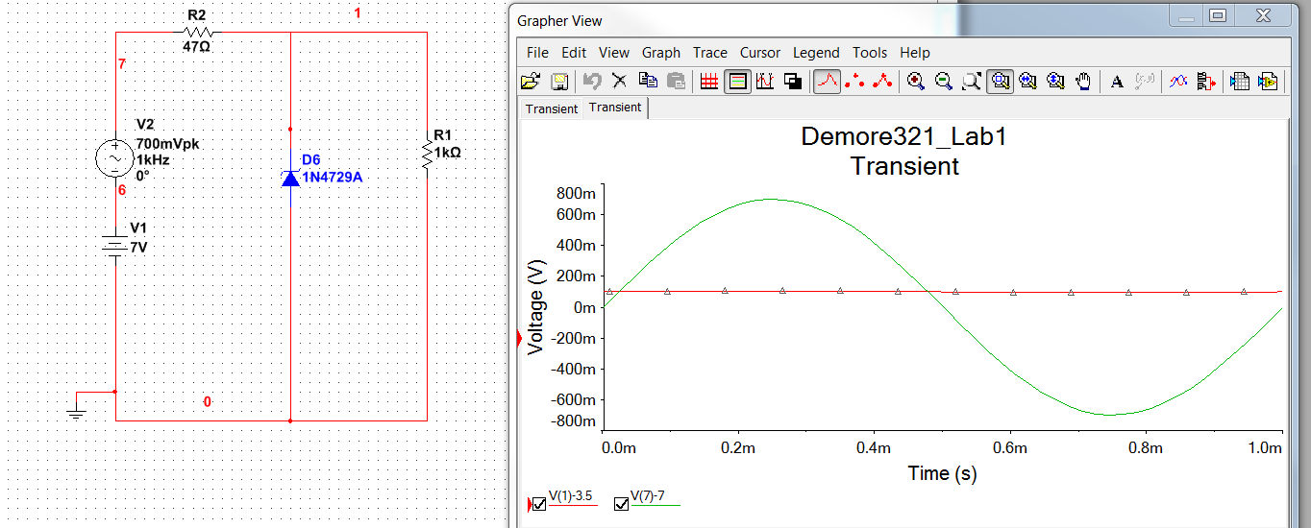

**Figure 4: Simulation of Zener Diode Voltage Regulation**

In Table 2 below, the results as measured from the oscilloscope in the lab, using the circuits shown in the simulation diagrams, are listed. As expected, both variations function better at larger input voltages. However, the Zener diode underperformed when compared to the 5 serial diodes.

**Table 2: Lab Measurements for Voltage Regulation**

|  |  |  |  |
| --- | --- | --- | --- |
| **Vi (V)** | **Asrc (mV pk-pk)** | **Aseries (mV pk-pk)** | **Azener (mV pk-pk)** |
| 7 | 480 | 34.8 | 57.9 |
| 5 | 513 | 74.2 | 110.8 |
| 3 | 828 | 418.2 | 751.0 |
| 2 | 967.1 | 408.4 | 952 |

**Part C. Large Signal Modeling**

When modeling the large signal output of the diode, a bridge rectifier was used to analyze the change in amplitude, as the signal moved from AC towards DC current. With the addition of a capacitor, the ripple increased the rectification and acted more as an AC/DC convertor. The simulation below in Fig. 5 shows the positive and negative outputs of the rectifier, which are added together to create the output signal.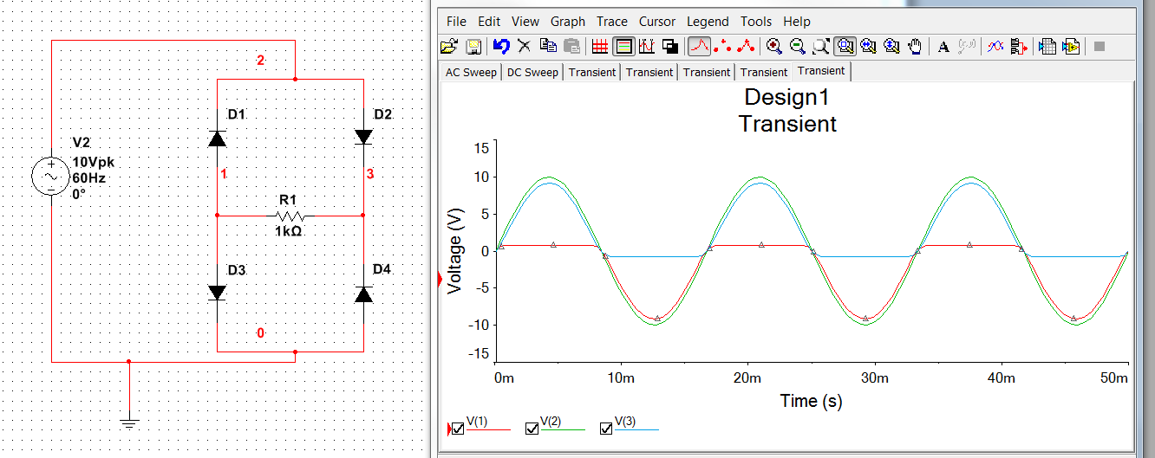

**Figure 5: Simulation of Rectified Signal**

The oscilloscope readings from the lab measurements, as shown in Figures 6 and 7, highlight the large signal attributes of the diode in the bridge rectifier. The measurements were obtained using the circuit shown in Fig. 5, and the results are shown in Table 3 below. The addition of the capacitor clearly creates the ripple and reduces the amplitude of the input signal, with ripple constant 1/RC.

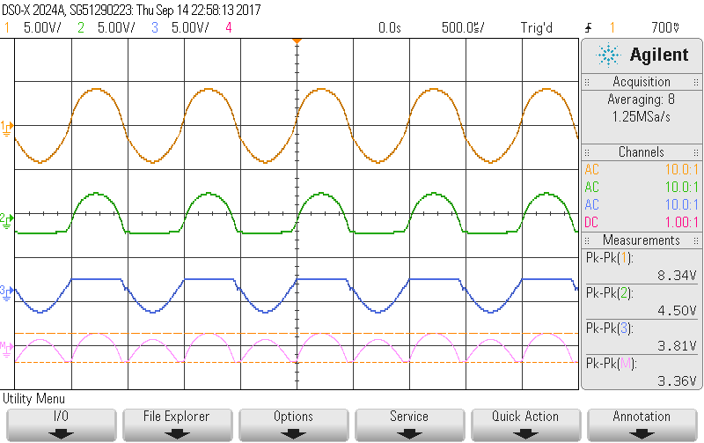

**Figure 6: Oscilloscope Reading of Input and Rectified Signal**

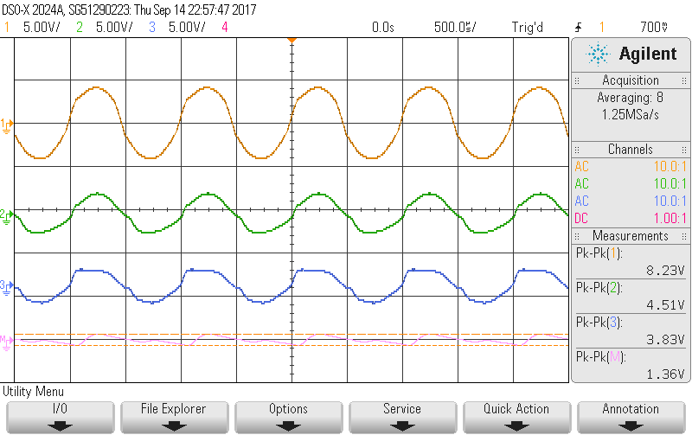

**Figure 7: Oscilloscope Reading of Input and Rectified Signal with Capacitor**

As shown by the results in Table 3, the most effective implementation of the bridge rectifier is in parallel with a smaller capacitor, increasing the ripple constant, and further reducing the signal amplitude. The significant rectification, and further rectification with the addition of the capacitor echoes expected results from the simulation and hand calculations.

**Table 3: Lab Measured Rectification**

|  |  |  |  |
| --- | --- | --- | --- |
| **Vi (V pk-pk)** | **R (Ω)** | **C (F)** | **A (V pk-pk)** |
| 8.30 | 1k | - | 3.40 |
| 8.20 | 1k | 1u | 1.37 |
| 8.14 | 1k | 4.7u | 450m |
| 8.09 | 1k | 10u | 250m |

**Conclusion**

In conclusion, the lab measurements compared well to the expected results based on simulations and hand calculations (included in pre-lab and lab notebook). Most errors are the result of simulation errors, with ideal component values as opposed to their true values in the lab. Moreover, assumptions, such as using the Zener diode well below the knee, lead to inaccurate predictions for voltage regulation. In the future, models and simulations will be better adapted to account for these non-idealities. The predictions and results of the lab are within the bounds of logical values for the characteristics of the diode, voltage regulation, and rectification. No significant difficulties were encountered throughout the lab, besides a lack of understanding of how to use some of the lab equipment. The distinct differences between large and small signal modeling lie in the behavior of the diode based on the various models (constant voltage, Shockley, etc.). With large signals, the diode behaves as a small, constant voltage source. With small signals, the diode behaves as a variable resistor dependent upon the source. Allowing current to pass in only one direction, there are many potential uses for diodes in electronic applications; as shown through the lab as voltage regulators and AC/DC converters.

Documentation: None