Mark Demore II

ECE332 – T6A

Lab 20d

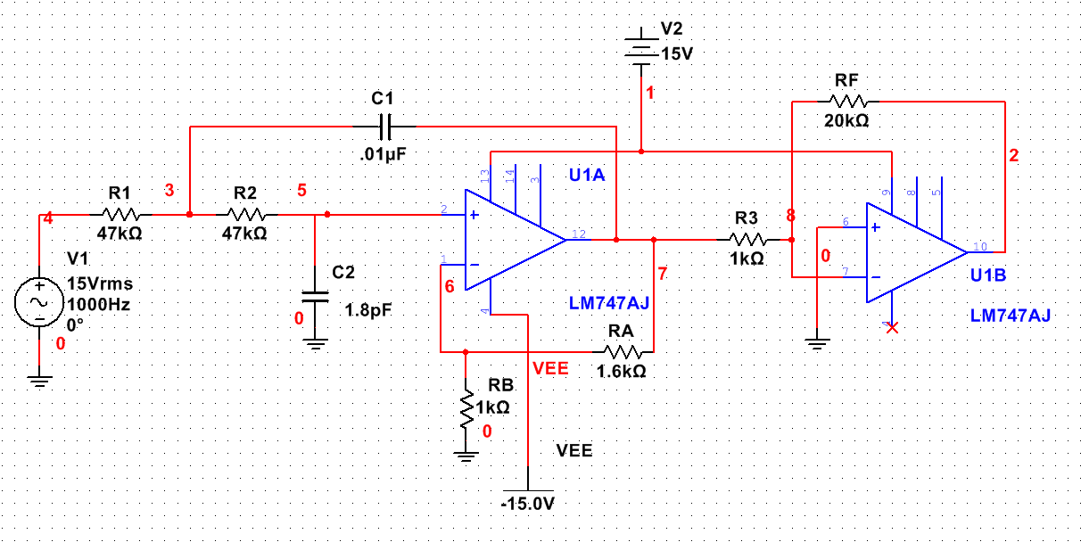

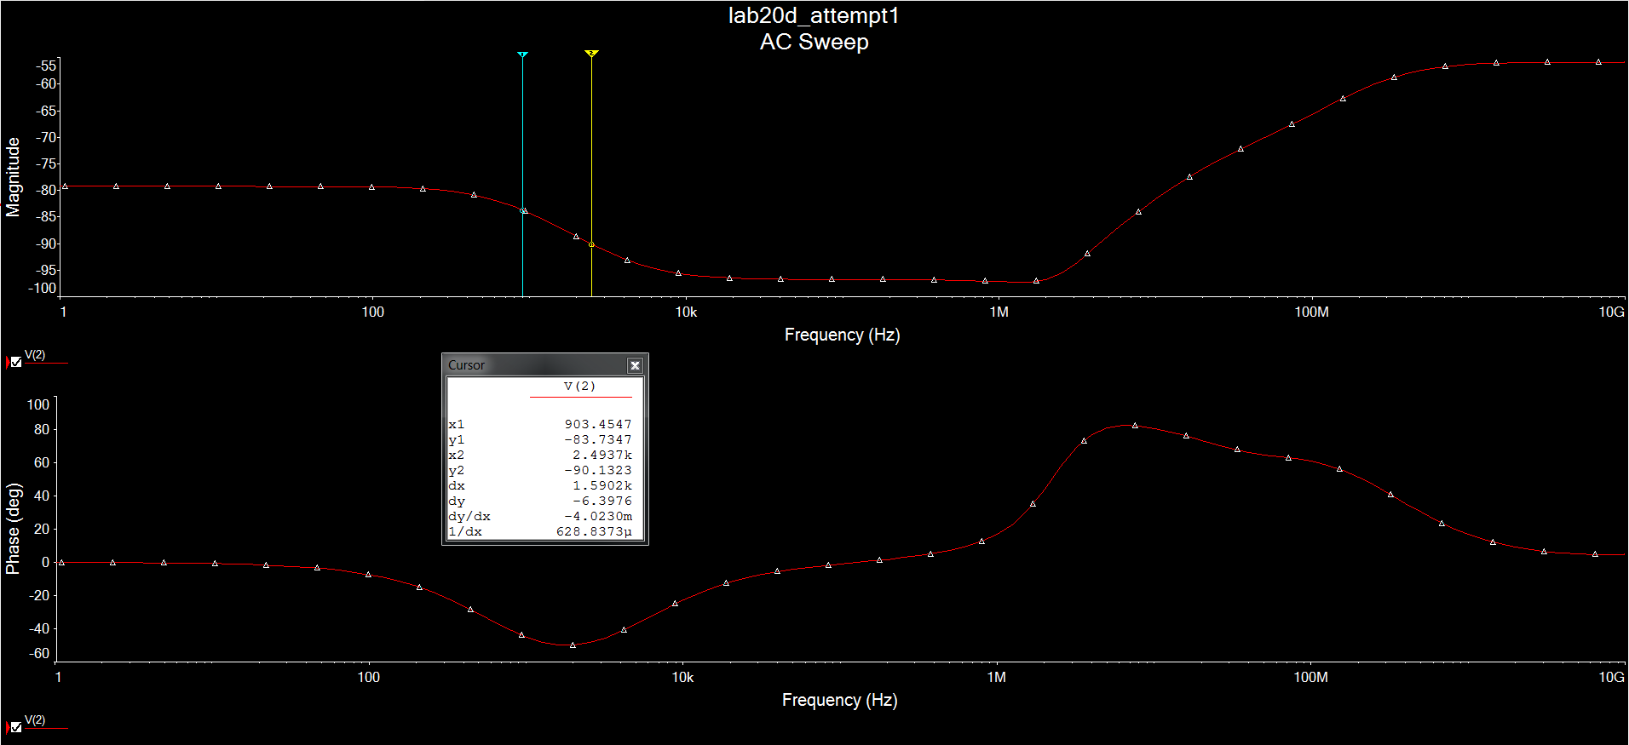

|  |  |  |  |  |  |  |
| --- | --- | --- | --- | --- | --- | --- |
|  | **Name?** | Demore |  |  |  |  |
|  | **Section?** | T6A |  |  |  |  |
|  | **Filter Type?** | Cheby |  |  |  |  |
|  | **Order?** | 3rd |  |  |  |  |
|  |  |  |  |  |  |  |
|  | **Lab 20d Cost Calculation** | | | | |  |
|  |  |  |  |  |  |  |
|  | Item | Qty/Filter | Unit Cost | Cost/Filter | Cost/500 |  |
|  | LM741 | 0 | $0.25 | $0.00 | $0.00 |  |
|  | LM747 | 1 | $0.40 | $0.40 | $200.00 |  |
|  | Resistors 5% | 6 | $0.02 | $0.12 | $60.00 |  |
|  | Resistors 1% | 0 | $0.04 | $0.00 | $0.00 |  |
|  | Capacitors | 2 | $0.12 | $0.24 | $120.00 |  |
|  | Board Area | 6 | $0.40 | $2.40 | $1,200.00 |  |
|  | Holes | 30 | $0.005 | $0.15 | $75.00 |  |
|  | Board Layout |  |  |  | $540.00 |  |
|  | Total |  |  |  | $2,195.00 |  |
|  |  |  |  |  |  |  |