United States Air Force Academy

Department of Electrical and Computer Engineering

ECE499 – Software Defined Radio

Pulse Verification and Message Transmission

C2C Mark Demore II

**Table of Contents**

Overview………………………………………………………………………………………..1

Pulse-Time Sink GRC Block…………………………………………………………………...1

Implemented Twilio SMS……………………………………………………………………....2

Iridium AT Command Implementation………………………………………………………....3

Works Consulted………………………………………………………………………………..5

1. **Overview**

In order to verify a predetermined pulse signal with Software Defined Radio (SDR), we implemented a Matched Filter (developed by C1C Josh Roseler), and a series of digital logic. Once passed through the matched filter using convolution, the series of pulses resemble one large pulse. When compared to a threshold value just above the noise level, the duration of this larger pulse can be measured digitally, represented by a stream of bits; 1 for above the threshold, or 0 for below the threshold. Since the pulse signal is already known, the length of the larger pulse is also known and the number of consecutive 1's in the bit stream can be determined with sample rate. GNU Radio Companion (GRC) features various blocks that can implement all of the functions necessary for the matched filter, as well as the threshold comparator that provides the bit stream. From here, I developed a GRC block that would verify the matched pulse length using digital logic based on an input array (the bit stream from the threshold block) and interface with the Twilio API to send an SMS with the time the signal was received. In the future, AT commands can be pushed from the PySerial library through USB to an Iridium phone to transmit SMS with the timestamp.

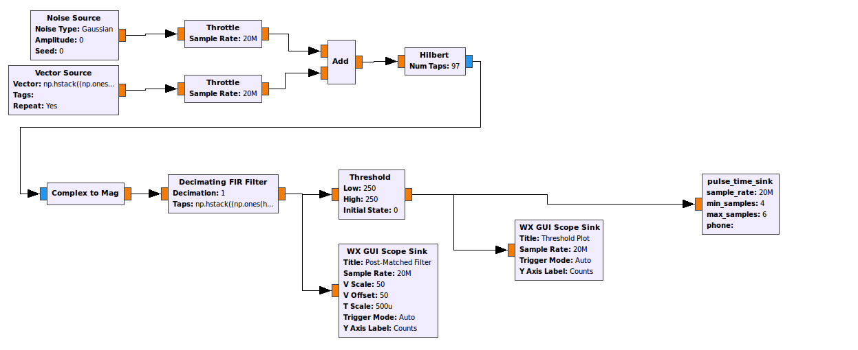

Figure 1. Overview of Receiver with Pulse-Time Sink

1. **Pulse-Time Sink GRC Block**

The Pulse-Time Sink GRC block takes input from the threshold block and its form of output is SMS containing the time the signal was received. The Pulse-Time Sink block stores the time as soon as the signal is received, uses a sliding average array to account for any signal glitches, and can be programmed to verify the signal within a range of positive samples. The block can also be programmed to send the timestamp SMS to any number.

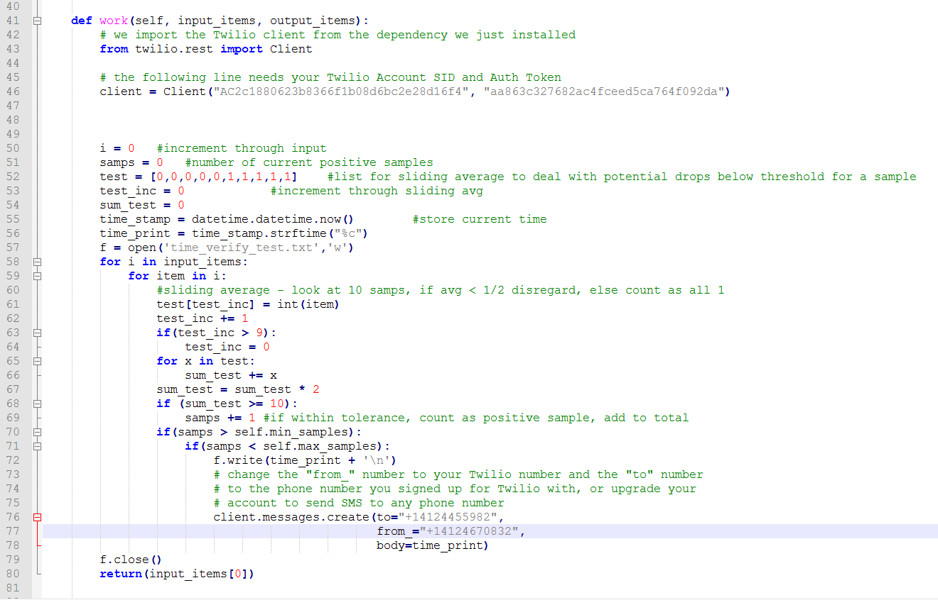

Figure 2. Pulse-Time Sink Code

1. **Implemented Twilio SMS**

The Twilio API allows SMS to be sent via internet connection, without the need for any other peripherals. The Pulse-Time Sink block is currently programmed with my Twilio account, but can be transferred to a more permanent account or alternate VOIP or similar API. The block authenticates with Twilio and sends the SMS over the internet from the account's assigned number to the number added in GRC.

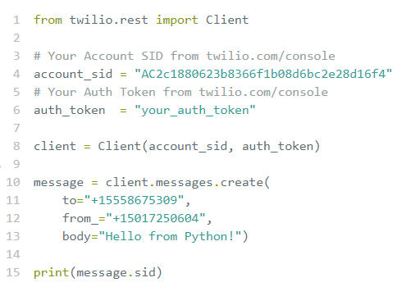

Figure 3. Twilio – Python Interface

1. **Iridium AT Command Implementation**

In order to eliminate dependency on an internet connection to transmit the SMS, the Pulse block can be modified to send AT commands through USB to an Iridium phone or GSM modem. Using the PySerial library, Python can interface with the phone or modem via USB. The AT commands can push SMS through the USB using GSM format. Given the ASCII formatting of the timestamp from the Pulse-Time Sink block, no additional formatting for the message is required. The recipient's number can still be programmed from GRC.

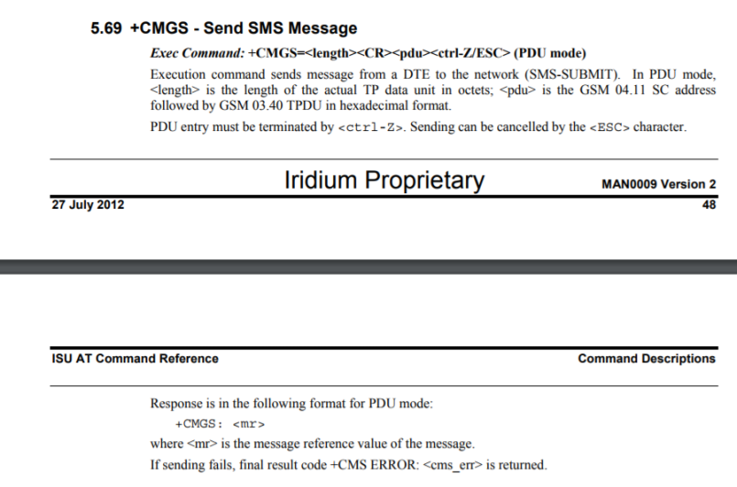

Figure 4. Iridium AT Command Reference for SMS

**Works Consulted**

“Guided Tutorial GNU Radio in Python.” *GNU Radio Wiki*, GNU Radio, 25 Mar. 2017, wiki.gnuradio.org/index.php/Guided_Tutorial_GNU_Radio_in_Python.

“BlocksCodingGuide.” *GNU Radio Wiki*, GNU Radio, 21 Mar. 2017, wiki.gnuradio.org/index.php/BlocksCodingGuide.

“OutOfTreeModules.” *GNU Radio Wiki*, GNU Radio, 12 Sept. 2017, wiki.gnuradio.org/index.php/OutOfTreeModules.

Makai, Matt. “How to Send SMS Text Messages with Python.” *Full Stack Python*, 28 Apr. 2017, www.fullstackpython.com/blog/send-sms-text-messages-python.html.

“Twilio Messaging API.” *Twilio*, Twilio, www.twilio.com/docs/api/messaging.

Palazzo, Stefano. “How to Send/Recieve SMS Using AT Commands.” *Stack Overflow*, 23 May 2017, stackoverflow.com/questions/2161197/how-to-send-receive-sms-using-at-commands.

“GR-Blocks Threshold Class Reference.” *GNU Radio*, Doxygen, 18 Aug. 2016, gnuradio.org/doc/doxygen/classgr_1_1blocks_1_1threshold__ff.html.

Rockson, Ned. “Writing File with Output of Variable and Timestamp.” *Stack Overflow*, 22 July 2015, stackoverflow.com/questions/31575703/writing-file-with-output-of-variable-and-timestamp.

Iridium Proprietary. “ISU AT Command Reference.” *Rock 7*, Iridium Proprietary, 27 July 2012, www.rock7.com/downloads/IRDM_ISU_ATCommandReferenceMAN0009_Rev2.0_ATCOMM_Oct2012.pdf.