Mark Demore II
ECE 332
Lab 14m

Part 1: Functions in the s-Domain

H1(s):

s = tf('s');
H1 = (40*s)/(s^2+100000000);
pzmap(H1)
grid on
title('Pole-Zero Plot for H1(s)')

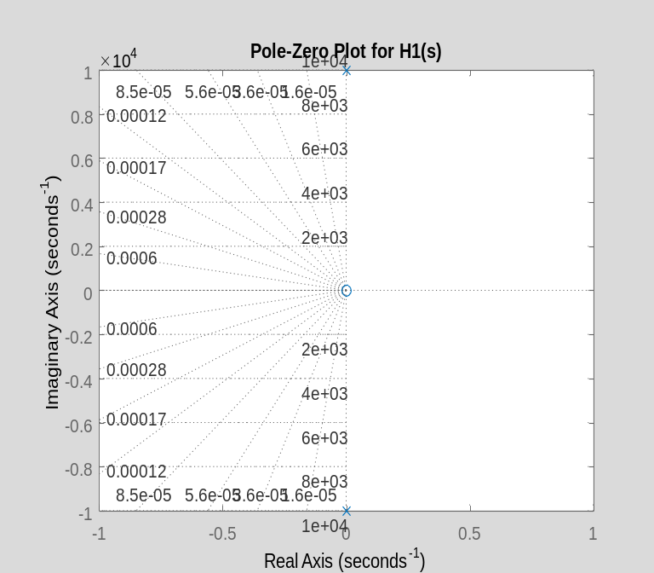

bode(H1)
grid on
title('Bode Plot for H1(s)')

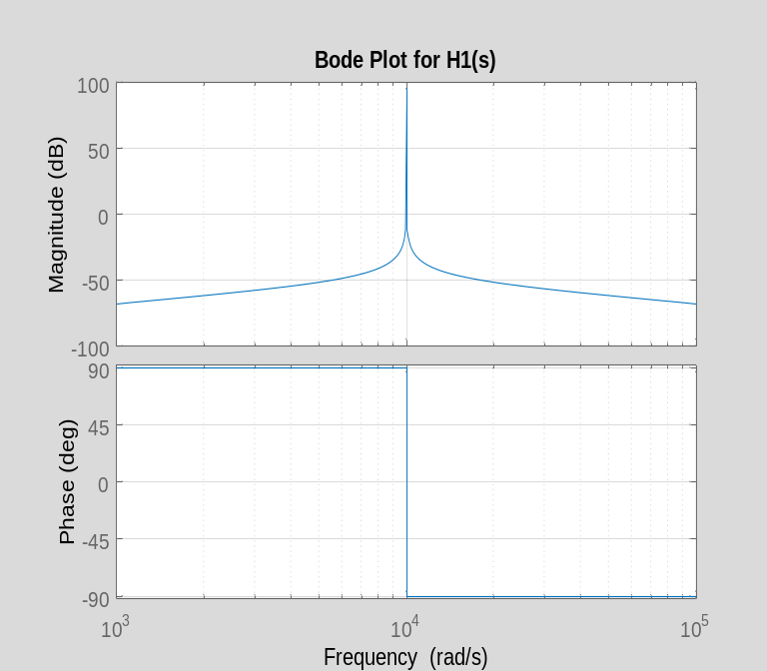

step(H1)
grid on
title('Step Response for H1(s)')

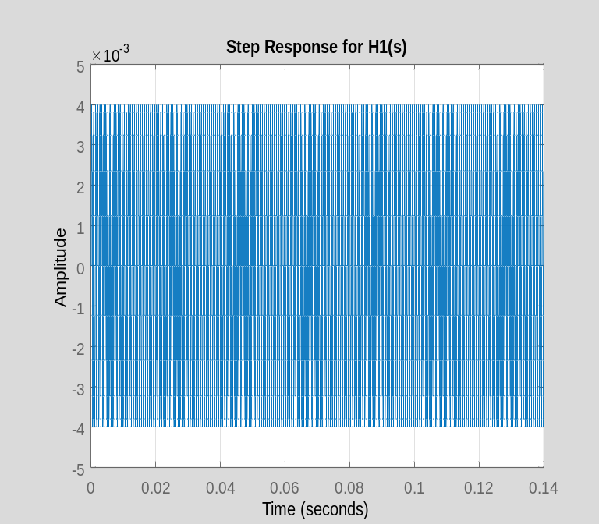

syms s t
H1 = (40*s)/(s^2+100000000);
ilaplace(H1)

ans =
40*cos(10000*t)
H2(s):

clear all
s = tf('s');
H2 = (200*(s+10))/(s^2+10000*s+100000000);
pzmap(H2)
grid on
title('Pole-Zero Plot for H2(s)')

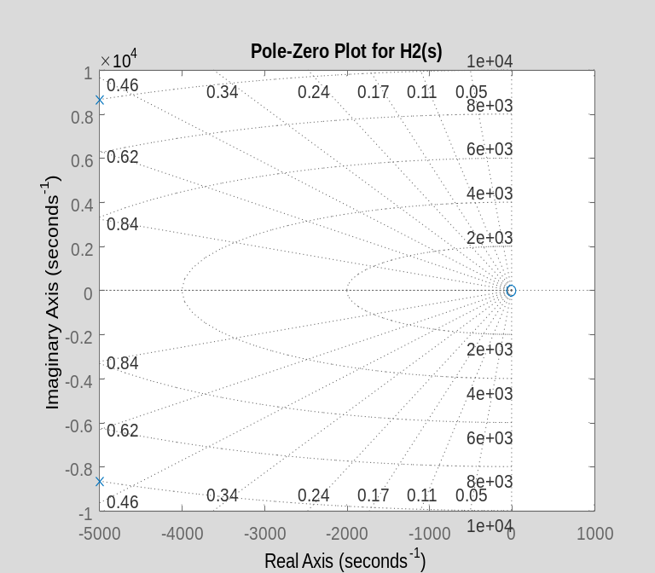

bode(H2)
grid on
title('Bode Plot for H2(s)')

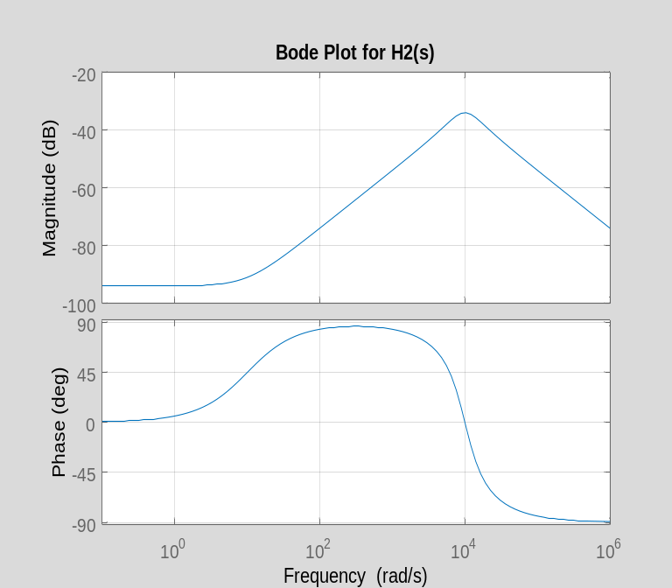

step(H2)
grid on
title('Step Response for H2(s)')

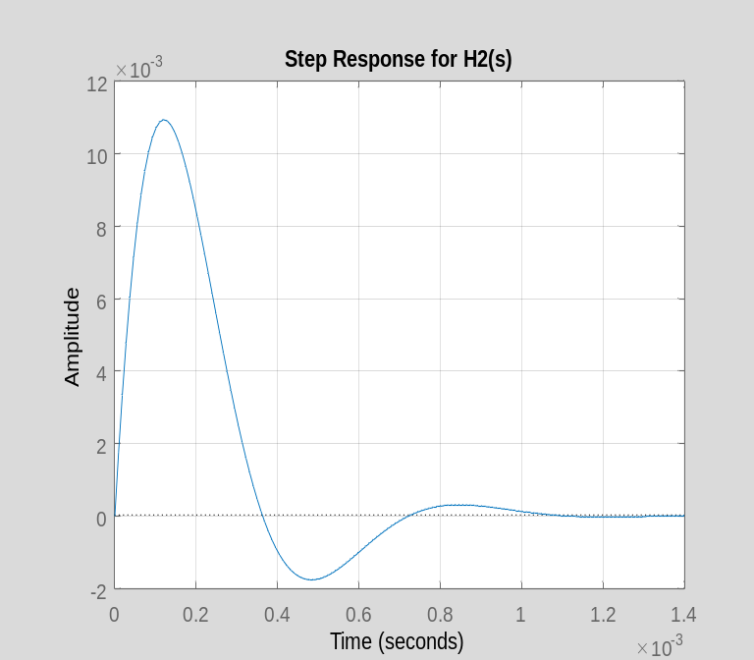

syms s t
H2 = (200*(s+10))/(s^2+10000*s+100000000);
ilaplace(H2)

ans =
200*exp(-5000*t)*(cos(5000*3^(1/2)*t) - (499*3^(1/2)*sin(5000*3^(1/2)*t))/1500)

H3(s):

clear all
s = tf('s');
H3 = (20000)/(s*(s^2+10000*s+100000000));
pzmap(H3)
grid on
title('Pole-Zero Plot for H3(s)')

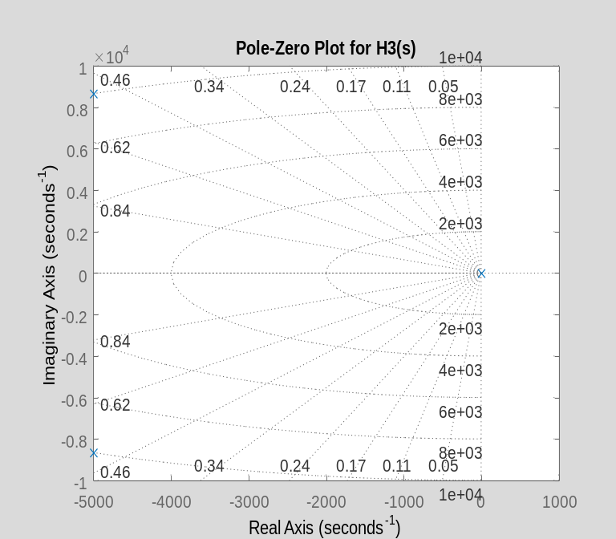

bode(H3)
grid on
title('Bode Plot for H3(s)')

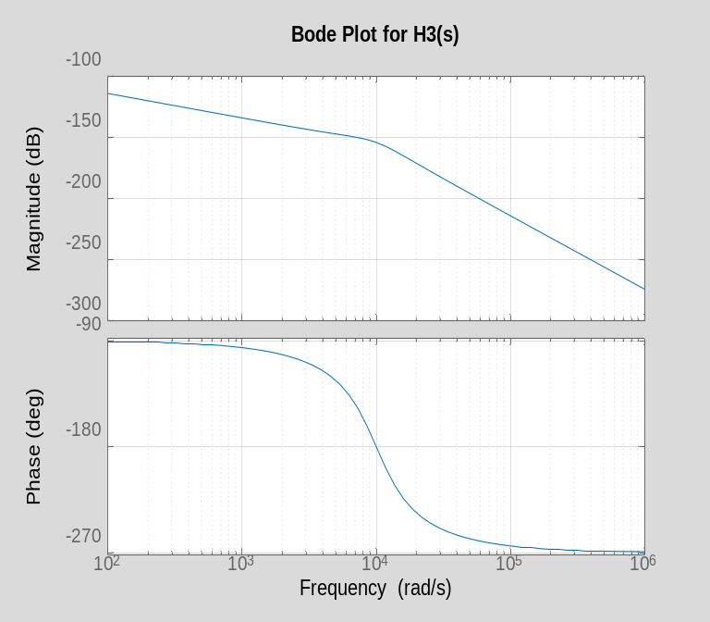

step(H3)
grid on
title('Step Response for H3(s)')

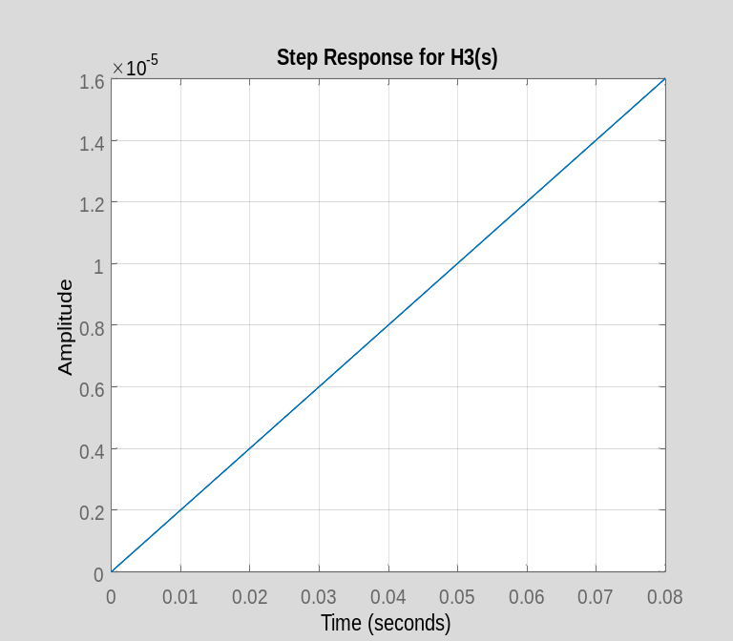

syms s t
H3 = (20000)/(s*(s^2+10000*s+100000000));
ilaplace(H3)

ans =
1/5000 - (exp(-5000*t)*(cos(5000*3^(1/2)*t) + (3^(1/2)*sin(5000*3^(1/2)*t))/3))/5000

H4(s):

clear all
s = tf('s');
H4 = (10000*s^3)/((s+10)*(s+10)*(s+10)*(s+10)*(s+10)*(s+10));
pzmap(H4)
grid on
title('Pole-Zero Plot for H4(s)')

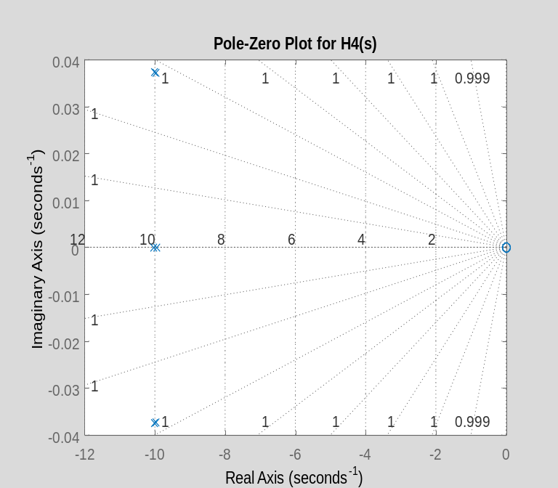

bode(H4)
grid on
title('Bode Plot for H4(s)')

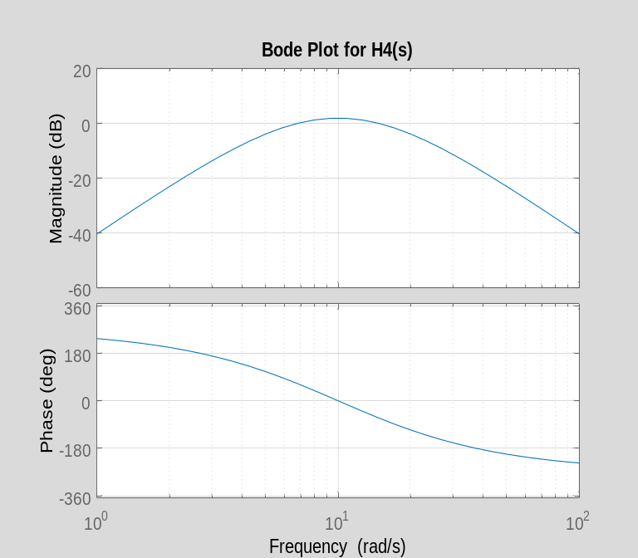

step(H4)
grid on
title('Step Response for H4(s)')

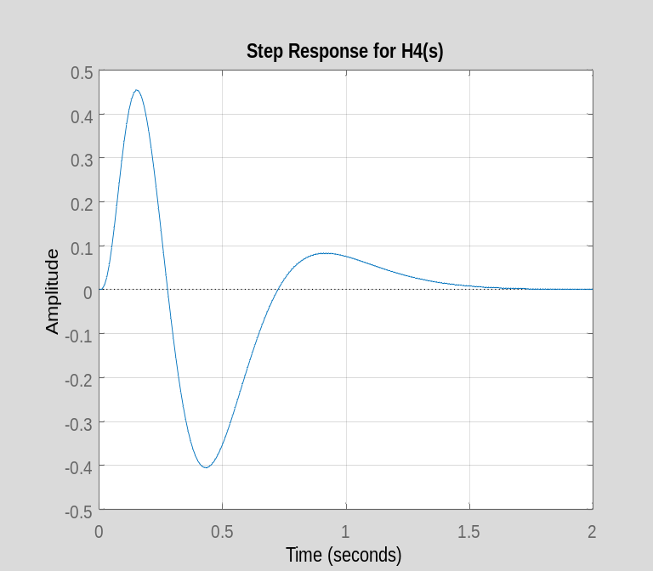

syms s t
H4 = (10000*s^3)/((s+10)*(s+10)*(s+10)*(s+10)*(s+10)*(s+10));
ilaplace(H4)

ans =
5000*t^2*exp(-10*t) - 50000*t^3*exp(-10*t) + 125000*t^4*exp(-10*t) - (250000*t^5*exp(-10*t))/3

Part 2: Laplace Transform

v1(t):

clear all
syms s t
v1 = (100*cos(10*t)-50)*heaviside(t);
laplace(v1)

ans =
(100*s)/(s^2 + 100) - 50/s

v2(t):

v2 = (exp(-50*t)*(100*cos(10*t)-50*sin(10*t)))*heaviside(t);
laplace(v2)

ans =
(100*(s + 50))/((s + 50)^2 + 100) - 500/((s + 50)^2 + 100)

i1(t):

i1 = 10*dirac(t) + (100*exp(-50*t)-100*exp(-200*t))*heaviside(t);
laplace(i1)

ans =
100/(s + 50) - 100/(s + 200) + 10

i2(t):

i2 = (10 + 100*exp(-100*t)-100*t*exp(-200*t))*heaviside(t);
laplace(i2)

ans =
100/(s + 100) - 100/(s + 200)^2 + 10/s

