Vinyl Crate
Project Documentation
Fundamentals of Web Technologies
Individual project
Author: Mehmet Demirci
Repository: github.com/mdemrc/vinyl-crate
June 2026

1. Introduction
Vinyl Crate is a web application for vinyl record collectors. After creating an account, members browse a catalogue of albums, filter it by genre, decade or artist, and open any album to see its full tracklist together with the reviews other members have written.
Every member can rate albums from one to five stars, mark other members’ reviews as helpful, and build a personal “crate” — their own record collection — split between titles they already own and a wishlist of titles they still want. Administrators maintain the catalogue and the community through a dedicated panel where they add albums, upload cover art, edit tracklists, manage genres, manage user accounts and moderate reviews.
The project follows the architecture of the course laboratory application. It is written in PHP with a MySQL database and uses jQuery for its asynchronous features, so it runs on a standard Apache (XAMPP) server with no build step.

2. Project type and division of work
This is an individual project. All of the work — database design, back end, front end and graphic styling — was carried out by the author, Mehmet Demirci.

3. Source code repository
The complete source code is available on GitHub: https://github.com/mdemrc/vinyl-crate
The repository also contains a README with setup instructions and the test accounts: an administrator (admin / admin123) and several regular users (demo / demo123, plus alex, sam and nina with the same name123 pattern).

4. Functionality

Accounts and access
- User accounts: registration, login and logout, with passwords stored as hashes (password_hash / password_verify)
- Roles: regular members and administrators, with admin-only pages protected by a guard

Catalogue and navigation
- Browse: a responsive grid of albums showing cover art, genre, release year and average rating
- Search: live phrase search by album title or artist, updating without a page reload
- Filtering: by genre (drop-down list), by decade (links) and by artist (links), plus sorting by newest, rating, year or title
- Quick navigation: a genre badge or an artist name links straight to the catalogue filtered by that value

Album management — full CRUD (administrators)
- Create / edit / delete: administrators create, edit and delete albums
- Image upload: cover art is uploaded as a real file, validated by image type and size, and stored on the server
- Tracklist editor: a dynamic editor adds or removes track rows, saved as related rows in a separate table

Records and social features
- Tracklists: each album shows its ordered tracklist with track lengths and total running time
- Reviews: a 1–5 star rating with a comment; one review per user per album, which can be edited
- Helpful votes: members mark other people’s reviews as helpful, and reviews are ordered by how helpful they are
- Personal crate: members mark albums as owned or wishlist and switch between the two instantly

Administration panel
- Dashboard: a dashboard with catalogue statistics and a management table of all albums
- Genres: add and delete genres
- Users: list members with their activity, promote or demote administrators and delete accounts, with protection against an admin locking themselves out
- Moderation: delete any member’s review directly from the album page

Asynchronous (AJAX) features
- Without reload: live search, the owned/wishlist crate toggle, marking a review helpful and review deletion all use asynchronous requests

5. Database schema
The database contains seven related tables. The diagram below shows the tables, their columns and the foreign-key relationships between them.
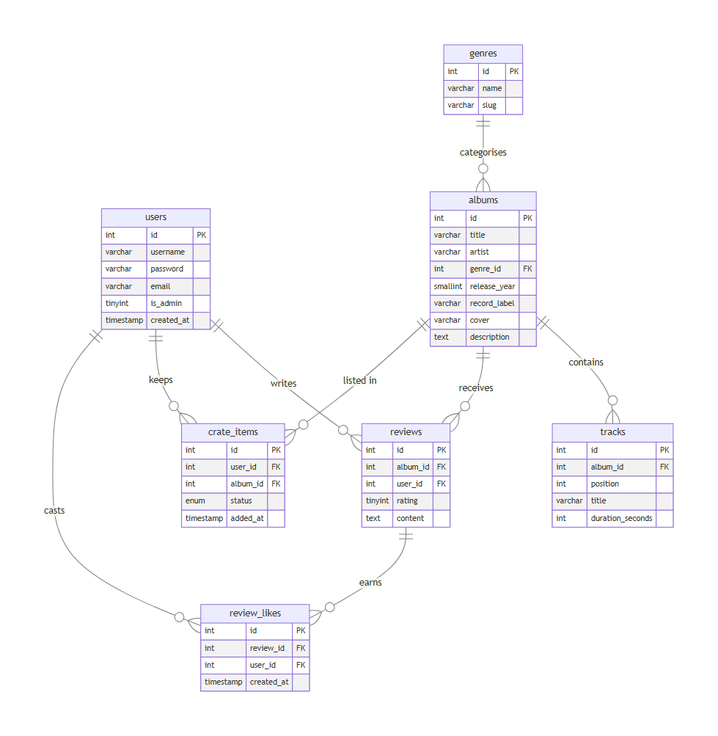
Entity-relationship diagram of the vinyl_crate database
- users: user accounts and the is_admin flag
- genres: album genres; referenced by albums
- albums: the catalogue — each album belongs to one genre
- tracks: the tracklist of an album (one album has many tracks)
- reviews: one rating and comment per user per album
- crate_items: a member’s owned and wishlist entries
- review_likes: which members marked which reviews as helpful (one vote per user per review)
Deleting an album cascades to its tracks, reviews and crate entries; deleting a review removes its helpful votes; deleting a genre leaves its albums in place (their genre is set to null).

6. Screenshots

Sign in
The entry screen. Visitors sign in or follow the link to create a new account; both forms share the application’s dark vinyl theme.
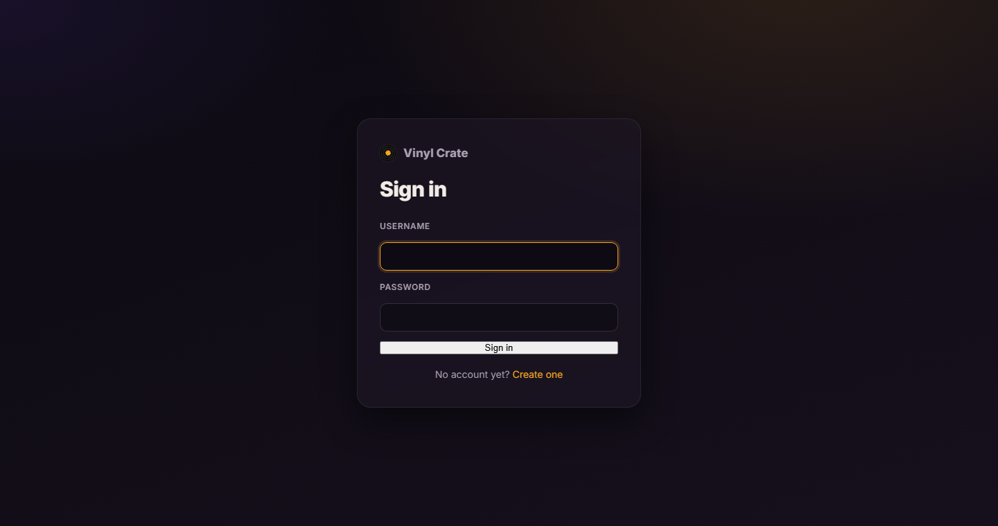

Browse the catalogue
The main catalogue: a grid of album cards with cover art, genre badges, year and average star rating, above the search box, genre/sort drop-downs and decade links.
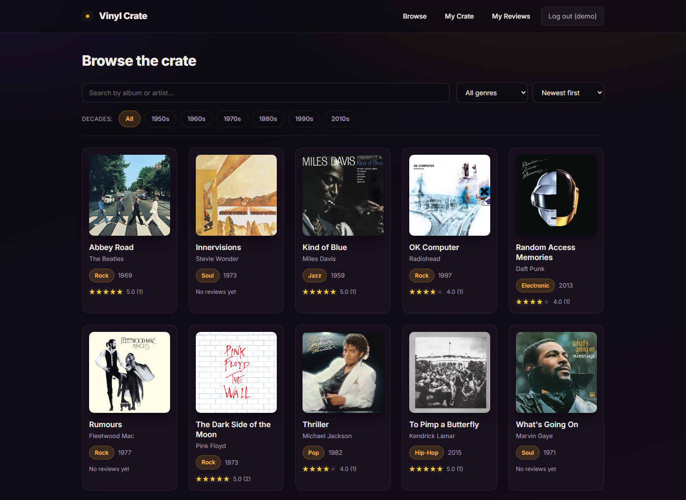

Album details
An album page (administrator view) with its cover, metadata, the full tracklist, the review form and the reviews — each can be marked helpful, and an administrator can delete any of them with the corner control.
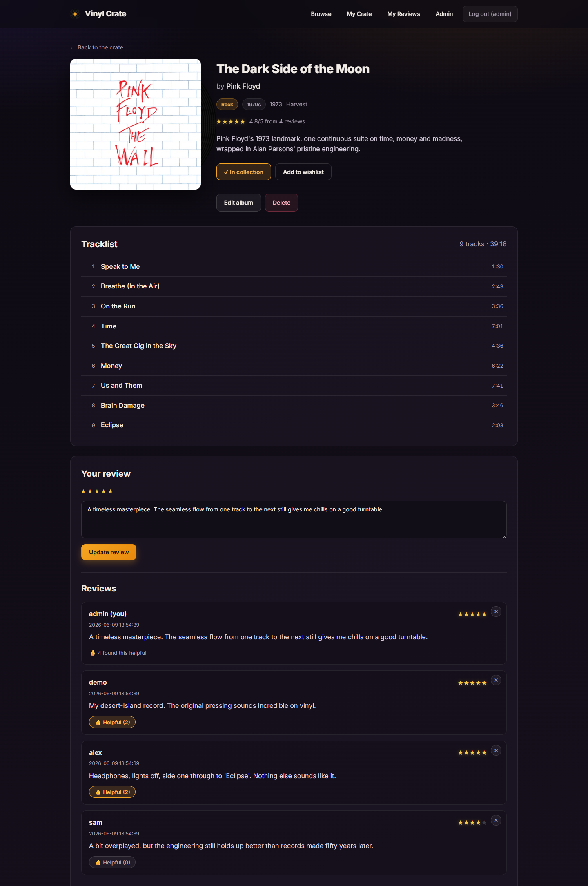

My Crate
The member’s personal collection, filtered into the whole crate, owned records and the wishlist, with a live owned/wishlist toggle on each card.
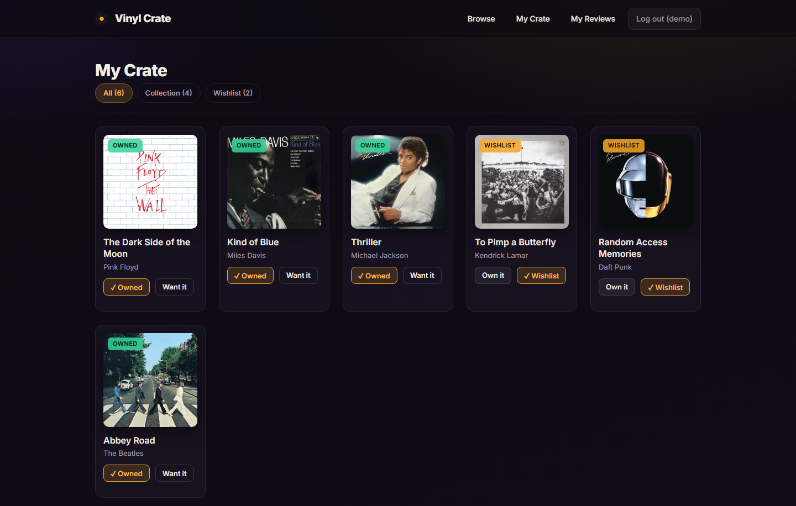

My Reviews
Every review written by the member, with its helpful count, a link back to the album, and inline edit and delete without reloading the page.
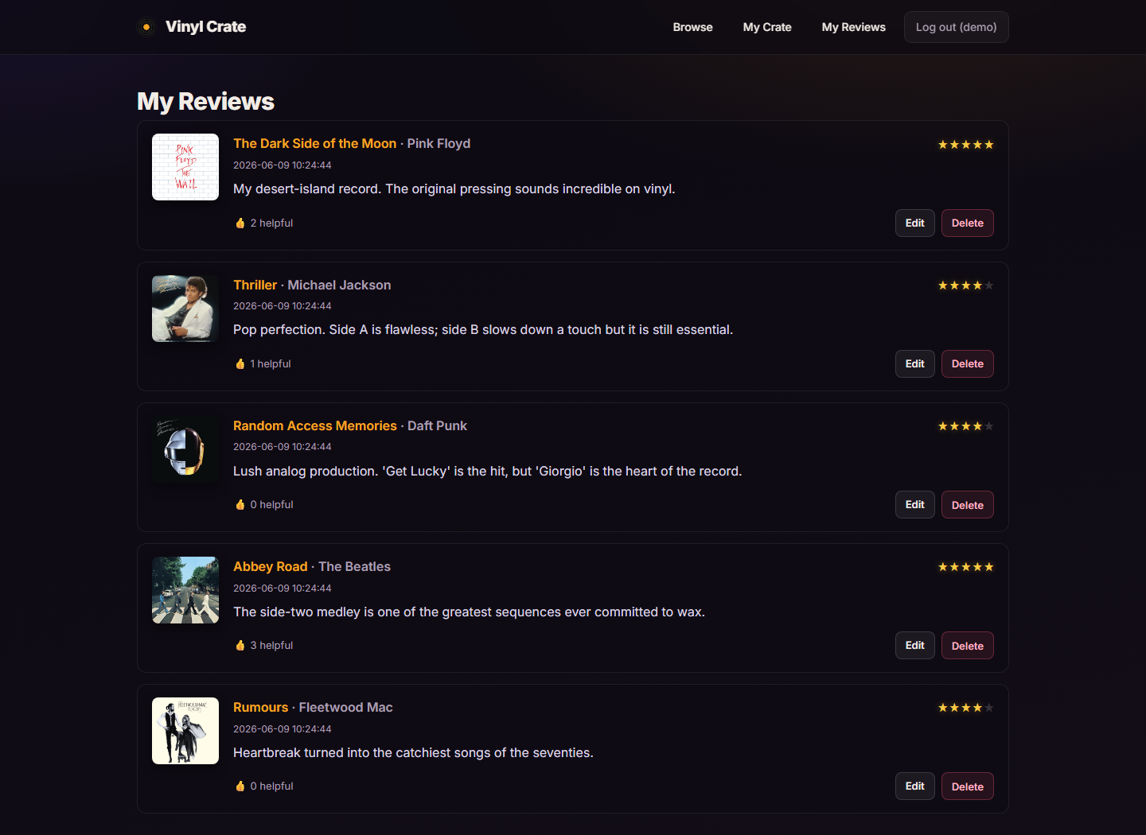

Admin dashboard
The administrator dashboard: catalogue statistics and a management table of every album with edit and delete actions.
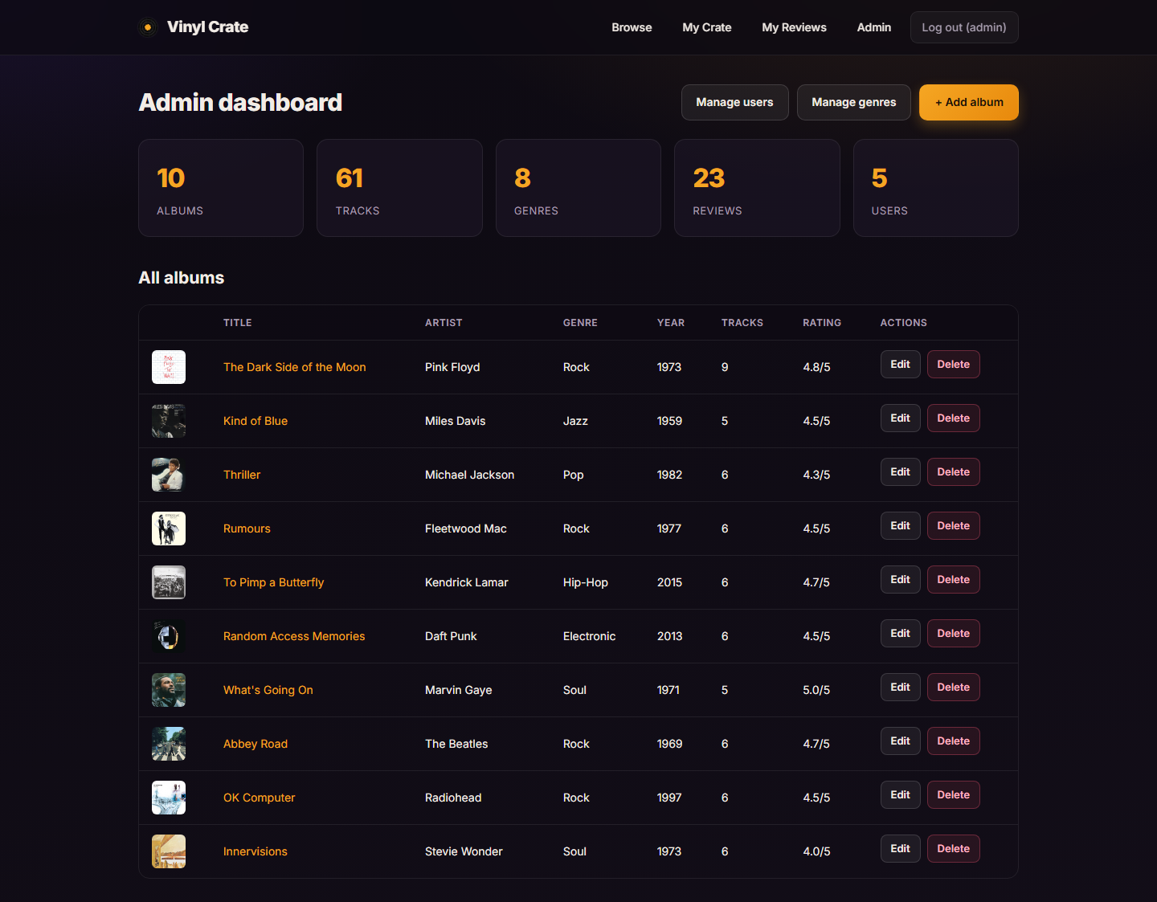

Manage users
User management: every member with their review and collection counts, controls to promote or demote administrators and to delete accounts. The administrator’s own row is protected.
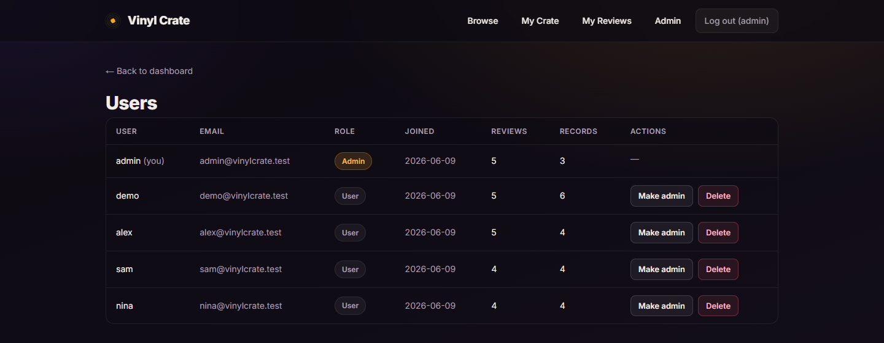

Add / edit album
The album form used to create or edit a record, including the cover-image upload field and the dynamic tracklist editor.
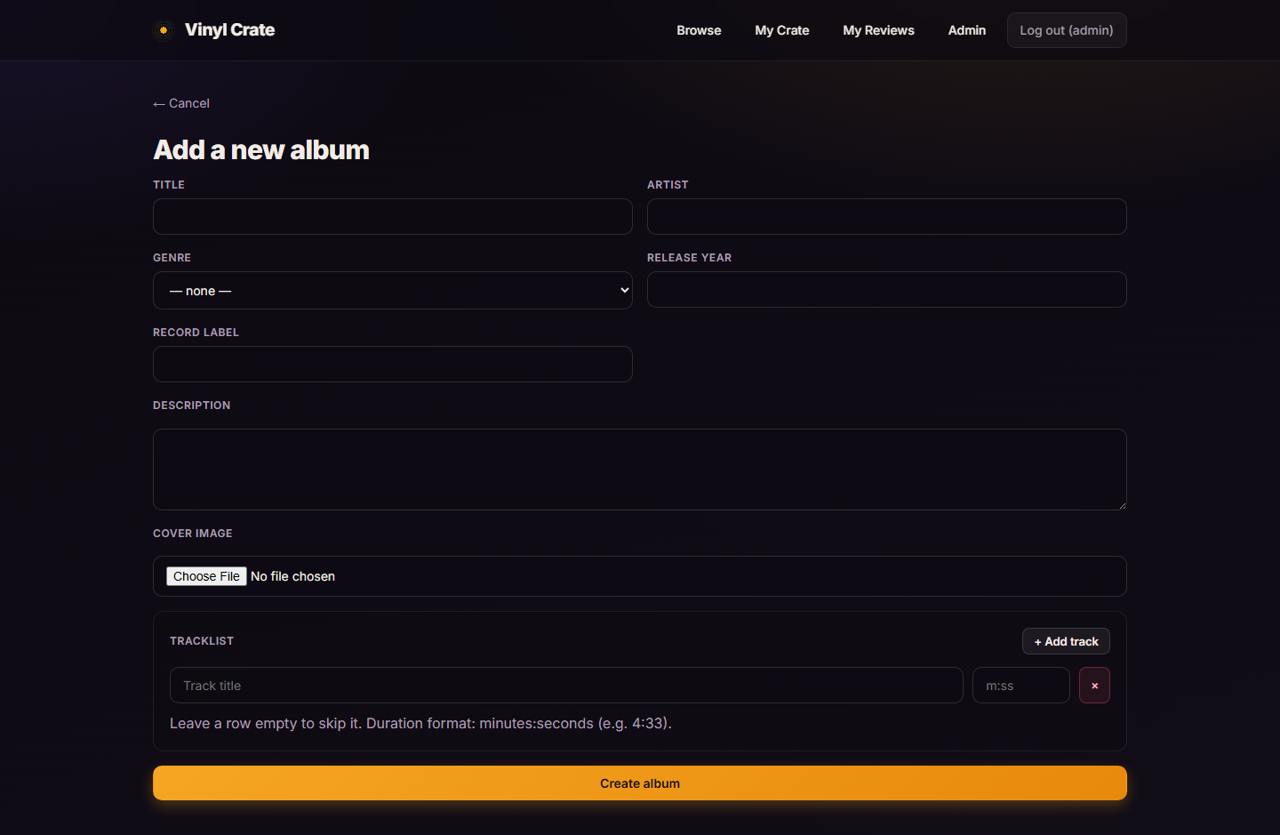

Manage genres
Genre management: a form to add a genre and a table listing every genre with its album count and a delete action.
